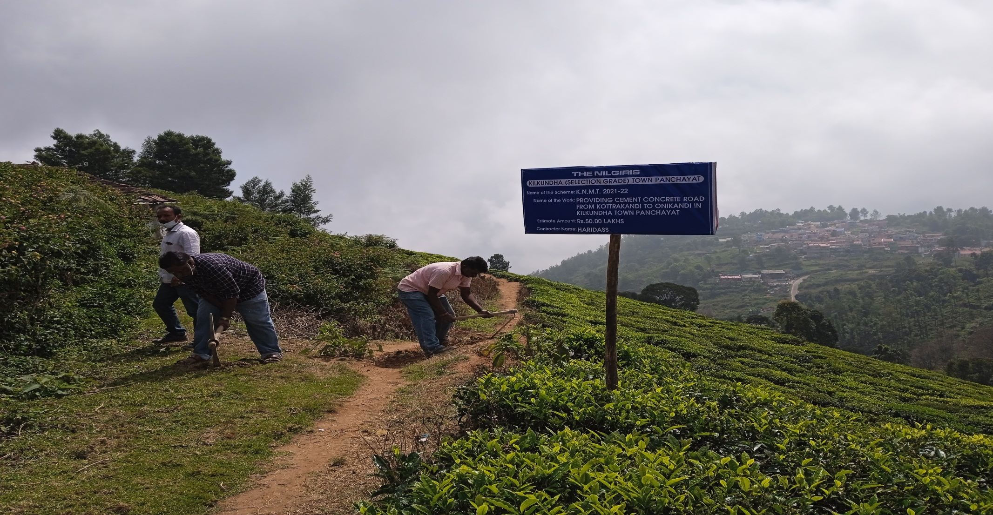

**NAME OF THE TOWN PANCHAYAT - KILKUNDAH TOWN PANCHAYAT**

**NAME OF THE WORK – PROVIDING CEMENT CONCRETE WORK AT KOTTRAKANDI**

**TO OONIKANDI**

**NAME OF THE SCHEME – KNMT 2021-2022**

**ESTIMATE AMOUNT – Rs. 50.00 Lakhs**