COIMBATORE DISTRICT – MOPPIRIPALAYAM TOWN PANCHAYAT KALAINGAR NAGARPURA MEMPATTU THITTAM (KNMT) SCHEME – 2021-2022

Providing BT road at ward No.9 from pallakorai to thottasalai street ESTIMATE AMOUNT – RS.73.80 LAKHS

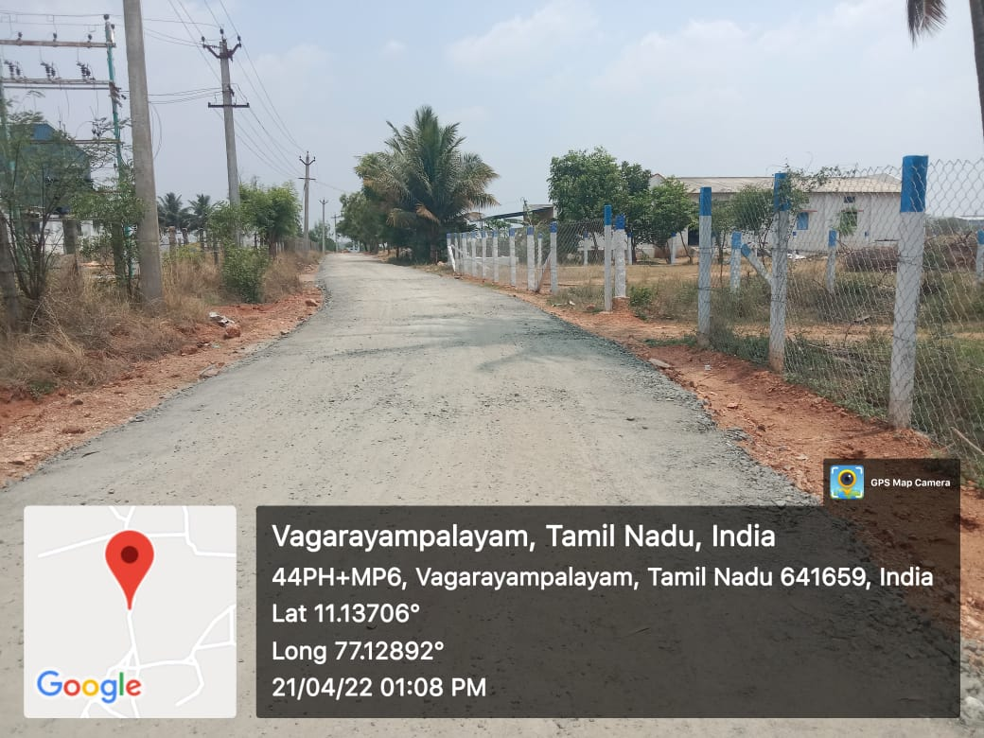

**Name of the Street : ROAD - Pallakorai to thottasalai street**