getData.xsjs

getData.xsjs?cmd=getUser&userID=XXXX

Return {username=xxxx}

getData.xsjs?cmd=getGroup&userID=Xxxxx

return {

1{GroupName=xxxxx

GroupProgress=xxxxx(100 steps Left,200 Point Gained)

Finished=xxx (200)

Remains=xxx(100)

}

2{ GroupName=xxxxx

GroupProgress=xxxxx(100 steps Left,200 Point Gained)

Finished=xxx (200)

Remains=xxx(100)

}

….

}

getData.xsjs?cmd=getGroupDetail&userID=xxxx&GoupID=xxx

{

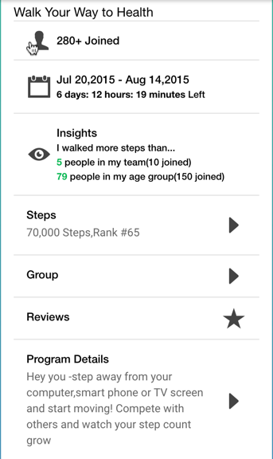



}

getData.xsjs?cmd=getLeaderBoard&userID=xxxx&groupID=xxxx

{



}

getData.xsjs?cmd=getGroupShare&userID=xxx&groupID=xxx&loadFrom=XXX(eg.0)&loadAmount=xxx(eg.50) TBD

()

getData.xsjs?cmd=getAssessment&userID=xxxx

Return{

AssessmentsOverview=xxxx(2 Qeustions Left | 400 Point Gained)

Finished=xxx(int)

Remained=xxx(int)

}

getData.xsjs?cmd=getAssessmentDetail&userID=xxx

Return{

Assessment= xxxx(Alcohol Use)

Questionare {

1{QuestionID=xxxxxx

Question=xxxxx }

2{QuestionID=xxxxxx

Question=xxxxx }}

}

}

}

getData.xsjs?cmd=getAssessmentResult&userID=xxx

Return{

