**Baseline Implementation**

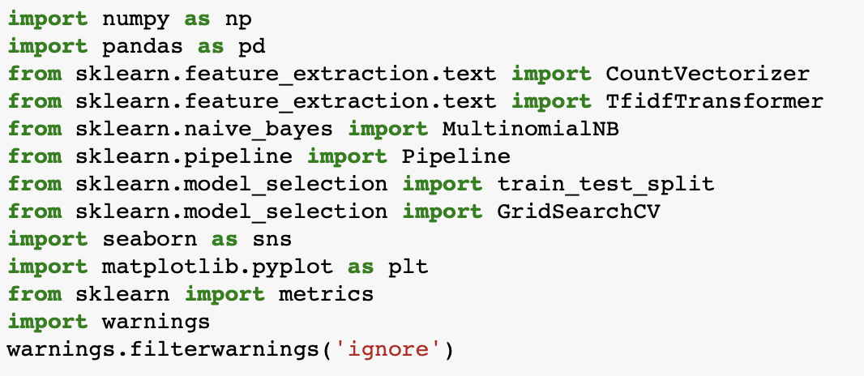

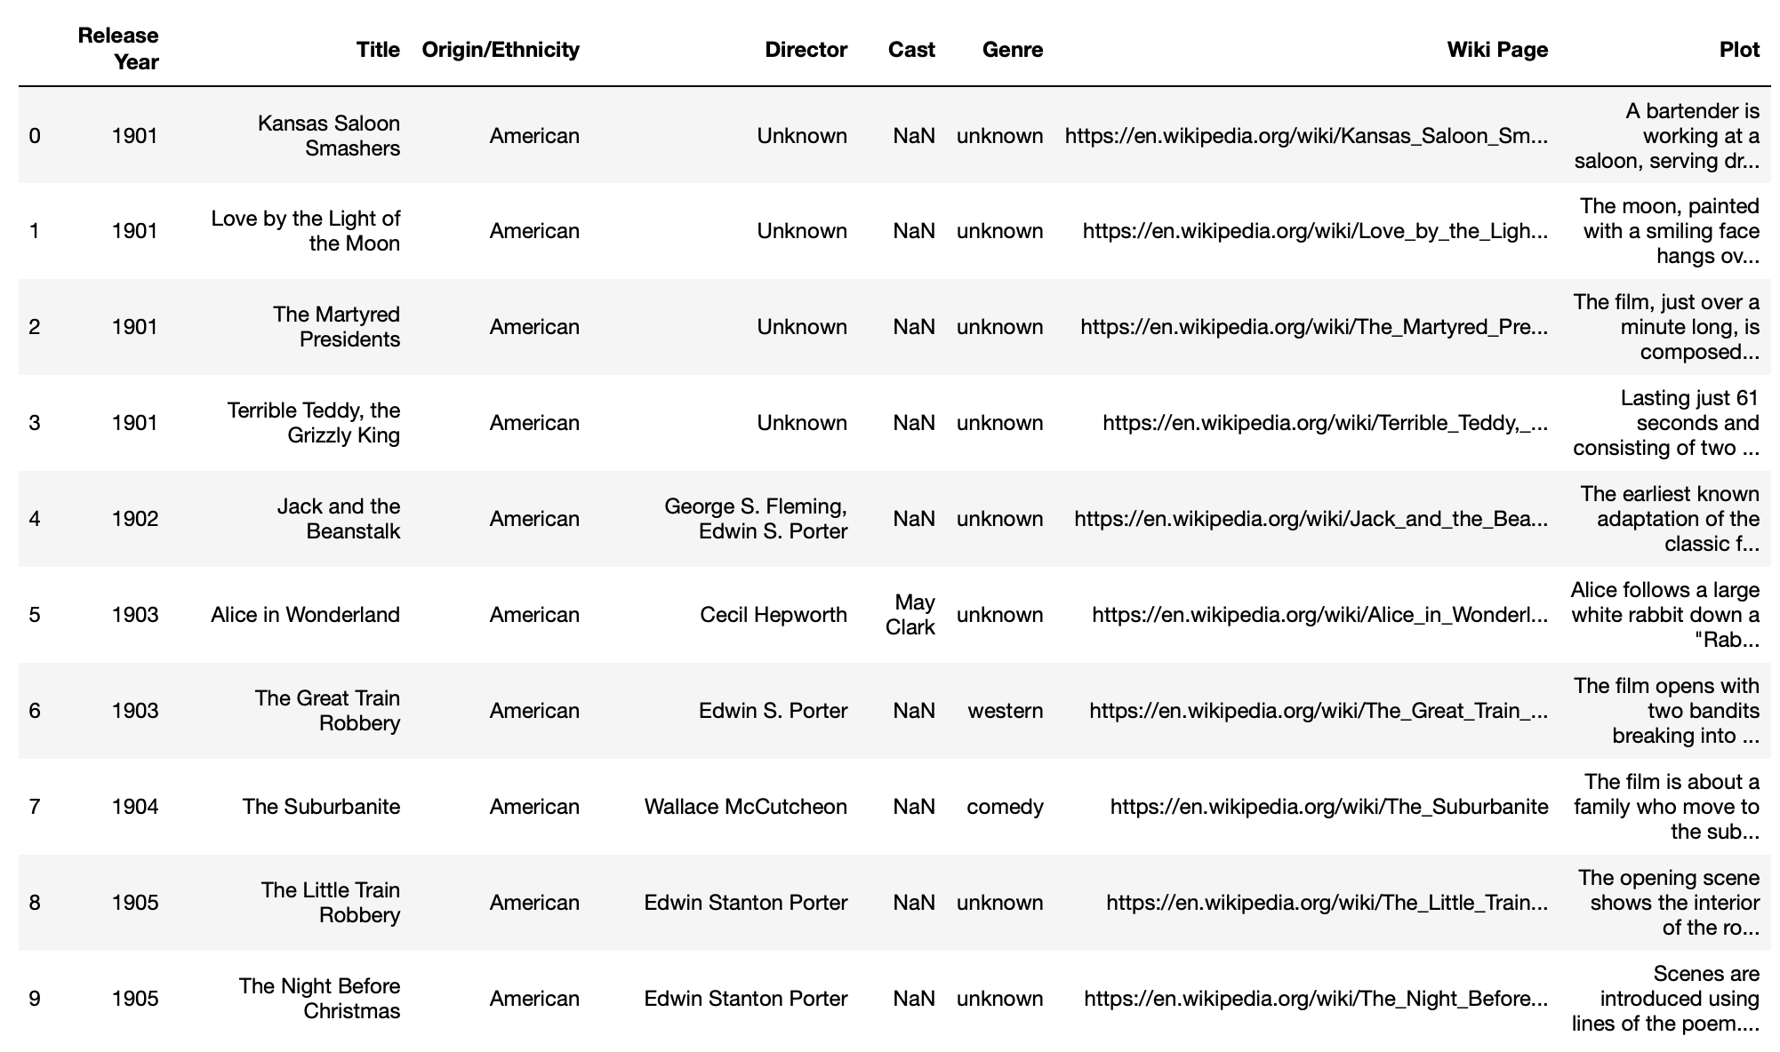

Output:

Output:

Output:

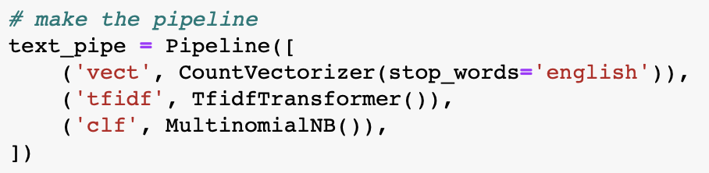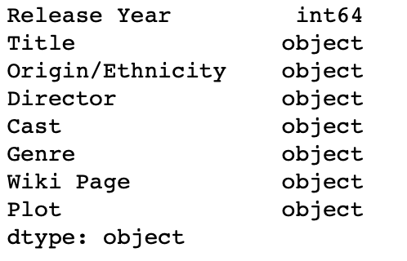

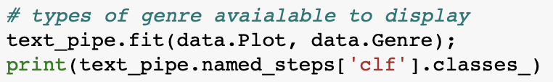Output:

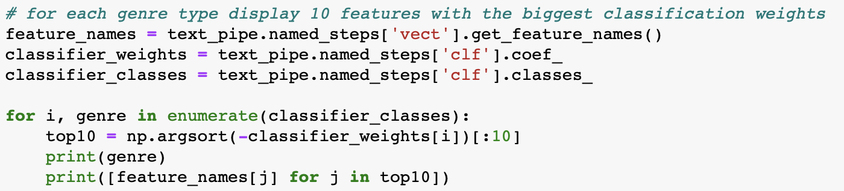

Output examples:

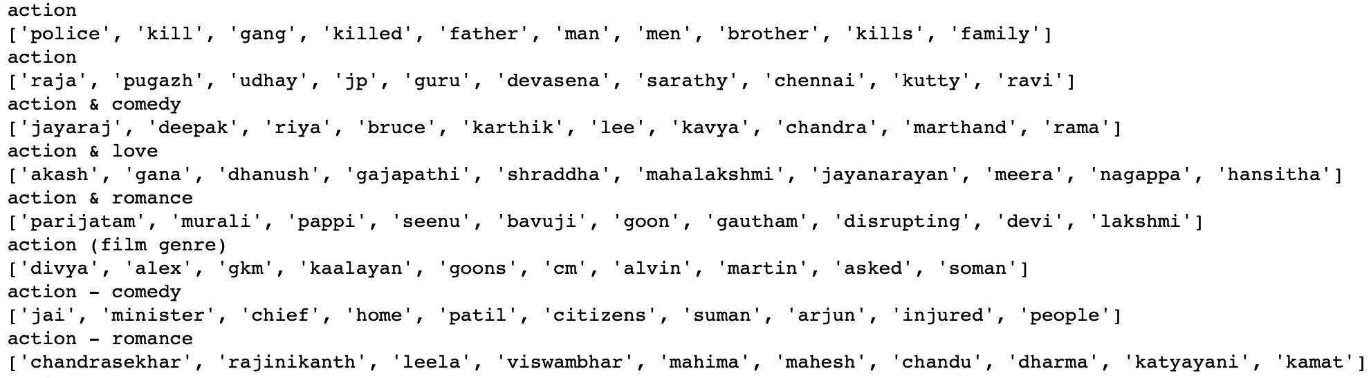 ...

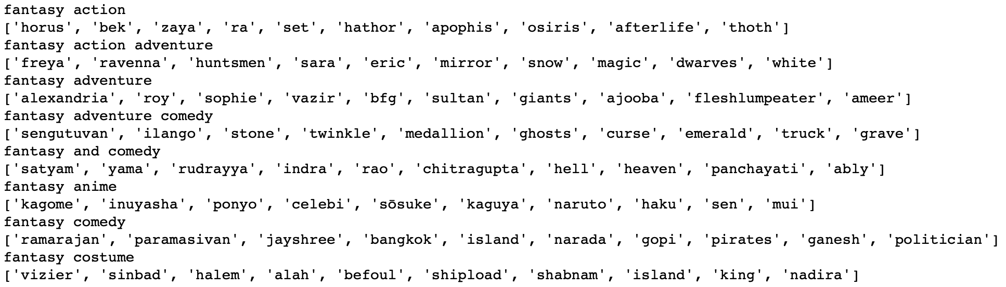

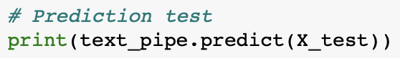

Output:

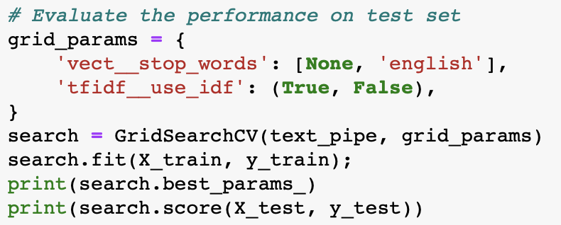

Output:



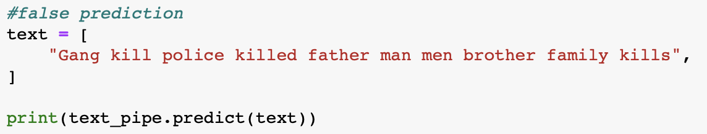

Output:



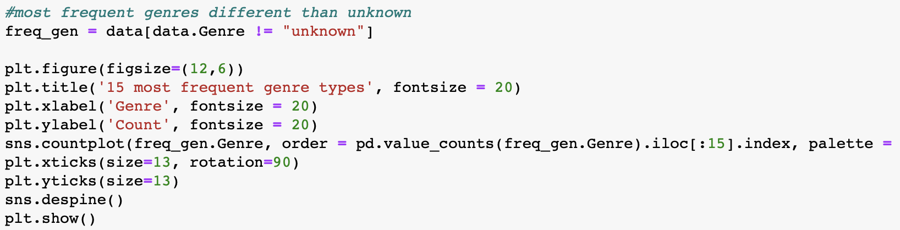

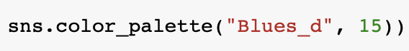

Output:

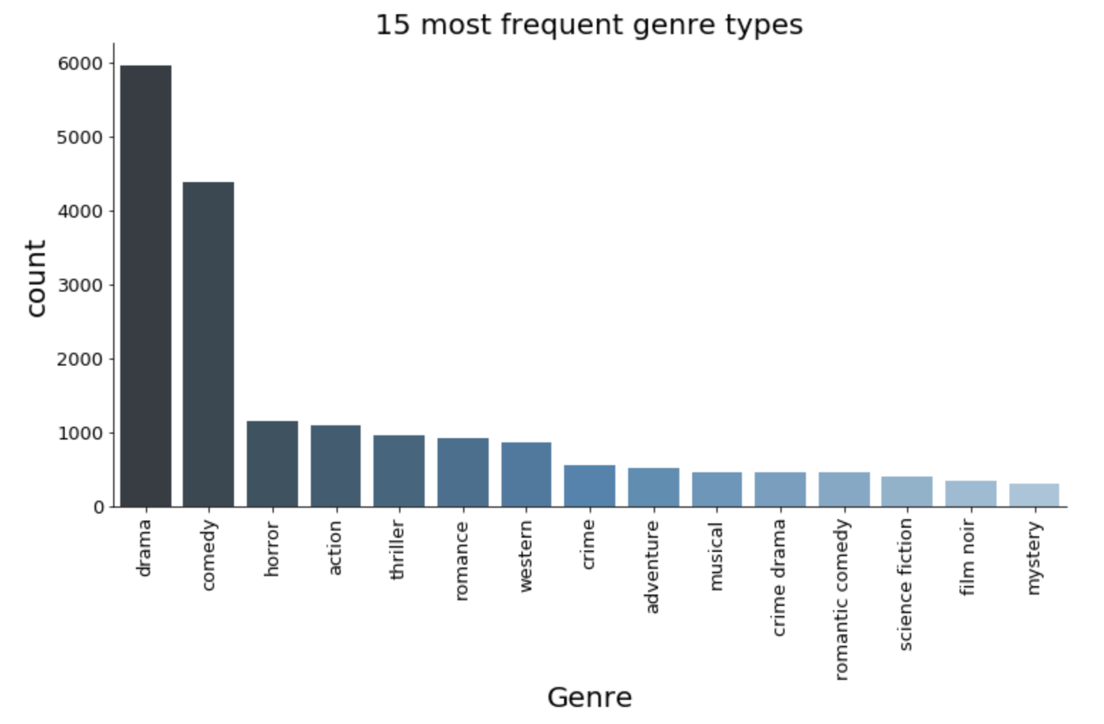

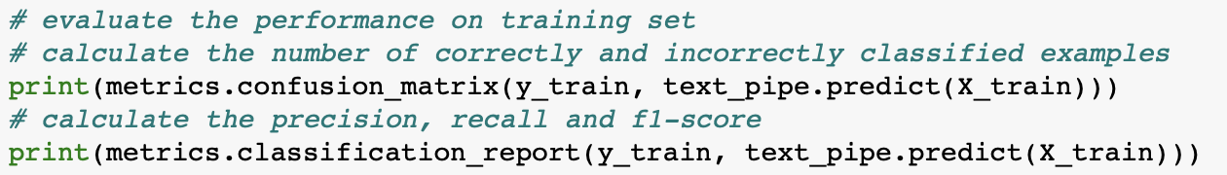

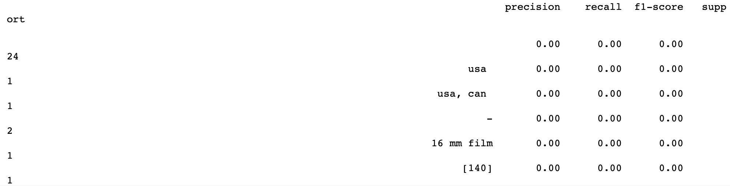Outputs:

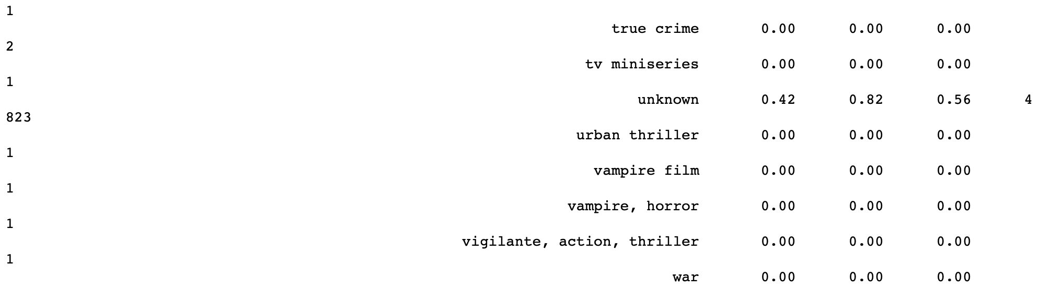

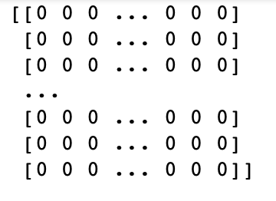

**BASELINE CODE:**

import numpy as np

import pandas as pd

from sklearn.feature_extraction.text import CountVectorizer

from sklearn.feature_extraction.text import TfidfTransformer

from sklearn.naive_bayes import MultinomialNB

from sklearn.pipeline import Pipeline

from sklearn.model_selection import train_test_split

from sklearn.model_selection import GridSearchCV

import seaborn as sns

import matplotlib.pyplot as plt

from sklearn import metrics

import warnings

warnings.filterwarnings('ignore')

data = pd.read_csv("wiki_movie_plots_deduped.csv", delimiter=',')

data.head(10)

data.shape

data.dtypes

# split data into training and test sets

X_train, X_test, y_train, y_test = train_test_split(data.Plot, data.Genre, test_size=0.2, random_state=0)

# make the pipeline

text_pipe = Pipeline([

('vect', CountVectorizer(stop_words='english')),

('tfidf', TfidfTransformer()),

('clf', MultinomialNB()),

])

# types of genre avaialable to display

text_pipe.fit(data.Plot, data.Genre);

print(text_pipe.named_steps[‚clf'].classes_)

# for each genre type display 10 features with the biggest classification weights

feature_names = text_pipe.named_steps['vect'].get_feature_names()

classifier_weights = text_pipe.named_steps['clf'].coef_

classifier_classes = text_pipe.named_steps['clf'].classes_

for i, genre in enumerate(classifier_classes):

top10 = np.argsort(-classifier_weights[i])[:10]

print(genre)

print([feature_names[j] for j in top10])

# Prediction test

print(text_pipe.predict(X_test))

# Evaluate the performance on test set

grid_params = {

'vect__stop_words': [None, 'english'],

'tfidf__use_idf': (True, False),

}

search = GridSearchCV(text_pipe, grid_params)

search.fit(X_train, y_train);

print(search.best_params_)

print(search.score(X_test, y_test))

#false prediction - should be „action”

text = [

"Gang kill police killed father man men brother family kills",

]

print(text_pipe.predict(text))

#diagram with most frequent genres, different than unknown

freq_gen = data[data.Genre != "unknown"]

plt.figure(figsize=(12,6))

plt.title('15 most frequent genre types', fontsize = 20)

plt.xlabel('Genre', fontsize = 20)

plt.ylabel('Count', fontsize = 20)

sns.countplot(freq_gen.Genre, order = pd.value_counts(freq_gen.Genre).iloc[:15].index, palette = sns.color_palette("Blues_d", 15))

plt.xticks(size=13, rotation=90)

plt.yticks(size=13)

sns.despine()

plt.show()

# evaluate the performance on training set

# calculate the number of correctly and incorrectly classified examples

print(metrics.confusion_matrix(y_train, text_pipe.predict(X_train)))

# calculate the precision, recall and f1-score

print(metrics.classification_report(y_train, text_pipe.predict(X_train)))