CFA-L2-Practice-Port-2017
Reading 47: The Portfolio Management Process and The Investment Policy Statement

Task 1: Portfolio Management Process and IPS

1. In which step of the portfolio management process developing an IPS occur? 486399
A) Strategic asset allocation.
B) Planning.
C) Feedback.

Answer: B
Developing an IPS occurs in the planning steps of the process. The purpose of developing an IPS is to govern decision making.

2. Which of the following is not considered to be an investment constraint? 486400
A. Tax concerns.
B. Risk tolerance.
C. Time horizon.

Answer: B
An investor’s risk tolerance is included under objectives. Constraints include liquidity needs, time horizon, tax concerns, legal and regulatory factors, and unique circumstances.

Reading 48: An Introduction to Multifactor Models

Task 2: Arbitrage Pricing Theory (APT)

1. The factor risk premium on factor j in the arbitrage pricing theory (APT) can be interpreted as the: 486401
A) expected risk premium investors require on a factor portfolio for factor j.
B) sensitivity of the market portfolio to factor j.
C) expected return investors require on a factor portfolio for factor j.

Answer: A
We can interpret the APT factor risk premiums similar to the way we interpret the market risk premium in the CAPM. Each factor price is the expected risk premium (extra expected return minus the risk-free rate) investors require for a portfolio with a sensitivity of one (β_{p,j} =1) to that factor and a sensitivity of zero to all the other factors (a factor portfolio).

2. Which of the following is NOT an assumption necessary to derive the arbitrage pricing theory (APT)? 486402
A) A large number of assets are available to investors.
B) The priced factors risks can be hedged without taking short positions in any portfolios.
C) Asset returns are described by a k-factor model.

Answer: B
Derivation of the APT requires three assumptions:
1. Asset returns are described by a factor model.
2. A large number of assets are available, which means investors can create diversified portfolios in which firm-specific risk is eliminated.
3. There are no arbitrage opportunities available to investors among these well-diversified portfolios. An arbitrage opportunity is an investment that has an expected positive net cash flow but requires no initial investment.

Task 3: Multifactor Models: Introduction

3. In a multi-factor macroeconomic model the mean-zero error term represents: 486403
A) sampling error in estimating factor sensitivities.
B) the no-arbitrage condition imposed in multi-factor models.
C) the portion of the individual asset's return that is not explained by the systematic factors.

Answer: C
The mean-zero error term represents the unsystematic, firm-specific, diversifiable risks that are not explained by the systematic factors.

4. Identify the most accurate statement regarding multifactor models from among the following.
486404
A) Macrofactor models include explanatory variables such as the business cycle, interest rates, and inflation, and fundamental factor models include explanatory variables such as firm size and the price-to-earnings ratio.
B) Macrofactor models include explanatory variables such as real GDP growth and the price-to-earnings ratio and fundamental factor models include explanatory variables such as firm size and unexpected inflation.
C) Macrofactor models include explanatory variables such as firm size and the price-to-earnings ratio and fundamental factor models include explanatory variables such as real GDP growth and unexpected inflation.

Answer: A
Macrofactor models include multiple risk factors such as the business cycle, interest rates, and inflation. Fundamental factor models include specific characteristics of the securities themselves such as firm size and the price-to-earnings ratio.

Task 4: Multifactor Models: Application

5. Last year the return on Harry Company stock was 5 percent. The portion of the return on the stock not explained by a two-factor macroeconomic factor model was 3 percent. Using the data given below, what is Harry Company stock’s expected return.
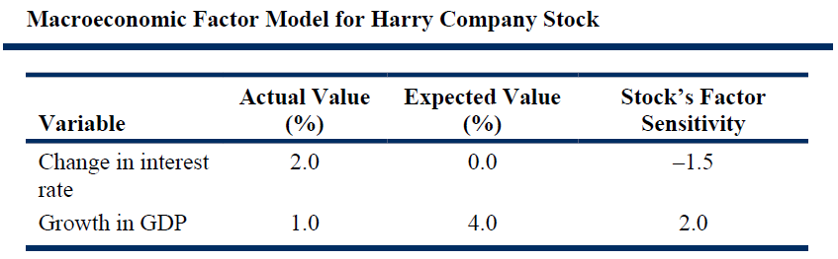

486405

A. 11%
B. 15%
C. 19%

Answer: A
5% = Expected return – 1.5*(Interest rate surprise) + 2*(GDP surprise) + Error term
= Expected return – 1.5*(2%) + 2*(–3%) + 3%
So, the expected return = 5% + 3% + 6% -3% = 11%.

Reading 49: Measuring and Managing Market Risk

Task 5: Value at Risk (VaR)

1. Given a VaR of $12.5 million at 5% for one month, which of the following statements is correct? 486406
A. There is a 5% chance of losing $12.5 million over one month.
B. There is a 95% chance that the expected loss over the next month is less than $12.5 million.
C. The minimum loss that would be expected to occur over one month 5% of the time is $12.5 million

Answer: C
It is the only statement that accurately expresses the VaR.
A is incorrect because VaR does not give the likelihood of losing a specific amount. B is incorrect because VaR is not an expected loss—it is a minimum loss.

2. Which of the following statements is not correct? 486407
A. A 1% VaR implies a downward move of 1%
B. A one standard deviation downward move is equivalent to a 16% VaR.
C. A 5% VaR implies a move of 1.65 standard deviations less than the expected value.

Answer: A
A 1% VaR (99% confidence) is the point on the distribution 2.33 standard deviations below the expected value. Answers B and C correctly describe a 16% and 5% VaR, respectively.

3. Which of the following statements about the historical simulation method of estimating VaR is most correct? 486408
A. A 5% historical simulation VaR is the value that is 5% to the left of the expected value.
B. A 5% historical simulation VaR is the value that is 1.65 standard deviations to the left of the expected value.
C. A 5% historical simulation VaR is the fifth percentile, meaning the point on the distribution beyond which 5% of the outcomes result in larger losses

Answer: C
In the historical method, the portfolio returns are arrayed lowest to highest and the observation at the fifth percentile (95% of the outcomes are better than this outcome) is the VaR. A is not correct because it draws a point on the distribution relative to the expected value rather than the using the 5% of the outcomes that are in the left-most of the distribution. B confuses the parametric and historical methods. In the parametric method, the 5% VaR lies 1.65 standard deviations below the mean.

4. Which of the following is a limitation of VaR? 486409
A. It requires the use of the normal distribution.
B. The maximum VaR is prescribed by federal securities regulators.
C. It focuses exclusively on potential losses, without considering potential gains

Answer: C
VaR deals exclusively with left-tail or adverse events. A is wrong because although parametric VaR does generally use the normal distribution, the historical simulation method uses whatever distribution occurred in the past and Monte Carlo simulation uses whatever distribution the user chooses. B is incorrect because regulators do not specify maximum VaRs, although they may encourage and require that the measure be used.

Task 6: Sensitivity and Scenario Risk Measures

5. Which measures are based on market returns during a particular historical period? 486410
A. Hypothetical scenario analysis and duration sensitivity.
B. Historical scenario analysis and VaR
C. Option delta and vega.

Answer: B
Historical scenarios apply market returns from a particular period to the portfolio, and virtually all VaR methodologies use a historical period to underpin the VaR model, although certain methods may make adjustments if this historical period is seen to be anomalous in some way.

6. Which of the following most accurately characterizes duration and convexity? 486411
A. Sensitivity of bond prices to interest rates
B. First- and second-order effects of yield changes on bond prices
C. Weighted-average time to maturity based on the coupon payments and principal

Answer: B
Duration is the first-order effect and convexity is the second order effect of a change in interest rates on the value of a bond. A and C are correct with respect to duration, but not for convexity.

7. Which kind of market participant is least likely to use scenario analysis as a pass/fail stress test? 486412
A. Bank
B. Long-only asset manager
C. Hedge fund using leverage

Answer: B
Long-only asset managers do not typically use leverage and are thus less likely to become insolvent, making a pass/fail test for solvency less relevant to them. A and C are not correct because parties that use leverage, such as hedge funds and banks, are likely to use stress tests to determine what market movements could impair their capital and lead to insolvency.

Reading 50: Economics and Investment Markets

Task 7: Economics and Investment Markets (1)

1. All else equal, an investor expects future inflation to increase, but the uncertainty of future inflation to fall. For such an investor the break-even inflation rate: 486413
A. is uncertain
B. is expected to fall.
C. is expected to rise.

Answer: A
The break-even inflation rate is the difference between the yield on a zero-coupon default-free nominal bond and on a zero-coupon default-free real bond of the same maturity. The rate incorporates changing expectations about inflation and changing perceptions about the uncertainty of the future inflation environment. Consequently, if inflation is expected to rise, while the uncertainty about future inflation falls, it is unclear in which direction break-even inflation rates will move.

2. An asset’s risk premium is high when: 486414
A. there is no relationship between its future payoff and investors’ marginal utility from future consumption.
B. there is a positive relationship between its future payoff and investors’ marginal utility from future consumption.
C. there is a negative relationship between its future payoff and investors’ marginal utility from future consumption.

Answer: C
An asset’s risk premium is determined by the relationship between its future payoff and the marginal value of consumption as given by the covariance between the two quantities. When the covariance is negative —that is, payoffs are low and expected utility from consumption is high—or equivalently, when times are expected to be bad in the future and the value of an extra unit of consumption is high, the risk premium will be high. When the covariance term is zero (there is no relationship), the asset is risk free. When the covariance term is positive, the asset is a hedge and will have a rate of return less than the risk-free rate.

Task 8: Economics and Investment Markets (2)

3. When assessing investment opportunities in equities, investors should: 486415
A. assign higher equity risk premiums to non-cyclical companies, relative to cyclical companies.
B. forecast lower volatility in the growth rate of earnings for cyclical companies, relative to non-cyclical companies.
C. forecast higher growth rates in earnings for cyclical companies coming out of a recession, relative to non-cyclical companies

Answer: C
During recessions, cyclical companies are likely to experience sharp declines in earnings, more so than non-cyclical companies. In contrast, while coming out of a recession, cyclical companies are likely to generate higher earnings growth relative to non-cyclical companies.

4. Which of the following statements relating to commercial real estate is correct? 486416
A. Rental income from commercial real estate is generally unstable across business cycles.
B. Commercial real estate investments generally offer a good hedge against bad consumption outcomes.
C. The key difference in the discount rates applied to the cash flows of equity investments and commercial real estate investments relate to liquidity

Answer: C
To arrive at an appropriate discount rate to be used to discount the cash flows from a commercial real estate investment, a liquidity premium is added to the discount rate applicable to equity investments. The added liquidity premium provides additional compensation for the risk that the real estate investment may be very illiquid in bad economic times.

Reading 51: Analysis of Active Portfolio Management

Task 9: Value Added by Active Management

1. Wei Liu makes two statements about active portfolio management:
Statement 1: The “active return” of an actively managed portfolio is the difference between the portfolio’s return and the return on the benchmark portfolio, and is equal to the managed portfolio’s alpha.
Statement 2: The active weights are the differences in the managed portfolio’s weights and the benchmark’s weights.
Are Liu’s statements correct? 486417
A. Only Statement 1 is correct.
B. Only Statement 2 is correct.
C. Both statements are correct.

Answer: B
Although the first part of Statement 1 is correct (active return, or value added, equals the difference between the managed portfolio return and the benchmark return), active return is not the same as alpha. In other words, R_{A} = R_{P} – R_{B}, while α_{P} = R_{P} – β_{P} × R_{B}. Statement 2 correctly defines active weights.

2. The benchmark weights and returns for each of the five stocks in the Capitol index are given below. The Tukol Fund uses the Capitol Index as its benchmark, and the fund’s portfolio weights are also shown in the table.
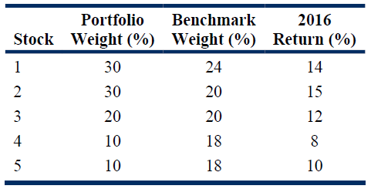

What is the value added (active return) for the Tukol Fund? 486418
A. 0.00%
B. 0.90%
C. 1.92%

Answer: B
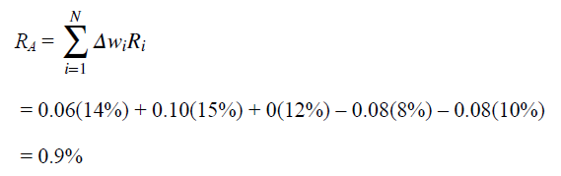

Task 10: The Fundamental Law

3. Manager 1 has an information coefficient of 0.15, a transfer coefficient of 1.0, and invests in 50 securities. Manager 2 has a different strategy, investing in more securities, but is subject to investment constraints that reduce his transfer coefficient. Manager 2 has an information coefficient of 0.10, a transfer coefficient of 0.8, and invests in 100 securities. The investment selections of each manager are independent decisions. If both managers target an active risk of 5.0%, which manager will have the greater expected active return? 486419
A. Manager 1
B. Manager 2
C. Both managers will have the same active return.

Answer: A
Manager 1’s IR = TC × IC × BR^{1/2} = 1.0 × 0.15 × 50^{1/2} = 1.06. Manager 2’s IR = 0.8 × 0.10 × 100^{1/2} = 0.80. Manager 1’s active return is 1.06(5.0) = 5.3% and Manager 2’s expected active return is 0.80(5.0) = 4.0%. Manager 1 has the greater expected active return.

4. Nick Young is concerned that Goudon Partners, one of his money managers, overestimates its expected active return because Goudon overstates its strategy breadth. Young makes two notes about his concern:
Note 1: Although Goudon claims that the number of independent asset decisions is high because it uses 200 stocks, many of these stocks cluster in industries where the same general analysis applies to several stocks.
Note 2: Goudon claims that each stock is independent and evaluated each month, or 12 times per year. These analyses are not independent because some of their strategies, such as favoring a particular industry or favoring value stocks, persist beyond one month. For example, a strategy of favoring low-P/E stocks will persist for several months and the investment decisions are not independent.
If his judgments are correct, are Young’s notes about the overstatement of breadth correct?
486420
A. Only Note 1 is correct.
B. Only Note 2 is correct.
C. Both Notes 1 and 2 are correct.

Answer: C
If the decisions about each of the 200 stocks are not independent, and if the decisions about a stock from one month to the next are not independent, then Goudon Partners is overstating its estimates of its breadth and its expected active returns.

Reading 52: Algorithmic Trading and High-Frequency Trading

Task 11: Algorithmic Trading and High-Frequency Trading

None.

