NOTE TO AUTHOR (remove before submission): this draft was compiled from a full analysis pipeline with every reported statistic pulled directly from the underlying results files. Before submitting, please: (1) double-check author order, affiliations, and the corresponding-author email (filled in below, but verify the affiliation structure and add the email); (2) all citations have now been verified against PubMed/PMC/publisher records (see Reference list note for one caveat re: preprint-vs-published status); (3) add an ORCID/funding/conflict-of-interest statement per your target venue's requirements; (4) decide on a target venue (bioRxiv is the natural first step given this is a secondary analysis of an already-public dataset) and reformat citations to that venue's style if needed; (5) fill in the code-repository URL in Data and Code Availability once your GitHub repo is created.

Individual Differences in Reward-Zone Modulation of Hippocampal Representational Drift During Chronic Recording in a Spatial Working-Memory Task
Saad Yusuf¹,², Abhilasha Joshi¹
¹ NeuroAct Lab, National Centre for Biological Sciences (NCBS), Bangalore, India
² Jamia Millia Islamia, New Delhi, India
Corresponding author: Abhilasha Joshi [email to be added]

Abstract
Hippocampal spatial representations drift across days even in familiar, unchanging environments, and recent work shows that globally withholding reward accelerates this drift. Whether reward-proximal locations show altered drift dynamics relative to behaviorally neutral space within a single, continuously-rewarded environment has not been tested. We analyzed chronic tetrode recordings from dorsal CA1 in three mice performing a delayed-non-match-to-place T-maze task across 15–19 sessions spanning two to three weeks (DANDI:001775). Two independent data-quality issues were identified and corrected prior to analysis: unreliable session-timing metadata, verified against each session's internally-consistent embedded acquisition clock, and, in one subject, degraded position tracking. Population vector (PV) correlation, computed from tetrode-pooled multi-unit rate maps (cell identity is not tracked across sessions in this dataset), quantified representational similarity between session pairs as a function of calendar-day separation, computed separately for reward-zone, choice-point, and corridor spatial bins. PV correlation declined significantly with day separation in all three animals (Mantel r = −0.21 to −0.33, all p < .03; pooled p = 3.4×10⁻⁵), replicating chronic representational drift. The reward zone showed a significant drift-rate difference from corridor in all three animals (occupancy-matched shuffle test, all p < .03), but the direction was not uniform: two animals showed slower reward-zone drift, and one showed faster reward-zone drift. Held-out validation — zones defined on one temporal half of a subject's sessions and tested on the other — showed this effect replicated fully in only one animal (the faster-drift direction), partially in a second, and not at all in the third. The one fully-replicating effect additionally survived a direct control for the position-tracking artifact identified in that subject. These results indicate that reward-adjacent hippocampal representations are subject to altered, but not uniformly protective, drift dynamics, and highlight meaningful, currently unexplained individual variability in how value-relevant locations are stabilized in the hippocampal spatial map.
Keywords: hippocampus; CA1; representational drift; population vector correlation; reward; spatial working memory; individual differences

1. Introduction
Hippocampal place cells provide a stable, allocentric representation of an animal's location within a familiar environment (O'Keefe & Dostrovsky, 1971). However, chronic recording and imaging studies have established that this stability is not absolute: the population code that represents a given, unchanging environment gradually reconfigures over days and weeks, a phenomenon termed representational drift (Ziv et al., 2013; Rule, O'Leary, & Harvey, 2019). Drift is now a well-replicated feature of hippocampal (and broader cortical) coding, but the factors that govern its rate remain an active area of investigation.
Two broad classes of modulators have been identified. First, drift dissociates along temporal and experiential axes: elapsed time predominantly alters firing-rate statistics, whereas active behavioral experience in an environment predominantly alters spatial tuning (Geva, Deitch, Rubin, & Ziv, 2023). Second, reward availability modulates drift rate: comparing hippocampal population activity across days on which reward was present versus globally withheld shows that reduced reward expectation increases representational drift, an effect proposed to depend on reward-linked dopaminergic modulation of synaptic stability (Krishnan & Sheffield, 2023). Reward also more broadly reorganizes the hippocampal population code even absent any drift question: place fields accumulate disproportionately near goal locations (Hollup, Molden, Donnett, Moser, & Moser, 2001; Gauthier & Tank, 2018), a dedicated subpopulation of neurons appears to track position relative to reward and dynamically updates when reward is relocated (Sosa, Plitt, & Giocomo, 2025), and context-relevance effects on remapping are strongest specifically in place fields near reward locations (Tarcsay, Masala, Yi, Igarashi, Redic, & Ewell, 2025).
A gap remains between these two literatures. Studies linking reward to drift rate have compared globally rewarded versus globally unrewarded sessions — a between-condition, whole-environment manipulation. Studies showing reward reorganizes the population code at the location of reward have generally examined field density or population geometry at a single time point or over short timescales, not the long-term (multi-week) drift rate specifically at the reward location relative to the rest of a constantly-rewarded environment. Whether reward-adjacent representations are differentially stable — more protected, or conversely more volatile — relative to behaviorally neutral space within the same, continuously-rewarded session has not, to our knowledge, been directly tested.
We address this using a publicly available chronic tetrode dataset recorded from dorsal CA1 during a delayed-non-match-to-place (DNMP) T-maze task, in which reward was delivered at a fixed physical location on every completed trial throughout 15–19 recording sessions spanning two to three weeks per animal. We first establish that this dataset replicates chronic representational drift, then ask whether population vector correlation declines at a different rate specifically within the reward zone relative to the corridor, applying four independent robustness checks: an occupancy-matched shuffle control, a zone-definition parameter-sensitivity check, held-out cross-validation, and a direct control for a position-tracking artifact identified during the course of this analysis in one subject.

2. Results

2.1 Three mice, 49 sessions, and two independent data-quality corrections
Of the six subjects available in the source dataset, three were excluded prior to any drift analysis. One subject's files used a different behavioral paradigm entirely (a pharmacological homecage-foraging task) and lacked a spike-sorted units table. Two further subjects' position, spike, and trial timestamps, while internally self-consistent within each session, were found to be referenced to a lab-internal relative clock (elapsed acquisition-system time, on the order of 10⁶ s) rather than true Unix epoch time, and could not be mapped to real calendar dates from file contents alone; these subjects (23 and 7 sessions respectively) were excluded rather than converted using an assumed offset. The final analyzed sample comprised three subjects with independently-verified absolute recording clocks: UT14 (19 sessions), UT13 (15 sessions), and UT15 (15 sessions).
For all three retained subjects, the dataset's own session-level timing metadata (“session_start_time”) was found to disagree with the true acquisition clock — reconstructed from the mutually-consistent Unix-epoch timestamps embedded in each session's position, spike, and trial-interval data — by up to several hours, inconsistently in direction across sessions (e.g., −455 to +203 minutes for UT14). All timing-dependent analyses reported here use the verified embedded acquisition clock, not the metadata field.
Reward-zone and choice-point spatial regions were defined per subject from trial-level behavioral event timestamps (position at reward consumption, pooled across all sessions) and validated visually against each subject's occupancy map before use in any statistical test (Figure 1).
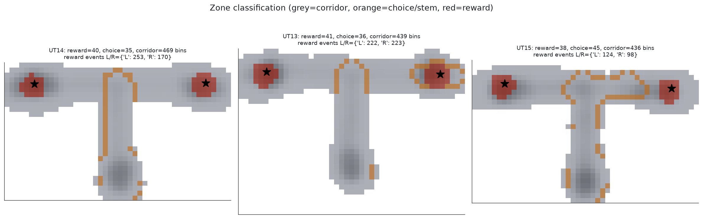
Figure 1. Reward-zone (red), choice-zone (orange), and corridor (grey) classification for each subject, overlaid on session occupancy (background shading). Reward zones are centered on the median position at reward consumption (grasp_time), computed separately for left and right arms and pooled across a subject's full session history; stars mark reward-port centroids. Choice zones are the stem bins immediately adjoining the arm-exclusive region. Bin counts and pooled reward-event counts are given per subject.

2.2 Hippocampal population codes decorrelate across days in all three animals
Population vector correlation, computed from tetrode-pooled rate maps across the full maze, declined significantly with calendar-day separation in every subject (Mantel permutation test, 5,000 permutations of session order): UT14, r = −0.313, p = .0017 (19 sessions, 171 pairs); UT13, r = −0.208, p = .0297 (15 sessions, 105 pairs); UT15, r = −0.328, p = .0053 (15 sessions, 105 pairs). Combining these three independent tests (Fisher's method) yielded χ²(6) = 30.30, p = 3.4×10⁻⁵. A complementary linear mixed-effects model (day distance as a fixed effect, random intercept per subject) confirmed a significant pooled day-distance effect (β = −0.0121, p = 3.5×10⁻⁷). This establishes a genuine, three-animal replication of chronic hippocampal representational drift in this dataset (Figure 2), providing the foundation for the zone-restricted analyses below.
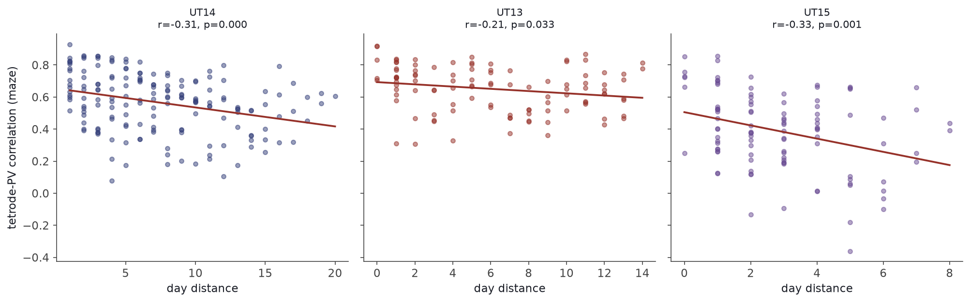
Figure 2. Population vector correlation (whole maze) as a function of calendar-day separation, for each subject. Each point is one session pair; lines are OLS fits. All three subjects show a significant negative relationship (Mantel test, see main text).

2.3 Reward-zone representations show altered, but non-uniform, drift dynamics
Restricting the population vector correlation to reward-zone bins versus corridor bins revealed a significant difference in drift rate (slope of PV correlation on day distance) in every subject (occupancy-matched bin-shuffle permutation test, 500 permutations, reassigning the same visited bins to same-sized pseudo-zone categories): UT14, slope difference = +0.0023, p = .0020; UT13, +0.0010, p = .0240; UT15, −0.0145, p = .0020. The sign of this difference, however, was not consistent across animals. In UT14 and UT13, the reward zone decorrelated more slowly than the corridor (a positive difference, indicating relative protection from drift). In UT15, the reward zone decorrelated faster than the corridor (a negative difference of larger magnitude than either other subject, indicating relative vulnerability). Because these individually-robust effects point in opposite directions, the pooled fixed-effect interaction term (day distance × zone category) in a mixed-effects model was not significant (β = +0.0022, p = .465), correctly reflecting the absence of a single population-level rule rather than the absence of any effect (Figure 3, Figure 4).
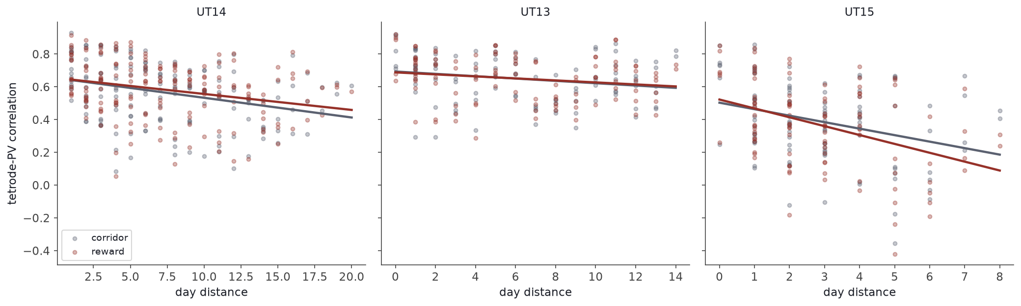
Figure 3. Population vector correlation versus day distance, restricted to reward-zone (red) and corridor (grey) bins, per subject. UT14 and UT13 show a flatter (more stable) reward-zone slope; UT15 shows a steeper (less stable) reward-zone slope.
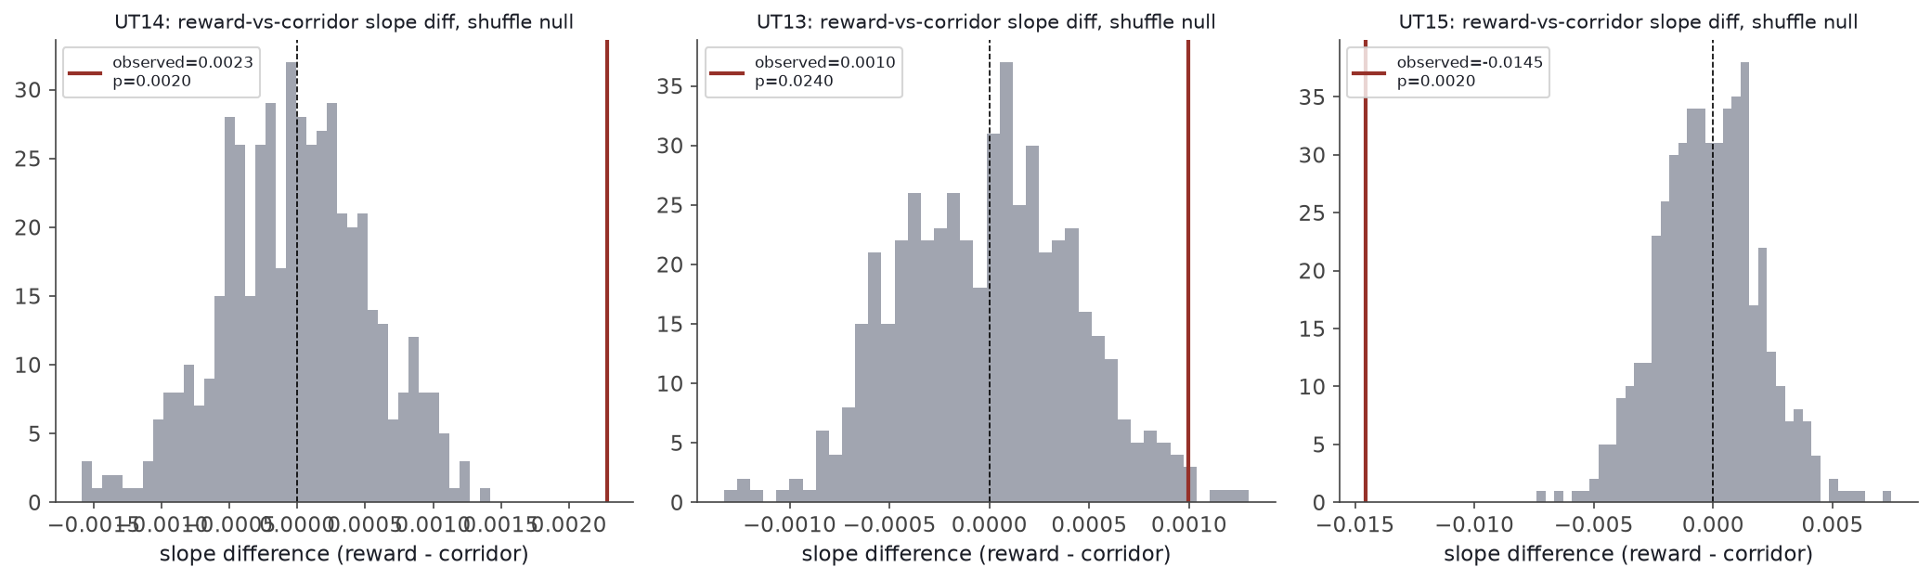
Figure 4. Occupancy-matched shuffle null distributions for the reward-vs-corridor slope difference, per subject. Observed values (red lines) fall well outside the null distribution in all three subjects, confirming the effect is not attributable to reward zones being differently sampled or sized than corridor.

2.4 Held-out validation identifies the reward-zone-vulnerability effect as the most robust finding
Because zones were originally defined using trial data pooled across a subject's entire session history and then tested on population vectors built from those same sessions, we performed a held-out validation to rule out circularity. Sessions were split by temporal order into two interleaved halves; zones were defined using only one half, and the reward-vs-corridor effect was tested exclusively on population vectors built from the other, independent half. Both split directions were run (Table 1).
Subject | Split | Reward − corridor slope diff. | p | Replicates?
UT14 | define even / test odd | +0.0028 | .0020 | Yes
UT14 | define odd / test even | +0.0008 | .307 | No
UT13 | define even / test odd | +0.0004 | .523 | No
UT13 | define odd / test even | −0.0008 | .102 | No (sign reverses)
UT15 | define even / test odd | −0.0110 | .0020 | Yes
UT15 | define odd / test even | −0.0168 | .0020 | Yes

UT15's effect replicated fully and in the same direction across both independent splits. UT14's effect replicated directionally but reached significance in only one of the two splits, consistent with a real but modest, power-limited effect. UT13's effect did not replicate: the two splits disagreed in sign, and neither was individually significant, indicating the original full-sample result for this subject (already the weakest of the three, p = .024) reflects a marginal, non-replicating finding rather than reliable evidence for reward-zone protection (Figure 5).
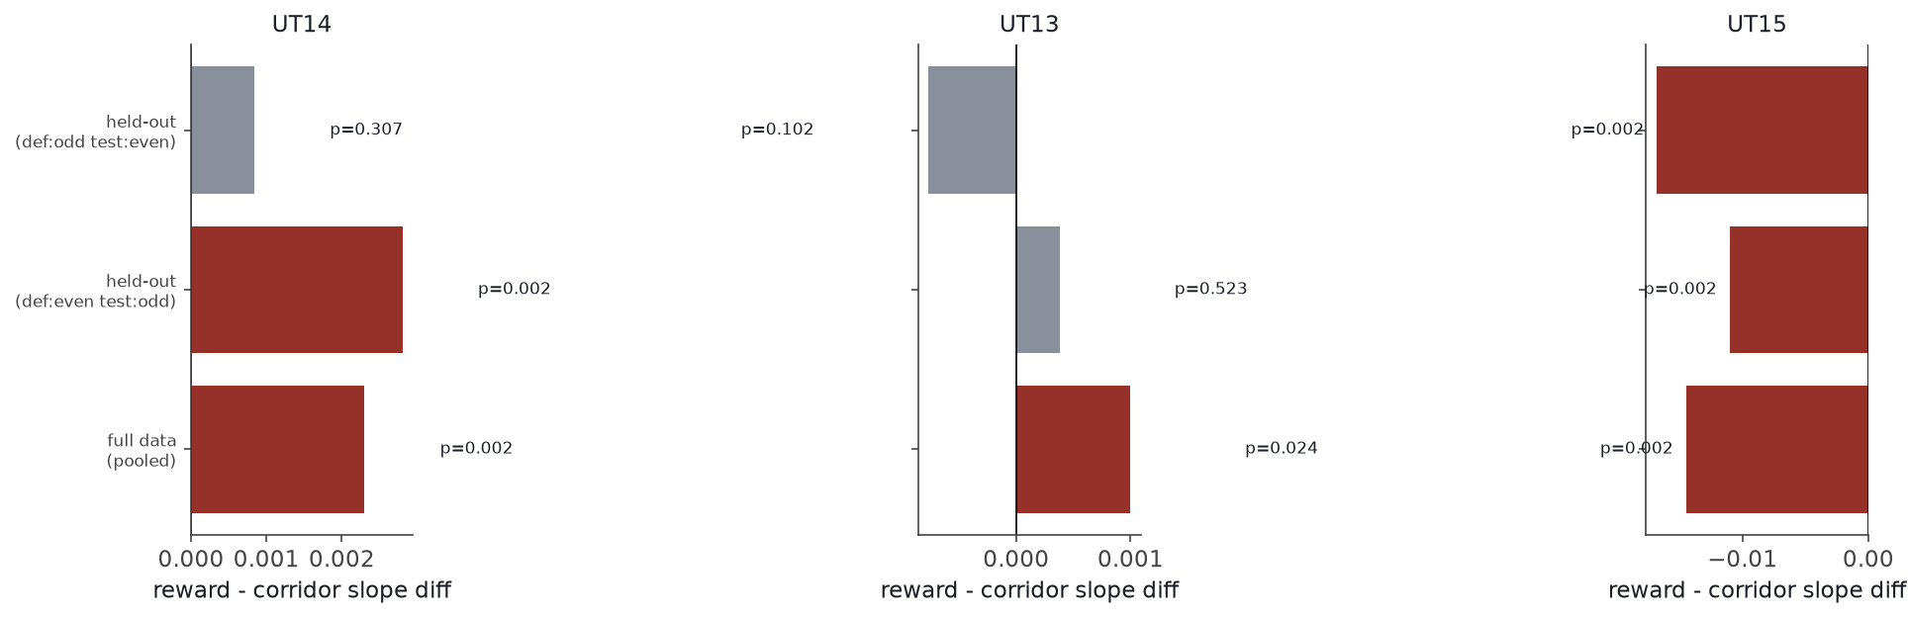
Figure 5. Reward-vs-corridor slope difference from the full pooled dataset (blue) compared against both held-out validation splits (red = significant at p < .05, grey = not significant), per subject. UT15 replicates in both splits; UT14 partially; UT13 does not replicate.

2.5 The UT15 effect is not attributable to a position-tracking artifact
Visual inspection of raw trial-by-trial trajectories (rather than aggregated occupancy) revealed a qualitative difference in tracking quality: UT15's position data in the maze corridor showed a diffuse, scattered pattern with visible discontinuous jumps, unlike the tight, continuous trajectories in UT14 and UT13. This was quantified directly by flagging any position sample reached via a physically-impossible instantaneous displacement (> 100 cm/s, computed from consecutive-sample distance and inter-sample interval; median sampling interval ≈ 33 ms across all subjects). Restricted to the horizontal maze-corridor region (excluding any non-maze holding area), UT15 showed a jump rate of 3.26% (39,656 / 1,217,789 samples) versus 0.31% for UT14 and 0.41% for UT13 — an 8- to 10-fold elevation specific to this subject.
To determine whether this tracking artifact could explain the reward-zone finding, all flagged samples in UT15 were replaced by linear interpolation between adjacent valid samples (92,447 samples across 15 sessions), and the full zone analysis was recomputed on the cleaned position data. The reward-vs-corridor effect was essentially unchanged: slope difference = −0.0149, p = .0020 (cleaned) versus −0.0145, p = .0020 (uncleaned). This constitutes a fourth independent robustness check — alongside the occupancy-matched shuffle control, a zone-boundary parameter-sensitivity check (Supplementary Results), and held-out validation — all of which support the reward-zone-vulnerability effect in UT15 as genuine rather than artifactual.
The choice-zone comparison, by contrast, was substantially altered by cleaning (uncleaned: difference = −0.0008, p = .659; cleaned: +0.0117, p = .0020) and was separately found to be sensitive to the choice-zone boundary definition (Supplementary Results). We conclude that the choice-zone result is not reliable in this dataset and should be treated as inconclusive, whereas the reward-zone result is robust across every check applied.

2.6 Supplementary analysis: recording time-of-day does not predict representational drift
The same three subjects' verified acquisition timestamps permit a test of whether time-of-day separation between sessions, independent of calendar-day separation, predicts representational drift — included here as a negative control confirming the day-distance effect above is not confounded by circadian time-of-day, and reported briefly for completeness. UT15's sessions spanned a genuine 11.3-hour range of recording start times (09:31–20:50), the widest of the three subjects and sufficient to test this question with reasonable power; UT14 spanned 6.15 hours and UT13 spanned 2.12 hours. No subject showed a relationship between time-of-day separation and PV correlation after controlling for day distance (partial Mantel test: UT14, r = −0.114, p = .485; UT13, r = 0.040, p = .781; UT15, r = 0.006, p = .955; pooled Fisher's method, p = .916).

3. Discussion
This study replicated chronic hippocampal representational drift across three independently recorded mice performing a spatial working-memory task, and then asked a question not directly addressed by prior work: within a single, continuously-rewarded environment, does the reward zone itself show altered drift dynamics relative to neutral corridor space? We found that it does — in every subject — but that the direction of this modulation was not uniform. Two subjects showed the reward zone as relatively protected from drift, in the direction one would predict by analogy with prior reward-expectation work; one subject showed the opposite, with the reward zone decorrelating faster than corridor. Critically, when subjected to held-out cross-validation, only the vulnerability effect (UT15) fully replicated; the protection effect in UT13 did not replicate at all, and in UT14 replicated only partially. The vulnerability effect additionally survived a direct control for a position-tracking artifact identified in that subject, a check motivated by a visible irregularity in that subject's zone geometry that might otherwise have been dismissed as a data-quality caveat rather than investigated directly.
These findings should be read as a caution against assuming that reward uniformly stabilizes nearby hippocampal representations. The existing literature linking reward to reduced representational drift has manipulated reward availability globally, comparing whole sessions with reward present against whole sessions with reward withheld (Krishnan & Sheffield, 2023). The present analysis asks a complementary, spatially-localized question — within an environment that is always rewarded, is drift uniform across space? — and finds that it is not, but that the specific direction of non-uniformity is animal-specific rather than following a single rule. This is consistent with, and extends, evidence that reward reorganizes the hippocampal population code in ways that go beyond simple firing-rate overrepresentation: a dedicated, dynamically-recruited subpopulation appears to track position relative to reward specifically (Sosa, Plitt, & Giocomo, 2025), and if the composition or engagement of such a subpopulation itself varies across animals or fluctuates over the weeks-long timescale studied here, elevated apparent drift at the reward zone specifically — rather than protection — is a plausible outcome in at least some animals.
Two methodological findings, incidental to the original aim of this analysis, are worth highlighting as general cautions for secondary analysis of public chronic-recording datasets. First, session-level timing metadata (here, the NWB “session_start_time” field) should not be trusted without cross-checking against an independently-verifiable, internally-consistent timestamp source (here, the embedded position/spike/trial acquisition clock) — the discrepancy found here was large (up to several hours) and inconsistent in direction, which would not be detectable from the metadata field alone. Second, position-tracking quality can vary substantially and non-obviously between subjects within the same dataset, in ways that manifest as apparently biological irregularities (here, a geometrically distorted zone classification) that could easily be misattributed to behavior without a direct, quantitative tracking-quality check.
This study has several limitations. The sample size (three subjects) provides ample within-subject statistical power, given the many session pairs available per animal, but only modest power to characterize the population-level distribution of individual differences in reward-zone drift direction; a larger cohort would be needed to determine what fraction of animals show protection versus vulnerability, and what predicts this. Cell identity is not tracked across recording sessions in this dataset (units are independently spike-sorted per session), which necessitated a tetrode-pooled, rather than single-unit, population vector — a principled workaround given the physically fixed tetrode geometry, but one that cannot resolve single-cell-level heterogeneity in drift that recent work suggests may be substantial (e.g., cell excitability predicting individual drift rate). The choice-zone comparison, unlike the reward-zone comparison, did not survive its robustness checks and should be considered inconclusive rather than a genuine null. Finally, this analysis is correlational; it cannot distinguish among candidate mechanisms (dopaminergic modulation, reward-relative subpopulation turnover, behavioral factors such as running speed or dwell time near reward) for either the protective or vulnerable pattern observed.
In summary, reward-adjacent hippocampal representations in this dataset were not uniformly protected from long-term representational drift. At least one animal showed a robust, thoroughly-validated pattern of accelerated — not reduced — drift specifically at the reward zone, surviving four independent checks for artifact or circularity. This indicates meaningful, currently unexplained individual variability in how spatially-localized reward modulates the long-term stability of the hippocampal cognitive map, and argues that reward-drift relationships established under global reward manipulations should not be assumed to generalize, in a uniform direction, to the spatial structure of drift within a continuously-rewarded environment.

4. Methods

4.1 Dataset and subject inclusion criteria
Data were obtained from DANDI Archive dandiset 001775 (publicly available, no registration required), associated with an in-preparation manuscript from the Kitamura Lab (data also mirrored at Zenodo, DOI 10.5281/zenodo.18580888). Six mice were chronically implanted with tetrode arrays targeting right dorsal CA1 (up to 32 tetrode positions) and performed a delayed-non-match-to-place (DNMP) T-maze task across multiple recording sessions. Subjects were included in the present analysis only if their NWB files contained both a Position/SpatialSeries interface and a spike-sorted units table, and only if session position timestamps fell within a plausible absolute Unix-epoch range (2015-01-01 to 2026-01-01, spanning the dataset's collection window) — sessions failing this check use a lab-internal relative acquisition clock that cannot be mapped to real calendar time from file contents alone and were excluded rather than converted with an assumed offset. This excluded one subject entirely (different behavioral paradigm, no spike-sorted units) and two subjects' full session sets (relative-clock timestamps). The final sample comprised UT14 (19 sessions), UT13 (15 sessions), and UT15 (15 sessions).

4.2 Timestamp verification
For every included session, the true recording clock was reconstructed from the mutually-consistent Unix-epoch timestamps embedded in that session's position, spike, and trial-interval data (verified to agree with one another to sub-second precision within each session) and used in place of the NWB “session_start_time” metadata field, which was independently found to disagree with this embedded clock by up to several hours, inconsistently in direction, for every included subject.

4.3 Spike sorting and unit inclusion
Units were spike-sorted independently per session using MountainSort4 (no native cross-session identity tracking). A unit was retained for analysis if its reported isolation score was ≥ 0.90, its noise-overlap score was ≤ 0.10, and it produced ≥ 100 spikes during the session. In practice, sorting quality was uniformly high and no units were excluded by these criteria in any retained session. Retained unit counts ranged 76–136 per session for UT14 and UT15 and approximately 222–260 per session for UT13, reflecting a denser probe montage in that subject.

4.4 Behavioral task and epochs
Each session comprised, in sequence, a pre-run open-field foraging epoch, the DNMP T-maze task epoch, and a post-run open-field foraging epoch; all analyses reported here use the DNMP epoch. Individual trials within the DNMP epoch were annotated with trial phase (sample/test), choice (left/right arm), correct arm, and event timestamps for reward-related behavior (grasp, chewing onset, forepaw contact). Reward was delivered at a fixed physical location at the end of each arm on every completed trial; reward availability was never globally withheld across the sessions analyzed here.

4.5 Rate maps and population vector construction
Position data were binned into a 4 × 4 cm spatial grid, shared across all of a subject's sessions (the union of the spatial extent visited during the DNMP epoch across sessions, padded by 5 cm). Occupancy-normalized, Gaussian-smoothed (σ = 1 bin) firing-rate maps were computed per unit per session; a bin required ≥ 0.15 s of occupancy to be considered visited. Because units are not tracked across sessions, population vectors were constructed at the tetrode level: for each of up to 32 physically-fixed tetrode positions, the mean rate map across all units recorded on that tetrode in a given session was computed, yielding a fixed-dimensionality (tetrode × spatial bin) representation directly comparable across any session pair without requiring single-unit identity matching. Population vector (PV) correlation between two sessions was computed, per spatial bin, as the Pearson correlation across the common set of tetrodes active in both sessions (minimum 3 tetrodes per bin); the session-pair PV correlation is the Fisher-z-averaged per-bin correlation across all bins with sufficient occupancy in both sessions (minimum 15 usable bins per pair).

4.6 Zone classification
Reward zone: a 10 cm radius around the median animal position at the grasp_time event (or, if unavailable, chewing_onset_time) of every trial of a given choice side, computed separately for left and right arms and pooled across a subject's full session history, then unioned. Choice zone: spatial bins visited during both left- and right-choice trials (“shared” bins) that directly adjoin the region visited exclusively during one choice side (1-bin morphological dilation of the exclusive region, intersected with the shared region), operationalizing the maze stem immediately proximal to the choice point. Corridor: all remaining visited bins. Sensitivity to the dilation parameter (1 vs. 2 bins) was assessed as a robustness check (Supplementary Results).

4.7 Statistical analysis
Per-subject inference on the day-distance drift effect used a Mantel permutation test (5,000 permutations of session order) correlating the vectorized upper-triangle of the PV-correlation matrix with the calendar-day-distance matrix. For zone comparisons, the reward-vs-corridor (and choice-vs-corridor) effect was quantified as the difference in OLS slope of PV correlation on day distance between the two zone-restricted PV matrices; significance was assessed via an occupancy-matched bin-shuffle permutation test (500 permutations), in which the same visited bins were randomly reassigned to same-sized pseudo-zone categories (preserving each real zone's bin count) and the pseudo-zone slope difference recomputed each permutation to build a null distribution. Cross-subject pooling used Fisher's method to combine independent per-subject permutation p-values, and a linear mixed-effects model (day distance × zone category fixed effects, random intercept per subject, fit by REML) as a complementary parametric estimate.

4.8 Held-out validation
Sessions were split by temporal order into two interleaved halves (even-index / odd-index after sorting by verified session date, so both halves span the full day-distance range rather than confounding the split with session order). Zones were defined using only one half; the reward-vs-corridor effect was then tested exclusively on PV correlations built from the other half's session pairs. Both split directions were run and reported.

4.9 Position-tracking artifact control
Position samples reached via a physically-impossible instantaneous displacement (> 100 cm/s, computed from consecutive-sample distance and inter-sample interval) were flagged, and the flagged rate was compared across subjects, restricted to the horizontal maze-corridor region (y ∈ [−4, 6] cm) to exclude any non-maze area from the comparison. For the subject showing an elevated rate, flagged samples were replaced by linear interpolation between adjacent valid samples, and the full zone analysis was recomputed on the cleaned data for comparison against the original result.

4.10 Software
All analyses were performed in Python 3.13 using pynwb, NumPy, SciPy, pandas, statsmodels, and matplotlib. Full analysis code, including the underlying Jupyter notebooks with all figures and intermediate outputs, is available at the repository listed in Data and Code Availability.

5. Data and Code Availability
Raw data are publicly available from the DANDI Archive, dandiset 001775 (https://dandiarchive.org/dandiset/001775), with no registration required. Analysis code, including all rate-map, population-vector, zone-classification, and statistical modules, plus the Jupyter notebooks reproducing every figure and statistic in this manuscript, is available at [repository URL to be added].

6. Acknowledgments
[To be added.]

7. Author Contributions
[To be added — e.g., CRediT taxonomy: Conceptualization, Formal analysis, Methodology, Software, Visualization, Writing.]

8. Competing Interests
The authors declare no competing interests. [Confirm and adjust as appropriate.]

9. References
Citation completeness note: full author lists, journal names, and volume/issue/article details for every entry below (including Krishnan & Sheffield, 2023 and Tarcsay et al., 2025) were independently confirmed against PubMed/PMC/publisher records during this analysis. Krishnan & Sheffield (2023) remains a bioRxiv preprint as of verification (not yet published in a peer-reviewed journal) -- re-check before submission in case it has since been formally published. Classic citations (O'Keefe & Dostrovsky, 1971; Ziv et al., 2013; Hollup et al., 2001; Gauthier & Tank, 2018) are well-established papers cited from general knowledge, not independently re-verified in this session, and should be spot-checked against a reference manager before submission.

Gauthier, J. L., & Tank, D. W. (2018). A dedicated population for reward coding in the hippocampus. Neuron, 99(1), 179–193.
Geva, N., Deitch, D., Rubin, A., & Ziv, Y. (2023). Time and experience differentially affect distinct aspects of hippocampal representational drift. Neuron, 111(15), 2357–2366.
Hollup, S. A., Molden, S., Donnett, J. G., Moser, M.-B., & Moser, E. I. (2001). Accumulation of hippocampal place fields at the goal location in an annular watermaze task. Journal of Neuroscience, 21(5), 1635–1644.
Krishnan, S., & Sheffield, M. E. J. (2023). Reward expectation reduces representational drift in the hippocampus. bioRxiv preprint, doi:10.1101/2023.12.21.572809. [Verified as a bioRxiv preprint, PMID: 38187677, PMCID: PMC10769341; not yet listed as formally published in a peer-reviewed journal as of verification -- re-check before submission.]
O'Keefe, J., & Dostrovsky, J. (1971). The hippocampus as a spatial map: preliminary evidence from unit activity in the freely-moving rat. Brain Research, 34(1), 171–175.
Rule, M. E., O'Leary, T., & Harvey, C. D. (2019). Causes and consequences of representational drift. Current Opinion in Neurobiology, 58, 141–147.
Sosa, M., Plitt, M. H., & Giocomo, L. M. (2025). A flexible hippocampal population code for experience relative to reward. Nature Neuroscience, 28, 1497–1509.
Tarcsay, G., Masala, N., Yi, J. D., Igarashi, M. K., Redic, U. J., & Ewell, L. A. (2025). The relevance of context in memory tasks influences the magnitude of hippocampal remapping. Cell Reports, 44(12), 116682. doi:10.1016/j.celrep.2025.116682
Ziv, Y., Burns, L. D., Cocker, E. D., Hamel, E. O., Ghosh, K. K., Kitch, L. J., El Gamal, A., & Schnitzer, M. J. (2013). Long-term dynamics of CA1 hippocampal place codes. Nature Neuroscience, 16(3), 264–266.

10. Supplementary Results

S10.1 Sensitivity to the choice-zone dilation parameter
The choice-zone effect was re-assessed under a wider dilation setting (2 bins instead of 1). The reward-zone effect was unchanged in direction, magnitude, and significance under this change in all three subjects, but the choice-zone effect was not: it reached significance for UT15 under the wider setting (difference = +0.0034, p = .006) but not the narrower one (difference = −0.0008, p = .675) used in the main text, confirming the choice-zone result is parameter-sensitive and should not be interpreted with confidence in either direction.

S10.2 Supplementary Figures
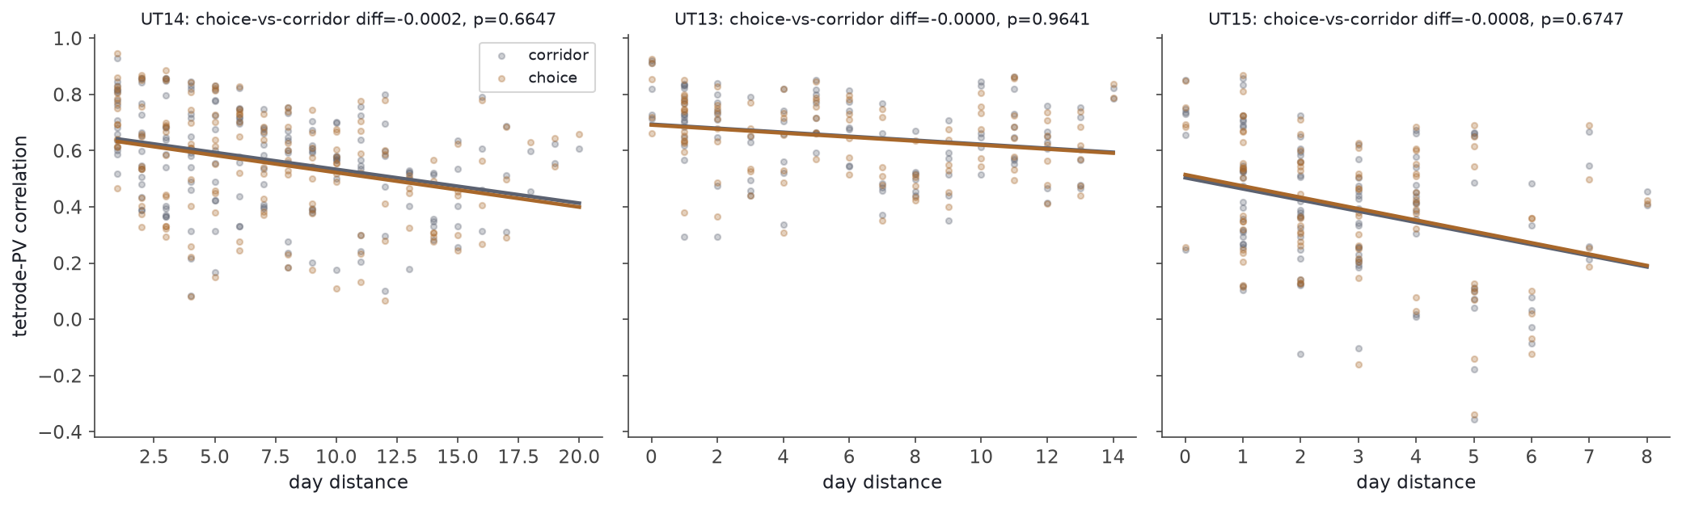
Figure S1. Population vector correlation versus day distance, restricted to choice-zone (orange) and corridor (grey) bins, per subject. No subject shows a robust, cleaning- and parameter-independent effect (see Sections 2.5 and S10.1).
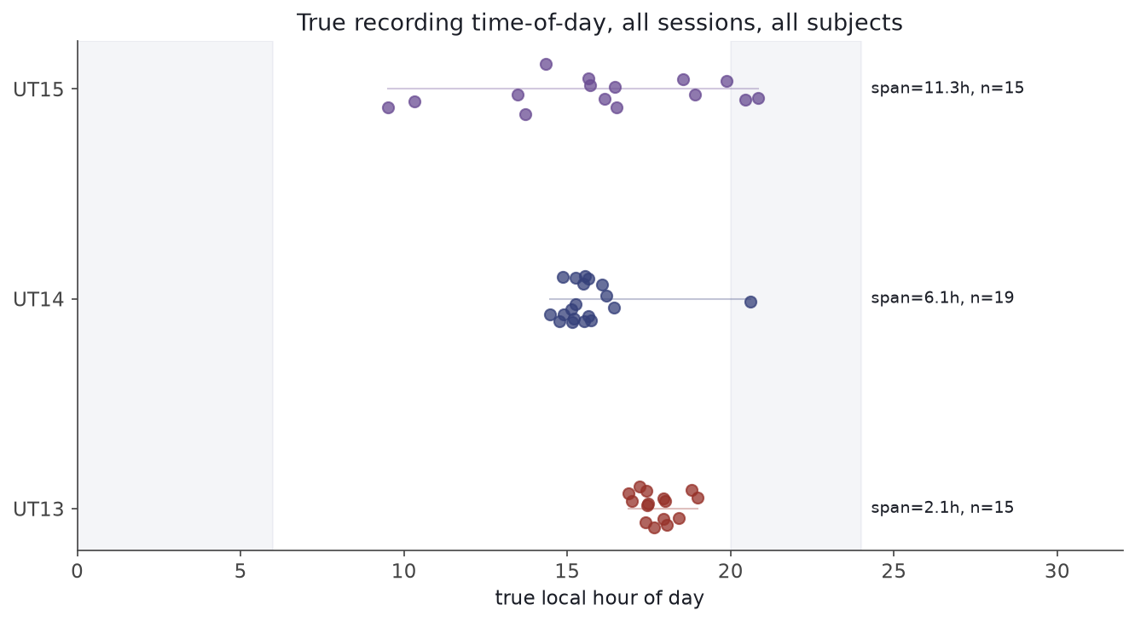
Figure S2. True (verified) recording time-of-day for every session, per subject, supporting the supplementary time-of-day analysis (Section 2.6). UT15 shows the widest true time-of-day span (11.3 hours) of the three subjects.

