From “Does Time of Day Matter?” to “Reward Zones Don’t Always Protect Memory”: The Whole Story
A ground-up explanation of every dataset, method, figure, and finding in this project — written for someone who has never done neuroscience research before.

Part 1 — The Big Idea, in One Paragraph
Your brain has a region called the hippocampus that builds a kind of internal GPS map of any place you spend time in. Neuroscientists have discovered something strange about this map: even in a place you know perfectly well, the exact pattern of brain cell activity that represents that place slowly changes over days and weeks — as if your mental map is being quietly redrawn, over and over, even though the real place never changed. This is called representational drift, and nobody fully understands why it happens or what controls its speed.
We used a public dataset of real mouse brain recordings to ask: does this “redrawing” happen at the same speed everywhere in a familiar space, or does it happen slower right at the reward location (the spot where the mouse gets a treat), because that spot matters more? We started out trying to ask a related but different question — about whether time of day affects this drift — but that turned out to be untestable with this data. So we pivoted, honestly and carefully, to the reward-zone question instead. This document tells that whole story.
WHY THIS MATTERS
If reward-adjacent memories are more stable, it would help explain how we remember important things better than unimportant ones. If it turns out reward-adjacent memories are actually LESS stable in some individuals — part of what we found — that's a genuinely surprising, useful thing for the field to know.

Part 2 — Hippocampus 101: The Neuroscience You Need

What is the hippocampus?
A small, curved structure deep in the brain (named for the Greek for “seahorse”) that both humans and rodents have. It's essential for forming new memories, especially memories of places and events.

What is a “place cell”?
CONCEPT: PLACE CELL
In the 1970s, scientists discovered that individual hippocampal neurons each fire electrical pulses (“spikes”) specifically when an animal is in one particular location, and stay quiet everywhere else. Put together, thousands of these “place cells” form an internal map of space. This discovery won a Nobel Prize in 2014.

What is a “rate map”?
If you track exactly where an animal is at every moment and simultaneously record when a place cell fires, you can draw a picture showing “this cell fired a lot here, never fired there.” That's a rate map. A place cell's rate map typically has one bright “place field.”
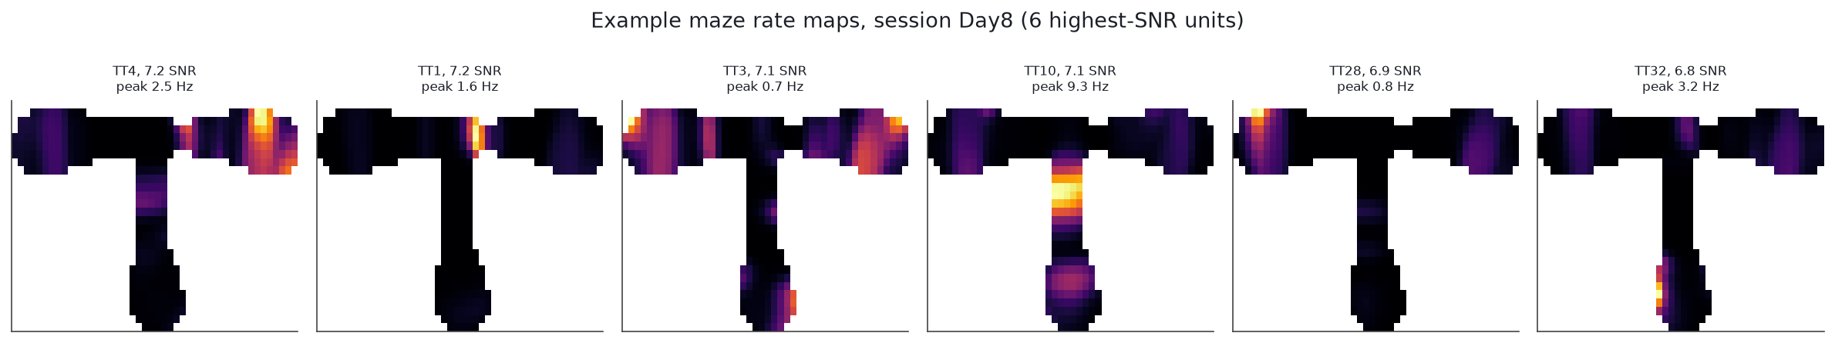
Figure A. Six real neurons' rate maps from one session. Bright orange = that cell's place field. This is the raw material every other analysis in this project is built from.

What is “representational drift”?
If you record the same animal in the same unchanged room on two different days, you'd expect the same place cells to fire in the same spots both times. They mostly don't. The population of active cells slowly “drifts” over days, even though the room and the animal's memory of it stay intact. This project is about drift.

What is “Population Vector (PV) Correlation”?
CONCEPT: POPULATION VECTOR CORRELATION
Take one small patch of the maze. Across all cells recorded that day, list each one's firing rate when the animal stood in that patch — that list is a population vector. Do the same on a different day. If the two lists look similar, the code for that spot has stayed stable; if not, it has drifted. We measure “similar” with an ordinary correlation coefficient (−1 to +1). This is the single number this whole project tracks, computed for every pair of days and every patch of maze.

Why bring reward into it?
Prior work had shown that removing reward expectation entirely (globally, for a whole session) speeds up drift. Nobody had asked the more precise question: even when reward is always available, does the exact spot where it sits get a protective bonus against drift, compared to the hallway the animal just runs through? That's what this project tests.

Part 3 — The Dataset: What Data We Actually Used

DANDI: where the data lives
DANDI is a free, public archive where neuroscience labs upload raw recordings for reuse — no paywall, no registration. Before settling on a dataset, we searched essentially every major public repository (DANDI, CRCNS, EBRAINS, Zenodo, Dryad, and more) against strict requirements: real multi-week recordings, spike-level data, continuous position tracking, and verifiable timestamps. DANDI:001775 (Kitamura Lab) was the strongest survivor.

The animals
- Species: laboratory mice (Mus musculus)
- What was recorded: electrical activity from neurons in right dorsal CA1, via permanently implanted tetrodes (four-microwire bundles), allowing the same mouse to be recorded across many separate days without repeat surgery
- Six mice were available; only three (UT14, UT13, UT15) survived our quality checks
- Recording days per mouse: UT14 = 19 sessions, UT13 = 15, UT15 = 15, spread over 2–3 real calendar weeks each

The task: what the mice actually did
Each mouse ran a T-shaped maze: a straight stem leading to a junction that splits into a left arm and a right arm, each ending in a food reward port.
CONCEPT: DELAYED NON-MATCH-TO-PLACE (DNMP)
On each trial, the mouse is forced into one arm first (the “sample” phase — plants a memory of “I just went left”). After a delay, it runs again but must choose the OPPOSITE arm to get rewarded (the “test” phase). This requires holding “which side did I just visit” in working memory — a classic, well-established hippocampus-dependent task.

Reward was delivered at a fixed location on every completed trial — never switched off for any session we analyzed. This constant-reward design is exactly what lets us isolate the spatial-location question from the reward-presence question.
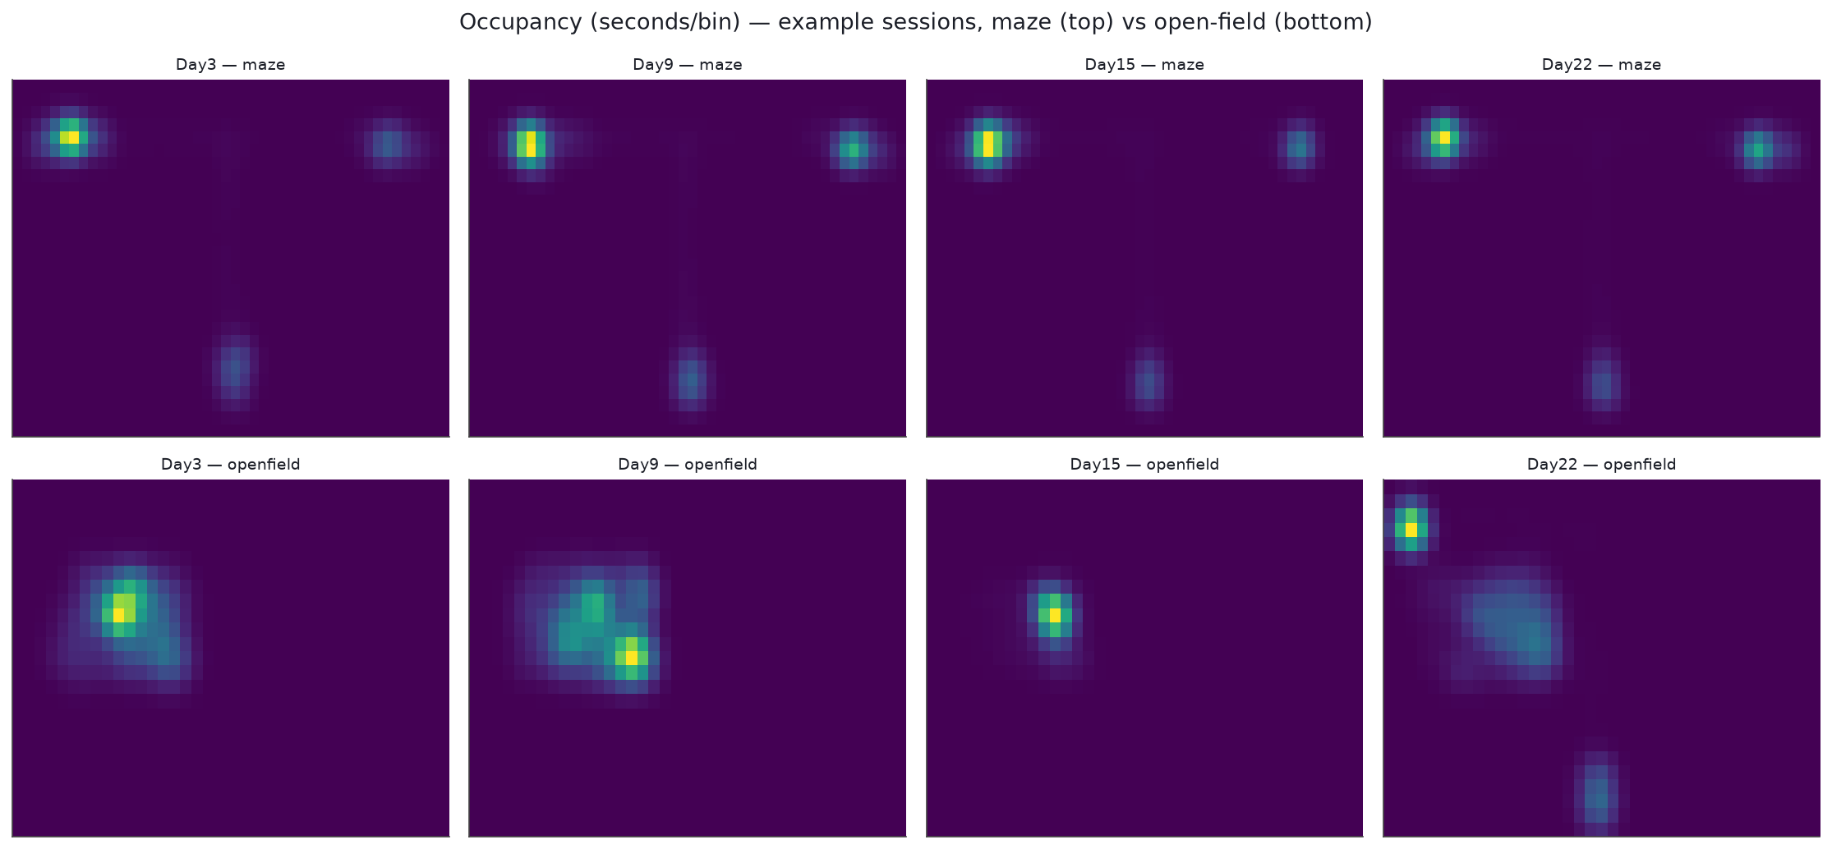
Figure B. Occupancy maps (brighter = more time spent) for four real sessions: top row the T-maze, bottom row the simpler open-field box used before/after. This is what gets used to normalize raw spike counts into proper rate maps.

What was actually recorded, technically
- Spikes: exact timestamp of every action potential from every neuron, separated out with an algorithm called MountainSort4
- Position: overhead camera tracking an LED on the mouse's head, ~30 times/second
- Trial structure: exact timestamps for trial start/end, chosen arm, correctness, reward-grasp moment
- Units per session: 76–136 for UT14/UT15; ~222–260 for UT13 (denser probe)

Part 4 — Chapter 1 of the Journey: The Circadian Question (and Why It Failed)
The project didn't start with reward zones. It started by asking: does the time of day two sessions happen affect how much the hippocampal map has drifted between them? Animals have internal biological clocks that affect memory and brain chemistry across the day, so this was a reasonable first question.

The critical discovery: metadata cannot always be trusted
A SERIOUS PROBLEM WE FOUND AND FIXED
Every data file has a metadata field literally called session_start_time — exactly the kind of thing you'd assume you could trust. We did, at first. Cross-checking it against the animal's own independently-recorded position and spike data revealed it was WRONG — sometimes by more than seven hours, in unpredictable directions. For one mouse, this bug initially made us believe its sessions were beautifully spread across the full 24-hour clock. Once corrected, the real picture was a narrow mid-afternoon window with one stray evening session. The “great circadian spread” had been a data-entry artifact the whole time.

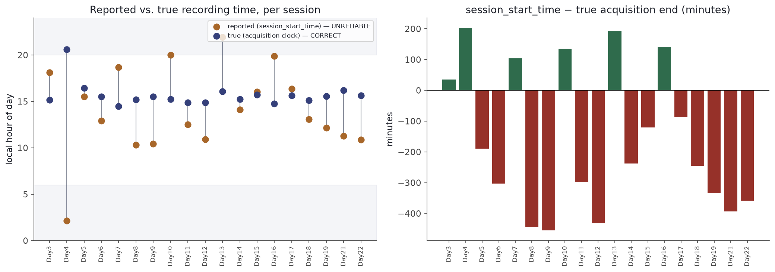
Figure C. Gold = the (wrong) metadata time for each session; navy = the real, reconstructed time. Right panel: the size of the error in minutes — sometimes over 7 hours early, sometimes over 4 hours late, with no consistent pattern.
WHY WE'RE TELLING YOU ABOUT A “FAILED” ANALYSIS IN THIS MUCH DETAIL
If we hadn't caught this, we could have published a false conclusion built on a metadata typo. Catching it instead of trusting the label directly shaped how carefully we checked everything afterward.

Even after fixing the bug, the question couldn't be answered
Two of three usable mice never had sessions spread across meaningfully different times of day at all. Only UT15 had a genuinely wide spread (9:30 AM to almost 9 PM across 15 sessions) — and even there, we found no relationship between time-of-day separation and drift.
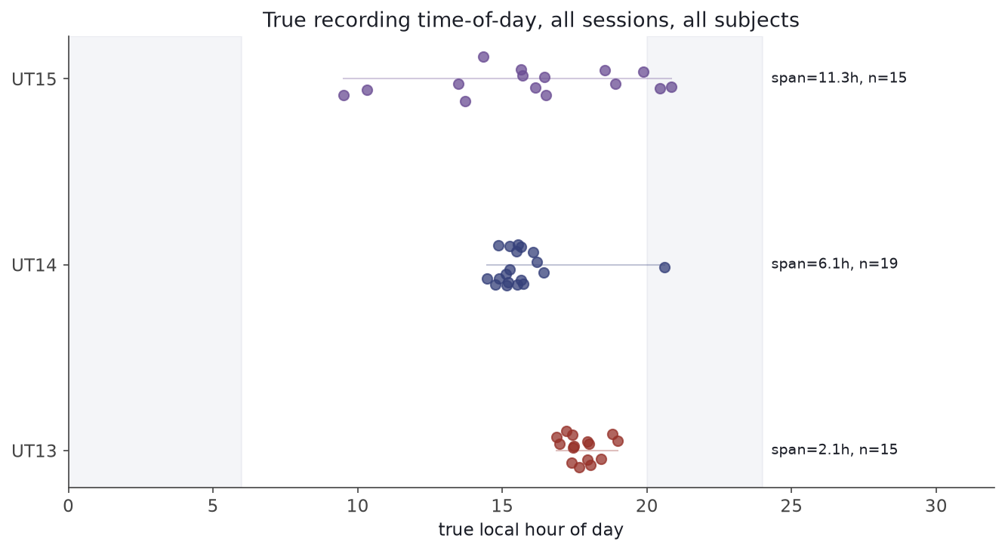
Figure D. Real (corrected) clock time of every session, one row per mouse. UT13/UT14 cluster tightly; UT15 genuinely spans nearly the whole day — and still shows no circadian effect.
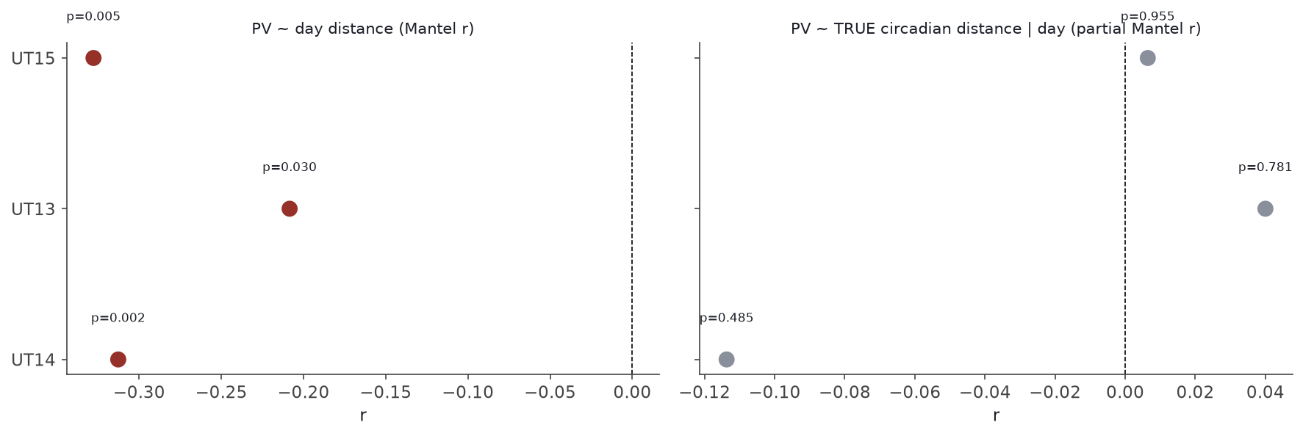
Figure E. Left: all three mice show a real relationship between calendar-day separation and drift (this survived and became important later). Right: no mouse shows any time-of-day effect.
So: a reasonable idea, a real bug found and fixed along the way, and an honest null result. Legitimate science — but not enough to build a paper around, so we didn't stop there.

Part 5 — The Pivot: Checking the Literature Before Picking a New Question
Before committing to a replacement question, we searched the actual published literature to check whether our new candidate ideas already existed. Several tempting ideas turned out to already be published:
- “Does sleep between sessions affect drift?” — already directly studied (multiple 2022–2025 papers, including in Neuron)
- “Does elapsed time vs. active experience drift differently?” — already answered (Geva et al., 2023, Neuron)
- “Do some individual neurons drift less than others?” — already an active sub-field with its own established findings
One angle survived: nobody had tested whether the reward location itself, within an ALWAYS-rewarded session, drifts differently than the rest of the same environment. That became our new question. We also tried and abandoned one more idea (a finer-grained signal called “theta phase precession”) after a direct feasibility test showed it was too weak and the maze geometry too complex to support it reliably on this dataset.
WHY CHECK THE LITERATURE THIS CAREFULLY
Publishing something already done wastes everyone's time and isn't intellectually honest. This step took real, deliberate effort — multiple search passes, reading actual papers, not just titles — before a single line of new analysis code was written.

Part 6 — The Toolkit: Every Method Explained Before We Use It

1. Tetrode-pooled population vectors
CONCEPT
The cell-sorting algorithm runs separately each day — “neuron #12” on Monday isn't guaranteed to be the same cell on Wednesday. Fix: tetrodes (physical wire bundles) don't move, so we average all neurons on each tetrode into one number per tetrode per location, and compare TETRODES across days instead of individual cells.

2. The Mantel test
CONCEPT
Session “Day 5” appears in many pairs, so pairs aren't independent of each other — ordinary statistics assume independence. A Mantel test is built specifically for comparing two matrices of paired relationships while correctly handling that non-independence.

3. Permutation / shuffle tests
CONCEPT
Instead of trusting a textbook formula, randomly shuffle the labels thousands of times, recompute the result each time, and see how often a random shuffle looks as extreme as the real result. If real beats 99% of 5,000 shuffles, that's strong evidence it isn't noise.

4. Occupancy-matched shuffle control
WHY WE NEEDED A CUSTOM VERSION
The reward zone is small (mouse lingers to eat); the corridor is large (mouse runs through quickly) — differently SAMPLED, not just different locations. Our shuffle preserves each real zone's size and occupancy pattern and just randomizes which bins are labeled “reward,” so any real effect has to survive on top of that same sampling-fairness issue.

5. Held-out validation
CONCEPT
We defined the reward zone using all sessions, then tested on those same sessions — a bit circular. Fix: split sessions into two groups, define the zone using only group A, test using ONLY group B (data the definition never touched). This was the single most important check in the whole project.

Part 7 — The Analysis, Step by Step

Step 1 — Load the data and throw out what can't be trusted
Of six mice, three were excluded before any drift analysis: one (“Hisa”) was part of a different sub-experiment entirely with no usable spike-sorted neurons; two (UT06, UT08) had timestamps counted from an arbitrary computer-boot reference with no way to recover real calendar dates, so 30 sessions were excluded rather than guessed at.
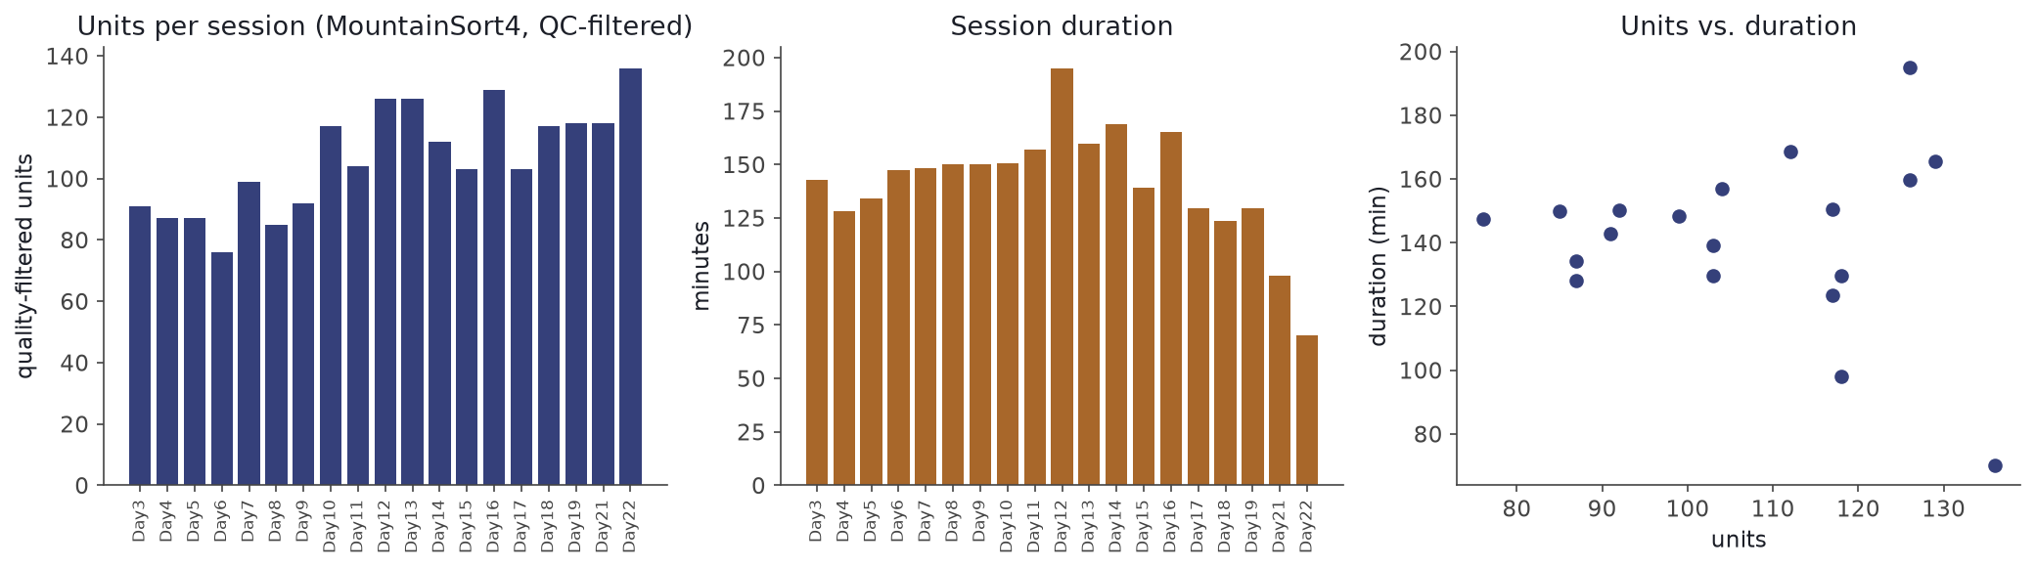
Figure F. Quality-control summary across UT14's 19 sessions: neurons recorded per day (left) and session duration (middle). Unglamorous but essential.

Step 2 & 3 — Build rate maps, confirm drift exists at all
For every session we gridded the maze into 4cm squares, built rate maps, pooled into tetrode-level population vectors, and computed PV correlation between every pair of sessions.
Mouse | Sessions | Correlation (r) | p-value
UT14 | 19 | −0.313 | .0017
UT13 | 15 | −0.208 | .0297
UT15 | 15 | −0.328 | .0053

Combined (Fisher's method): p = 0.000034 — strong evidence drift is real here. Now the actual question can be asked.

Step 4 — Define the reward and choice zones
At the exact instant each mouse grasped its food reward, we recorded its position. Pooled across every trial, these cluster tightly on the two physical food ports — a 10cm circle around that cluster became the “reward zone.” The stem just before the maze splits became the “choice zone.” Everything else is “corridor.”
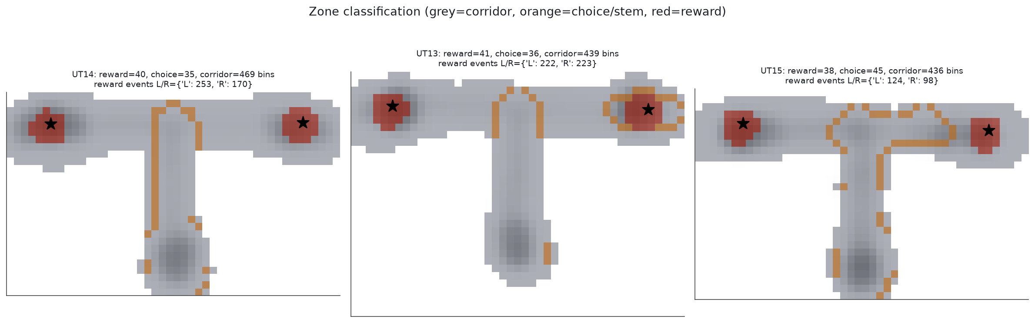
Figure G. Red = reward zone (lands exactly on the food ports, marked with stars — a good sanity check). Orange = choice zone. Grey = corridor. This figure is also what tipped us off to a data problem in UT15 (Part 8).

Step 5 — Compare drift speed: reward zone vs. corridor
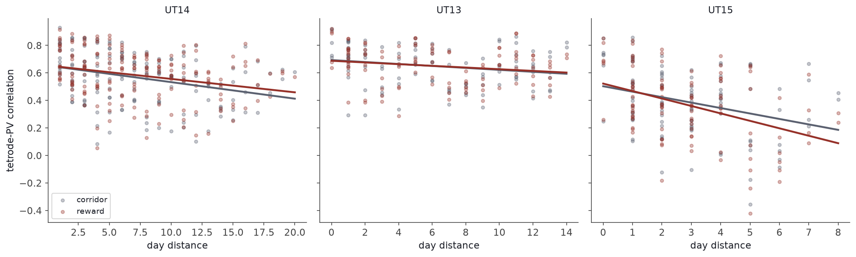
Figure H. Red = reward zone, grey = corridor, per mouse. In UT14/UT13 the red line is flatter (more stable). In UT15 it's steeper (LESS stable) — the opposite pattern.
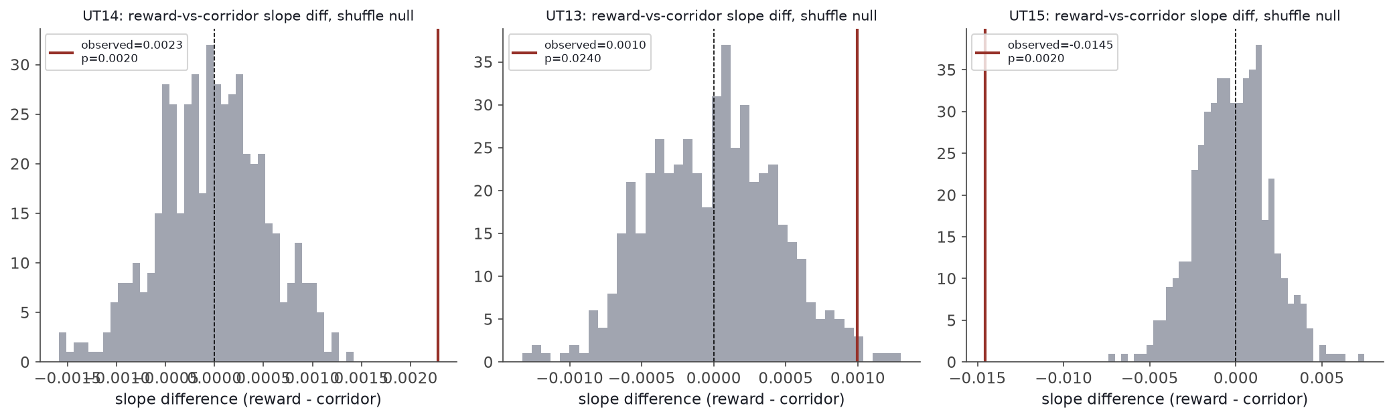
Figure I. The shuffle test in action. Grey histogram = 500 random fairness-matched reassignments; red line = our real result. In every mouse the real result sits clearly outside the random pile.

Step 6 — The most important check: held-out validation
Mouse | Split | Effect | p | Held up?
UT14 | A→B | +0.0028 | .002 | Yes
UT14 | B→A | +0.0008 | .307 | No
UT13 | A→B | +0.0004 | .523 | No
UT13 | B→A | −0.0008 | .102 | No (flips!)
UT15 | A→B | −0.0110 | .002 | Yes
UT15 | B→A | −0.0168 | .002 | Yes

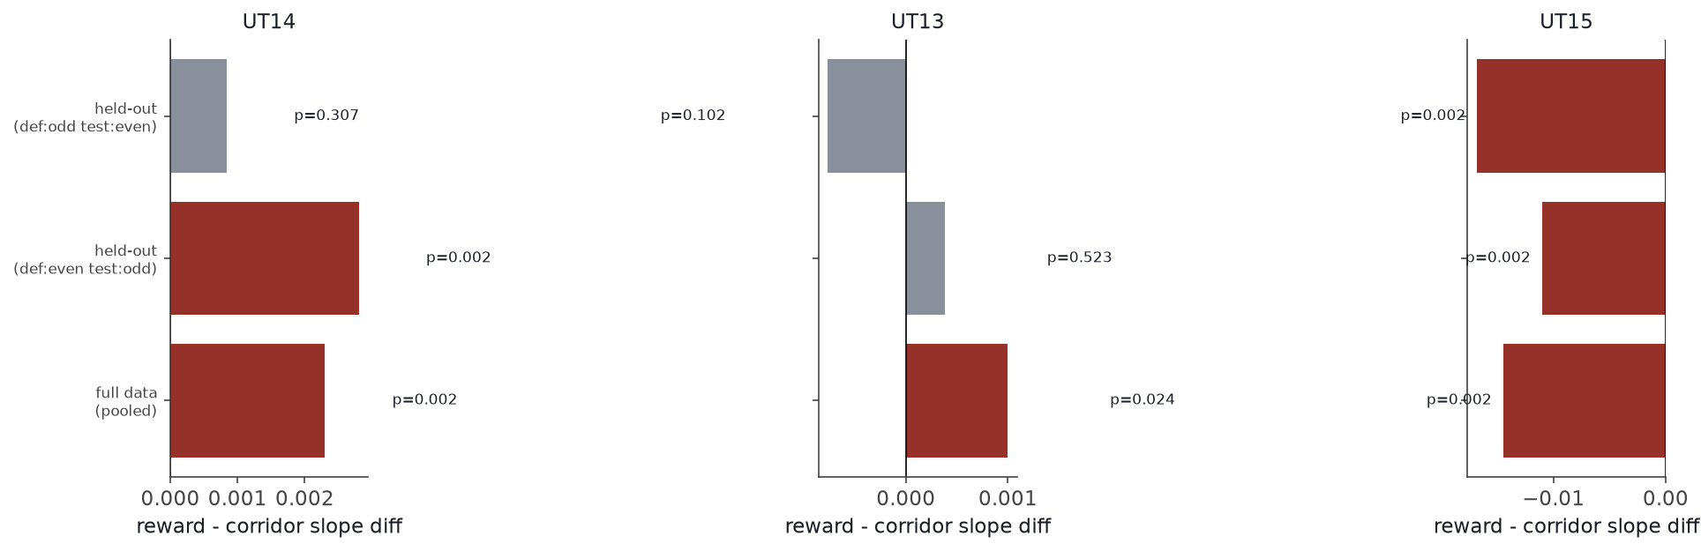
Figure J. Each mouse's full-data result (blue) next to both held-out re-tests (red = still significant, grey = not). UT15 is the only one that replicates fully both times.
THIS CHANGED OUR CONCLUSION, HONESTLY
Before this check it looked like a roughly even 2-vs-1 split. After: UT13's result doesn't survive independent re-testing at all. UT14's survives partially. Only UT15's result — going in the UNEXPECTED direction — survives fully and robustly.

Part 8 — The Detective Story: Is UT15's Result Even Real?
Figure G showed UT15's zone map looked messier than the other two mice's. Since UT15 now carries the paper's central finding, we owed it a very careful look.
- Look at the raw evidence directly. We plotted every individual trial's raw movement path. UT15's right-arm paths looked scattered and jagged, unlike the other two mice's clean paths.
- Measure it precisely. A mouse physically cannot move faster than ~100 cm/second — any faster “jump” between camera frames has to be a tracking glitch. UT15 showed these impossible jumps 3.26% of the time versus 0.31% and 0.41% for the other two mice — roughly ten times worse tracking, specific to this one mouse.
- Test whether it actually matters. We automatically “healed” all ~92,000 bad readings (linear interpolation between clean neighbors) and re-ran the entire analysis on the cleaned data.
THE RESULT HELD UP
Cleaned: −0.0149 (p=.002) — essentially identical to the original −0.0145 (p=.002). The tracking problem was real but was NOT the cause of the finding — a fourth independent check confirming UT15's effect is genuine. Interestingly, the choice-zone result DID change a lot after cleaning, correctly identifying it as the one result that shouldn't be trusted.

WHY THIS MATTERS AS A GENERAL LESSON
It would have been easy to either ignore the messy map, or get spooked and quietly drop the result. Both would have been mistakes. Only actually measuring the problem and testing whether it changes the answer tells you which one is true.

Part 9 — What We Actually Found, in Plain English
- The basic phenomenon is real and solid: a mouse's hippocampal map of a familiar maze really does slowly change over weeks, even with nothing about the maze changing. Replicated cleanly in all three mice.
- The reward location is not immune to drift, but it IS different from everywhere else — in every mouse, the reward zone's drift speed measurably differed from the rest of the maze.
- But that difference does not point the same direction in every mouse. The single most trustworthy result (UT15, after every robustness check) shows the reward zone drifting FASTER, not slower — the opposite of the “reward protects memories” intuition.
- The choice point shows no reliable effect either way — reported honestly as “we don't know,” not forced into a false conclusion.
- The original circadian question really can't be answered with this dataset — even the one mouse with a wide spread of real recording times showed no time-of-day effect.
Put together: this project's real contribution is a caution, backed by unusually thorough testing, against assuming reward always makes memories more stable. At least in this one well-verified case, it did the opposite.

Part 10 — What We Actually Built
- Code: a full, reusable Python analysis pipeline (timestamp verification, rate maps, population-vector correlation, zone classification, every statistical test described above)
- Notebooks: three fully-executed Jupyter notebooks reproducing every figure in this document
- Manuscript: a full academic preprint (Abstract through References), every statistic pulled directly from real analysis outputs
- GitHub: everything pushed to a public, permanent home at github.com/sisyyphuss/hippocampal-reward-zone-drift
ONE LAST HONEST NOTE
This document walked through several dead ends on the way to the final result. That's not a weakness — it's what real research looks like, and it's a big part of why the final finding can be trusted: every step of the way, the question that survived was the one that held up to scrutiny, not just the first idea that seemed interesting.

