**--1. Create a trigger on AmbulatoryVisits to raise exception on inserting new records with Provider_Id and VisitDepartmentID which doesn't exist in the hospital.**

create or replace function av_trig1()

returns trigger

Language PLPGSQL

as $$

begin

if (new."Provider_ID">40 or new."VisitDepartmentID">12) then

raise exception

'ERROR: Provider_ID or Visit department does not exist!';

else return new;

end if;

end $$;

create or replace trigger av_trig1

before insert on "AmbulatoryVisits"

for each row

execute procedure av_trig1();

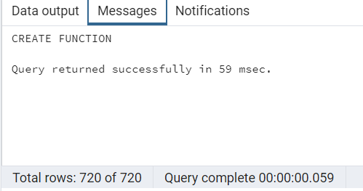

**--Here, new record is entered with wrong ProviderID which shows the error and doesn't allow to**

**--enter that record.**

insert into "AmbulatoryVisits" ("Visit_ID", "Provider_ID","VisitDepartmentID") values(12345,42,12)

**--Here, new record is entered with correct ProviderID and VisitDepartmentID,and it is entered sucessfully.**

insert into "AmbulatoryVisits" ("Visit_ID", "Provider_ID","VisitDepartmentID") values(12346,35,12)

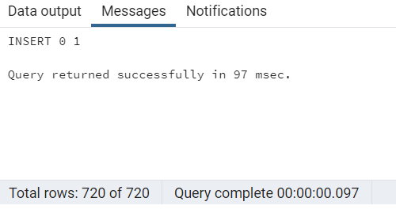

**-Both the records must be deleted for not to affect other outputs.**

delete from "AmbulatoryVisits" where "Visit_ID" between 12345 and 12346

**--2. Create a trigger on the AmbulatoryVisit for displaying message while inserting new record**

**--for any abnormal blood pressure record.**

create or replace function av_trig2()

returns trigger

Language PLPGSQL

as $$

begin

if new."BloodPressureSystolic"<90 then

perform 'Alarming: Low Systolic Blood Pressure';

END IF;

if new."BloodPressureSystolic">120 then

raise notice 'Alarming: High Systolic Blood Pressure';

END IF;

if new."BloodPressureDiastolic"<60 then

raise notice 'Alarming: Low Diastolic Blood Pressure';

END IF;

if new."BloodPressureDiastolic">80 then

raise notice 'Alarming: High Diastolic Blood Pressure';

END IF;

return new;

end

$$;

create or replace trigger av_trig2

after insert on "AmbulatoryVisits"

for each row

execute procedure av_trig2();

--Here, new record is entered with abnormal blood pressure.

insert into "AmbulatoryVisits"("Visit_ID","BloodPressureSystolic","BloodPressureDiastolic")

values (12341,89,85)

**--Both the records must be deleted for not to affect other outputs.**

delete from "AmbulatoryVisits" where "Visit_ID"=12341

**--3. Create a trigger on ReadmissionFlag when a patient gets readmitted.**

create or replace function rr_trig3()

returns trigger

Language PLPGSQL

as $$

begin

if (new."ReadmissionFlag"=1) then

raise exception

'Message: One Patient got readmitted';

end if;

return new;

end $$;

create or replace trigger rr_trig3

before update on "ReAdmissionRegistry"

for each row

execute procedure rr_trig3();

update "ReAdmissionRegistry" set "ReadmissionFlag" =1 where "Patient_ID"=10

**--4. Count the number of expired patients due to each illness type.**

select c."PrimaryDiagnosis" , count (d."Patient_ID") as "Expired_Patient"

from "Discharges" as d

Join "PrimaryDiagnosis" as c on c."Diagnosis_ID"= d."Diagnosis_ID"

Join "DischargeDisposition" as dd on d."Discharge_ID" = dd."Discharge_ID"

where dd."DischargeDisposition" = 'Expired'

group by c."PrimaryDiagnosis"

order by "Expired_Patient" desc

**-- 5. Use a function to calculate the percentage of patients transferred to other hospital per month.**

create or replace function count_transfer()

returns int

Language PLPGSQL

as $$

declare count_transfer int;

begin

select count("Patient_ID") into count_transfer

from "Discharges" as d

join "DischargeDisposition" as dd on d."Discharge_ID" = dd."Discharge_ID"

where dd."DischargeDisposition" = 'Transfer';

return count_transfer;

end $$;

select date_part('month',d."DischargeDate") as month,

round(count(d."Patient_ID")*100.0/ (select count_transfer()),2) as percent_transfer

from "Discharges" as d

join "DischargeDisposition" as dd on d."Discharge_ID" = dd."Discharge_ID"

where dd."DischargeDisposition" = 'Transfer'

group by month

order by month

**- 6. Calculate the percentage of expired patients in each month.**

**--Here, a function is created which returns the total expired persons and that then the function is called in next set of queries to input the total expired patients to get the percentage.**

create or replace function count_expired()

returns int

Language PLPGSQL

as $$

declare count_expired int;

begin

select count("Patient_ID") into count_expired

from "Discharges" as d

join "DischargeDisposition" as dd on d."Discharge_ID" = dd."Discharge_ID"

where dd."DischargeDisposition" = 'Expired';

return count_expired;

end $$;

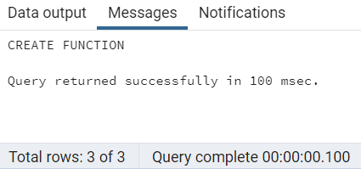

select date_part('month',d."DischargeDate") as month,

round(count(d."Patient_ID")*100.0/ (select count_expired()),2) as percent_expired

from "Discharges" as d

join "DischargeDisposition" as dd on d."Discharge_ID" = dd."Discharge_ID"

where dd."DischargeDisposition" = 'Expired'

group by month

order by month

**--7. Get the daily number of patients.**

select "DateofVisit" ,count("Patient_ID") as visits

from "AmbulatoryVisits"

group by "DateofVisit"

order by "DateofVisit" desc

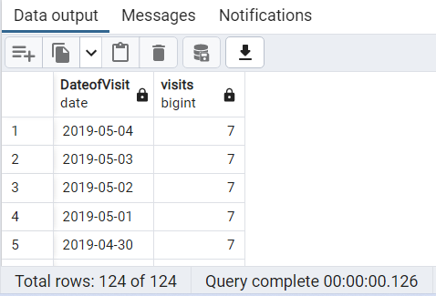

**--8. Number of patients visited the hospital on the next day of scheduled visit.**

select "DateofVisit"-date("DateScheduled") as days, count("Patient_ID")as num_patients

from "AmbulatoryVisits"

where "DateofVisit"-date("DateScheduled")=1

group by "DateofVisit"-date("DateScheduled");

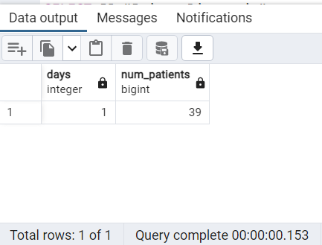

**--9. Number of patients admitted in every service.**

SELECT S."Service", COUNT(D."Patient_ID") as count_patients

FROM "Discharges" AS D

JOIN "Service" AS S

ON D."Service_ID" = S."Service_ID"

GROUP BY S."Service"

order by count_patients desc

**--10. Get a list of top 3 primary diagnosis based on number of patients got readmitted.**

SELECT PD."PrimaryDiagnosis", count(R."Patient_ID") AS "No_of_patients"

FROM "ReAdmissionRegistry" AS R JOIN "PrimaryDiagnosis" AS PD

ON R."Diagnosis_ID"= PD."Diagnosis_ID"

GROUP BY PD."PrimaryDiagnosis"

Order by "No_of_patients" desc limit 3

**--11. Get the number of patients who have at least two visits to the hospital.**

select count(*) as repeated_visit from

(select count("Patient_ID")as count

from "ReAdmissionRegistry"

group by "Patient_ID" ) x

where x.count>=2

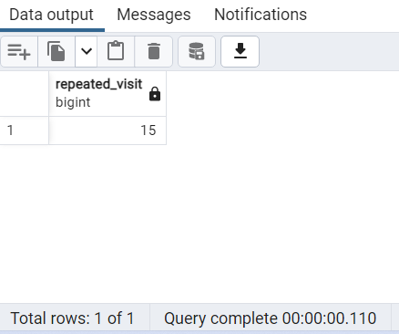

**-- 12. Classify the patients by the birthyear who got admitted to hospital due to heart failure.**

create view heart_patients as

select p."Patient_ID","DateOfBirth" from "Patients" as p

join "Discharges" as d on

p."Patient_ID"=d."Patient_ID"

join "PrimaryDiagnosis" as pd on

pd."Diagnosis_ID"=d."Diagnosis_ID"

where "PrimaryDiagnosis"='Heart Failure';

with ranges as (

SELECT 'Born before 1960' r UNION ALL

SELECT 'Born between 1961 and 1970' UNION ALL

SELECT 'Born between 1971 and 1980' UNION ALL

SELECT 'Born between 1981 and 1990' UNION ALL

SELECT 'Born after 1990'

), setup as (

SELECT CASE

WHEN DATE_PART('year', "DateOfBirth") < 1961 THEN 'Born before 1960'

WHEN DATE_PART('year', "DateOfBirth") BETWEEN 1961 AND 1970 THEN 'Born between 1961 and 1970'

WHEN DATE_PART('year', "DateOfBirth") BETWEEN 1971 AND 1980 THEN 'Born between 1971 and 1980'

WHEN DATE_PART('year', "DateOfBirth") BETWEEN 1981 AND 1990 THEN 'Born between 1981 and 1990'

WHEN DATE_PART('year', "DateOfBirth")>1990 THEN 'Born after 1990'

END as yearRange,

"Patient_ID"

FROM heart_patients

)

SELECT t.r as Birth_Range, COUNT(s."Patient_ID") as Frequency

FROM ranges t

LEFT JOIN setup s

ON t.r = s.yearRange

GROUP BY t.r

order by t.r

**--13. Top 5 providers based on the ambulatory visit patients.**

select "ProviderName", count(av."Patient_ID") as "No_of_patients"

from "AmbulatoryVisits" av

join "Providers" p on

av."Provider_ID" = p."Provider_ID"

group by "ProviderName"

Order by "No_of_patients" desc limit 5

**14. List the patients whose pulse rate or BP is either above or below normal.**

select "Patient_ID","DateofVisit" from "AmbulatoryVisits"

where "BloodPressureSystolic"<90

or "BloodPressureSystolic">120

or "BloodPressureDiastolic"<60

or "BloodPressureDiastolic">80

or "Pulse"<60

or "Pulse">100

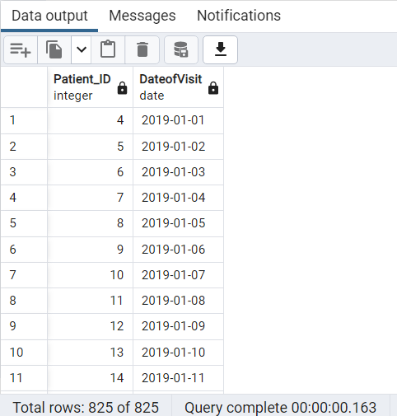

**--15. list of Patient_ID along with maximum Length of Stay partition by Diagnosis.**

SELECT "Patient_ID","Service","Diagnosis_ID",

max("ExpectedLOS") over (Partition by "Diagnosis_ID" ORDER BY "Diagnosis_ID" DESC) a

"MaximumLOS" FROM "Discharges" as D join "Service" as S on S."Service_ID"=D."Service_ID";

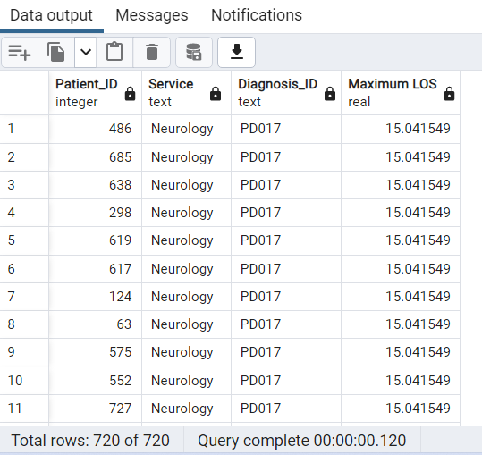

**--16. Number of expired patients in ICU who are below 40 years of age.**

select s."Service", count(d."Patient_ID") as "No_of_Expired patients"

from "Discharges" AS d

JOIN "Service" AS s ON

s."Service_ID" = d."Service_ID"

JOIN "DischargeDisposition" AS dd ON

d."Discharge_ID" = dd."Discharge_ID"

join "Patients" P on P."Patient_ID" = d."Patient_ID"

WHERE dd."DischargeDisposition"='Expired' and DATE_PART('year',d."AdmissionDate")-DATE_PART ('year', P."DateOfBirth") <'40' and s."Service" ='ICU'

Group by s."Service"

**--17. Get list of expired patients ID who got admitted due to car accident.**

select d."Patient_ID", concat("FirstName", ' ',"LastName") as "Fullname", "ReasonForVisit"

from "EDVisits" ed join "ReasonForVisit" rv on

ed."Rsv_ID"= rv."Rsv_ID"

join "Discharges" AS d on

d."Patient_ID"= ed."Patient_ID"

JOIN "DischargeDisposition" AS dd ON

d."Discharge_ID" = dd."Discharge_ID"

join "Patients" p on

P."Patient_ID"= d."Patient_ID"

where dd."DischargeDisposition"='Expired' and "ReasonForVisit"= 'Car Accident'

**--18. Number of expired patients based on service.**

select s."Service", count(d."Patient_ID") as "No_of_Expired patients" from "Discharges" AS d

JOIN "Service" AS s ON

s."Service_ID" = d."Service_ID"

JOIN "DischargeDisposition" AS dd ON

d."Discharge_ID" = dd."Discharge_ID"

WHERE dd."DischargeDisposition"='Expired'

GROUP BY s."Service"

**--19. Rank the patients based on Service and Expected Mortality.**

select "Patient_ID", "ExpectedMortality" ,

"Service", rank() over(partition by ra."Service_ID" order by "ExpectedMortality" desc ) as "Rank"

from "ReAdmissionRegistry" ra

join "Service" s on ra."Service_ID" = s."Service_ID"

**--20.Rank the service by using window function based on admissions.**

create or replace view patient_service as

SELECT count("Patient_ID") as patients,rr."Service_ID"

FROM "ReAdmissionRegistry" as rr

join "Service" as S on S."Service_ID"=rr."Service_ID"

group by rr."Service_ID";

select "Service",patients ,

rank() over( order by patients desc ) as "Rank"

from patient_service as ps

join "Service" as s on

s."Service_ID"=ps."Service_ID"

**21. Find which Visit type of patients are maximum in cancelling their appointment.**

**-- A subquery is created to get the count of patients for each "AMV_ID". And then main query is**

**--is written to get the visit type where there are max patients. (Run both the queries together)**

create or replace view visit_id_cancelled as

select AV."AMVT_ID", count (AV."AMVT_ID") as "Cancelled" from "AmbulatoryVisits" as AV

join "VisitStatus" as VS on AV."VisitStatus_ID" = VS."VisitStatus_ID" where VS."VisitStatus" = 'Canceled'

group by AV."AMVT_ID";

select "VisitType" from "VisitTypes" as vt join visit_id_cancelled as vic on vt."AMVT_ID"=vic."AMVT_ID"

where vic."Cancelled"=(select max ("Cancelled") from visit_id_cancelled );

