Write a program suppose, it is required to build a project consisting of a number of classes, possibly using a large number of programmers. It is necessary to make sure that every class from which all other classes in the project will be inherited. Since any new classes in the project must inherit from the base class, programmers are not free to create a different interface. Therefore, it can be guaranteed that all the classes in the project will respond to the same debugging commands.

1. Implement a program with a GUI that looks like the one shown below. Put the main method in a class named MyDemo1. 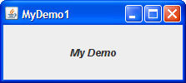
2. Make a copy of MyDemo1.java named MyDemo2.java. Add a menu bar to MyDemo2
3. Copy MyDemo1.java to MyDemo3.java. Add a button (JButton) to MyDemo3.java. Make it the default button.

Explain difference between heavyweight components and lightweight components.