# Project Report: Intelligent Excuse Generator

**Developed in Python with Google Gemini AI Integration**

## 1. Introduction

The **Intelligent Excuse Generator** is an AI-powered system designed to generate context-aware, believable excuses and apologies for various scenarios (work, school, social, family). It includes proof-generation capabilities and emergency simulation features to enhance credibility.

## 2. Features Implemented

**2.1 Core Features**

| **Feature** | **Description** |
| --- | --- |
| **AI-Generated Excuses** | Context-aware excuses for work, school, social, and family scenarios. |
| **Scenario-Based Customization** | Adjusts excuses based on **urgency (low/medium/high)** and **tone (professional/casual/emotional)**. |
| **Proof Generator** | Generates fake documents, chat screenshots, and location logs to support excuses. |
| **Emergency Simulation** | Simulates fake emergency calls/texts for high-urgency scenarios. |
| **Apology Generator** | Creates guilt-tripping apologies in different tones. |
| **Excuse History & Favorites** | Saves past excuses and allows marking favorites. |

**2.2 Technical Features**

✅ **Google Gemini AI Integration** (gemini-1.5-flash)  
✅ **Interactive CLI Menu** (VS Code/Python)  
✅ **Faker Library** for realistic fake data  
✅ **Pillow (PIL)** for generating chat screenshots  
✅ **JSON-based History Tracking**

## 3. System Architecture

**3.1 Modules**

| **File** | **Purpose** |
| --- | --- |
| main.py | Main application logic & interactive menu |
| generator.py | Generates AI-powered excuses |
| apology_generator.py | Creates AI-based apologies |
| proof_generator.py | Generates fake proofs (docs, chats, locations) |
| emergency_system.py | Simulates emergency calls/texts |
| history_manager.py | Manages excuse history & favorites |
| config.py | Stores API keys & settings |

**3.2 Workflow**

1. **User selects** excuse/apology/proof generation.
2. **Chooses scenario** (work, school, social, family).
3. **Customizes tone & urgency**.
4. **AI generates** output.
5. **Optionally generates proof/emergency alerts**.
6. **Saves to history** for future use.

## 4. Screenshots (Example Outputs)

**4.1 Excuse Generation**

For example:-

==================================================

INTELLIGENT EXCUSE GENERATOR

==================================================

■ GENERATED EXCUSE ■

--------------------

I sincerely apologize for missing the meeting today. My child had a sudden

fever, and I had to take them to the doctor immediately. I’ll catch up on

all pending tasks by EOD.

■ SUPPORTING EVIDENCE ■

------------------------

1. Medical Certificate:

- Title: Doctor’s Note

- Date: 2025-07-10

- Name: Dr. Sarah Lee

- Details: Patient required immediate care.

- Signature: Dr. Sarah Lee, MD

2. Chat Screenshot: Saved as 'chat_proof.png'

**4.2 Apology Generation**

text

■ GENERATED APOLOGY ■

---------------------

Dear Team,

I deeply regret my absence today. Family emergencies are unpredictable,

and I appreciate your understanding. I’ll ensure this doesn’t affect deadlines.

Best regards,

[Your Name]

## 5. Setup Instructions

**5.1 Prerequisites**

* Python 3.10+
* Google Gemini API Key
* Libraries:

bash

pip install google-generativeai pillow faker pyttsx3

**5.2 How to Run**

1. **Configure**config.py with your Gemini API key.
2. Run:

bash

python main.py

1. Follow the **interactive menu**.

## 6. Future Enhancements

* **Multi-language support** (Spanish, French, etc.)
* **Voice integration** (text-to-speech for excuses)
* **WhatsApp/Email auto-send**

## 7. Conclusion

This project demonstrates how **AI can automate social interactions** while maintaining believability. It’s useful for professionals, students, and anyone needing quick, credible excuses.

**Developed By**: Prince Yadav (9717240085) & Sitanshu (9971472204)

# About the Developers:-

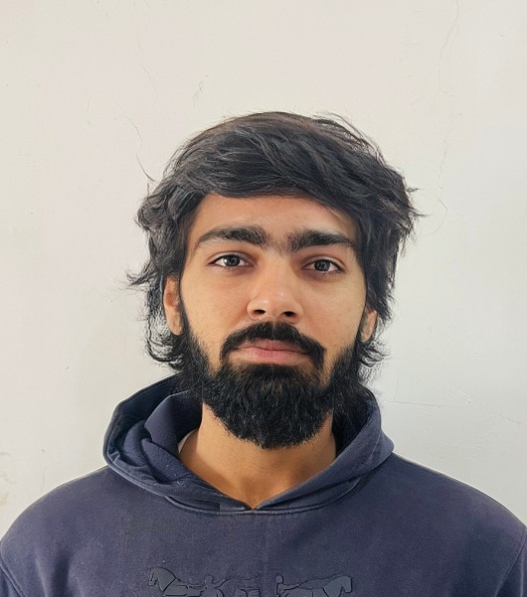

Prince Yadav Sitanshu

Both are ready for part-time paid work.

Skills :- Python, C, C++, HTML, AI &ML

Email-ID :- [princeyadav1724@gmail.com](mailto:princeyadav1724@gmail.com) & [sitanshurao2323@gmail.com](mailto:sitanshurao2323@gmail.com)

Interest in:- Web development, App development, Software development

Education:- Currently pursuing B-tech computer science in AI&ML.

THANK YOU