<https://codesandbox.io/p/sandbox/coding-challenge-forked-2qsvxr>

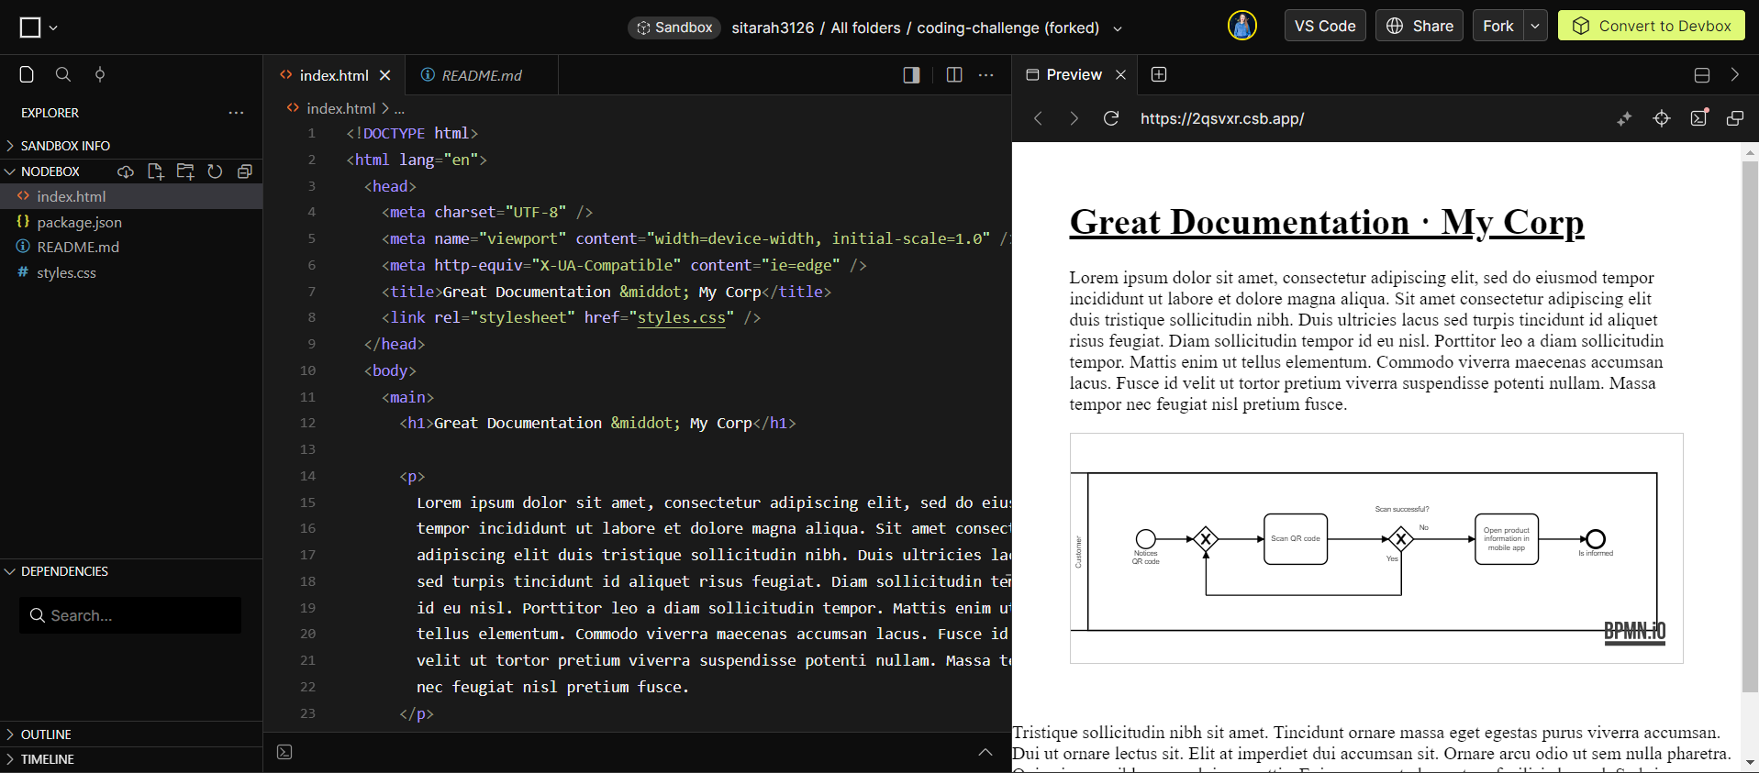

**What You’ll Be Doing:**Your responsibilities will include:

* Contribute to improving Camunda’s modeling tools for BPMN and DMN ( https://bpmn.io ).
* Learn to navigate and maintain a large JavaScript code-base / an open ecosystem of libraries.
* Work with people in different roles, both internals and the community.
* Thi s is a remote role and can be based anywhere where we are eligible to hire, please find a list of available countries here . Most of the team is in CE(S)T timezone and an overlap of +/- 1 hour ( GMT-EET are fine) is necessary for a close collaboration.

**What You’ll Bring:**

* Studies in a computer science or related field
* Prior experience in software development and an interest in the web platform
* A pragmatic approach to get things done
* Eagerness to grow and learn new things
* Interest in user-centered design. We build modeling tools people love, embeddable everywhere, by everyone .
* Interest in library and open source development.
* Interest in working with GitHub, CI/CD systems.
* Ability and/or willingness to use our product .