The Fusion of Chatbots and Augmented Reality for Unmatched E-Commerce Experiences

Sitara Khurram Research Skills,

Ilmenau University of Technology, [sitarah3126@gmail.com](mailto:sitarah3126@gmail.com)

***Abstract*- This research paper introduces a transformative approach to revolutionize the online shopping experience through the integration of Chat bots with Augmented Reality. With the help of AR and designed algorithms the smart mirror will be able to provide real time apparel try-ons allowing users to visualize how different apparel items suit them in real time. The usefulness of smart mirrors increases with the help of chatbots that can answer all questions about products, recommend sizes and styles based on user preferences, show the most recent prices of the item, and compare it with those of other e-commerce stores.**

***Keywords—Smart Mirror, Price Comparison, Chat bot Integration, Virtual try-ons, E-Commerce.***

# INTRODUCTION

Online shopping has become increasingly popular in the retail industry, which is continually evolving. Despite its convenience, this change brings to light long-standing problems, particularly with regard to home-based online buying. When they don't have the benefit of a real try-on experience and the lowest pricing, customers usually find it difficult to narrow down the vast array of options accessible to them and difficult to select appropriate apparel. The whole online shopping experience suffers greatly as a result of these issues. Customers find it more difficult to enjoy shopping when they are forced to choose from a wide variety of alternatives without being able to try them on. Customers thus avoid buying because of a fear of making the wrong choice and a reluctance to explore new products.

For enhancing the online shopping experience, this research paper provides a unique solution by integrating AR with chatbot. With this integration, the chatbot will be able to perform various functions like addressing product inquiries, conducting price comparisons, offering tailored recommendations and can also serve as a virtual shopping assistant. This suggested system intends to reshape the online shopping experience by seamlessly merging the capabilities of a chatbot with augmented reality, offering customers with the guidance and confidence they need to make informed and satisfying purchase decisions. The later portions of this paper will explain the technical details of the chatbot integration and how it will further enhance the shopping experience of user.

# LITERATURE SURVEY

Several solutions exist to address challenges in at-home online shopping, each with its benefits and limitations. Some alternatives include A virtual try-on system based on deep learning, that emphasis is on achieving visually attractive virtual try-ons with high accuracy. This approach also enhances the visual effects of try-ons but also uses refined techniques, such as predicting

semantic layouts and altering reference images for detailed clothing representation.

Another research, The Future of Smart Dressing Mirror - an open innovation concept video [1]. Developed by the Lab of Intelligent Computing at Beijing Institute of Technology, this is about mirror digitizing clothes, uses machine learning, and utilizes computer vision technologies. It offers also interactive functions, recommends fashionable clothing combinations, and even facilitates e-shopping directly through the mirror interface, providing an advanced solution to the daily issue of choosing the right outfit.

Likewise, Marker-less Augmented Reality based application for E-Commerce to Visualize 3D Content [2]. A study in which innovations not only target to improve the virtual try-on experience but also address existing problems in online shopping, such as decision-making problems and the need for customized, interactive solutions. By combining these studies, it helps to recognize groundwork for understanding the importance of Fusion of Chat-bots and Augmented Reality in online shopping. The study [3] introduces a deep learning-driven virtual fitting system that allows users to virtually experiment with garments, resulting in visually appealing effects

Into 3D-Reconstructed Apparel over Virtual Try-On with Virtual Reality [4] is another research that addresses the limitations of conventional 2D image views in online shopping. For this issue in online shopping, augmented reality emerges as a transformative solution. By combining the real world with the virtual, AR in e-commerce enables customers to visualize products in their physical space before making a purchase. By using this approach, it aims to streamline decision-making by allowing users to try out garments virtually in a much convenient manner.

Although, mentioned research papers contribute important information to the field of augmented reality (AR) in e- commerce, they are considered insufficient because of few factors like no Focus on Inadequate Real-Time Price Comparisons, Size recommendations and a much more that a chatbot assistance can provide.

Enhancing the creative idea of The Fusion of Chatbots and Augmented Reality this paper introduces several key enhancements that significantly improve the user experience, providing a superior and more comprehensive solution to the common challenge of deciding what to wear.

The advanced chatbot on the mirror is essential to its functionality, equipped with natural language processing (NLP) to address user inquiries comprehensively. The chatbot not only provides assistance during the virtual try-on process but also serves as a knowledgeable companion throughout the user's journey. Users can ask various questions about product details, materials, and care instructions, receiving instant and accurate responses including size recommendations, information regarding shipping fostering confidence in their purchasing decisions. It can also suggest complementary items or alternatives based on the user’s feedback.

The above-mentioned researches are unable to offer dynamic and real-time price comparison services, deteriorates the overall user online shopping experience.

One notable improvement this paper provides over existing smart mirrors is the integration of real-time price comparison capabilities with the help of chatbot. The mirror scans various e-commerce platforms to provide users with an overview of the prices for a selected product. With the help of this function, customers can make well-informed judgements and guarantee they get the greatest bargain without having to waste time manually browsing through numerous different websites.

# PROPOSED METHODOLOGY

The chatbot employs various approach to engage users within the virtual shopping experience. Initially, motion sensors detect user presence, triggering the chatbot's activation. Once initiated, the chatbot introduces itself in a user-friendly manner, presenting a range of assistance options, including virtual try-ons, product inquiries, and style recommendations.

For virtual try-ons, the chatbot employs step-by-step guidance, utilizing advanced algorithms to showcase diverse styles, provide tailored suggestions, and offer real-time feedback on the user's virtual appearance. This process involves various complex backend processes, including image recognition and rendering algorithms to ensure a smooth and realistic virtual try-on experience.

In the case of product inquiries, users can interact with the chatbot to obtain specific details or personalized recommendations. The chatbot accesses its extensive database, utilizing natural language processing algorithms to comprehend user queries and deliver accurate information promptly. Machine learning models also play a role in continuously refining the chatbot's ability to understand and respond to user inquiries effectively.

Throughout the user interaction, the chatbot employs advanced complex algorithms for decision-making support, enhancing the user's understanding of available products and facilitating informed choices. The seamless integration of these methods not only augments the virtual shopping journey but also underscores the technical complexity and adaptability of the chatbot in catering to diverse user needs. When users select an outfit, the mirror initiates a real-time price comparison by employing algorithms that dynamically scan various e-commerce platforms. Utilizing machine learning algorithms and web scraping techniques, the smart mirror systematically extracts relevant product information from different online sites.

The system employs a product matching algorithm to identify identical or closely similar items across platforms, ensuring accuracy in comparing prices. Additionally, a price tracking algorithm continuously updates the displayed prices to show the most recent information available.

The user interface of the smart mirror is designed to present the results in a organized way, displaying not only the matched products but also their corresponding prices and links to the original listings on respective e-commerce sites. This technical approach enhances the transparency of the comparison process, providing users with a detailed and real-time analysis of product pricing across multiple platforms.

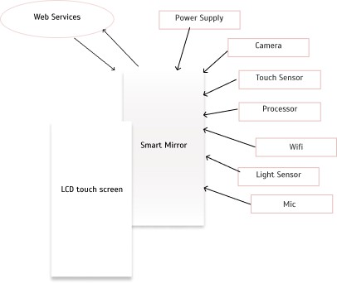

Fig 3.1 Architecture Design

# HARDWARE

1. The Smart Mirror combines a sophisticated 32-inch LCD display with an interactive touch surface. Its dimensions, at 40 inches by 24 inches, provide an optimal balance between usability and aesthetics
2. Input Devices: - The mirror employs an array of touch sensors, and microphone enabling users to interact intuitively with the interface. These sensors facilitate a seamless and inclusive user experience.
3. Camera System: - Equipped with a high-resolution camera system featuring 1080p resolution and a wide- angle lens, the smart mirror enhances virtual try-on experiences and augments the functionality of the integrated chatbot for personalized interactions.
4. Display Technology: - The smart mirror utilizes an LED-backlit LCD display with a resolution of 1920 x 1080 pixels, providing crisp and clear visuals. The display technology ensures accurate representation of clothing items for virtual try-ons.
5. Processing Unit: - Powered by a robust quad-core processor, the mirror's processing unit handles real- time image processing, machine learning tasks, and supports the integration of advanced functionalities of chatbot.
6. Connectivity: - With Wi-Fi connectivity, the smart mirror establishes a seamless connection to e- commerce platforms for real-time price comparison.
7. Power Supply: - The mirror operates on standard electrical power, ensuring continuous functionality.

# PROCESS FLOW

User approaches the Smart Mirror.

* 1. User Engagement:

Motion sensors detect user presence.

* 1. Interface Interaction:

Users interact with the mirror using touch gestures or voice commands.

* 1. Virtual Try-On:

Users choose the "Virtual Try-On" option.

Camera captures real-time images for virtual try-ons.

* 1. Chatbot Interaction: Chatbot interacts in real-time.

Users ask questions, receive style recommendations.

* 1. Real-Time Price Comparison: Users select an outfit.

Mirror scans e-commerce platforms for real-time price comparison.

* 1. E-Shopping Integration:

Users can access to e-shopping directly through the mirror. Browse, select, and purchase items.

* 1. Size Recommendations and Post-Purchase Support: Mirror provides size recommendations based on historical data. Offers post-purchase support for personalized assistance.
  2. Checkout and Payment: Secure checkout process initiated.

Users review selections, input payment details, and place orders.

* 1. Delivery Information: Mirror displays order history. Users track the status of deliveries.
  2. End:

Shopping process concludes.

# REAL TIME COMPARISION MODULE

In the user interaction phase, individuals engage with the smart mirror through which user can have the access to functions such as virtual clothing try-ons and exploring through different apparels. Price comparison on different online platforms of a desired item is possible with the help of combination of Chatbot and User Interface Module as shown in *Fig 6.1*. At the system's core, the Real-Time Price Comparison Module operates through a series of structured designed processes as depicted in *Fig 6.2*.

The E-Commerce Platforms Integration Module establishes important API connections with various e-commerce platforms to retrieve the updated data. Following this, the Product Identification and Price Data Retrieval process uses advanced web scraping techniques and machine learning algorithms to identify specific products and extract real-time pricing information from the connected E-Commerce platforms.

To ensure data consistency and coherence, the Data Normalization step employs statistical methods and data formatting techniques, which standardizes pricing data formats across different e- commerce platforms. Subsequently, the Comparison Algorithm & Selection component utilizes advanced statistical models, applying machine learning algorithms, to analyze the normalized data. This analysis displays the price comparisons with the most favorable price of the one’s desired item.

The Display Results to User module utilizes a simple and easily understandable user interface, presenting these price comparison outcomes through the smart mirror interface. The User Confirmation & Integration with E-Shopping ensures a seamless transition for users to initiate the purchasing process, integrating with e-commerce platforms for secure and user-friendly transactions.

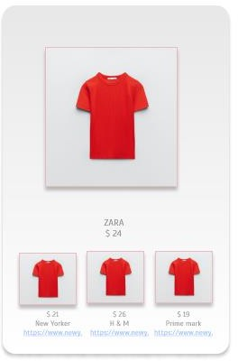

Fig 6.1 Price Comparison Template

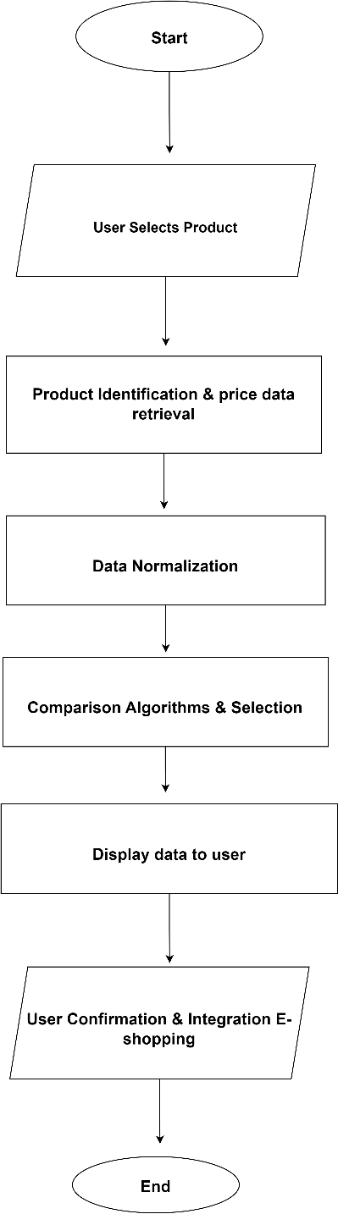

Fig 6.2 Data Flow Diagram

# CONCLUSION

The integration of a chatbot with augmented reality smart mirrors revolutionizes the experience of online buying. The system, characterized by dynamic user engagement, real-time price comparison, and seamless e-shopping integration, addresses challenges like choice overload and customer worry. Technically, advanced algorithms, web scraping, and statistical models power modules such as E-Commerce Platforms Integration, Product Identification, Data Normalization, and Comparison Algorithm & Selection. The system's refined and understandable user interface enhances visual representation, ensuring a user-friendly and secure purchasing experience. This unique idea of smart mirror system not only overcomes challenges in online shopping but also empowers users with real-time information and personalized recommendations, creating a supported and enjoyable online retail experience.

REFERENCES

1. Guangyu Gao, Chenchen Bai, Wei Zheng and Chi Harold Liu,” The Future of Smart Dressing Mirror - an open innovation concept video”, 2015 IEEE.
2. Yashvi Desai, Vrushali Shah, Dr. Prasenjit Bhavathankar, Prof. Kaisar Katchi. Department Of Information Technology “Markerless Augmented Reality based application for E-Commerce to Visualise 3D Content”, 2021 IEEE
3. Jianhua Hu, Weimei Wu, Mengjun Ding, Xi Huang, Xuankai Li, zhi jian Deng. Department Of Information Technology “A virtual try-on system based on deep learning”, 2023 IEEE
4. Surasachai Doungtap, Jirayu Petchhan, Varinya Phanichraksaphong, Jenq-Haur Wang. International Graduate Program of Electrical Engineering and Computer Science “Into 3D-Reconstructed Apparel over Virtual Try-On with Virtual Reality”, 2023 IEEE