The Fusion of Chatbots and Augmented Reality for Unparalleled Shopping Experiences

Sitara Khurram

Research Skills,TU Ilmeanu , [sitarah3126@gmail.com](mailto:sitarah3126@gmail.com)

***Abstract*-** **This research paper introduces a transformative approach to revolutionize the online shopping experience through the integration of Chat bots with Augmented Reality.** **With the help of AR and designed algorithms the smart mirror will be able to provide real time apparel try-ons allowing users to visualize how different apparel items suit them in real time. The usefulness of smart mirrors increases with the help of chatbots that can answer all questions about products, recommend sizes and styles based on user preferences, show the most recent prices of the item, and compare it with those of other e-commerce stores.**

***Keywords—Smart Mirror, Price Comparison, Chat bot Integration, Virtual try-ons***

## **INTRODUCTION**

Online shopping has become increasingly popular in the retail industry, which is continually evolving. Despite its convenience, this change brings to light long-standing problems, particularly with regard to home-based online buying. When they don't have the benefit of a real try-on experience and the lowest pricing, customers usually find it difficult to narrow down the vast array of options accessible to them and difficult to select appropriate apparel. The whole online shopping experience suffers greatly as a result of these issues. Customers find it more difficult to enjoy shopping when they are forced to choose from a wide variety of alternatives without being able to try them on. Customers thus avoid buying because of a fear of making the wrong choice and a reluctance to explore new products.

For enhancing the online shopping experience, this research paper provides a unique solution by integrating AR with chatbot. With this integration, the chatbot will be able to perform various functions like addressing product inquiries, conducting price comparisons, offering tailored recommendations and can also serve as a virtual shopping assistant. This suggested system intends to reshape the online shopping experience by seamlessly merging the capabilities of a chatbot with augmented reality, offering customers with the guidance and confidence they need to make informed and satisfying purchase decisions. The later portions of this paper will explain the technical details of the chatbot integration and how it will further enhance the shopping experience of user.

## **LITERATURE SURVEY**

Several solutions exist to address challenges in at-home online shopping, each with its benefits and limitations. Some alternatives include A virtual try-on system based on deep learning,that emphasis is on achieving visually appealing virtual try-ons with high accuracy. This approach also enhances the visual effects of try-ons but also employs refined techniques, such as predicting semantic layouts and altering reference images for detailed clothing representation.

Another research, The Future of Smart Dressing Mirror - an open innovation concept video [1]. Developed by the Lab of Intelligent Computing at Beijing Institute of Technology, this is about mirror digitizing clothes, employs machine learning, and utilizes computer vision technologies. It offers also interactive functions, recommends fashionable clothing combinations, and even facilitates e-shopping directly through the mirror interface, providing a futuristic solution to the daily dilemma of choosing the right outfit.

Similarly, Marker-less Augmented Reality based application for E-Commerce to Visualize 3D Content [2]. A study in which

innovations not only aim to enhance the virtual try-on experience but also address common challenges in online shopping, such as decision-making problems and the need for personalized, interactive solutions. The combination of these studies lays the groundwork for understanding the potential impact of Fusion of Chat-bots and Augmented Reality on the online shopping landscape.

Into 3D-Reconstructed Apparel over Virtual Try-On with Virtual Reality [4] is another research that addresses the limitations of traditional 2D image views in online shopping, augmented reality emerges as a transformative solution. By combining the real world with the virtual, AR in e-commerce allows customers to visualize products in their physical space before making a purchase. This approach aims to streamline decision-making by allowing users to try out garments virtually, both off-the-shelf and custom, without hindrance.

The mentioned research papers contribute valuable insights to the field of augmented reality (AR) in e-commerce, they are considered insufficient because of few factors like no such Focus on Inadequate Real-Time Price Comparisons, Size recommendations and a much more that a chatbot assistance can provide.

Enhancing the creative idea of The Fusion of Chatbots and Augmented Reality this paper introduces several key enhancements that significantly elevate the user experience, providing a superior and more comprehensive solution to the common challenge of deciding what to wear.

Central to the mirror's capabilities is its advanced chatbot, equipped with natural language processing (NLP) to address user inquiries comprehensively. The chatbot not only provides assistance during the virtual try-on process but also serves as a knowledgeable companion throughout the user's journey. Users can ask questions about product details, materials, and care instructions, receiving instant and accurate responses including size recommendations, information regarding shipping fostering confidence in their purchasing decisions. It can also suggest complementary items or alternatives based on the user’s feedback.

The present collection of research is unable to offer dynamic and real-time price comparison services, potentially limiting users' ability to make informed decisions based on the most current information.

One notable enhancement this paper provides over existing smart mirrors is the integration of real-time price comparison capabilities with the help of chatbot. The mirror scans various e-commerce platforms to provide users with a comprehensive overview of the prices for a chosen product. With the help of this function, customers can make well-informed judgements and guarantee they get the greatest bargain without having to waste time manually browsing through numerous websites.

## **PROPOSED METHODOLOGY**

The chatbot employs a multifaceted approach to engage users within the virtual shopping experience. Initially, motion sensors detect user presence, triggering the chatbot's activation. Once initiated, the chatbot introduces itself in a user-friendly manner, presenting a range of assistance options, including virtual try-ons, product inquiries, and style recommendations.

For virtual try-ons, the chatbot employs step-by-step guidance, leveraging advanced algorithms to showcase diverse styles, provide tailored suggestions, and offer real-time feedback on the user's virtual appearance. This process involves intricate backend processes, including image recognition and rendering algorithms to ensure a seamless and realistic virtual try-on experience.

In the case of product inquiries, users can interact with the chatbot to obtain specific details or personalized recommendations. The chatbot accesses its extensive database, utilizing natural language processing algorithms to comprehend user queries and deliver accurate information promptly. Machine learning models may also play a role in continuously refining the chatbot's ability to understand and respond to user inquiries effectively.

Throughout the user interaction, the chatbot employs sophisticated algorithms for decision-making support, enhancing the user's understanding of available products and facilitating informed choices. The seamless integration of these methods not only augments the virtual shopping journey but also underscores the technical complexity and adaptability of the chatbot in catering to diverse user needs. When users select an outfit, the mirror swiftly initiates a real-time price comparison by employing sophisticated algorithms that dynamically scan various e-commerce platforms. Utilizing machine learning algorithms and web scraping techniques, the smart mirror systematically extracts relevant product information from different online sites.

The system employs a product matching algorithm to identify identical or closely similar items across platforms, ensuring accuracy in comparing prices. Additionally, a price tracking algorithm continuously updates the displayed prices to reflect the most recent information available.

The user interface of the smart mirror is designed to present the results in a structured manner, displaying not only the matched products but also their corresponding prices and links to the original listings on respective e-commerce sites. This technical approach enhances the transparency of the comparison process, providing users with a detailed and real-time analysis of product pricing across multiple platforms.

A. *Architecture*

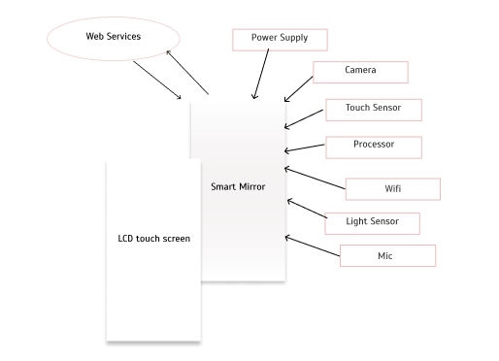

Fig 3.1 Block Diagram

## **HARDWARE**

1. -The Smart Mirror combines a sophisticated 32-inch LCD display with an interactive touch surface. Its dimensions, at 40 inches by 24 inches, provide an optimal balance between usability and aesthetics
2. Input Devices: - The mirror employs an array of touch sensors, and microphone enabling users to interact intuitively with the interface. These sensors facilitate a seamless and inclusive user experience.
3. Camera System: - Equipped with a high-resolution camera system featuring 1080p resolution and a wide-angle lens, the smart mirror enhances virtual try-on experiences and augments the functionality of the integrated chatbot for personalized interactions.
4. Display Technology: - The smart mirror utilizes an LED-backlit LCD display with a resolution of 1920 x 1080 pixels, providing crisp and clear visuals. The display technology ensures accurate representation of clothing items for virtual try-ons.
5. Processing Unit: - Powered by a robust quad-core processor, the mirror's processing unit handles real-time image processing, machine learning tasks, and supports the integration of advanced functionalities of chatbot.
6. Connectivity: - With Wi-Fi connectivity, the smart mirror establishes a seamless connection to e-commerce platforms for real-time price comparison.
7. Power Supply: - The mirror operates on standard electrical power, ensuring continuous functionality.

## **PROCESS FLOW**

User approaches the Smart Mirror.

1. User Engagement:

Motion sensors detect user presence.

1. Interface Interaction:

Users interact with the mirror using touch gestures or voice commands.

1. Virtual Try-On:

Users choose the "Virtual Try-On" option.

Camera captures real-time images for virtual try-ons.

1. Chatbot Interaction:

Chatbot engages in real-time.

Users ask questions, receive style recommendations.

1. Real-Time Price Comparison:

Users select an outfit.

Mirror scans e-commerce platforms for real-time price comparison.

1. E-Shopping Integration:

Users can access to e-shopping directly through the mirror.

Browse, select, and purchase items.

1. Size Recommendations and Post-Purchase Support:

Mirror provides size recommendations based on historical data.

Offers post-purchase support for personalized assistance.

1. Checkout and Payment:

Secure checkout process initiated.

Users review selections, input payment details, and place orders.

1. Delivery Information:

Mirror displays order history.

Users track the status of deliveries.

1. End:

Shopping process concludes.

## **REAL TIME COMPARISION MODULE**

In the user interaction phase, individuals engage with the smart mirror, utilizing functionalities such as virtual clothing try-ons and apparel exploration. This interaction is facilitated by the Chatbot and User Interface Module, serving as intermediaries to the Real-Time Price Comparison Module. At the system's core, the Real-Time Price Comparison Module operates through a series of intricately designed processes.

The E-Commerce Platforms Integration Module establishes crucial API connections with various e-commerce platforms to retrieve the most current data. Following this, the Product Identification and Price Data Retrieval process leverages advanced web scraping techniques and machine learning algorithms to pinpoint specific products and extract real-time pricing information from the connected platforms.

To ensure data consistency and coherence, the Data Normalization step employs statistical methods and data formatting techniques, standardizing pricing data formats across different e-commerce platforms. Subsequently, the Comparison Algorithm & Selection component utilizes advanced statistical models, possibly incorporating machine learning algorithms, to analyze the normalized data. This analysis culminates in the selection of the e-commerce platform offering the most favorable price based on predetermined criteria.

The Display Results to User module utilizes a sophisticated user interface, presenting these price comparison outcomes through the smart mirror interface. The User Confirmation & Integration with E-Shopping ensures a seamless transition for users to initiate the purchasing process, integrating with e-commerce platforms for secure and user-friendly transactions. 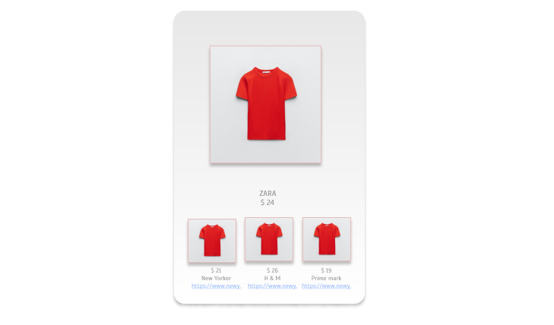

Fig 6.1 Price Comparison Template

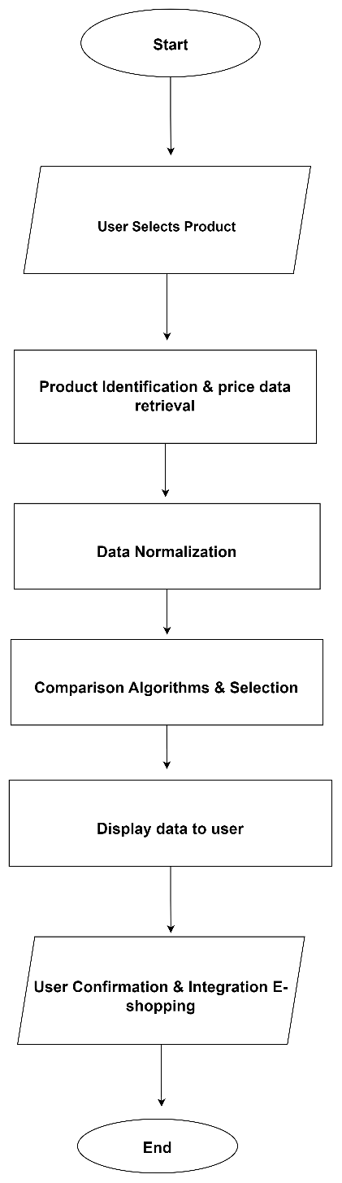

Fig 6.2 Data Flow Diagram

## **CONCLUSION**

The integration of a chatbot with augmented reality smart mirrors revolutionizes the online shopping landscape. The system, characterized by dynamic user engagement, real-time price comparison, and seamless e-shopping integration, addresses challenges like choice overload and customer apprehension. Technically, advanced algorithms, web scraping, and statistical models power modules such as E-Commerce Platforms Integration, Product Identification, Data Normalization, and Comparison Algorithm & Selection. The system's refined user interface enhances visual representation, ensuring a user-friendly and secure purchasing experience. This innovative smart mirror system not only overcomes challenges in online shopping but also empowers users with real-time information and personalized recommendations, creating a dynamic and enjoyable online retail experience.

# REFERENCES

1. Guangyu Gao, Chenchen Bai, Wei Zheng and Chi Harold Liu,” The Future of Smart Dressing Mirror - an open innovation concept video”, 2015 IEEE.
2. Yashvi Desai, Vrushali Shah, Dr. Prasenjit Bhavathankar, Prof. Kaisar Katchi. Department Of Information Technology “Markerless Augmented Reality based application for E-Commerce to Visualise 3D Content”, 2021 IEEE
3. Jianhua Hu, Weimei Wu, Mengjun Ding, Xi Huang, Xuankai Li, zhi jian Deng. Department Of Information Technology “A virtual try-on system based on deep learning”, 2023 IEEE
4. Surasachai Doungtap, Jirayu Petchhan, Varinya Phanichraksaphong, Jenq-Haur Wang. International Graduate Program of Electrical Engineering and Computer Science “Into 3D-Reconstructed Apparel over Virtual Try-On with Virtual Reality”, 2023 IEEE