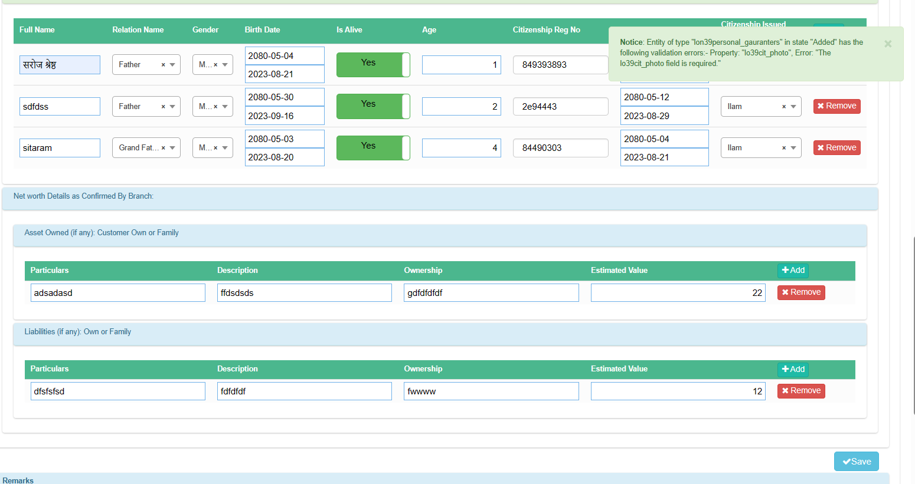

photo milena vanera validation dinu parney esto ako cha client ley nabujne khalko , here validate message should be something like unsupported file extension

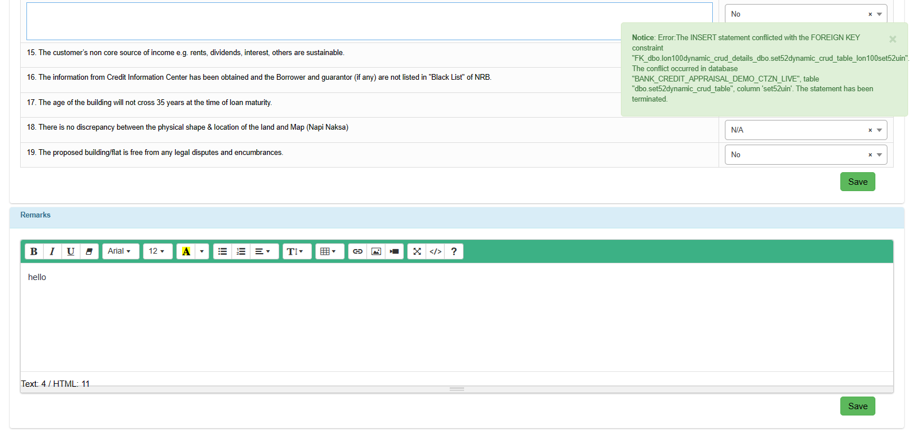

while saving the remarks it throws this error in Eligibility Checklist of subsidized Appraisal