Persistence
Persistence in LangGraph refer to the ability to save and restore the state of a workflow over time.
In LangGraph, persistence means saving the state of a graph during execution so that it can be resumed, inspected, or reused later. This is done using checkpointers, which store snapshots of the graph’s state at each step. These snapshots are organized into threads, enabling features like memory, fault tolerance, time travel, and human-in-the-loop interactions.

What Persistence Means in LangGraph
- Persistence Layer: LangGraph has a built-in persistence system that records the state of your workflow as it runs.
- Checkpointers: These are mechanisms that save a checkpoint of the graph’s state at every super-step (a major execution step).
- Threads: Each checkpoint is tied to a thread (a unique identifier). A thread contains the accumulated state of multiple runs, so you can revisit or continue from where you left off.
- Automatic Handling: If you use the LangGraph Agent Server, persistence is handled automatically—you don’t need to configure checkpointers manually.

Why Persistence Is Useful
Persistence unlocks several powerful capabilities:
- Memory: The graph can remember past interactions across sessions.
- Human-in-the-loop: You can pause execution, inspect the state, and intervene before continuing.
- Time Travel: You can roll back to a previous checkpoint and re-run from there.
- Fault Tolerance: If something fails, you don’t lose progress—you can resume from the last checkpoint.

Example for Students
Imagine you’re building a chatbot workflow with LangGraph:

- Without Persistence:
  - Every time the chatbot runs, it starts fresh.
  - If the system crashes or you close it, all context is lost.
- With Persistence (Checkpointer + Threads):
- At each step, the chatbot’s state (conversation history, variables, decisions) is saved.
- If the system crashes, you can restart from the last checkpoint.
- You can even rewind to an earlier checkpoint to see how the chatbot responded differently.
Example Code (Python-like pseudocode)

from langgraph.checkpoint import MemorySaver
from langgraph.graph import StateGraph

# Define a simple graph
graph = StateGraph()

# Add persistence with a checkpointer
checkpointer = MemorySaver()
compiled_graph = graph.compile(checkpointer=checkpointer)

# Run the graph with persistence
thread_id = "student_chat_1"
result = compiled_graph.invoke({"input": "Hello!"}, thread_id=thread_id)

# Later, resume the same thread
result2 = compiled_graph.invoke({"input": "How are you?"}, thread_id=thread_id)

Here:
- MemorySaver acts as the checkpointer.
- thread_id ensures all checkpoints are tied to the same conversation.
- You can stop and restart, and the chatbot will still remember the earlier context.

Key Takeaways
- Persistence = Saving graph state with checkpoints.
- Threads = Organize checkpoints for continuity.
- Benefits = Memory, fault tolerance, time travel, human-in-the-loop.
- Practical Example = Chatbots, workflows, or AI agents that need to remember past runs.

- Checkpointers:

In LangGraph, checkpointers are the core of its persistence system. They save a checkpoint (snapshot) of the graph’s state at every major step, allowing you to pause, resume, rewind, or inspect execution later.

What Are Checkpointers?

- Definition: A checkpointer is a persistence mechanism that records the state of a LangGraph workflow at each super-step (a major execution step).
- Checkpoint: A snapshot of the graph’s state at a given time. It includes the current data, configuration, metadata, and any pending writes.
- Thread Association: Each checkpoint is tied to a thread (a unique identifier). A thread contains the accumulated state of multiple runs, so you can revisit or continue from where you left off.
- Automatic Handling: If you use the LangGraph Agent Server, checkpointing is handled automatically—you don’t need to configure it manually.

Why Checkpointers Matter
Checkpointers enable several advanced features:
- Memory: The graph can remember past interactions across sessions.
- Human-in-the-loop: You can pause execution, inspect the state, and intervene before continuing.
- Time Travel: You can roll back to a previous checkpoint and re-run from there.
- Fault Tolerance: If something fails, you don’t lose progress—you can resume from the last checkpoint.

Example for Students

Imagine you’re building a chatbot workflow with LangGraph:
- Without Checkpointers:
  - Every run starts fresh.
  - If the system crashes, all context is lost.
- With Checkpointers:
- At each step, the chatbot’s state (conversation history, variables, decisions) is saved.
- If the system crashes, you can restart from the last checkpoint.
- You can rewind to an earlier checkpoint to see how the chatbot responded differently.

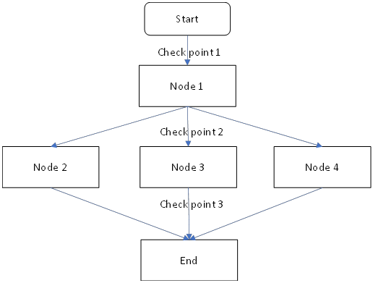

Example Code (Python-like pseudocode)
from langgraph.checkpoint import MemorySaver
from langgraph.graph import StateGraph
# Define a simple graph
graph = StateGraph()
# Add persistence with a checkpointer
checkpointer = MemorySaver()
compiled_graph = graph.compile(checkpointer=checkpointer)
# Run the graph with persistence
thread_id = "student_chat_1"
result = compiled_graph.invoke({"input": "Hello!"}, thread_id=thread_id)
# Later, resume the same thread
result2 = compiled_graph.invoke({"input": "How are you?"}, thread_id=thread_id)

Here:
- MemorySaver acts as the checkpointer.
- thread_id ensures all checkpoints are tied to the same conversation.
- You can stop and restart, and the chatbot will still remember the earlier context.

Key Takeaways
- Checkpointers = Persistence layer in LangGraph.
- Checkpoint = Snapshot of graph state.
- Threads = Organize checkpoints for continuity.
- Benefits = Memory, fault tolerance, time travel, human-in-the-loop.

Types of Checkpointers in LangGrap

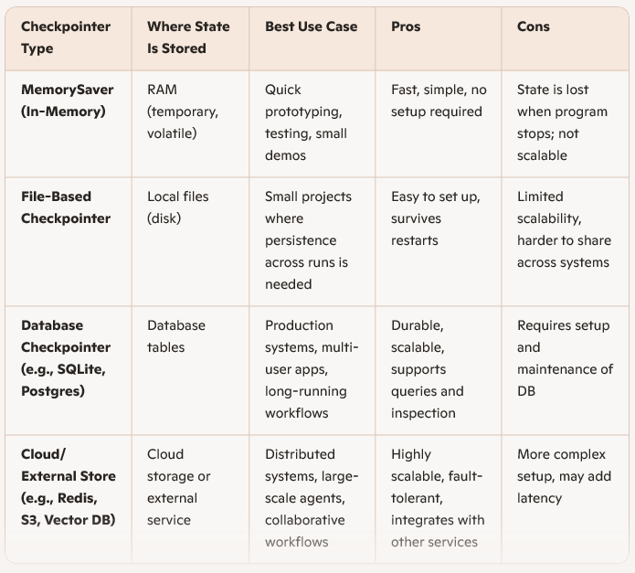

1. MemorySaver Example

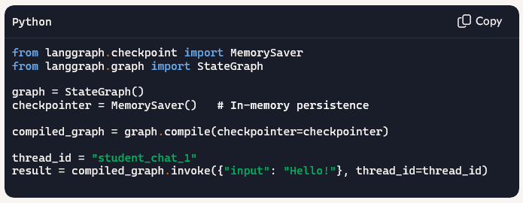

2. Database Checkpointer Example

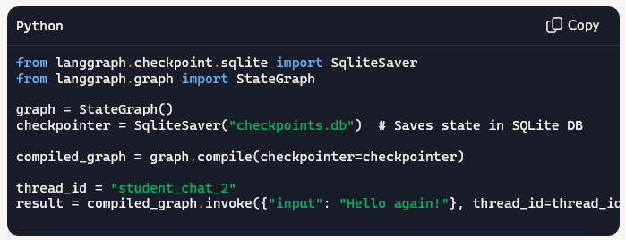

Key Takeaways
- Checkpointers = Persistence mechanism in LangGraph.
- Choose based on scale:
  - MemorySaver → quick tests.
  - File-based → small projects.
  - Database/Cloud → production systems.
- Threads tie checkpoints together so you can resume or rewind execution

What Is a Thread in LangGraph

In LangGraph, a thread is a unique identifier that ties together a sequence of checkpoints—essentially forming a timeline of a graph’s execution. Think of it as a conversation history or a workflow journal

What Is a Thread in LangGraph?
- Thread = Execution Timeline
A thread represents one run (or session) of a LangGraph workflow. It contains all the checkpoints created during that run.
- Checkpoints = Snapshots
Each checkpoint saves the state of the graph at a specific step. The thread collects these in order.
- Thread ID = Unique Key
You assign a thread_id when invoking the graph. This ID is used to store and retrieve all related checkpoints.

Student-Friendly Analogy
Imagine you're chatting with a smart assistant:
- Every message you send is saved as a checkpoint.
- The entire conversation is stored in a thread.
- You can pause the chat, come back later, and resume from where you left off—because the thread remembers everything.

- Example Code

from langgraph.checkpoint import MemorySaver
from langgraph.graph import StateGraph

graph = StateGraph()
checkpointer = MemorySaver()
compiled_graph = graph.compile(checkpointer=checkpointer)

# Start a new thread
thread_id = "student_session_001"
compiled_graph.invoke({"input": "Hello!"}, thread_id=thread_id)

# Continue the same thread
compiled_graph.invoke({"input": "Tell me about LangGraph."}, thread_id=thread_id)

Here:
- thread_id = "student_session_001" keeps all checkpoints tied together.
- You can inspect or resume this thread anytime.

🧠 Why Threads Matter
- Memory: Threads allow the graph to remember past steps.
- Resumability: You can pause and resume workflows.
- Debugging: You can inspect past checkpoints.
- Human-in-the-loop: You can intervene mid-thread and change direction.

