What is Parallel Workflow?
Parallel Workflow is a design pattern where multiple AI agents run simultaneously on different subtasks, and their outputs are later combined or aggregated. Unlike sequential workflows (step-by-step), parallel workflows allow tasks to be executed independently, which speeds up processing and makes the system more scalable.

🧩 Key Characteristics
- Concurrent Execution: Agents work at the same time, not waiting for each other.
- Task Independence: Each agent handles a distinct subtask (e.g., summarizing different documents).
- Aggregation Step: A final agent or process merges results into a unified output.
- Efficiency: Reduces latency compared to sequential workflows.

⚙️ Example of Parallel Workflow
Imagine building an AI-powered market research assistant:
- Agent A: Scrapes financial news.
- Agent B: Analyzes social media sentiment.
- Agent C: Processes stock price data.
- Aggregator Agent: Combines all insights into a single report.
All three agents (A, B, C) run at the same time, and the aggregator merges their outputs.

🚨 Challenges
- Synchronization: Results must be merged correctly.
- Resource Usage: Running agents in parallel consumes more compute.
- Complexity: Requires orchestration logic to handle multiple outputs.

💡 Why It Matters
Parallel workflows are ideal when:
- You need fast responses from multiple data sources.
- Tasks are independent and don’t rely on each other’s outputs.
- You’re scaling AI systems for enterprise automation, analytics, or monitoring.
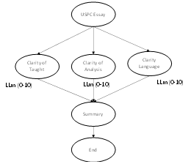

Example 1: Create simple parallel workflow non LLM based
Create Application which have input like runs, balls, 4s & 6s
Output - Stikerate, runs in boundary percentage, balls per boundary (All three can be calculated parellely)
Example 2: LLM based simple parallel workflow
Create application which will accept the essay from the trainee and evaluate based on taught, analysis and language and summaries with scores from 0 to 10 and return to user.

