What is a Conditional Workflow?

- A conditional workflow means the execution path is not fixed.
- Instead of always going from Node A → Node B → Node C, the graph can branch depending on conditions.
- This makes workflows adaptive and context-aware

Example:
- If the user asks for factual info, route to a search agent.
- If the user asks for creative writing, route to a text generation agent.
- If the user uploads a file, route to a file analysis agent

Key Concept: Conditional Edges

- LangGraph provides add_conditional_edges to define branching logic.
- A router node decides which edge to follow based on the state or intent.

graph.add_conditional_edges(
"router",
{
"search": "search_agent",
"generate_text": "text_agent",
"file_upload": "file_agent",
}
)

Here:
- "router" = decision-making node.
- Keys (search, generate_text, file_upload) = conditions.
- Values (search_agent, text_agent, file_agent) = next nodes.

State Management

- LangGraph maintains a state object throughout execution.
- Conditions can check values in this state:
- intent (user’s request type)
- has_file (whether a file is uploaded)
- confidence_score (model’s certainty)

Example Workflow Diagram (Textual)

[User Input]
↓
[Router Node]
├── if intent == "search" → [Search Agent]
├── if intent == "generate_text" → [Text Agent]
├── if has_file == True → [File Agent]
└── else → [Fallback Agent]

Benefits of Conditional Workflows

- Flexibility: Adapt to different user needs.
- Scalability: Add new branches without rewriting the whole workflow.
- Efficiency: Route tasks to specialized agents.
- Human-in-the-loop: Can pause for human approval before branching.

Example:

- Calculate quadratic equation of discriminant

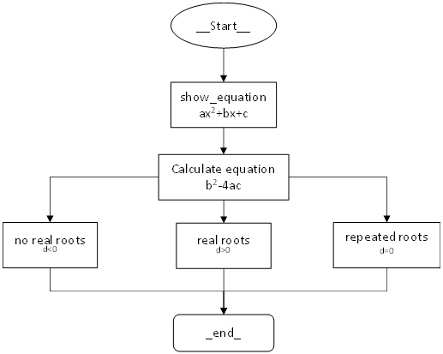
Example 2 LLM Based Review Handling Workflow

