An Iterative Workflow in LangGraph is a looping system where the agent repeatedly cycles through steps (like analysis, research, response generation, and validation) until the output meets certain criteria or a maximum iteration limit is reached.

1. Introduction
- LangGraph is a framework for building agentic workflows.
- Unlike simple linear workflows, an iterative workflow allows the agent to revisit steps multiple times.
- This is useful when tasks require refinement, validation, or improvement before completion.

2. Definition
- An Iterative Workflow is a stateful loop in LangGraph where nodes are executed repeatedly until:
- The response is validated as complete, OR
- A maximum iteration threshold is reached.

3. Core Components
- StateGraph: Maintains the workflow state across iterations.
- Nodes: Each node performs a specific role (e.g., routing, analysis, research, response generation, validation).
- Looping Mechanism: After validation, the workflow decides whether to stop or go back to earlier nodes for refinement.

4. Example Workflow (Textual Diagram)
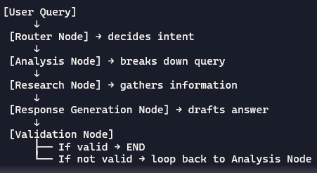

5. Benefits of Iterative Workflows
- Improved Accuracy: The agent can refine answers until they meet quality standards.
- Error Handling: If validation fails, the workflow retries with adjustments.
- Complex Reasoning: Supports multi-step reasoning and self-correction.
- Human-in-the-loop: Can pause for human validation before continuing.

6. Practical Use Cases
- Research Agents: Iteratively refine search results until relevant.
- Content Generation: Improve drafts until they meet style/quality checks.
- Data Analysis: Re-run calculations until thresholds are satisfied.
- Customer Support Bots: Validate responses against policies before sending.

7. Risks & Considerations
- Infinite Loops: Must set a maximum iteration limit to avoid endless cycles.
- Performance Costs: More iterations mean higher compute and time usage.
- Validation Quality: The effectiveness depends on how well the validation node is designed.

8. Key Takeaway
- Iterative Workflow = Looping refinement system in LangGraph.
- It ensures that agents don’t just react once but re-analyze, improve, and validate their outputs until they’re correct or complete.

