**INTRODUCTION:**

**PRO- ENGINEER** is a multi-platform [CAD](http://en.wikipedia.org/wiki/Computer-aided_design)/[CAM](http://en.wikipedia.org/wiki/Computer-aided_manufacturing)/[CAE](http://en.wikipedia.org/wiki/Computer-aided_engineering) [software suite](http://en.wikipedia.org/wiki/Software) developed by the PTC Corporation US based company in 1987. Written in the [C++](http://en.wikipedia.org/wiki/C%2B%2B) [programming language](http://en.wikipedia.org/wiki/Programming_language), Present version of PRO-E is “CREO 3.0”.

CREO is a powerful program used to create complex designs with a great precision. The design intent of any 3D model or an assembly is defined by its specification and its use. We can use the powerful tolls of CREO to capture the design intent of any complex model by interpolating intelligence in to design.

It is a solid modeling package developed by US based company PTC Corporation. Some other modeling packages used in market for several purpose the packages are CATIA, Unigraphics, Auto Desk Inventor, Mechanical Desktop and Solid works etc.

These solid modeling packages are used to view both the internal and external features of a solid object. Most of the packages are wire frame followed. CREO is mostly similar to Auto CAD extending modules and features in 3Dmodeling.

The packages have application in various parts such as industries, education, design to view the parts of construction etc. Now simply CREO is an application of conventional computer techniques with the aid of a data processing system to present a graphic solution. It deals with the creation storage manipulation of modules of objects of their pictures in a computer.

**MODULES IN CREO:**

Some of the modules could be understood simply by their names.

1. CREO SKETCHER
2. CREO PART DESIGN
3. CREO ASSEMBLY DESIGN
4. CREO DRAFTING
5. CREOMANUFACTURING
6. CREO REPORT
7. CREO PARAMETRIC
8. **SKETCHER**

**Creating sketches in sketcher module:**

To create any cross-section in the sketch module of CREO certain basic steps have to be followed. The following steps outline the procedure to use the sketch module.

1. Sketch the required section geometry.

The different sketcher tools available in this module can be used to sketch the required section geometry.

1. Add the constraints and dimensions to the sketch.
2. Add relations to the sketch.
3. Regenerate the section.

Entering the Sketch module:

1. Select Part ->Uncheck default template -> Select units from the menu bar.
2. Select the reference plane XY/YZ/ZX in the geometry area. (OR)

Select the reference plane from the specification tree.

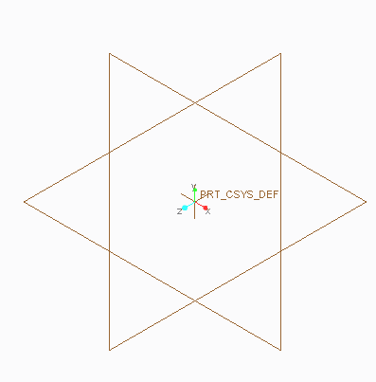The Sketcher workbench appears as shown in figure, with the main Sketcher toolbars displayed on the right hand side and at the bottom.

Now, let's see more precisely the different

**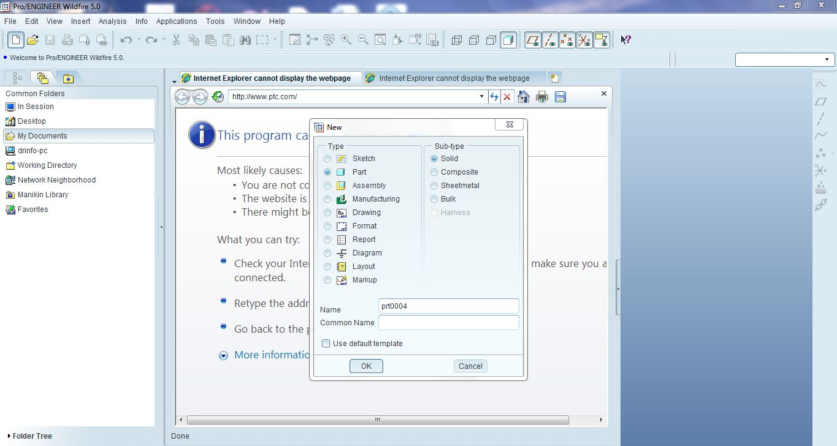**

**SKETCHING TOOL BAR**

|  |  |
| --- | --- |
|  | [Profiles](file:///C:\Program%20Files\Dassault%20Systemes\B14doc\English\online\dysug_C2\dysugbt0315.htm)creation |
| I_RectangleP2 | [Rectangles](file:///C:\Program%20Files\Dassault%20Systemes\B14doc\English\online\dysug_C2\dysugbt0325.htm) |
| I_Rectangle3PtP2 | Slanted Rectangle |
| I_ParalleloP2 | [Parallelograms](file:///C:\Program%20Files\Dassault%20Systemes\B14doc\English\online\dysug_C2\dysugbt0308.htm) |
| I_HexagonP2 | [Hexagons](file:///C:\Program%20Files\Dassault%20Systemes\B14doc\English\online\dysug_C2\dysugbt0204.htm) |
| I_AxisLineP2 | [Axes](file:///C:\Program%20Files\Dassault%20Systemes\B14doc\English\online\dysug_C2\dysugbt0311.htm) |
| I_CircleCtrRadP2 | [Basic Circles](file:///C:\Program%20Files\Dassault%20Systemes\B14doc\English\online\dysug_C2\dysugbt0305.htm) |
|  | [Three Point Circles](file:///C:\Program%20Files\Dassault%20Systemes\B14doc\English\online\dysug_C2\dysugbt0350.htm) |
|  | Concentric [Circles](file:///C:\Program%20Files\Dassault%20Systemes\B14doc\English\online\dysug_C2\dysugbt0323.htm) |
|  | [Tri-Tangent Circle](file:///C:\Program%20Files\Dassault%20Systemes\B14doc\English\online\dysug_C2\dysugbt0320.htm) |
|  | [Ellipses](file:///C:\Program%20Files\Dassault%20Systemes\B14doc\English\online\dysug_C2\dysugbt0306.htm) |
|  | [Basic Arcs](file:///C:\Program%20Files\Dassault%20Systemes\B14doc\English\online\dysug_C2\dysugbt0307.htm) |
|  | [Arcs Three Point](file:///C:\Program%20Files\Dassault%20Systemes\B14doc\English\online\dysug_C2\dysugbt0324.htm) |
|  | [Splines](file:///C:\Program%20Files\Dassault%20Systemes\B14doc\English\online\dysug_C2\dysugbt0309.htm) |
| I_Line2TangentP2 | [Bi-Tangent Line](file:///C:\Program%20Files\Dassault%20Systemes\B14doc\English\online\dysug_C2\dysugbt0319.htm) |
| iconbisline | [Bisecting Line](file:///C:\Program%20Files\Dassault%20Systemes\B14doc\English\online\dysug_C2\dysugbt0330.htm) |
| I_SktCenteredRectP2 | [Centered Rectangle](file:///C:\Program%20Files\Dassault%20Systemes\B14doc\English\online\dysug_C2\dysugbt0906.htm) |
| I_SktCenteredParalleloP2 | [Centered Parallelogram](file:///C:\Program%20Files\Dassault%20Systemes\B14doc\English\online\dysug_C2\dysugbt0907.htm) |
| I_PointP2 | [Points](file:///C:\Program%20Files\Dassault%20Systemes\B14doc\English\online\dysug_C2\dysugbt0312.htm) |
| I_PointPanelP2 | [Points Using Coordinates](file:///C:\Program%20Files\Dassault%20Systemes\B14doc\English\online\dysug_C2\dysugbt0322.htm) |
| I_PointsSpacesP2 | [Equidistant Points](file:///C:\Program%20Files\Dassault%20Systemes\B14doc\English\online\dysug_C2\dysugbt0351.htm) |
| iconpointinters | [Intersection](file:///C:\Program%20Files\Dassault%20Systemes\B14doc\English\online\dysug_C2\dysugbt0331.htm) |
| iconpointproject | [Projection Point](file:///C:\Program%20Files\Dassault%20Systemes\B14doc\English\online\dysug_C2\dysugbt0333.htm) |

**OPERATION TOOL BAR**

|  |  |
| --- | --- |
|  | [Creating Corners (Both Elements Untrimmed](file:///C:\Program%20Files\Dassault%20Systemes\B14doc\English\online\dysug_C2\dysugbt0313.htm)) |
|  | [Creating Corners (Both Elements Trimmed](file:///C:\Program%20Files\Dassault%20Systemes\B14doc\English\online\dysug_C2\dysugbt0313.htm)) |
|  | [Creating Elliptical Corners (No Elements Trimmed](file:///C:\Program%20Files\Dassault%20Systemes\B14doc\English\online\dysug_C2\dysugbt0313.htm)) |
|  | [Creating Elliptical Corners (Both Elements Trimmed)](file:///C:\Program%20Files\Dassault%20Systemes\B14doc\English\online\dysug_C2\dysugbt0314.htm) |
|  | [Creating Chamfers (Both Elements Untrimmed](file:///C:\Program%20Files\Dassault%20Systemes\B14doc\English\online\dysug_C2\dysugbt0314.htm)) |
|  | [Creating Chamfers (Both Elements Trimmed)](file:///C:\Program%20Files\Dassault%20Systemes\B14doc\English\online\dysug_C2\dysugbt0314.htm) |
|  | [Trimming Elements](file:///C:\Program%20Files\Dassault%20Systemes\B14doc\English\online\dysug_C2\dysugbt0501.htm) |
|  | [Breaking Elements](file:///C:\Program%20Files\Dassault%20Systemes\B14doc\English\online\dysug_C2\dysugbt0503.htm) |
|  | [Breaking and Trimming](file:///C:\Program%20Files\Dassault%20Systemes\B14doc\English\online\dysug_C2\dysugbt0502.htm) |
|  | [M](file:///C:\Program%20Files\Dassault%20Systemes\B14doc\English\online\dysug_C2\dysugbt0904.htm)odify dimensions |
|  | [Creating Mirrored Elements](file:///C:\Program%20Files\Dassault%20Systemes\B14doc\English\online\dysug_C2\dysugbt0509.htm) |

|  |  |
| --- | --- |
|  | Creating Dimension |
|  | [Creating](file:///C:\Program%20Files\Dassault%20Systemes\B14doc\English\online\dysug_C2\dysugbt0313.htm) Perimeter Dimension |
|  | Creating Reference Dimension |
|  | Creating Ordinate Dimension Base line |

**DIMENSION TOOL BAR**

**PART MODELING**

Part module enables us to create components. In Part Mode, we create part files (.prt), the separate components that are joined together in an assembly file (.asm). Part mode we can create and edit the features–the extrusions, cuts, blends, and rounds–that comprise each part being modelled. Most features start with a two dimensional outline, or section. When the section is defined, we assign a third dimension value to it in order to make it a 3D shape. We create the 2D section in a tool called Sketcher. As the name implies, in sketcher we roughly draw the section with lines, angles, or arcs, and then input the precise dimensional values later. We use an interface called the dashboard to create and edit 3D feature geometry. The dashboard presents feature-specific fields for input as we can switch from feature to feature. Once a 3D feature is created, it can be edited directly in the graphics window.

**EXTRUDE**: Adds the material normal to the 2D sketch.

**REVOLVE**: Revolves the 2D sketch.

**SLOT**: This task shows you how to create a slot thatis how to sweep a profile along a center curve to remove material.

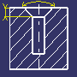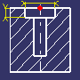**HOLE:**Creating a hole consists in removing material from a body. Various shapes of standard holes can be created. These holes are:

SIMPLE TAPERED COUNTER BORED COUNTER SUNK

**SHAFT**: Material will be added by revolving around the axis.

**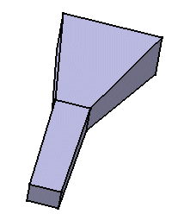LOFT**: We can generate it by sweeping one or more planar section curves along a computed or user-defined spine. The feature can be made to respect one or more guide curves. The resulting feature is a closed volume.

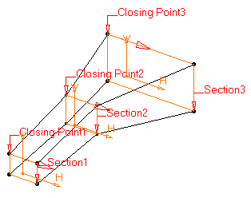

1. **ASSEMBLY DESIGN**

ENTERING ASSEMBLY DESIGN WORKBENCH

Select the File ->New -> Assembly command to launch the assembly design workbench.

Uncheck the Use default template icon at the bottom of dialogue box.

Select the units as per the given model and press Ok.

**Inserting an Existing Component.**

1. Select Assemble icon  in the component tool bar.
2. Select the Existing Component to be assembledand press Ok. Hence forth the components will be displayed isometrically.

**CONSTRAINTS TOOLS BAR:**

1. **AutomaticConstraint:** This constraint is used to place the component by automatically pressing Ok option.
2. **Coincident Constraint:** This constraint is used to align dimension depending upon the selected elements. We may constraint concentricity, coaxiality or co planarity.
3. **Distanceconstraint:** This constraint is between two components need to satisfy how faces are oriented (similar/opposite). The distance value displayed next to the offset constraint.
4. **Angle Offset constraint:**This constraint is between the two components by providing the angle between them. Fixing the component means arresting degrees of freedom in all directions. There are two ways of fixing the component.
5. By fixing the position according to the geometrical origin of the assembly which means setting absolute position.
6. By fixing the position according to other component which means setting a relative position.

1. **Fix constraint:** Fixing the component means arresting degrees of freedom in all directions. There are two ways of fixing the component.
2. By fixing the position according to the geometrical origin of the assembly which means setting absolute position.
3. By fixing the position according to other component which means setting a relative position.
4. **Default constraint:** The Default constrain means that the component will be placed by default in the coordinate system by selecting the option.
5. **DRAFTING**

DRAFTING is the process of deriving the views (Front View, Top View, Left side view, Right side view etc.) from the part body or assembly.

**ENTERING DRAFTING WORKBENCH:**

Select **File**🡪**New**🡪**Drawing** and uncheck the option (Use default template) and press Ok.

**DEFINING THE DRAWING SHEET:**

This task shows you how to define the drawing sheet that will be used for creating the views.

After pressing Ok new window appears which helps to find select the page size and the paper orientation.

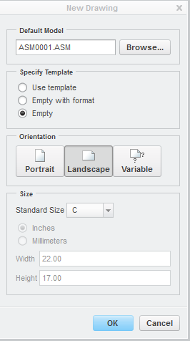

**INSERTING A VIEW:**

This task will show you how to create a view on the sheet you defined, from the 3D part created.

Select **General View **from Menu bar🡪select No combined state and press Ok. From the new window appeared select the desired view and insert them accordingly.

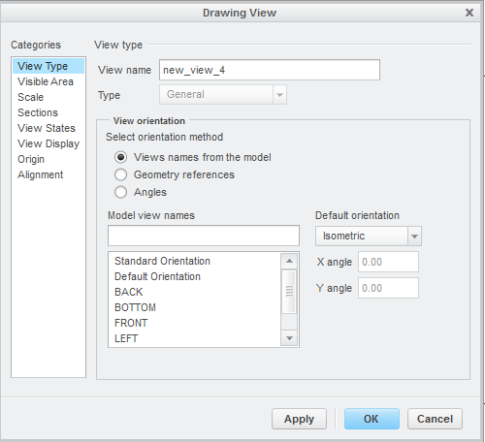

**2D DRAWING**

**EXP:01 DATE:**

**AIM:**

To drawthe given two dimensionalsketch as per the dimensions given by using PRO-E software.

**TOOL USED**:

Pro-E CREO Parametric (Version 3.0)

**Initial steps to draw two dimensional drawings**

1. Double click on the Pro-E Parametric Icon on desktop
2. After opening main page , click on **New**,to open a Popup window
3. In the Popup window Part > solid> (deselect the default template> ok
4. Select mmns\_part\_solid > ok.
5. Select TOP view(F2)plane>sketch>saved orientations > top>ok.

**Procedure:**

Commands to be used:

CENTRE LINE , circle, fillet, line, arc, normal……etc.,

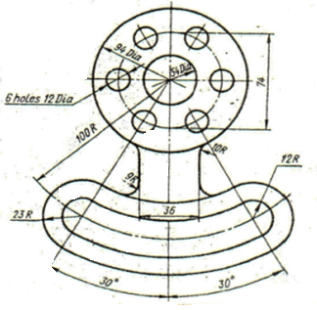

**Result:** The given 2D sketch is drawn using ProEcreo (Parametric) software successfully.

**2D DRAWING**

**EXP:02 DATE:**

**AIM:**

To draw the given two dimensional sketch as per the dimensions given by using PRO-E software.

**TOOL USED**:

Pro-E CREO Parametric (Version 3.0)

**Initial steps to draw two dimensional drawings**

1. Double click on the Pro-E Parametric Icon on desktop
2. After opening main page , click on **New**,to open a Popup window
3. In the Popup window Part > solid> (deselect the default template> ok
4. Select mmns\_part\_solid> ok.
5. Select TOP view(F2)plane> sketch >saved orientations > top>ok.

**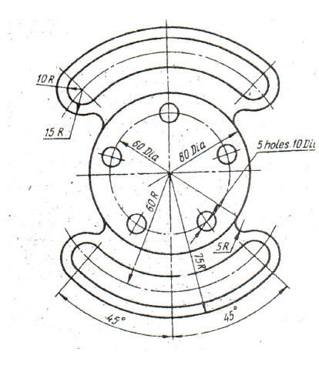Procedure:**

Commands to be used:

CENTRE LINE , circle, fillet, line, arc……etc.,

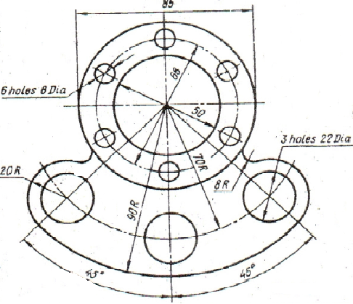

**Result:** The given 2D sketch is drawn using ProE creo (Parametric) software successfully.

**3D MODEL DESIGN**

**EXP NO: 03 DATE:**

**AIM:**

To model the drawing as per the dimensions given and also to convert the 3D model into different views with Bill of materials.

**TOOL USED**:

CREO 3.0

**OPERATIONS**:

Sketcher tool bar, Dimension, Extrude, Union, Subtract, etc:

**Procedure:**

1.Sketch the center curve for the **COMPONENT**.

2. Sketch the given section in a different planes which is perpendicular to

the plane on which the center curve drawn.

3.From the main menu of CREOSelect**File**🡪**New**🡪**Part.**

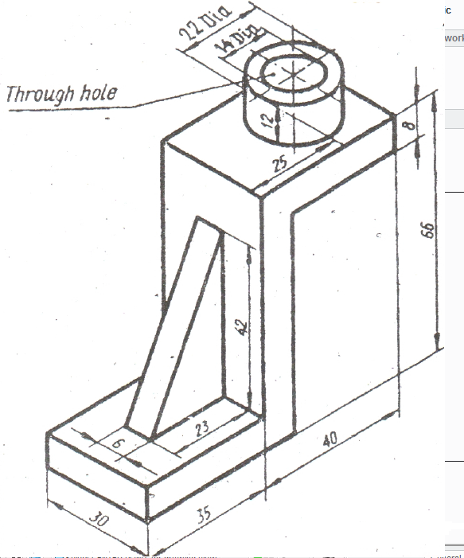

**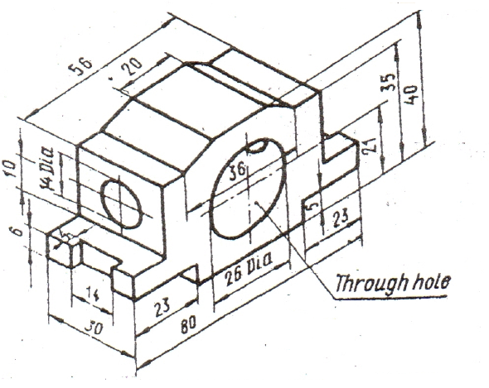**

**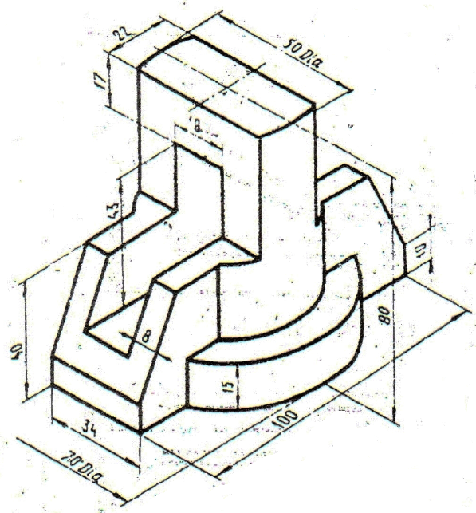**

**Result:** The given 3D sketch is drawn using ProEcreo (Parametric) software successfully.

**3D MODEL DESIGN**

**EXP NO: 04 DATE:**

**AIM:**

To model the drawing as per the dimensions given and also to convert the 3D model into different views with Bill of materials.

**TOOL USED**:

CREO 3.0

**OPERATIONS**:

Sketcher tool bar, Dimension, Extrude, etc:

**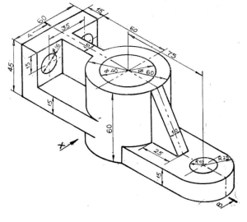**

**Result:** The given 3D sketch is drawn using ProEcreo (Parametric) software successfully.

**Detailing of Assembly Drawing**

**EXP NO:05 DATE:**

**AIM:**

To model and assemble the flange coupling as per the dimensions given and also

Convert the 3D model into different views with Bill of materials.

**TOOL USED**: CREO 3.0

**OPERATIONS**: Sketcher tool bar, Dimension, Extrude, etc:

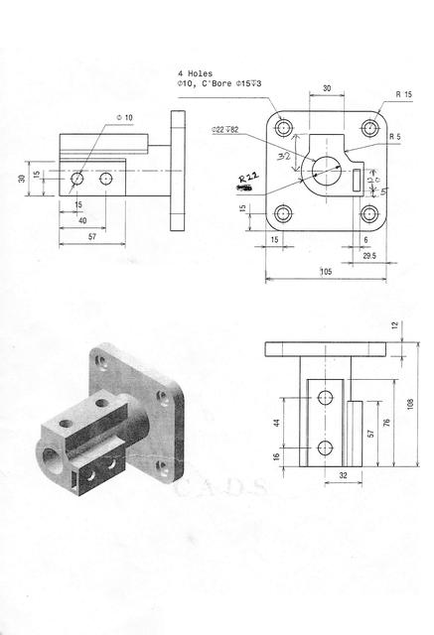

**Result:** The given Assembly detailing is done using ProEcreo (Parametric) software successfully.

**Detailing of Assembly Drawing**

**EXP NO:06 DATE:**

**AIM:**

To model and assemble the flange coupling as per the dimensions given and also

Convert the 3D model into different views with Bill of materials.

**TOOL USED**: CREO 3.0

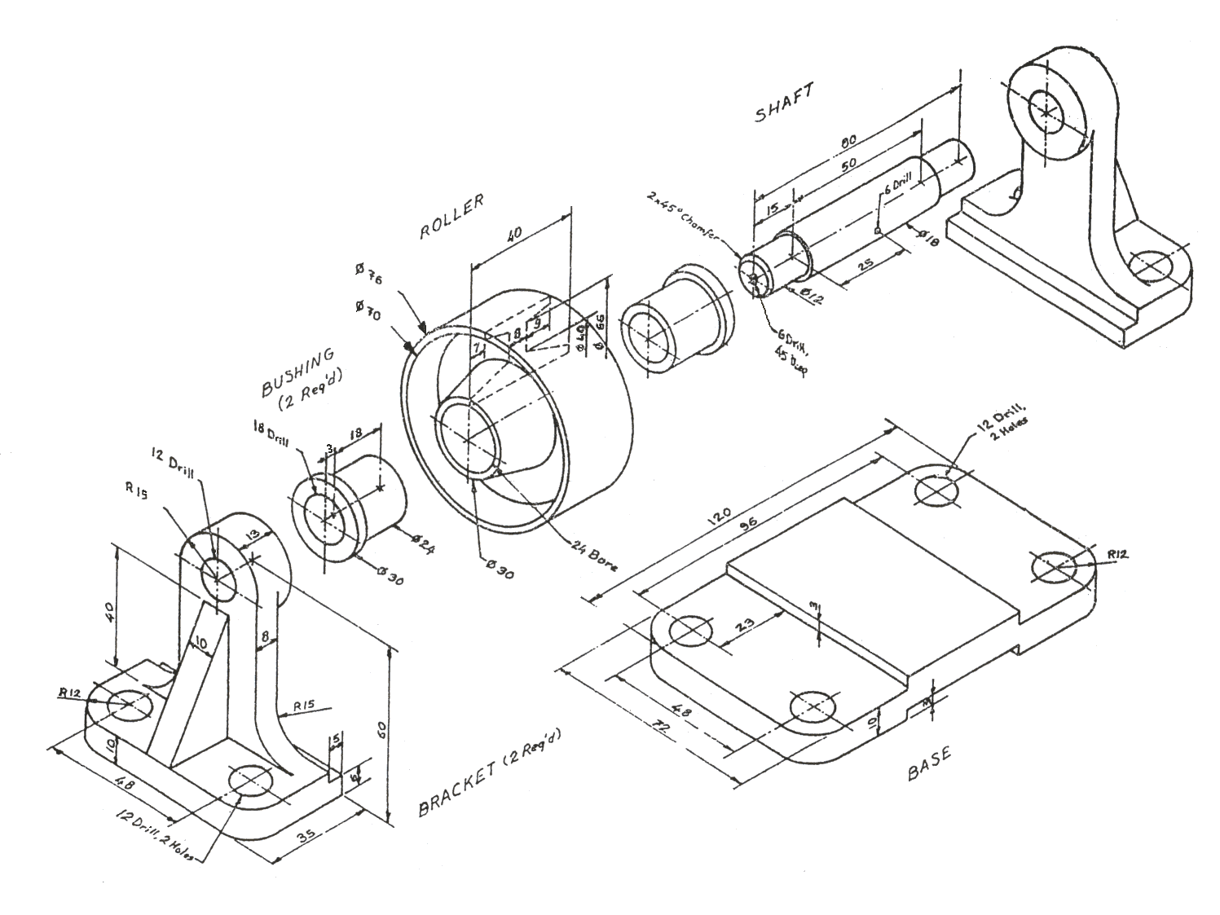

**Result:** The given Assembly model is modeled and assembled successfully by using Creo 3.0

**INTRODUCTION OF FINITE ELEMENT ANALYSIS (FEA)**

Finite element analysis (FEA) is a fairly recent discipline crossing the boundaries of mathematics, physics, engineering and computer science. The method has wide application and enjoys extensive utilization in the structural, thermal and fluid analysis areas. The finite element method is comprised of three major phases: (1) pre-processing, in which the analyst develops a finite element mesh to divide the subject geometry into sub-domains for mathematical analysis, and applies material properties and boundary conditions, (2)solution, during which the program derives the governing matrix equations from the model and solves for the primary quantities, and (3) post-processing, in which the analyst checks the validity of the solution, examines the values of primary quantities (such as displacements and stresses), and derives and examines additional quantities (such as specialized stresses and error indicators).

The advantages of FEA are numerous and important. A new design concept may be modeled to determine its real world behavior under various load environments, and may therefore be refined prior to the creation of drawings, when few dollars have been committed and changes are inexpensive. Once a detailed CAD model has been developed, FEA can analyze the design in detail, saving time and money by reducing the number of prototypes required. An existing product which is experiencing a field problem, or is simply being improved, can be analyzed to speed an engineering change and reduce its cost. In addition, FEA can be performed on increasingly affordable computer workstations and personal computers, and professional assistance is available.

It is also important to recognize the limitations of FEA. Commercial software packages and the required hardware, which have seen substantial price reductions, still require a significant investment. The method can reduce product testing, but cannot totally replace it. Probably most important, an inexperienced user can deliver incorrect answers, upon which expensive decisions will be based. FEA is a demanding tool, in that the analyst must be proficient not only in elasticity or fluids, but also in mathematics, computer science, and especially the finite element method itself.

Which FEA package to use is a subject that cannot possibly be covered in this short discussion, and the choice involves personal preferences as well as package functionality. Where to run the package depends on the type of analyses being performed. A typical finite element solution requires a fast, modern disk subsystem for acceptable performance. Memory requirements are of course dependent on the code, but in the interest of performance, the more the better, with a representative range measured in gigabytes per user. Processing power is the final link in the performance chain, with clock speed, cache, pipelining and multi-processing all contributing to the bottom line. These analyses can run for hours on the fastest systems, so computing power is of the essence.

One aspect often overlooked when entering the finite element area is education. Without adequate training on the finite element method and the specific FEA package, a new user will not be productive in a reasonable amount of time, and may in fact fail miserably. Expect to dedicate one to two weeks up front, and another one to two weeks over the first year, to either classroom or self-help education. It is also important that the user have a basic understanding of the computer's operating system.

**INTRODUCTION TO ANSYS**

Ansys is a general purpose finite element modeling package for numerically solving a wide variety of mechanical, electrical problems.

These problems include

1. Static/Dynamic structural analysis(both linear and non linear)
2. Fluid analysis

* Laminar flow
* Turbulent flow

1. Acoustic analysis
2. Electromagnetic analysis
3. Model analysis
4. Thermal analysis

* Conduction
* Convection
* Radiation

1. Transient thermal analysis
2. Buckling analysis
3. Spectrum analysis
4. Harmonic analysis

**static analysis**

in this type of problem we determine the elastic data deflections and stresses at critical points due to a system to external forces acting on structure nodal.

**Model analysis**

In this type of prolem we determine the vibration characteristics.

**Harmonic analysis**

We will determine the response of structure to harmonically time varying loads.

**Buckling analysis**

We determine the buckling loads and also buckling shape in this analysis.

**Thermal analysis**

Inthis we determine low thermal stresses are there in given structure.

**Fluid analysis**

In this we see how a comprehensive got that fluid flows through given number under given condition.

**STEPS INVOLVED IN ANSYS**

In general, a finite element solution can be broken into the following these categories.

**1. Preprocessing stage**

The preprocessing stage consists of specifying, the element type to be used, material properties and real constants. After specifying these, above said parameters, the user begins to model the component.

**2. Processing (or) solution stage**

This stage usually follows the preprocessing stage. After the model is completed and different boundary conditions are applied. The system is solved.

**3.Post processor stage**

This stage follows the solution. In this stage the results obtained in the solution stage are displayed on the output window and the results are analyzed if the match the required conditions.

**OVERVIEW OF STRUCTURAL ANALYSIS**

Structural analysis is probably the most common application of the finite element method. The term structural (or structure) implies not only civil engineering structures such as bridges and buildings, but also naval, aeronautical, and mechanical structures such as ship hulls, aircraft bodies, and machine housings, as well as mechanical components such as pistons, machine parts, and tools**.**

**TYPES OF STRUCTURAL ANALYSIS**

**1 Static analysis**

It is used to determine displacements, stresses under static loading conditions for both linear and nonlinear static analysis. Nonlinearities can include plasticity, stress stiffening, large deflection, large strain, hyper elasticity, contact surfaces, and creep**.**

**2 Modal analysis**

It is used to calculate the natural frequencies and mode shapes of a structure. Different mode extraction methods are available.

**3 Harmonic analysis**

It is used to determine the response of a structure to harmonically time-varying loads.

**4 Transient Dynamic Analysis**

It is used to determine the response of a structure to arbitrarily time-varying loads. All nonlinearities mentioned under static Analysis above are allowed.

**5 spectrum analysis**

An extension of the modal analysis, used to calculate stresses and strains due to a response spectrum or a PSD input (random vibrations).

**6 Buckling analysis**

Used to calculate the buckling loads and determine the buckling mode shape. Both linear (Eigen valve) buckling and nonlinear buckling analysis are possible.

**7 Explicit Dynamic Analysis**

This type of structural analysis is only available in the ANSYS LS-DYNA program. ANSYS LS-DYNA provides an interface to the LS-DYNA explicit finite element program. Explicit dynamic analysis is used to calculate fast solutions for large deformation dynamics and complex contact problems.

DETERMINATION OF DEFLECTION AND STRESSES IN 2D TRUSS

**Ex.No:1 Date:**

**Aim:** To determine the deflection and stresses in a 2-Dimensional truss



**Hardware required:**

1. Pentium 4 processor.

2. 500MB RAM.

3. VGA colour monitor.

4. 2 GB hard disk free space.

5. Colour printer.

**Software required:**

1. Windows XP O.S.

2. ANSYS 19.2

**Procedure:**

1. **Open a new file with ANSYS and name it as 2D truss**
2. **Define the type of element:**

<Preprocessor> <Element Type> <Add/Edit/Delete> <Add> <OK>

<Structural Link..3D infinit stn 180> <OK>

1. **Define element material properties:**

<**Preprocessor**> **<Material Props>< material models>structural>linear >elastic>Isotropic**

(i) Youngs Modulus EX = 200000

(ii) Poison's ratio PRXY = 0.3

1. **Define the Area**

<**Preprocessor**> **<Sections> Link<Add>**

**Add Link Section With Id: 1 <OK>**

**Section name<Link\_1>**

**Link Area<3250>**

# Create a model:

<**Preprocessor**> **<Modeling—Create><Nodes><In Active CS>**

Input the coordinates (0, 0), (1800, 3118), (3600, 0), (5400, 3118), (7200, 0),(9000, 3118), (10800, 0) of node 1, 2,… 7 respectively. >**OK.**

1. **<Elements>** **<Auto Numbered>Thru Nodes>**

> click on nodes 1 and 2, hit Apply>click on nodes 2 and 3, hit Apply>click on nodes 3 and 4, hit Apply >**OK**

# Apply Constraints

Preprocessor **<Loads> Apply> <Structural—Displacement> <On Nodes>**

Pick the node 1.Hit Apply.<All DOF> Hit Apply .Pick the node 7. Hit Apply

Choose <FY > Hit Apply.>Pick the node 4. Hit Apply

# Apply loads

Preprocessor **<Loads>**<**Apply><Structural—Forces/Moments> <On Nodes>**

>Pick the node 1, hit **APPLY>**Set Fy to –280000 , hit **OK**

>Pick the node 3, hit **APPLY>**Set Fy to –210000 , hit **OK**

>Pick the node 5, hit **APPLY>**Set Fy to –280000 , hit **OK**

>Pick the node 7, hit **APPLY>**Set Fy to –360000 , hit **OK**

1. **<Solution><-Solve- Current LS> OK**
2. **<General Postproc>** **<Plot Results>**

**<Deformed Shape>def+ undef shape>**

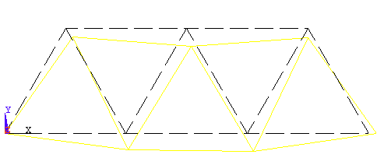

1. **<General Postprocessor> <List Results> <Nodal solution>**

NODE UX UY

1 .00000 .00000

2 3.0836 -3.5033

3 .74604 -6.5759

4 1.5916 -7.2363

5 2.3127 -6.9923

6 -.49736E-01 -3.7330

7 3.1334 .00000

MAXIMUM ABSOLUTE VALUES

NODE 7 4

VALUE 3.1334 -7.2363

1. **<General Postprocessor> <List Results><Reaction Solu> all items>** Gives Reaction Forces

NODE FX FY

1. **<General Postprocessor> <Element table > define table >Add**

Enter the following parameters

User label for item :**SAXL**

Item, component, results data item : select **By sequence num>LS>LS,1**

Click on **OK** and close theelement table datawindow.

1. **Element table>Plot Element table >Click OK**
2. **<General Postprocessor> <Element table>List Element table**

RESULT:

# DETERMINATION OF DEFLECTION AND STRESSES IN 2D BEAM

**Ex.No:2 Date:**

**AIM:** To determine the deflections, support reactions and stresses in the 2D beam shown.



**Hardware required:**

1. Pentium 4 processor.

2. 500MB ram.

3. VGA colour monitor.

4. 2 GB hard disk free space.

5. Colour printer.

**Software required:**

1. Windows xp O.S.

2. ANSYS 19.2

**Procedure:**

### 1. <Preprocessor> <Element Type><Add/Edit/Delete><Add><OK>

### <beam > structural Beam..3 node 189><OK>

### 2,<Preprocessor><Material Props>< material models>structural> linear>elastic>Isotropic

1. Young’s modulus EX = 206850e6
2. Poisson’s ratio PRXY = 0.3

**<OK>**

**3 Sections** <Beam>Common sections< dialogue box

Select the C/S B:0.1, H:0.1 >O.K.

### 4. <Preprocessor><Modeling—Create><key points>

|  |  |  |
| --- | --- | --- |
| Key point | Coordinates |  |
| 1 | (0, 0) | Apply |
| 2 | (1.5, 0) | Apply |
| 3 | (3,0) | Apply |
| 4 | (5.4,0) | Apply |
| 5 | (7.2,0) | **OK** |

5.<**Preprocessor**>**<Modeling—Create>** **<lines>straight line**

Select key point 1 and 2, 2 and 3, 3 and 4, and 4 and 5> O.K.

6. <**Preprocessor**>**<Meshing>Mesh tool> dialogue box ----Set line---select>lines< pick all >No. of divisions>100**

**7. Meshing>Mesh tool> Mesh< Select >all>O.K.**

8. **<Loads><Loads—Apply><Structural—Displacement><On key points>**

Pick the key point **1**.>**Apply** **<Ux, Uy>** Hit Apply>**OK**

9. Pick the key point 3, 4 and 5.> **apply >**Deselect **<All DOF>** Select **UY>OK**

**9. Apply loads<Loads><Loads—Apply><Structural—Force /Moment / on <keypoints> choose keypoint 2<Fy><-22500> O.K.**

**10.<Loads—Apply><Structural—Pressure / on <Beams> dialogue box> select ‘box’ in dialogue box> Zoom the line 4> select the line>apply> dialogue box> Pressure at J><18000> < O.K.**

**11**. S**ave Jobname..db**

**12.** **<Solution>Analysis type>Solution control>Solution options>Precondition C.G**

**<-Solve- Current LS> <OK>Close**

**13.** General post processor>List results<Reaction solution> Fy

NODE FY

1 13700.

5 9393.0

8 16781.

12 15026.

TOTAL VALUES

VALUE 54900.

**14. <General Postprocessor>**

**<Plot Results><Deformed Shape><Def+Undef edge>OK**

# 15. <General Postprocessor><List Results><Nodal solution>

**DOF solution< y component of deflection>**

**DOF solution< Z component of rotation>**

**16. <General Postprocessor><Element table>define table> Add**

In the Element table window enter the following parameters

User label for item :**SMAXI**

Item, component, results data item :select **By sequence num> NMISC>NMISC, 1**

**<Apply>**

User label for item :**SMAXJ**

Item, component, results data item :select **By sequence num> NMISC>NMISC, 3**

Click on **OK** and close.

**16. <General Postprocessor><List Results><Element solution>**

<**by sequence number>NMISC>NMISC, 1**

**RESULT:**

# DETERMINATION OF DEFLECTION AND STRESSES IN 3D BEAM

**Ex.No:3 Date:**

**Aim:** To Determine the deflections and support reactions at the corner points of the 3D beam. Area moment of inertia Ixx = 40000 mm4, Area moment of inertia Iyy = 324000000 mm4 , Area moment of inertia Izz = 333333.33 mm4, Cross sectional area=1200mm2.

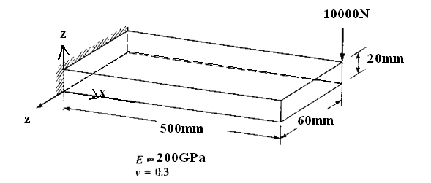

**Hardware required:**

1. Pentium 4 processor.

2. 500MB ram.

3. VGA colour monitor.

4. 2 GB hard disk free space.

5. Colour printer.

**Software required:**

1. Windows xp O.S.

2. ANSYS 19.2

**Procedure:**

### 1.<Preprocessor> <Element Type><Add/Edit/Delete><Add><OK>

### <beam > structural 3D elastic 4><OK>

## 2.<Preprocessor> on the Main menu <Real Constants>

**<Add><OK>**

In the real constants for BEAM 3 window enter the following geometric properties

1. Cross sectional area =0.500
2. Area moment of inertia Ixx = 40000
3. Area moment of inertia Iyy = 324000000
4. Area moment of inertia Izz = 333333.33
5. Thickness along z-axis= 60
6. Thickness along y-axis= 20<OK>

### 3<Preprocessor><Material Props>< material models>

**structural> linear>elastic>Isotropic**

1. Young’s modulus EX = 200e3
2. Poisson’s ratio PRXY = 0.3 **<OK>**

### 4.<Preprocessor><Material Props> < material models>

**structural> linear>density**

Enter the following density for steel:7800

### 5.<Preprocessor><Modeling—Create><nodes>

Input the coordinates of the first and last nodes, in the 2D coordinates as

|  |  |  |
| --- | --- | --- |
| Key point | Coordinates |  |
| 1 | (0, 0) | Apply |
| 2 | (500, 0) | Apply |
| 3 | (500,20) | Apply |
| 4 | (0,20) | Apply |
| 5 | (0,20, -60) | Apply |
| 6 | (0,0, -60) | Apply |
| 7 | (500,0, -60) | Apply |
| 8 | (500,20, -60) | **OK** |

**6**.<**Preprocessor**>**<Modeling—Create><Elements>Autonumbered<thru nodes>**

Select nodes 1 and 2, 2 and 3, 3 and 4, 4and 1, 1and 6, 6 and 5, 5 and 4, 6 and 7, 7and 8, 8 and 5, 8 and 3, 7 and 2>OK

**7.<Plot ctrls> Numbering> Turn on <Keypoints> and <Nodes>**

**8.<Loads—Apply><Structural—Displacement><On nodes>**

Type 1, 6,5,4 >t O.K

**<All DOF>Force/moment><On nodes>**Pick the node 8.

<Fy> -10000>O.K>Save.db

#### 9.<Solution><Solve- Current LS> <OK>

**10.Post processor**>List results<Reaction solution>Fy

NODE FY

1 2497.4

4 2497.7

5 2503.6

6 2501.3

TOTAL VALUES

VALUE 10000.

**11.** List results<Reaction solution>

List results<Reaction solution> Y component of displacement

NODE UY

1 0.0000

2 -1.2524

3 -1.2525

4 0.0000

5 0.0000

6 0.0000

7 -1.2530

8 -1.2534

MAXIMUM ABSOLUTE VALUES

NODE 8

VALUE -1.2534

### 12.<General Postprocessor><Plot Results><Deformed Shape><Def+Undef edge>OK.

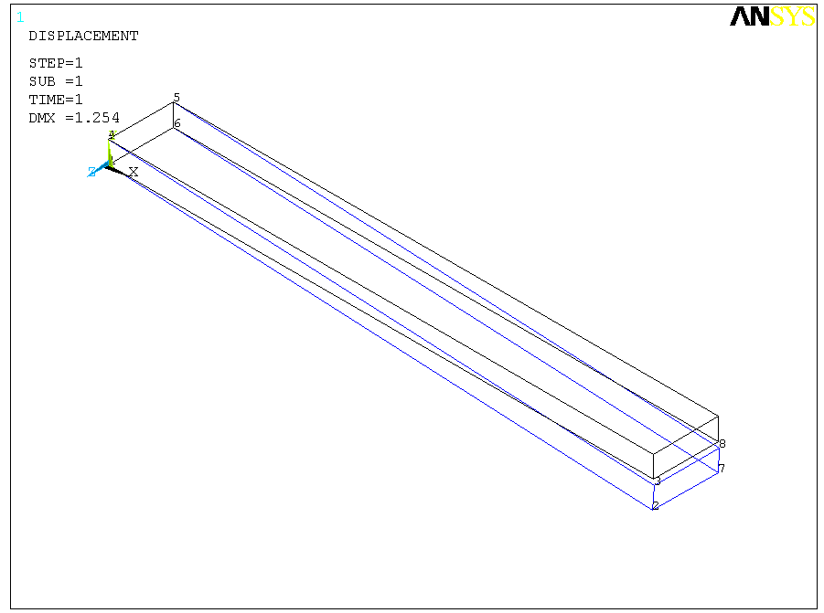

**Ex.No:4 Date:**

DETERMINATION OF DEFLECTION AND STRESSES IN 2D PLANE

**AIM:** To determine the deflection and stresses in the following 2D plane



Modulus of elasticity : 200000 N/mm2

Poisson’s ratio : 0.3

Size : 1m x 1m x 0.01m

Pressure at end : 150N/mm2

#### 1.Plane Stress Analysis:

#### PROCEDURE

1.<**Preferences**> <**structural**>**OK>**

2. **<Element Type><Add/Edit/Delete><Add><OK>**

* Choose **<Structural ..solid >Quad 4node 182>OK>**
* <**Options**>Click and hold the element behaviour K3, and select <**plane stress** >**OK**>

3.**<Real Constants> <Add>OK>**

Enter the thickness THK <10**<OK>**

**4.**<**Preprocessor**> **<Material Props>< material models> structural> linear>elastic>Isotropic**

* Enter the following geometric properties

Young’s modulus EX = 200000 and Poisson’s ratio PRXY = 0.3

# 5.<Preprocessor> <Modeling—Create> Areas> Rectangle> By 2 corners>

* Enter the following parameters

Width : 1000

Height : 1000 **<OK>**

6. **<Modeling—Create>** < **Areas**> **Circle** > **Solid circle** >

* Enter the center point coordinates and radius of the circle

WPX : 500

WPY : 500

Radius: 100

**<OK>**

7. **<Modeling—Operate>**< **Boolean> Subtract> Areas**

* Pick the rectangle in the graphics window
* Click on <**OK**> in multiple window
* Click on <**Apply**> in subtract areas window

8.**<Modeling—Operate>** < **Boolean> Subtract> Areas**

* Pick the circle in the graphics window
* Click on <**NEXT**> in multiple window
* Click on <**OK**> in multiple window
* Click on <**OK**> in subtract areas window

The rectangle with circular hole is displayed in the graphics window

9.<**Preprocessor**>**<Meshing>size controls>Global>Size>**

Enter number of element divisions: 20 **<OK>**

* **Preprocessor**> **<Meshing>Mesh> Areas>Free>**
* Pick the model <**OK**>

10. **<Loads—Apply><Structural—Displacement><symmetry>on lines>**

* select the top end of the plate
* Hit **Apply <All DOF>** Hit <**OK>**

**11. <Loads>** <**Apply>**e **<Structural—pressure> <On lines>**

* Select bottom end of the plate
* In the window that appears
* Pressure value : -150 **< OK>**

# 12. <Solution><-Solve- Current LS> (Load Step)…<OK>

## 13. <General Postproc><Plot Results> <Deformed Shape>def+ undef shape>

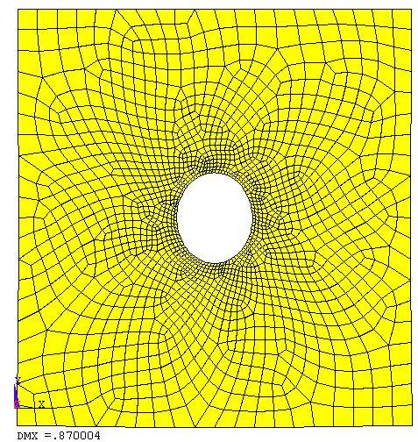

Max Deflection: 0.87mm

## 14. <General Postprocessor> < plot results> Nodal solution >

Item to be contoured **: stress> Von Mises SEQU>**

**<OK>**

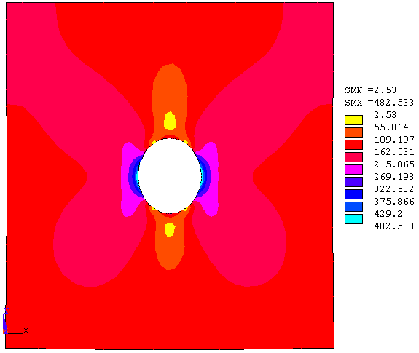

**2.Plane Strain Analysis:**

# Go to

# 15. Preprocessor<Choose <Element Type> <Add/Edit/Delete>

**<Add> <OK>**

* Choose **<Structural ..solid >Quad 8node 82>OK>**
* <**Options**> Click and hold the element behaviour K3, and select <**plane strain**>**OK**> >Close back to Preprocessor Window

16. **<Solution><-Solve- Current LS>** (Load Step)…**<OK>**

**17. <General Postproc>**Choose **<Plot Results><Deformed Shape>def+ undef shape>**

**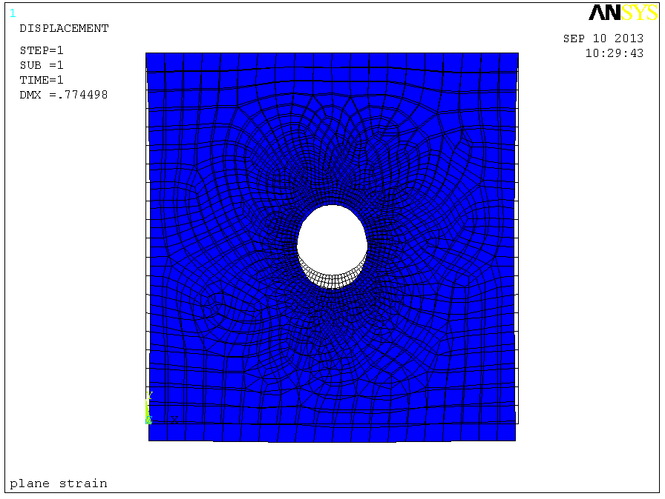**

Max Deflection: 0.77mm

## 18.<General Postprocessor> < plot results> Nodal solution >

Item to be contoured **: stress> Von Mises SEQU>**

**<OK>**

**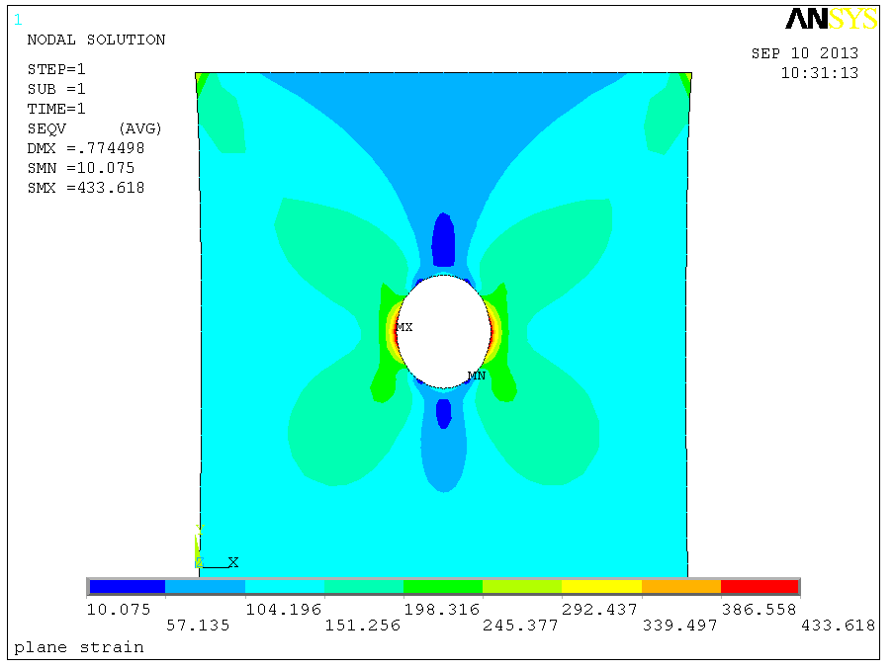**

**3.Axisymmetric Analysis:**

19.Preprocessor**<Element Type><Add/Edit/Delete><Add><OK>**

* Choose **<Structural ..solid >Quad 8node 82>OK>**
* <**Options**>Click and hold the element behaviour K3, and select <Axisymmetric>**OK**> Close back to Preprocessor Window

20.. **<Solution>** **<-Solve- Current LS>** (Load Step)… **<OK>**

**21. <General Postproc>** **<Plot Results><Deformed Shape>def+ undef shape>**

**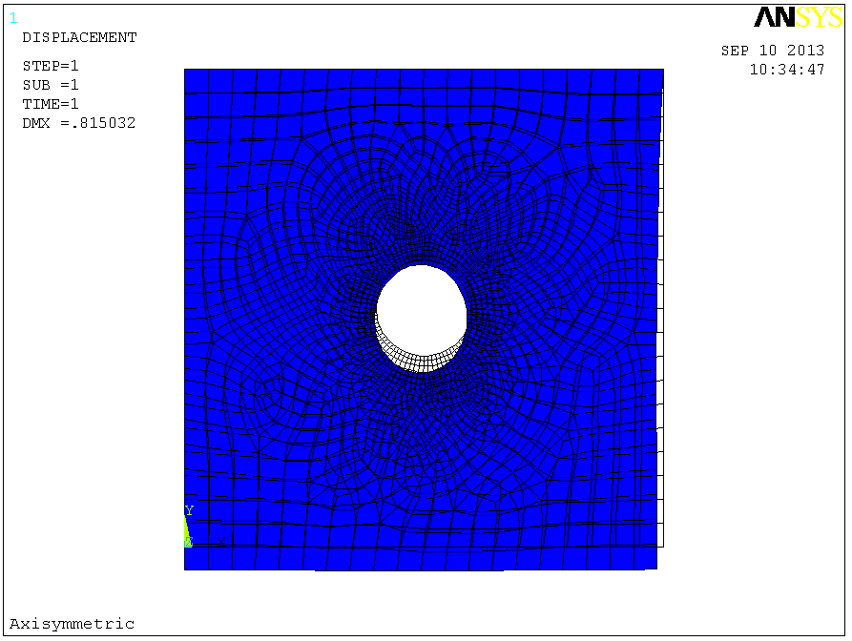**

Max Deflection: 0.815mm

## 22.<General Postprocessor>< plot results> Nodal solution >

Item to be contoured **: stress> Von Mises SEQU>**

**<OK>**

**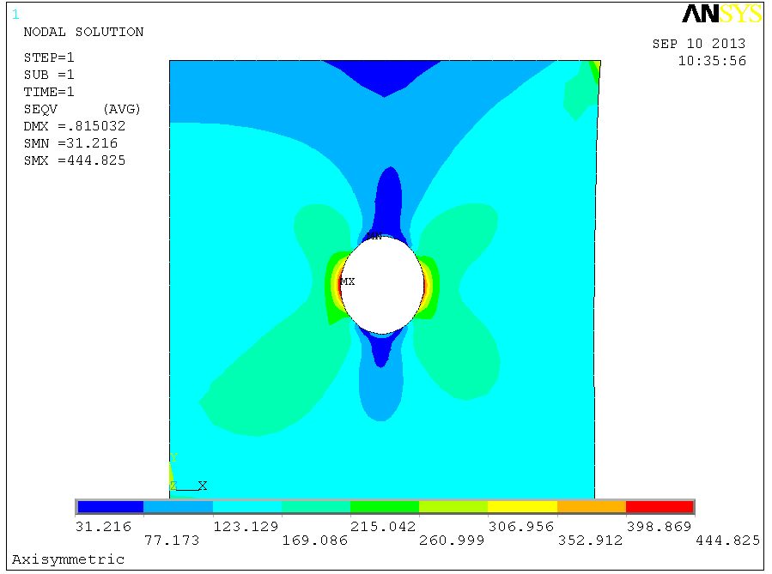**

# STEADY STATE THERMAL ANALYSIS

# Ex.No:5 Date:

## Aim: Finding the nodal temperature distribution in a block with the thermal constraints as shown in the figure. Thermal conductivity (k) of the material is 10 W/m\*C and the block is assumed to be infinitely long.

T= 500°C

T= 100°C

T= 100°C

T= 100°C

K= 10 W/m°C

**Hardware required:**

1. Pentium 4 processor.

2. 500MB ram.

3. VGA colour monitor.

4. 2 GB hard disk free space.

5. Colour printer.

**Software required:**

1. Windows xp O.S.

2. ANSYS 19.2

## Procedure:

## Preferences>Thermal>O.K.

## Preprocessor > Element Type > Add/Edit/Delete... > click 'Add' > Select Thermal Mass Solid, Quad 4Node 55

## Preprocessor > Material Props > Material Models > Thermal > Conductivity > Isotropic > KXX = 10

## Preprocessor > Modeling > Create > Areas > Rectangle > By 2 Corners > X=0, Y=0, Width=1, Height=1

## Preprocessor > Meshing > Size Cntrls > ManualSize > Areas > All Areas > 0.05

## Preprocessor > Meshing > Mesh > Areas > Free > Pick All

## Solution > Analysis Type > New Analysis > Steady-State

## Solution > Define Loads > Apply >Thermal > Temperature > On Nodes

* + Click the **Box** option (shown below) and draw a box around the nodes on the top line.

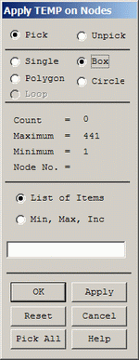

The following window will appear:

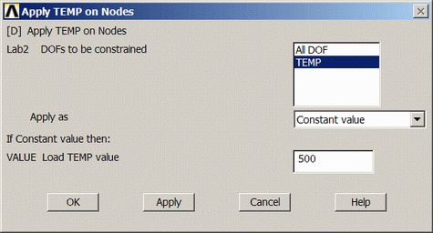

* + Fill the window in as shown to constrain the side to a constant temperature of 500
  + Using the same method, constrain the remaining 3 sides to a constant value of 100

1. Solution > Solve > Current LS>SOLVE
2. General Postprocessor > Plot Results > Contour Plot > Nodal Solution ... > DOF solution, Temperature TEMP

Desk

RESULT:

**INTRODUCTION TO CNC PROGRAMMING**

This manual provides basic programming principles necessary to begin programming the HAAS C.N.C. Milling Machine. In a “CNC” (Computerized Numerical Control) machine, the tool is controlled by a computer and is programmed with a machine code system that enables it to be operated with minimal supervision and with a great deal of repeatability. The same principles used in operating a manual machine are used in programming a CNC machine. The main difference is that instead of cranking handles to position a slide to a certain point, the dimension is stored in the memory of the machine control once. The control will then move the machine to these positions each time the program is run. In order to operate and program a CNC controlled machine, a basic understanding of machining practices and a working knowledge of math is necessary. It is also important to become familiar with the control console and the placement of the keys, switches, displays, etc., that are pertinent to the operation of the machine. This workbook can be used for both operator’s and programmer’s. It is intended to give a basic understanding of CNC programming and it’s applications. It is not intended as an in-depth study of all ranges of machine use, but as an overview of common and potential situations facing CNC programmers. Much more training and information is necessary before attempting to program on the machine. This programming manual is meant as a supplementary teaching aid to users of the HAAS Mill. The information in this workbook may apply in whole or in part to the operation of other CNC machines. Its use is intended only as an aid in the operation of the HAAS Milling Machine. For a complete explanation and an in-depth description, refer to the Programming and Operation Manual that is supplied with your HAAS Lathe.

**CNC Programs**

**EXP. No.01 Date:**

**AIM:** To write a part program for the given model by CNC Turning operation.

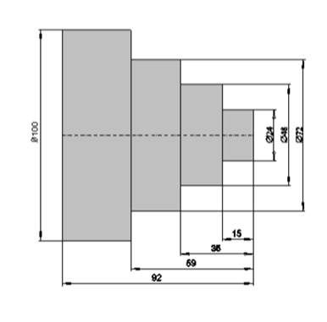

**Program:**

N10 G40 G64 G54 G71 G90 G95

N20 G75 X0 Z0

N30 G00 X100 Z100

N40 G01 X0 Z0 F0.2

N50 X24

N60 Z-15

N70 X48

N80 Z-38

N90 X72

N100 Z-92

N110 X100

N120 Z-100

N130 G00 X105

N140 M05

N150 M30

**RESULT:**

**EXP No.02 Date:**

**AIM:** To write a part program for the given model by CNC Milling operation.

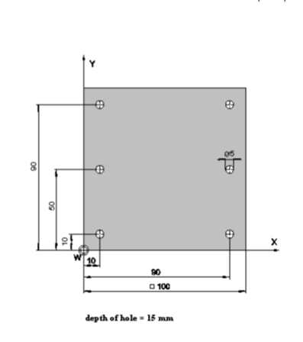

**PROGRAM:**

N00 G17 G40 G54 G71 G90 G95

N01 G75 Z0

G75 X0 Y0

G00 Z50

G01 Z0 F200

X-10 Y-10

Z-15

Z15

Y-60

Z-15

Z15

Y-90

Z-15

Z15

X-90

Z-15

Z15

X-90 Y-60

Z-15

Z15

X-90 Y-10

Z-15

Z15

G75 Z0

G75 X0 Y0

M05

N26 M30

**RESULT:**