**ASSIGNMENT-1:** Pseudocode Development - Task: Write a detailed pseudocode for a simple program that takes a number as input, calculates the square if it's even or the cube if it's odd, and then outputs the result. Incorporate  
conditional and looping constructs.

**SOLUTION:**

**Pseudocode:**

Start

Declare variable number as integer

Declare variable result as integer

Display: “Enter a number:”

Read number

if number modulo 2 equals to 0 then

assign result = number**2

else

assign result = number**3

endif

Display result

End

**FLOWCHART:**

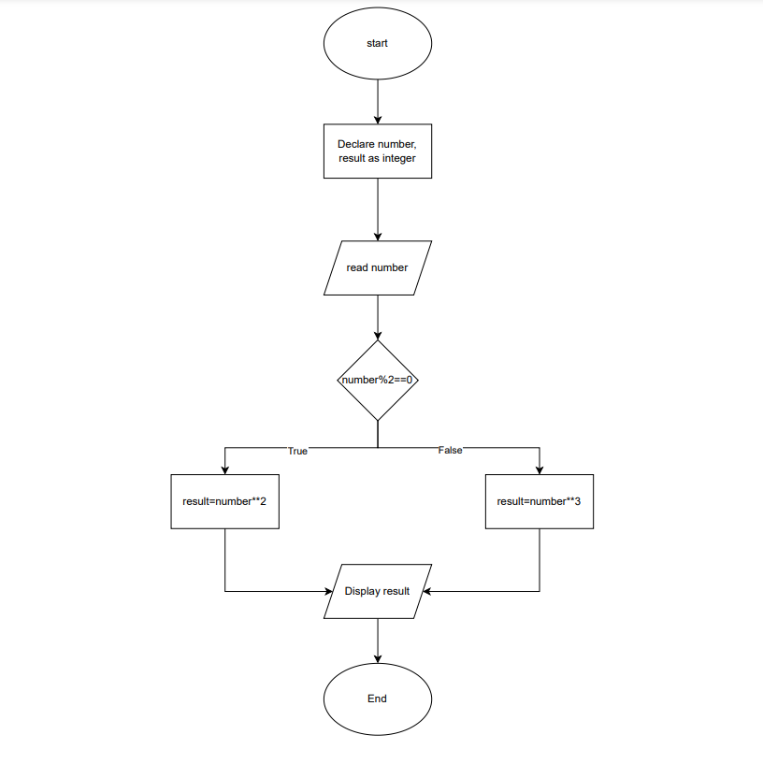

Step1: Start

Step2: initialize variables one for input and other for result

Step3: ask the user for input and store it in input variable

Step4: check for the number to be positive

If the number is less than 0 return message “number should be positive”

Else continue to the next step

Step4: check if the number to be even

Calculate the square of the input number and store it in the ‘result’ variable

Else if the number is odd

Calculate the cube of the input number and store it in the ‘result’ variable

Step5: display the result to the user

Step6: End