**ASSIGNMENT 2:**  Flowchart Creation - Design a flowchart that outlines the logic for a user login process. It should include conditional paths for successful and unsuccessful login attempts, and a loop that allows a user three attempts before locking the account.

**SOLUTION:**

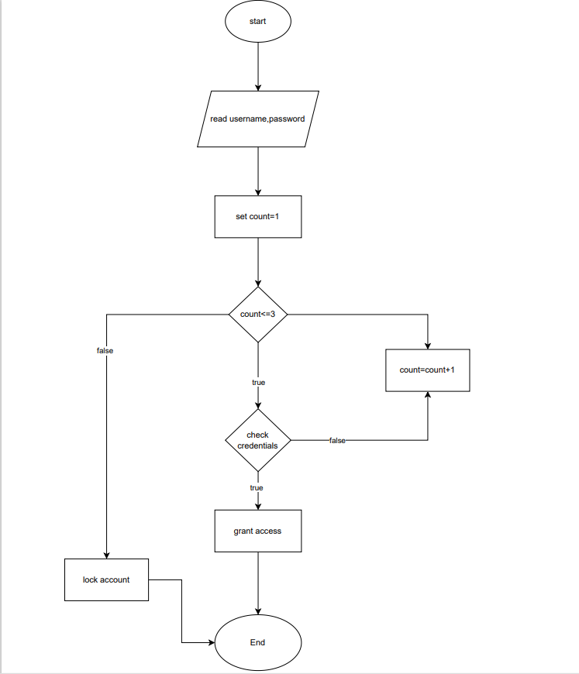

**PseudoCode:**

procedure userLogin()

// Define variables

let Attempts = 3

let attemptCount = 0

let isLoggedIn = false

start the while loop to count for number of attempts

while attemptCount < Attempts AND isLoggedIn equals false do:

// Prompt user for username and password

input username

input password

if username equals correctUsername AND password equals correctPassword then:

isLoggedIn = true

output "Login successful. Welcome, ", username

else:

// Increment attempt count

attemptCount = attemptCount + 1

output "Login failed. You have ", Attempts - attemptCount, " attempts remaining."

if attemptCount = Attempts then:

output "Maximum login attempts reached. Your account is locked."

Exit loop

end procedure