**Assignment 1:** Pseudocode and Flowchart for Sorting Algorithm - Write  
pseudocode and create a flowchart for a bubble sort algorithm. Provide a  
brief explanation of how the algorithm works and a simple array of integers  
to demonstrate a dry run of your algorithm.

**Flowchart:**

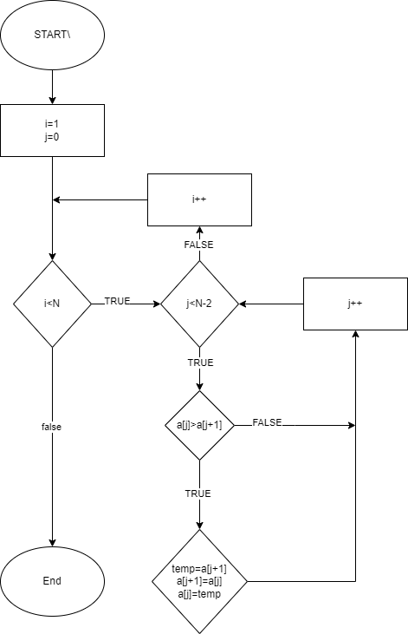

**PSEUDOCODE:**

BubbleSort(int a[],int n){

int temp=0,i=0,j=0;

for(i=0;i<n-1;i++)

{

For(j=0;j<n-1-I;j++)

{

If(a[j+1]<a[j])

{

temp=a[j+1];

a[j+1]=a[j];

a[j]=temp;

}

}

}

}

**ALGORITHM:**

1.start

2.set i=1

3.set j=0

4.if(a[j]>a[j+1])

Swap a[j],a[j+1]

5.j=j+1

6.if(j<n-i goto step 3

7.i=i+1;

8.if i<n goto step 3

9.stop.

The Bubble sort algorithm works by repeatedly checking through the list to be sorted, comparing each pair of adjacent items and swapping them if they are in wrong order. The process is repeated until no swaps are needed, which indicates that the list is sorted.

Consider array[15,13,18,12,11] for simple demonstration of the bubble sort algorithm.

1.start

2.first compare 15 and13 since 15>13 swap them array becomes[13,15,18,12,11].

3.compare 15 and 18.since 15<18 which is correct sequence no need to swap.

4.compare 18 and 12.since 18>12,swap them the array becomes[13,15,12,18,11].

5.compare 8 and 1.since 18>11, swap them then the array becomes[13,15,12,11,18].

6.once pass through the array is completed. The largest element is 18 is now in its correct position at the end.

7.Repeat steps 2-6 for the remaining elements(excluding the last element since it is already sorted).

8.After multiple passes the array will be sorted[11,12,13,15,18].