Optimization in High-Performance Computing: A Data Structure Optimization Case Study Based on an Empirical Analysis of HPC Performance Bugs

Sandip Sitaula
University of Cumberland
Algorithms and Data Structures (MSCS-532-B01)
August 10, 2026

Optimization in High-Performance Computing: A Data Structure Optimization Case Study
High-performance computing (HPC) helps scientists solve big problems, like forecasting climate or discovering new drugs. These programs handle huge amounts of data on many processors at once. Because of this, even a small mistake in how data is stored can waste a lot of time and computing power. Writing fast HPC code is hard. A programmer has to think about the algorithm, the compiler, and how computer memory works, all at the same time (Azad et al., 2023).
Azad, Iqbal, Hassan, and Roy (2023) studied this problem. Their paper was presented at the 2023 Mining Software Repositories (MSR) conference. The team looked at 1,729 commits from 23 open-source HPC projects that seemed related to performance. After checking each one by hand, they confirmed 186 real performance bugs. From this, they built a list of common bug types and the fixes used for them. Their biggest finding was that bad algorithms and data structures caused the most bugs, 39.3% of all the bugs they found. Problems with data locality, meaning how data sits in memory, were the top cause inside the hardware-related bug group.
This report looks closely at that study. It picks one optimization technique from the study and builds a small Python project to show how it works. The report explains the study's method and results, explains why this technique was chosen, lists its pros and cons, describes the code that was written, shows the test results, and ends with lessons learned from comparing the real results to what the study expected.
The Empirical Study: Methodology and Key Findings
Azad et al. (2023) picked 23 popular, long-running open-source HPC projects. These included LAMMPS, GROMACS, OpenBLAS, CGAL, Kokkos, MFEM, and QMCPACK. Each project had over 1,000 commits and at least 20 stars on GitHub. The team built a tool that searched commit messages for words like "speed up" or "optimize." This search found 1,729 possible performance commits. But keyword searches catch a lot of false matches. So four researchers checked every commit by hand. This took about seven months and 1,900 hours of work. In the end, they confirmed 186 real performance bugs. They also checked how much they agreed with each other and got a strong agreement score (Fleiss' kappa of 0.64 for spotting bugs and 0.72 for finding root causes).
The team sorted the 186 bugs into ten root-cause groups. The three biggest groups were bad algorithms or data structures (39.3%), code that does not fit the hardware well (31.2%), and missing or weak parallel code (14.5% combined). They also sorted the fixes into types. The biggest fix type was hardware-specific optimization (34.4%), and inside that group, fixing data locality made up 21% of all fixes (Azad et al., 2023).
The study also measured how hard these bugs were to fix. On average, performance-bug fixes changed about 35 lines of code and touched more files than normal bug fixes. This gap was statistically real (p < 0.05, Mann-Whitney U test). Developers who fixed these bugs also had much higher HPC skill scores (median 2.245) than the average developer (median 0.301). Only 4.4% of all developers reached that skill level. This shows that fixing HPC performance bugs takes real expertise, and that expertise is rare.
Selected Optimization Technique and Justification
This report focuses on one technique: fixing data structures so they work better with computer cache memory. The study calls this "data locality optimization," and it makes up 21% of all fixes. It also connects to a bug type called "inefficient data-structure," which is about picking the wrong container for the job. The study gives two real examples. In CGAL (commit 8855eb5), the team replaced a linked list (std::list) with a normal array-like container (std::vector). In TileDB (commit d51b082), they replaced a linked-list type called forward_list with a vector for the same reason. Arrays keep their data next to each other in memory, so the computer can read them quickly, one after another. Linked lists scatter their data all over memory, so the computer has to jump around to find each piece, which is slow (Azad et al., 2023).
This technique was picked over other ones in the study, like fixing math operations or adding GPU code, for two reasons. First, it works in almost any programming language, including simple, high-level languages like Python. GPU tricks usually need special hardware and low-level code. Second, this technique connects to a similar idea from the same study: Array-of-Structures (AoS) versus Structure-of-Arrays (SoA). The study found this pattern in a GROMACS commit (85c36b9). Looking at both patterns together gives a fuller picture of what "data structure optimization" really means: picking the right container, and also arranging the data inside it the right way.
Most importantly, this technique matters a lot in real life. Bad algorithms and data structures caused 39.3% of all confirmed HPC bugs in the study, more bugs than any other cause, even more than all parallelism bugs put together. If a programmer learns just one lesson, use tightly packed, contiguous memory instead of scattered, pointer-based containers when reading data in order, they can avoid the single biggest source of HPC performance bugs that Azad et al. (2023) found.
Strengths and Weaknesses of the Technique
Strengths
The biggest strength of this technique is that it uses a fixed, well-known fact about how computer hardware works, not a fact about any specific algorithm. Computer caches load data in fixed-size chunks called cache lines. When the hardware sees a program reading memory in order, it tries to guess what comes next and loads it early (Chilimbi et al., 1999). A plain array fits this pattern naturally. A linked list breaks it, because the computer does not know where the next node lives until it has already loaded the current one. Since this benefit comes only from how data is laid out, it works well together with almost any other speed trick, without needing to change the algorithm at all. This is likely why the study saw a 200x speedup from a similar fix in Kokkos (commit 75fd8bc), just from padding an array to avoid a memory conflict.
A second strength is that this change often makes code simpler, not more complex. Swapping a linked list for std::vector, or a Python list for a NumPy array, usually removes pointer-management code instead of adding new code. A third strength, shown clearly in this project's SoA test, is that packed, contiguous data allows the computer to process many values at once (SIMD), whether through a C++ compiler or NumPy's fast inner loops. So one simple layout change can improve both cache use and raw speed.
Weaknesses
This technique does have trade-offs. A contiguous array sometimes needs to grow, and when it runs out of room, it must copy all its data into a bigger block, an expensive step that a linked list never needs, since it just adds one new node. So programs that insert or delete items often in the middle of a list may actually run slower with a plain array, unless smarter growth rules or a different structure (like a deque) are used instead.
The Structure-of-Arrays layout has its own weakness: it is less flexible to change. Homann and Laenen (2018) point out that AoS is easier to extend, since adding one new property to a particle is a one-line change. In SoA, the same change means adding a whole new array and keeping it in sync with all the others, which is easy to get wrong. SoA can also lose its speed advantage when a task needs several fields of the same item together, since those fields now live far apart in memory. Both this study's examples and this report's own test only hold true for the specific access pattern they were built to measure.
Implementation
To show how this technique works, two small Python projects were built and tested. They match the two examples from the study described above.
Prototype 1: Linked List vs. Contiguous Array Traversal
The first project copies the CGAL and TileDB example directly. A simple singly linked list was built by hand, using small Node objects that each hold a value and point to the next node. A normal Python list was also built, using the same values. Both were filled with the same random numbers and tested on the same task: walk through every item in order and add up the total. This was tested at sizes from 10,000 up to 2,000,000 elements. In Python, each Node is created separately on the heap, so nearby nodes are usually not stored near each other in memory. This means reading the linked list forces the computer to jump to a new, unpredictable memory spot at every step, which is the same problem the study describes for forward_list and list.
Prototype 2: Array-of-Structures vs. Structure-of-Arrays
The second project copies a small piece of a molecular-dynamics program: moving N particles forward by one small time step, using the rule position += velocity * dt, repeated for 20 steps. In the AoS version, each particle is a Python object holding six numbers (x, y, z, vx, vy, vz), and the code loops over a list of these objects. In the SoA version, the same six values are stored as six separate NumPy arrays, one for each field, and the update runs as three fast, vectorized operations. Figure 1 shows both layouts side by side: AoS keeps each particle's own numbers together but scatters different particles across memory, while SoA keeps all of one field (like every x value) packed together in one block.
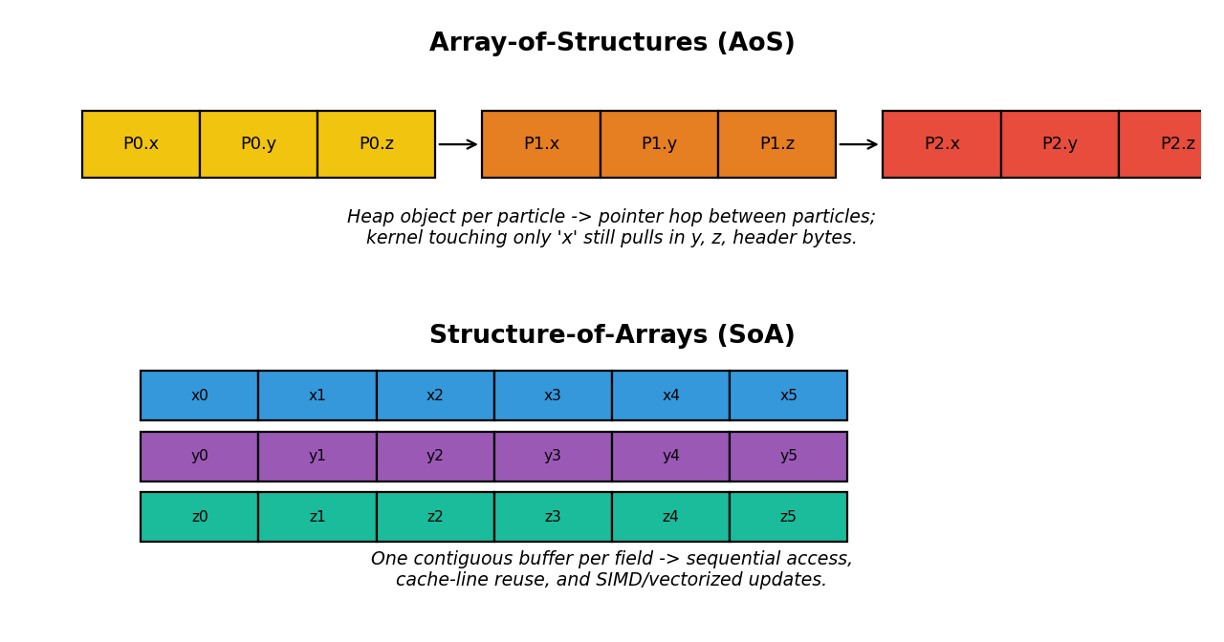
Figure 1. Memory layout of Array-of-Structures (AoS) versus Structure-of-Arrays (SoA).
Both projects were timed with Python's time.perf_counter, averaged over several runs at each size. Garbage collection was triggered between runs to reduce noise. The full code is included in the source-code documentation and the linked GitHub repository.
Results and Performance Analysis
Linked List vs. Array
Table 1 and Figure 2 show the results of the traversal test. The plain array beat the linked list every single time, with a speedup that stayed fairly steady, between about 2.3x and 2.7x. The gap is smaller than what a C++ program would show, because in Python, both structures store pointers to boxed integers, so they share some of the same overhead. Even so, the layout difference alone was enough to create a real, steady gap that grows in raw time as the data grows, which matches the pattern the study saw in CGAL and TileDB.
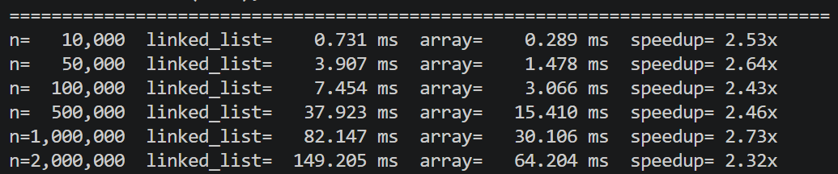
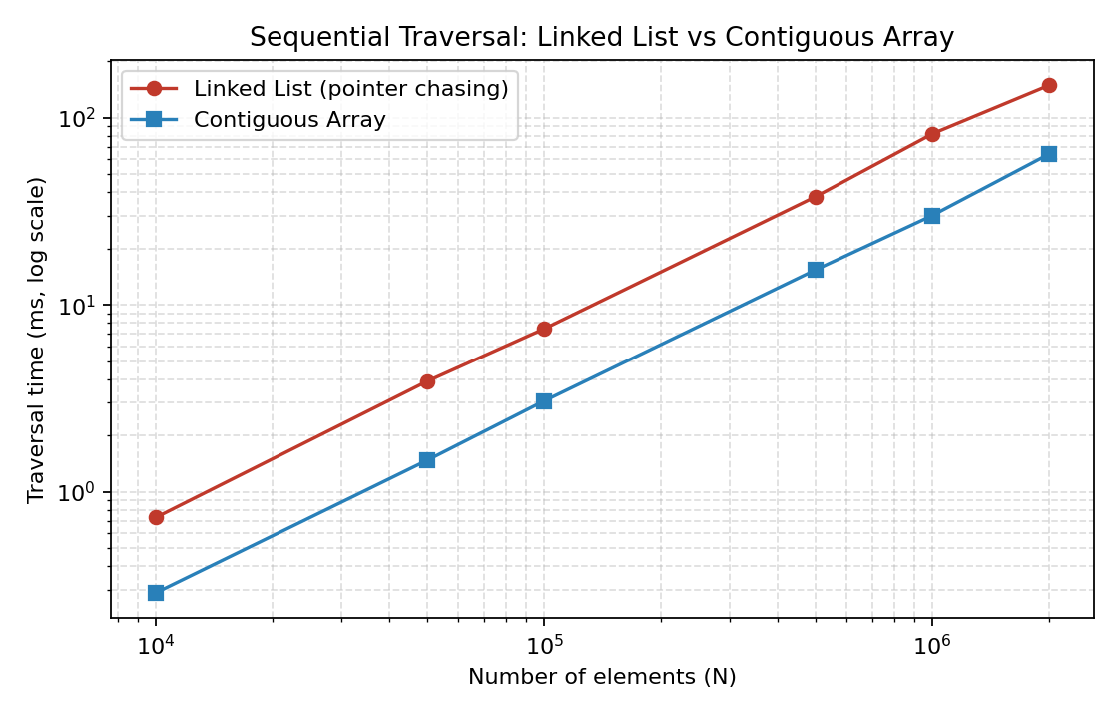
Figure 2. Traversal time (log scale) vs. problem size for the linked list and array.
Array-of-Structures vs. Structure-of-Arrays
The AoS/SoA test, shown in Figure 3 and Table 2, had a much bigger effect. The SoA (NumPy) version was somewhere between 18.9x and 244.9x faster than the AoS (plain Python objects) version, depending on the number of particles. This gap is much larger than the linked-list result because two things are happening at once: NumPy stores its data in contiguous memory, just like the array test above, and NumPy also runs each update as one fast, compiled loop instead of a slow Python loop. The pure-Python AoS version cannot skip that slow loop, since it has to look up each field on each object, one at a time.
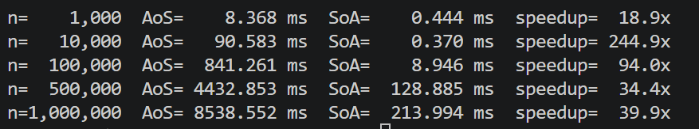
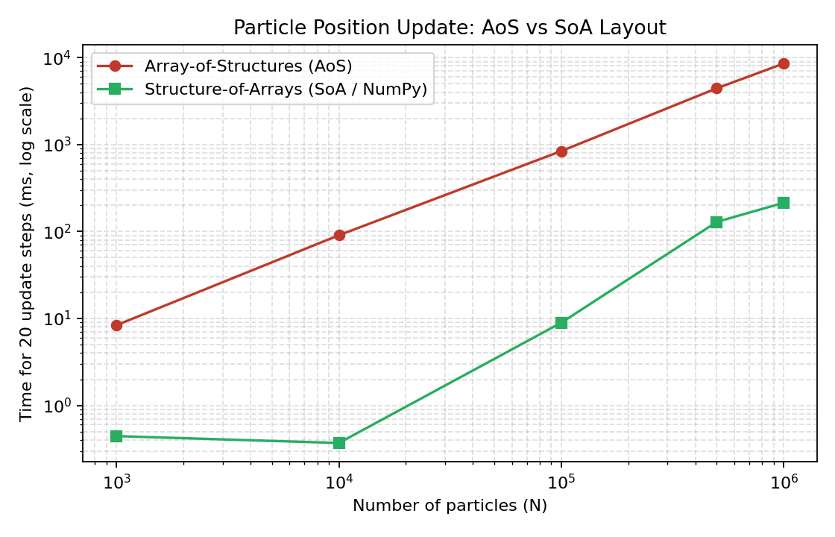
Figure 3. Update time (log scale) vs. particle count for AoS and SoA layouts.
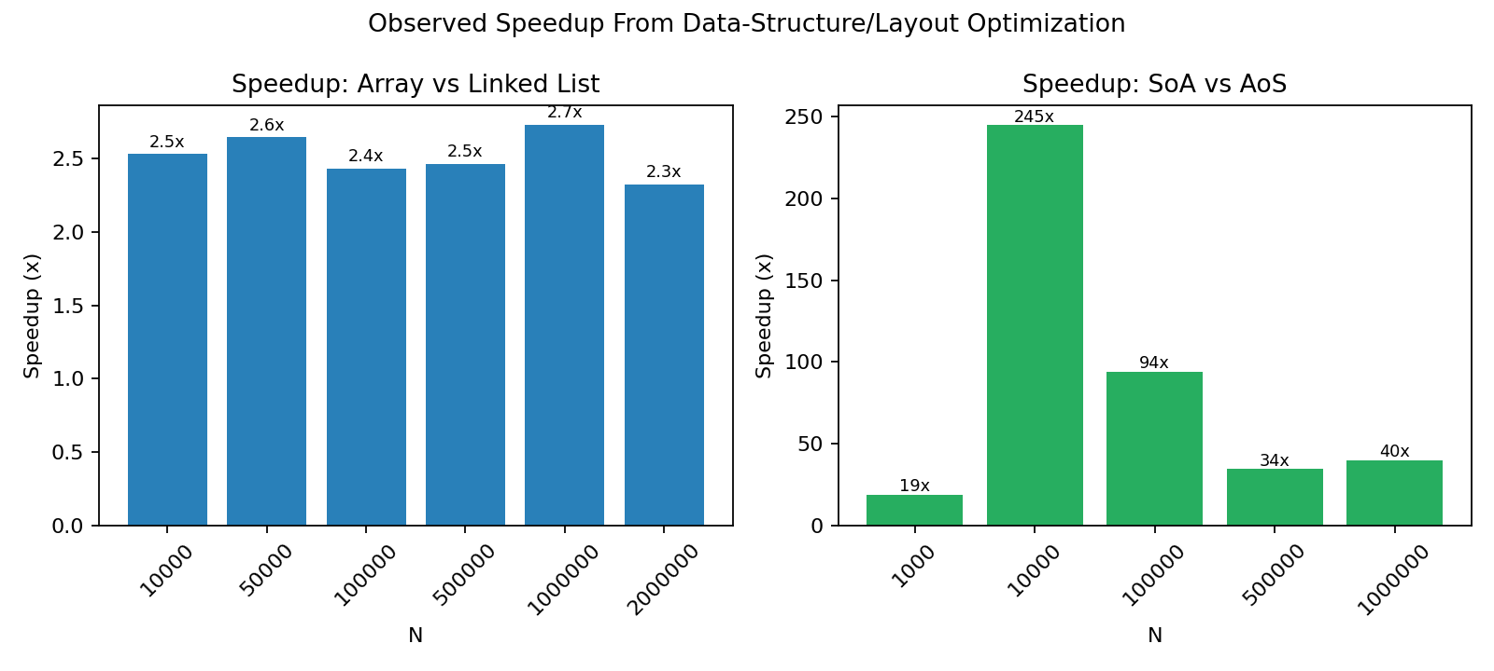
Figure 4. Speedup from each data-structure or layout change, by problem size.
Two smaller patterns are worth noting. First, the AoS/SoA speedup is highest at a medium size (10,000 particles, 244.9x) and drops sharply at larger sizes, before ticking back up slightly at the largest size tested. This makes sense: the AoS version's per-item Python cost grows steadily no matter the size, while the SoA version starts to feel its own, smaller slowdown once the arrays get too big to fit in cache, which narrows the gap substantially, though it never closes. Second, in both tests, the faster structure's lead grew larger in raw time as N grew, even when the multiplier itself moved around. A steady, sizable multiplier becomes more valuable, not less, as HPC problems scale up toward millions of elements.
Lessons Learned
The study talks about data-locality fixes mostly in terms of hardware effects: cache lines, prefetching, and memory delay. These effects are easiest to see in compiled languages like C and C++, where cache misses can dominate the whole runtime. Building the same test in Python showed something the study did not fully cover: in an interpreted language, the plain cache-locality effect is real but fairly small, around 2.3x to 2.7x for the linked-list test, because Python's own overhead, not memory delay, is often the bigger cost. The much bigger AoS/SoA speedup (up to nearly 245x) only showed up once the contiguous layout was paired with NumPy, which also removes that interpreter overhead. This is a useful update to the theory: in an interpreted language, a cache-friendly layout alone is not enough. It needs to be paired with something, like vectorization, that also gets the slow interpreter loop out of the way.
A second lesson is about how sensitive these results are to problem size and repeated testing, something a single commit message cannot easily show. Running each test many times, across sizes from 10,000 to 2,000,000 for the linked-list test and 1,000 to 1,000,000 for the particle test, showed that the linked-list speedup barely changed with size, while the AoS/SoA speedup swung by more than tenfold, from 18.9x up to 244.9x, depending on size. This means a single speedup number, like the study's "200x improvement," describes one specific test, not a fixed law that always applies.
A third, more cautious lesson comes from the weaknesses discussed earlier. The SoA speedup in this project depended on the task only needing one field (position, driven by velocity) at a time. If the task instead needed x, y, and z together for each particle, like measuring each particle's distance from the center, the SoA layout's spread-out fields would likely hurt performance instead of helping it. This matches Homann and Laenen's (2018) point that the best layout depends on how the data is used, not on some fixed rule that SoA always wins. The study's short commit messages could not show this kind of detail, but it became clear while building and testing this project.
Conclusion
This report looked at Azad et al.'s (2023) study of HPC performance bugs and picked one technique to study closely: fixing data structures so they fit computer cache memory better. This technique was chosen because bad algorithms and data structures caused more bugs than any other cause in the study (39.3%). Two small Python projects were built to test the idea: a linked list versus a plain array, and Array-of-Structures versus Structure-of-Arrays for updating particle positions. Both projects matched the pattern the study found in CGAL, TileDB, and GROMACS: packed, cache-friendly layouts beat scattered, pointer-based ones every time, with speedups from about 2.3x to 2.7x for simple traversal to nearly 245x once paired with vectorized code. Building this project also taught a few extra lessons not obvious from the study alone: Python's own overhead limits how much a cache fix can help by itself, the AoS/SoA trade-off depends heavily on how the data will be used, and speedup numbers can shift a lot depending on problem size. None of this contradicts the study, it just adds detail, and it backs up the study's main point: writing fast HPC code takes both knowledge of common fixes and careful testing.

GitHub Repo: https://github.com/sitaulasandip/MSCS532/tree/main/Final_Project_p1/src

References
Azad, M. A. K., Iqbal, N., Hassan, F., & Roy, P. (2023). An empirical study of high performance computing (HPC) performance bugs. In Proceedings of the 20th IEEE/ACM International Conference on Mining Software Repositories (MSR 2023). IEEE. https://foyzulhassan.github.io/files/MSR23_HPC.pdf
Chilimbi, T. M., Hill, M. D., & Larus, J. R. (1999). Cache-conscious structure layout. In Proceedings of the ACM SIGPLAN 1999 Conference on Programming Language Design and Implementation (PLDI '99) (pp. 1-12). Association for Computing Machinery. https://doi.org/10.1145/301618.301633
Harris, C. R., Millman, K. J., van der Walt, S. J., Gommers, R., Virtanen, P., Cournapeau, D., Wieser, E., Taylor, J., Berg, S., Smith, N. J., Kern, R., Picus, M., Hoyer, S., van Kerkwijk, M. H., Brett, M., Haldane, A., Fernández del Río, J., Wiebe, M., Peterson, P., ... Oliphant, T. E. (2020). Array programming with NumPy. Nature, 585(7825), 357-362. https://doi.org/10.1038/s41586-020-2649-2
Homann, H., & Laenen, F. (2018). SoAx: A generic C++ structure of arrays for handling particles in HPC codes. Computer Physics Communications, 224, 325-332. https://doi.org/10.1016/j.cpc.2017.11.015
Jin, G., Song, L., Shi, X., Scherpelz, J., & Lu, S. (2012). Understanding and detecting real-world performance bugs. ACM SIGPLAN Notices, 47(6), 77-88. https://doi.org/10.1145/2345156.2254075
NVIDIA Corporation. (2022). CUDA C++ best practices guide. https://docs.nvidia.com/cuda/cuda-c-best-practices-guide/
Python Software Foundation. (2024). array — Efficient arrays of numeric values. Python 3 Documentation. https://docs.python.org/3/library/array.html

