Quicksort: Implementation, Analysis, and Randomization
Assignment 5

Sandip Sitaula
Algorithms and Data Structures (MSCS-532-B01)
21 July 2026

Quicksort: Implementation, Analysis, and Randomization
Quicksort is one of the most commonly used sorting algorithms because it's usually very fast in practice and doesn't need extra memory the way merge sort does (Cormen et al., 2022). In this report covers two versions of Quicksort written in Python: a regular (deterministic) version and a randomized version. It explains how each one works, walks through the math behind their time complexity, and then actually runs both on different kinds of input to see how they behave in practice. The implementation and the complexity proofs follow Chapter 7 of Cormen et al. (2022). An outside source, Bentley and McIlroy (1993), is also used, because the textbook doesn't really cover what happens when the array has a lot of repeated values, which turned out to be one of the more interesting things found during testing. Hoare's (1962) original paper is cited for a bit of history, since that's where Quicksort was first introduced.
Implementation
Both versions uses Lomuto partition scheme (Cormen et al., 2022, Ch. 7). The basic idea is pick a pivot, move everything smaller than it to one side and everything bigger to the other side, then repeat that same process on each side. The complete, tested source code is provided in the file quicksort.py.
Deterministic Quicksort
In this version, the pivot is always the last element of the current part of the array. It's the simplest way to write Quicksort, and it's exactly what's shown in Cormen et al. (2022). The downside, covered below, is that "always pick the last element" turns out to be a bad rule for certain kinds of input, specifically for already-sorted input.
Randomized Quicksort
This version performs the exact same partitioning, but before it partitions, it picks a random element from the current subarray and swaps it into the last position. So instead of always trusting the last element to be a decent pivot, it just rolls the dice. This is the RANDOMIZED-PARTITION procedure described by Cormen et al. (2022, Sec. 7.3). That's really the only difference between the two algorithms; everything else about how they sort is identical.
Theoretical Performance Analysis
Every time the partition step runs, it does one pass through the subarray, so that single call costs Θ(n). The real question is how many times it gets called, and how much each call shrinks the problem. That depends entirely on how balanced the split is, meaning how close to equal the two resulting halves are in size.
Best Case: Θ(n log n)
If the pivot always happens to land right in the middle, so both halves are roughly the same size, the recurrence is T(n) = 2T(n/2) + Θ(n). Solving this with the Master Theorem gives T(n) = Θ(n log n). The intuition is pretty simple: since the array keeps splitting in half, it only takes about log2(n) rounds of splitting before everything is down to single elements. Each round still touches every element exactly once (Θ(n) total), and there are log(n) rounds, so the total is n log (n) (Cormen et al., 2022).
Worst Case: Θ(n²)
This happens when the split is as unbalanced as it can possibly be: one side ends up with everything, and the other side ends up empty. The recurrence becomes T(n) = T(n − 1) + Θ(n), which works out to Θ(n²), basically n + (n-1) + (n-2) + ... + 1, which is roughly n²/2. For the deterministic version specifically, this bad case is not some rare fluke, it happens every single time on an already-sorted or reverse-sorted array. If the array is sorted and the pivot is always the last (largest) element, then literally everything else in the array is smaller than the pivot, so the partition puts everyone on one side and nobody on the other, the worst possible split, and this keeps happening at every level of recursion. Since sorted or nearly sorted data appears frequently in real applications, this is not just a theoretical concern.
Average Case: Θ(n log n)
Here's the interesting part: the split doesn't have to be perfectly 50/50 for Quicksort to still run in Θ(n log n). Cormen et al. (2022, Sec. 7.4.2) show that even a pretty lopsided split, like 90/10, still keeps the recursion depth at Θ(log n), because the array is still being cut down by some constant fraction each time. On average, across all the possible pivot choices, bad splits and good splits tend to even out; a couple of unlucky splits in a row are usually balanced out by a lucky one later. Working through the actual math with an expected-value recurrence and the substitution method confirms that the expected running time is O(n log n).
Space Complexity
Quicksort sorts the array in place, so it doesn't need extra arrays or buffers; that part is O(1). But because it's recursive, it does use stack space, and how much depends on how deep the recursion goes. In the best and average cases, recursion depth is about Θ(log n), so that's how much stack space gets used. In the worst case, recursion only shrinks the problem by one element each time, so the depth is Θ(n), meaning Θ(n) stack space too. There's a known trick to avoid this, recursing into the smaller half first and looping instead of recursing on the bigger half, which keeps the stack depth at O(log n) no matter what (Cormen et al., 2022, problem 7-4). This implementation doesn't include that trick, to keep the code simple and close to the textbook version, but it matters in practice: in the empirical tests below, Python's recursion limit had to be raised manually just to get the deterministic version to finish on larger sorted arrays without crashing.
Why Randomizing the Pivot Actually Helps
Randomizing the pivot does not get rid of the Θ(n²) worst case. It's still technically possible for the random number generator to keep picking the worst possible pivot every time. What changes is why the worst case would happen. For the deterministic version, the input itself decides what pivots get picked, so a specific kind of input (sorted data) can force the worst case every single time, guaranteed. For the randomized version, the pivots depend on random chance instead, completely separate from what the input looks like. So for any input, the expected running time is Θ(n log n), and the odds of actually hitting the bad case get smaller as n grows; Cormen et al. (2022) show this probability shrinks exponentially. Basically, there's no way to hand the randomized version an input that's guaranteed to make it slow, because the slowness would have to come from an unlucky sequence of random picks, not from the data itself.
Testing It Out
Method
A script (empirical_analysis.py) times both versions on four kinds of input, random, already sorted, reverse sorted, and an array with only 5 distinct values repeated a lot, at sizes from 100 up to 4000. Each combination was run 3 times and the results were averaged. The raw numbers are in results.csv, and the chart is shown in Figure 1.
Results
Table 1 shows the average running time, in seconds, for both algorithms across all sizes and distributions tested.
Table 1
Average Running Time (Seconds) by Distribution, Size, and Algorithm
n | Random (Det.) | Random (Rand.) | Sorted (Det.) | Sorted (Rand.) | Reverse (Det.) | Reverse (Rand.) | Duplicates (Det.) | Duplicates (Rand.)
100 | 0.00005 | 0.00008 | 0.00028 | 0.00008 | 0.00023 | 0.00008 | 0.00009 | 0.00016
500 | 0.00034 | 0.00055 | 0.00786 | 0.00050 | 0.00582 | 0.00065 | 0.00177 | 0.00225
1000 | 0.00079 | 0.00116 | 0.03359 | 0.00179 | 0.02422 | 0.00113 | 0.00681 | 0.00767
2000 | 0.00202 | 0.00243 | 0.14278 | 0.00240 | 0.10296 | 0.00247 | 0.02696 | 0.02895
4000 | 0.00383 | 0.00521 | 0.58314 | 0.00503 | 0.40824 | 0.00509 | 0.10961 | 0.11000
Note. Det. = deterministic Quicksort; Rand. = randomized Quicksort. Each value is the mean of three runs.
Figure 1
Deterministic vs. Randomized Quicksort Running Time by Input Distribution
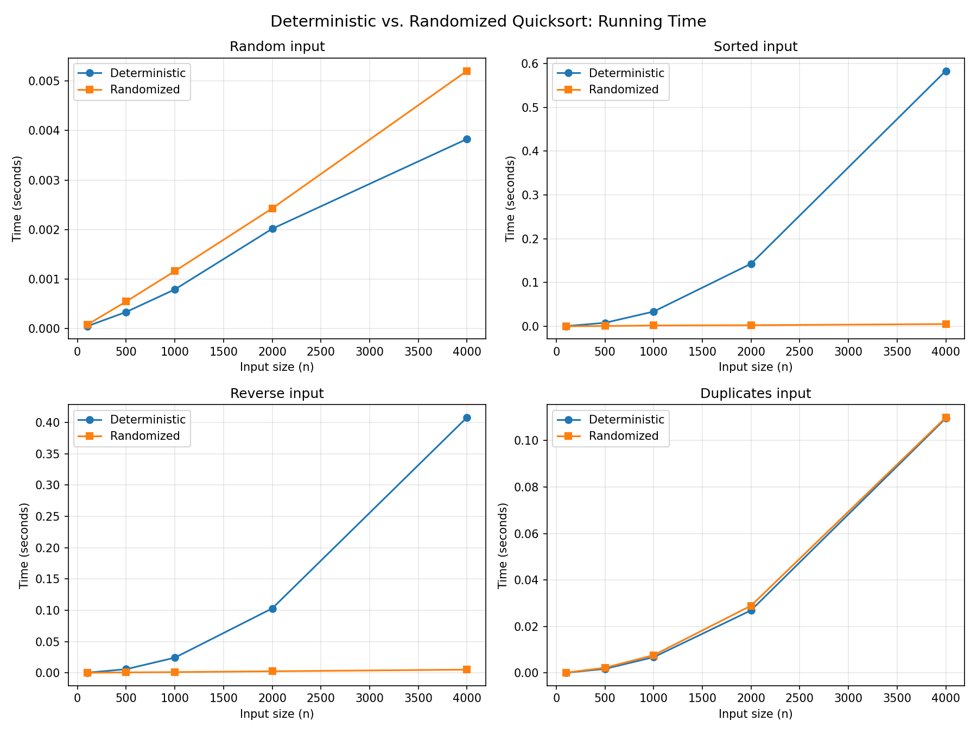
Note. Each panel plots average running time (seconds) against input size (n) for one input distribution.
What the Numbers Actually Show
Random input: both versions scale about the same, which lines up with the Θ(n log n) expectation. The randomized one is a bit slower here, maybe 30 to 40 percent, but that's just the overhead of calling random.randint at every step, a small tax you pay for the safety randomization gives you.
Sorted and reverse-sorted input: this is where things get dramatic. Look at the deterministic column for sorted input, the time roughly quadruples every time n doubles (0.0079 s to 0.0336 s to 0.1428 s to 0.5831 s going from n = 500 to n = 4000). That's the classic sign of Θ(n²) growth. Meanwhile, the randomized version barely changes at all across these same inputs, its times stay close to what was seen on random data. By n = 4000, the deterministic version is about 115 times slower than the randomized version on sorted input, and about 80 times slower on reverse-sorted input. This is a really clean, visible confirmation of the theory discussed earlier.
Duplicate-heavy input: this one was a bit surprising. Both versions slowed down together here, tracking each other almost exactly, and both were noticeably slower than you'd expect from Θ(n log n). The reason comes down to how the partition step works: it only checks whether something is less than or equal to the pivot, so when a huge chunk of the array is equal to the pivot, those equal elements still get shuffled around one at a time instead of being grouped together in one go. This creates a lopsided split no matter which of the equal-valued elements happens to get picked as the pivot, so randomizing the pivot choice doesn't actually fix anything here, because the problem isn't which value gets picked, it's that there are too many copies of it. This is exactly the issue Bentley and McIlroy (1993) point out, and they fix it with a three-way partition that groups all the equal elements together in one pass instead of one at a time. That's not something the CLRS version does, but it's a good example of how real, production-grade sorting code goes a step further than the basic textbook algorithm.
Conclusion
Basically, everything comes down to how balanced the splits are. Balanced splits give you Θ(n log n), and badly unbalanced splits give you Θ(n²). The deterministic version is simple to write, but it's fragile, it hits its absolute worst case on something as ordinary as sorted data, which is a real problem since sorted or nearly-sorted data shows up constantly in the real world. The timing tests back this up clearly: the deterministic version got 80 to 115 times slower than the randomized one at n = 4000 on sorted and reverse-sorted input. Randomizing the pivot doesn't make the worst case disappear in theory, but it makes it depend on bad luck instead of bad input, which in practice means it basically never happens. The one thing randomization doesn't fix is the slowdown from lots of duplicate values, since that's caused by how the partitioning itself works, not by which pivot gets picked. Fixing that would require a different partitioning approach (three-way partitioning), which is described in the outside reference used here, Bentley and McIlroy (1993).

Github Repo Link:

References
Bentley, J. L., & McIlroy, M. D. (1993). Engineering a sort function. Software: Practice and Experience, 23(11), 1249–1265. https://doi.org/10.1002/spe.4380231105
Cormen, T. H., Leiserson, C. E., Rivest, R. L., & Stein, C. (2022). Introduction to algorithms (4th ed.). MIT Press.
Hoare, C. A. R. (1962). Quicksort. The Computer Journal, 5(1), 10–15. https://doi.org/10.1093/comjnl/5.1.10

