Analyzing and Implementing Divide and Conquer Algorithms

Sandip Sitaula
Algorithms and Data Structures (MSCS-532-B01)
Assignment 2
07/11/2026

Introduction
Divide and conquer solves a large problem by splitting it into smaller versions of the same problem, solving each one, and joining the answers. This report studies two sorting methods that use this idea, Merge Sort and Quick Sort. For each one it explains the method, analyzes the running time and memory, and then compares real test results with the theory.

Merge Sort
The Problem and the Steps
Merge Sort begins by splitting the list into two halves. Each half is sorted separately using the same process. Once both sides are sorted, they are rejoined by comparing the first value from each half and moving the smaller one into a new list. This continues until every value has been copied over. One advantage of Merge Sort is that equal values stay in the same order they started, making it a stable sorting algorithm.
Time Complexity
Merge Sort takes about the same amount of time no matter how the input is arranged. It does not matter if the list is already sorted, in reverse order, or completely random because the algorithm always follows the same steps. It keeps splitting the list into smaller parts and then merges them back together. Because of this, its best, average, and worst-case running times are all Θ(n log n).
Recurrence Relation and How to Solve It
Merge Sort spends time splitting the list and then merging it back together. The work done in each step grows in a straight line with the input size, so it is written as cn. Since the list is divided into two equal halves, the recurrence is T(n) = 2T(n/2) + cn, with T(1) = c.
The substitution method guesses that T(n) is at most k times n log base two of n and then proves it. Placing this guess into the recurrence gives two copies of k times (n/2) log base two of (n/2). Since log base two of (n/2) equals log base two of n reduced by one, the total stays at or below k times n log base two of n when k is large enough. This gives O(n log n), and a matching lower bound gives Theta(n log n).
The recursion tree method draws the work as levels. The top level does cn work. The next level has two nodes that together do cn, the level below has four nodes that also sum to cn, and so on. The list halves at each step, so there are log base two of n plus one levels. Work per level times the number of levels gives Theta(n log n).
For the master method, a is 2 and b is 2, so the compare value is n raised to the power log base b of a, which is n. The extra work f(n) also grows like n, so the recurrence falls into the second case. That case gives Theta(n log n), matching the other two methods (Cormen et al., 2022).
Practical Implications
Merge Sort suits cases where steady speed matters more than saving memory. Its worst case is still Theta(n log n), so it never slows down unexpectedly. It is stable, which helps when sorting by more than one field, and it reads data in order, which fits sorting files too large for memory. Its cost is the extra space it needs while merging.

Quick Sort
The Problem and the Steps
Quick Sort also returns a list in sorted order but splits the work differently. It picks one item as the pivot, then rearranges the list so smaller items sit left of the pivot and larger items sit right. This partition step places the pivot in its final spot. Quick Sort then calls itself on the left and right parts. There is no separate merge step.
Time Complexity
Quick Sort is usually faster, but its speed depends on where the pivot ends up. If the pivot splits the list into two similar-sized parts, the algorithm runs in theeta(n log n) time. This is what normally happens with random data. If the pivot is always the smallest or largest value, one side becomes much bigger than the other, making Quick Sort much slower. In that case, the running time becomes theeta(n²). Choosing the pivot randomly makes this situation much less likely, so Quick Sort usually performs close to Θ(n log n).
Recurrence Relation and How to Solve It
Quick Sort has two recurrences. A balanced split gives T(n) = 2 T(n/2) + cn, the same form as Merge Sort, which the master method solves as Theta(n log n). The worst split gives T(n) = T(n - 1) + cn, since one side is empty and the other holds all but the pivot.
The substitution method handles the worst case. Guess that T(n) is at most k times n squared. Replacing T(n - 1) with k times (n - 1) squared, expanding, and adding cn keeps the total at or below k times n squared for large n. This proves Theta(n squared).
The worst case tree is tall and thin. Each level removes only one item, so there are about n levels, and the work near the top is about cn per level. The work summed across all levels grows like n squared, which matches Theta(n squared).
The master method does not apply to the worst case. It needs a form where the size divides by a constant factor, such as n over two, but the worst case shrinks by one item at a time. It still solves the balanced recurrence, so it covers the average case but not the worst case.
Practical Implications
Quick Sort is often the fastest method for data held in memory. It sorts in place, so it uses almost no extra memory, and it touches nearby memory in order, which processors handle well. Its main risk is the worst case on sorted or nearly sorted input, which a random or smart pivot avoids. Many standard libraries use a tuned form of Quick Sort for this reason, while others use a merge based method such as Timsort, which Python itself uses for its built in sort (Sedgewick & Wayne, 2011).

Implementation and Comparison
Method
Both algorithms were written in Python. The tests came in three parts. The first part timed all three methods on random data at sizes from one thousand to thirty two thousand items. The second part timed the plain Quick Sort on random, sorted, and reversed data at sizes from five hundred to four thousand items, where the worst case shows most clearly. The third part measured peak memory for Merge Sort and Quick Sort on random data across the larger sizes. Timing used a high resolution timer and reported the middle value across several runs. Peak memory used the tracemalloc tool from the Python standard library (Python Software Foundation, 2024), and a fixed random seed kept every test repeatable. The result figures were drawn with Matplotlib (Hunter, 2007).
Results
Table 1. Median running time on random data for the three sorting methods.
n | Merge Sort (s) | Quick Sort (s) | Randomized Quick (s)
1000 | 0.0016 | 0.0009 | 0.0015
2000 | 0.0037 | 0.0019 | 0.0026
4000 | 0.0077 | 0.0042 | 0.0056
8000 | 0.0166 | 0.0086 | 0.0112
16000 | 0.0355 | 0.0194 | 0.0242
32000 | 0.0783 | 0.0483 | 0.0519
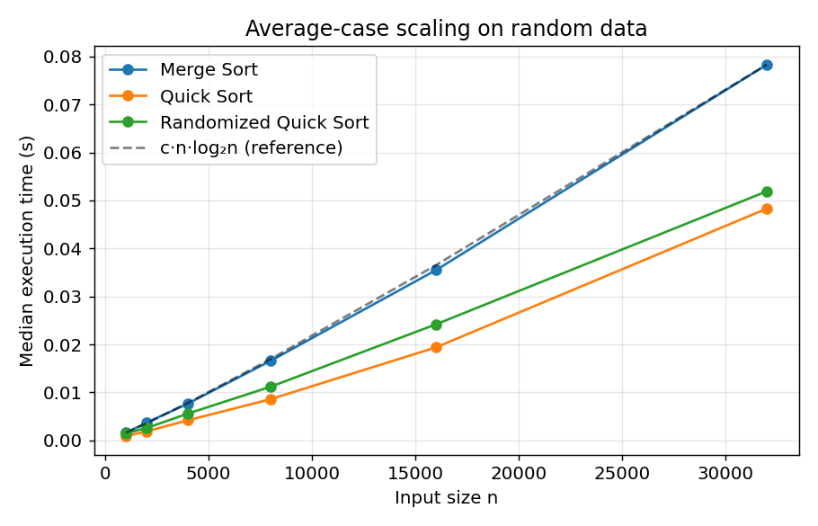
Figure 1. Average case scaling on random data. All three methods track the dashed n log n reference line.
Table 2. Running time of plain Quick Sort on random, sorted, and reversed input.
n | Random (s) | Sorted (s) | Reverse (s)
500 | 0.0004 | 0.0098 | 0.0073
1000 | 0.0011 | 0.0546 | 0.0298
2000 | 0.0033 | 0.1635 | 0.1002
4000 | 0.0050 | 0.5676 | 0.3984
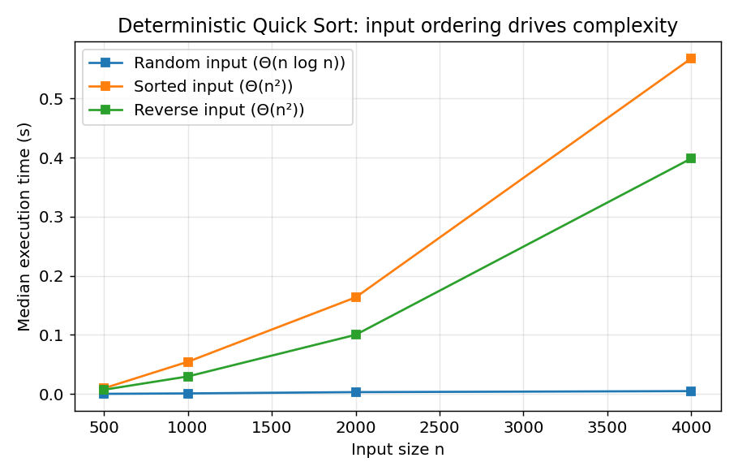
Figure 2. Plain Quick Sort. Sorted and reversed input grow like n squared while random input stays low.
Table 3. Peak memory use as the input size grows.
n | Merge Sort peak (KB) | Quick Sort peak (KB)
1000 | 16.9 | 1.2
2000 | 33.3 | 1.6
4000 | 64.8 | 1.9
8000 | 130.2 | 1.9
16000 | 264.7 | 2.0
32000 | 537.7 | 2.3
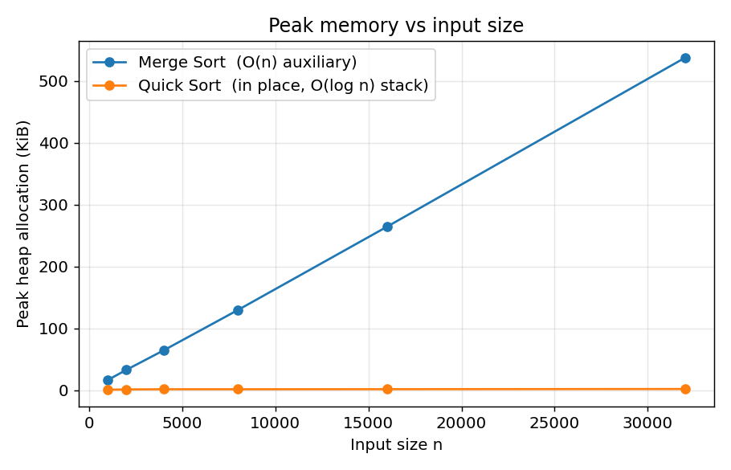
Figure 3. Peak memory. Merge Sort rises with input size while in place Quick Sort stays nearly flat.
What the Results Show
As expected, the results for the random data matched the theory. As shown in Figure 1, both algorithms followed the expected n log n trend. However, Quick Sort was faster at every input size. For example, when sorting 32,000 elements, Quick Sort finished in 0.048 seconds, while Merge Sort took 0.078 seconds. The main reason is that Quick Sort sorts the data in place. Merge Sort, on the other hand, creates additional lists during the sorting process, which adds extra work and increases the running time.

Figure 2 shows the worst-case results. Quick Sort became much slower when the input was already sorted or reverse sorted. For example, when the input size increased from 2,000 to 4,000 items, the running time went from about 0.16 seconds to about 0.57 seconds. That is close to the expected O(n²) growth. It is not exactly four times larger because of small overhead and other constant costs, but the overall pattern is still clear. Random data stayed much faster. At the largest input size, the sorted list took about 40% longer than the reverse-sorted list because of the way the pivot was chosen during partitioning.
Memory also matched the theory. Figure 3 shows Merge Sort rising from about 17 to about 538 kilobytes, while Quick Sort stayed near 2 kilobytes since it sorts in place. This confirms O(n) extra space for Merge Sort and only a small stack for Quick Sort.
Where Theory and Practice Differ
The randomized Quick Sort was slightly slower than the plain version on random data. Both grow at the same rate, so the gap comes from calling the random tool once per partition. On already random data the random pivot adds cost with no benefit, and its value shows only on ordered input. The low memory reading for Quick Sort reflects its in place work, since it allocates almost nothing on the heap. The tool measures heap allocations and does not count the space used by the call stack, so the depth of the recursion does not show up in the figure.

Conclusion
Both algorithms uses divide and conquer technique and shows a performance level of Theta(n log n) on normal inputs. Merge sort sacrifices additional space complexity for constant time complexity, whereas Quick sort sacrifices its worst-case performance for higher average speed and lower memory usage. The results of the testing confirmed the theory, with small differences being due to the hidden constant and space complexity, and not the order of growth.

GitHub Repository
The full source code files are available in the repository linked below.
https://github.com/sitaulasandip/MSCS532/tree/main/MSCS532_Assignment2

References
Cormen, T. H., Leiserson, C. E., Rivest, R. L., & Stein, C. (2022). Introduction to algorithms (4th ed.). MIT Press.
Hunter, J. D. (2007). Matplotlib. A 2D graphics environment. Computing in Science and Engineering, 9(3), 90 to 95.
Python Software Foundation. (2024). The Python standard library. Python Software Foundation.
Sedgewick, R., & Wayne, K. (2011). Algorithms (4th ed.). Addison Wesley.

