Encapsulation, Inheritance, and Polymorphism in a Ride Sharing System: C++ and Smalltalk

Sandip Sitaula
University Of Cumberlands
MSCS 632: Advanced Programming Languages
October 4, 2026
Encapsulation, Inheritance, and Polymorphism in a Ride Sharing System: C++ and Smalltalk
This report explains how a class-based ride sharing system demonstrates encapsulation, inheritance, and polymorphism in C++ and in Smalltalk. Both versions model a base Ride class, three ride subclasses, a Driver, and a Rider, and both produce identical fares for the same five sample trips, totaling $75.30.
Encapsulation
In C++, encapsulation is enforced by the compiler through access specifiers (Stroustrup, 2013). Every data member of Ride, Driver, and Rider is private. A driver's assignedRides vector can be changed only through addRide() and inspected only through rideCount(), totalEarnings(), and getDriverInfo(); an expression such as dana.assignedRides does not compile. The vector holds shared_ptr<const Ride>, so a driver cannot alter a ride it was given, and constructors throw std::invalid_argument for invalid values such as a zero distance.
Smalltalk has no access modifiers because instance variables are always private to their object; other objects can interact with it only by sending messages (Goldberg & Robson, 1983). Driver simply defines no assignedRides method, so when the demo sends that message, Pharo raises MessageNotUnderstood, which the program catches and reports. Validation lives in class-side constructors that signal a custom RideSharingError. The main difference is timing: C++ rejects a privacy violation at compile time, whereas Smalltalk rejects it when the message is sent.
Inheritance
Both versions share one hierarchy: StandardRide and PremiumRide inherit from Ride, and SharedRide inherits from StandardRide. In C++, StandardRide inherits the base constructor with using Ride::Ride, PremiumRide passes its base arguments through a member initializer list, and SharedRide::fare() reuses its parent's calculation by calling StandardRide::fare() before applying a 40% pool discount.
In Smalltalk, a subclass is created by sending subclass: to the parent class, and it inherits both instance variables and class-side methods (Black et al., 2009). The PremiumRide constructor calls the inherited id:from:to:miles: method; because self is the PremiumRide class, the inherited method answers a PremiumRide rather than a plain Ride. SharedRide reuses its parent's calculation with super fare.
Polymorphism
In C++, fare(), rideType(), and rideDetails() are declared virtual and redefined with override, which lets the compiler confirm that each redefinition matches a base-class method. The program stores every ride in a std::vector<std::shared_ptr<Ride>> and calls fare() and rideDetails() in a loop, and dynamic dispatch selects each subclass's version at run time.
In Smalltalk, every message send is dynamically bound, so no virtual keyword is needed (Goldberg & Robson, 1983). The rides are stored in an OrderedCollection, and rides do: [:ride | ride rideDetails] sends the same message to every object, each of which responds with its own method. Any object that understands fare and rideDetails could join that collection, whereas C++ requires a common base class.
References
Black, A. P., Ducasse, S., Nierstrasz, O., Pollet, D., Cassou, D., & Denker, M. (2009). Pharo by example. Square Bracket Associates.
Goldberg, A., & Robson, D. (1983). Smalltalk-80: The language and its implementation. Addison-Wesley.
Stroustrup, B. (2013). The C++ programming language (4th ed.). Addison-Wesley.

GitHub Repo: https://github.com/sitaulasandip/MSCS632_APL/tree/main/assignment_5
C++ Implementation
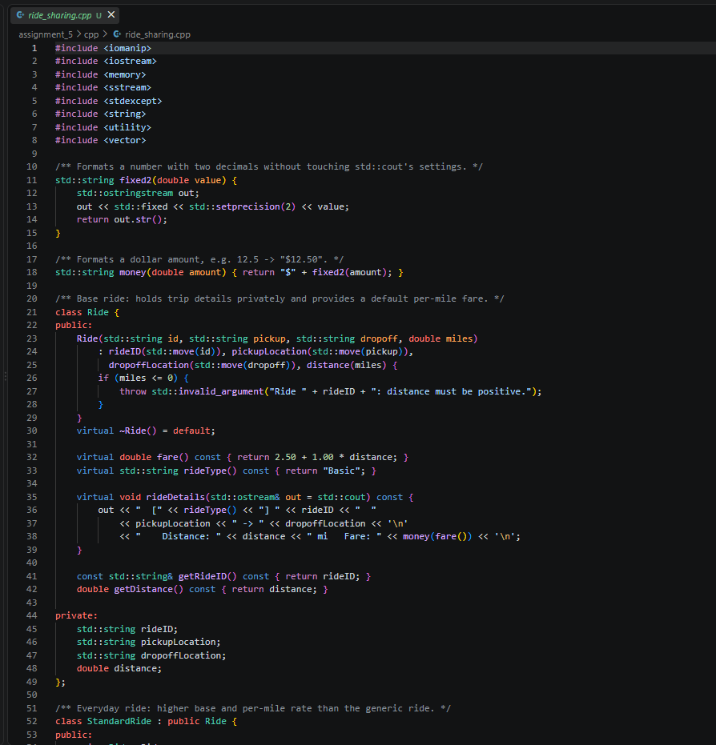
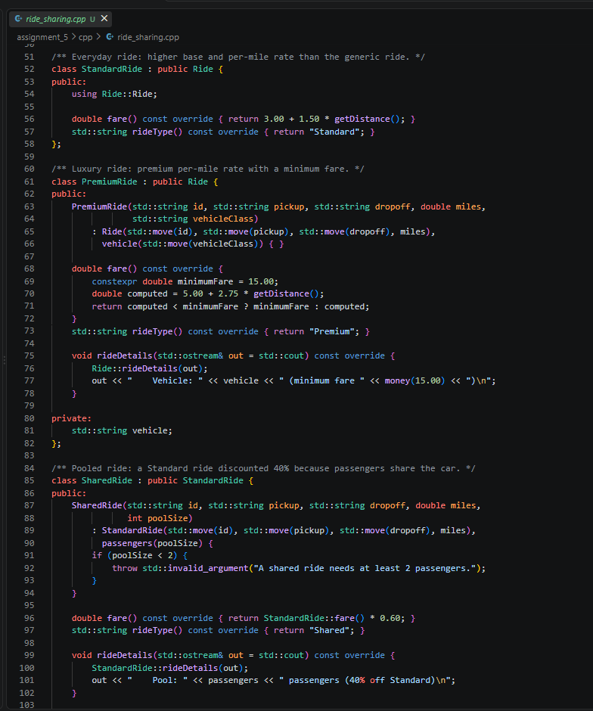
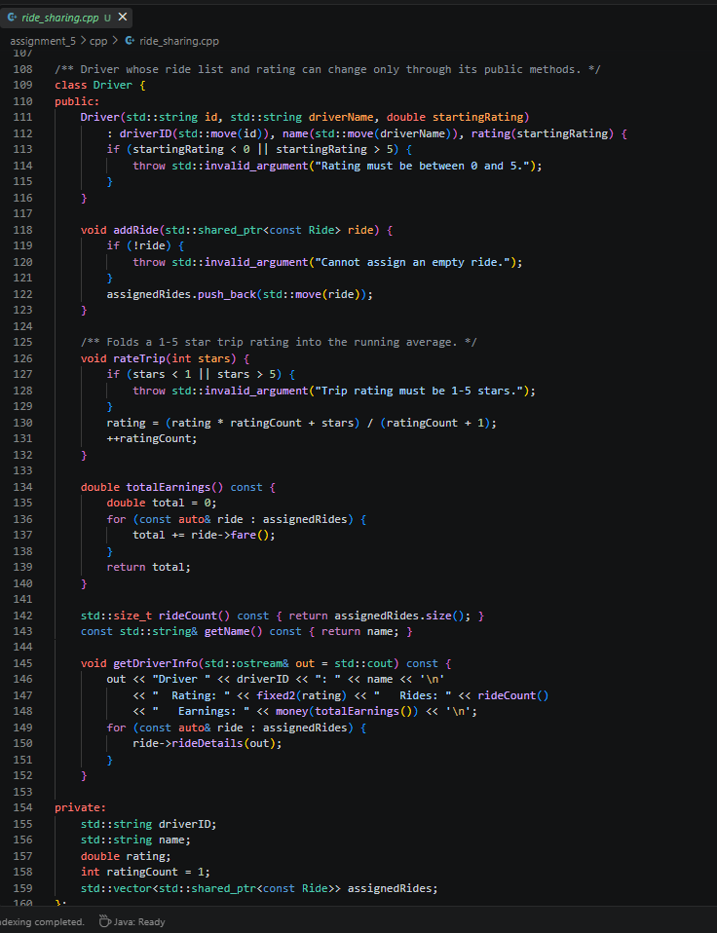
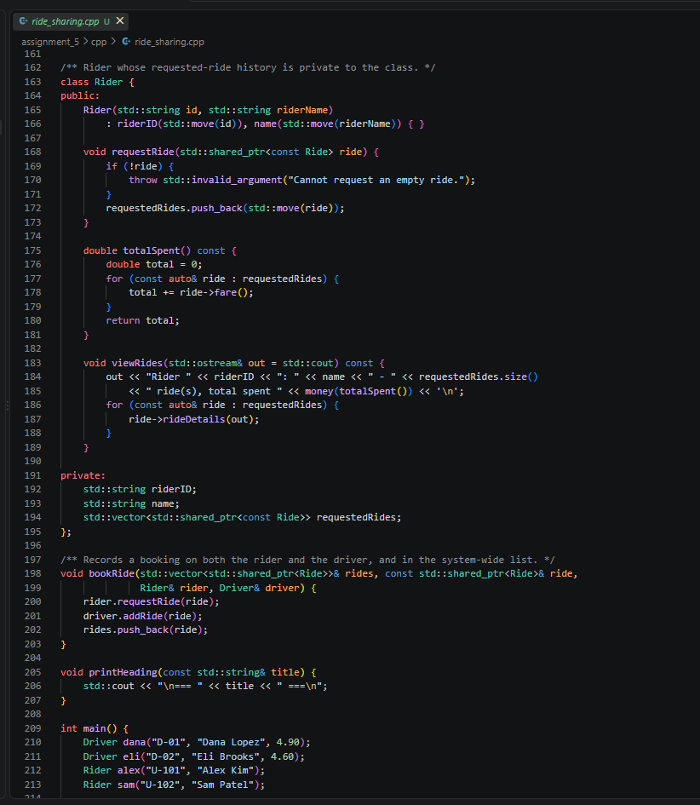
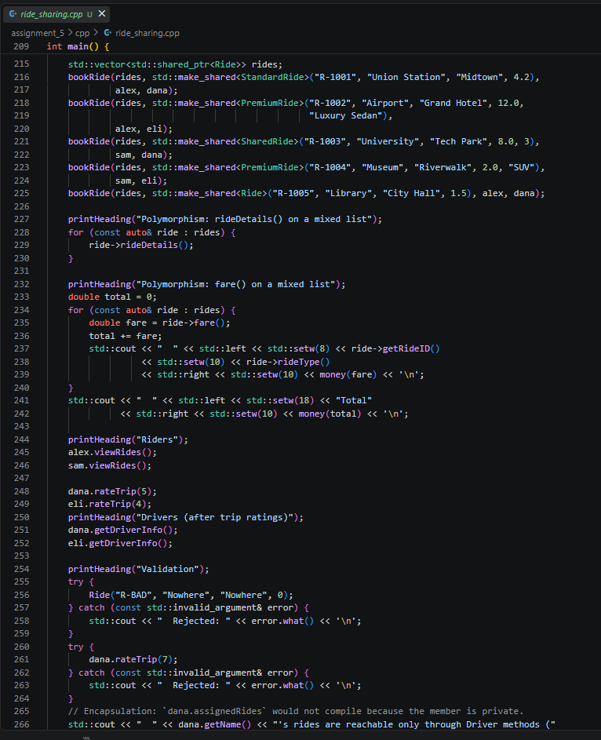

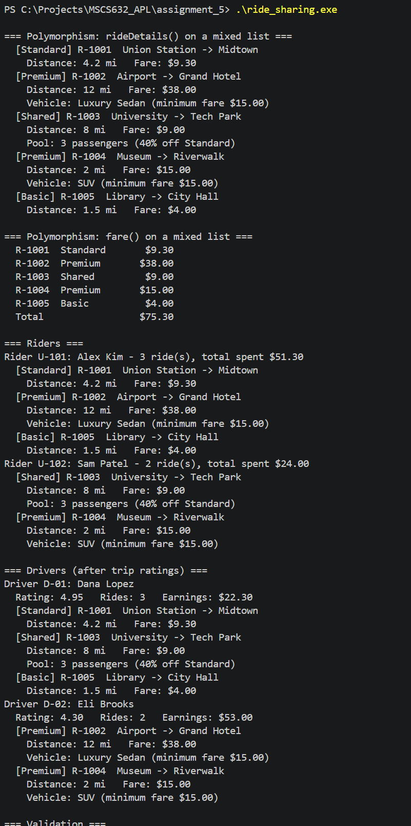

Smalltalk Implementation
