Option Changed to “Build with Parameters”

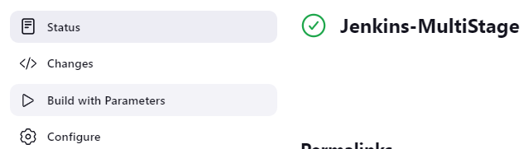

Select Stage:

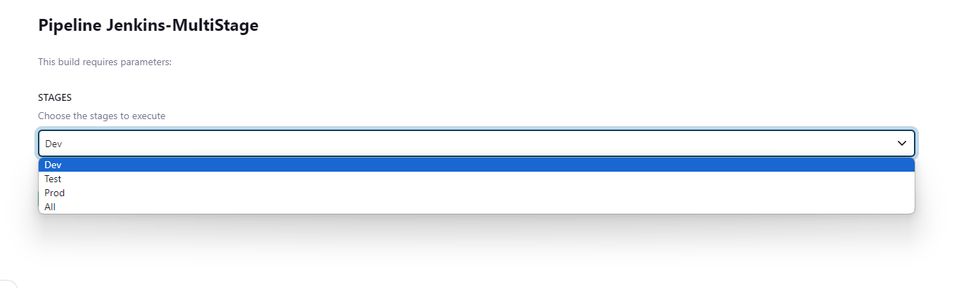

Console Output shows builds result for each Stage:

