April Auger

December 19, 2019

Exercise 1.4 – TypeScript

**SCREENSHOT OF CLI WINDOW WITH THE TRANSPILE COMMAND**

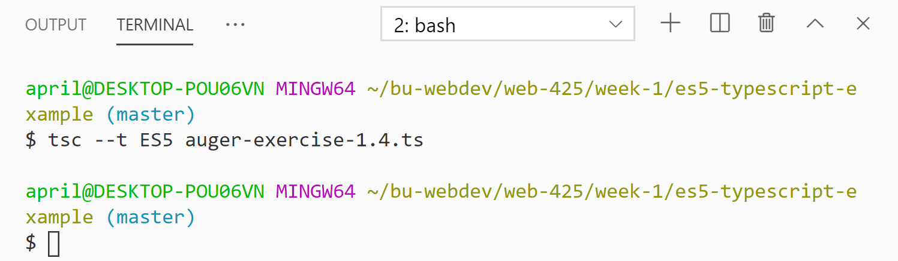

**SCREENSHOT OF FOLDER STRUCTURE CONTAINING BOTH FILES**

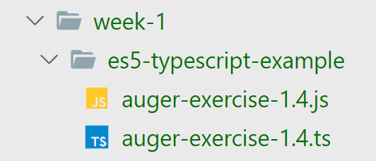

**SCREENSHOT OF OUTPUTTED MESSAGE**

