April Auger

January 7, 2020

Exercise 2.2 – One-Way Binding

GitHub Repository: <https://github.com/sitepioneers/web-425>

**Pre-Click**

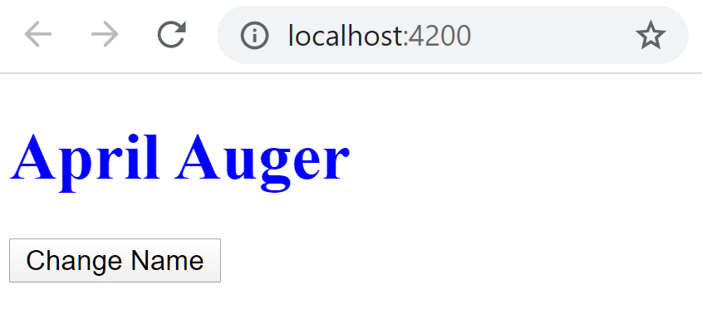

**Post-Click**

