April Auger

January 15, 2020

Exercise 3.3 – Child Routes

GitHub Repository: <https://github.com/sitepioneers/web-425>

**Home**

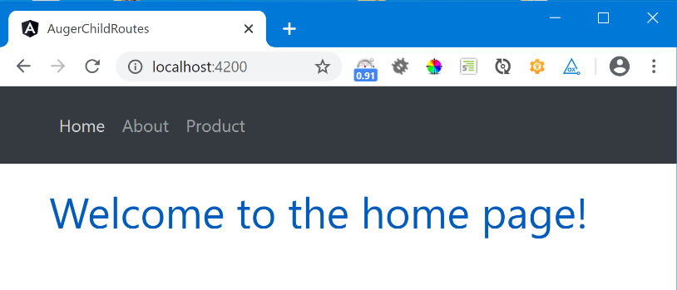

**Product Description**

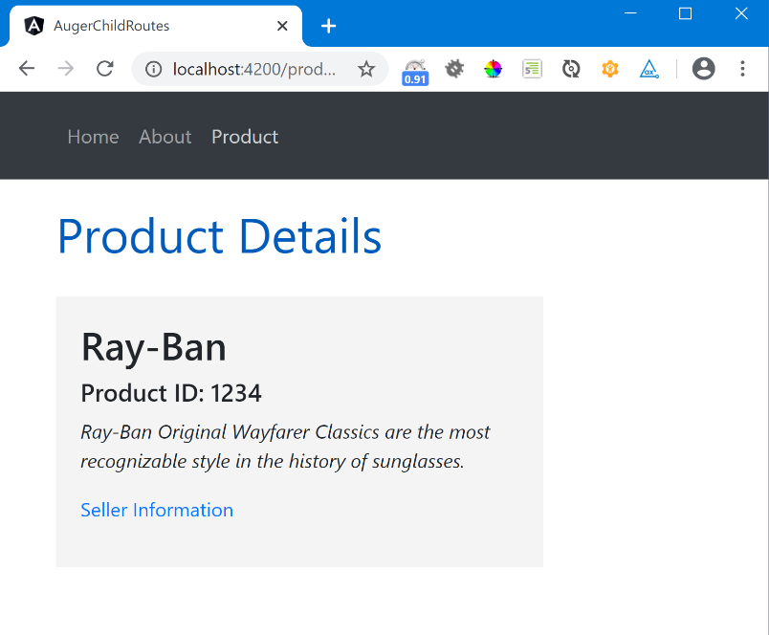

**Seller Information**

