April Auger

February 20, 2020

Exercise 8.2 – Server-Side Communications with Node.js and Express

**Screenshot of http://localhost:3000**

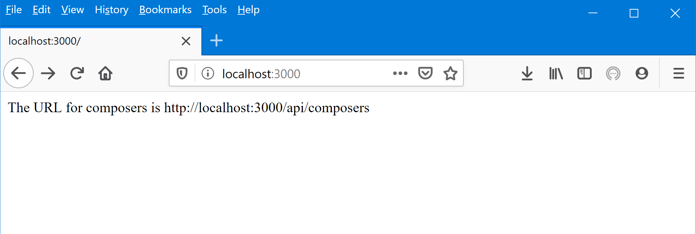

**JSON and Raw Data Screenshots for http://localhost:3000/api/composers**

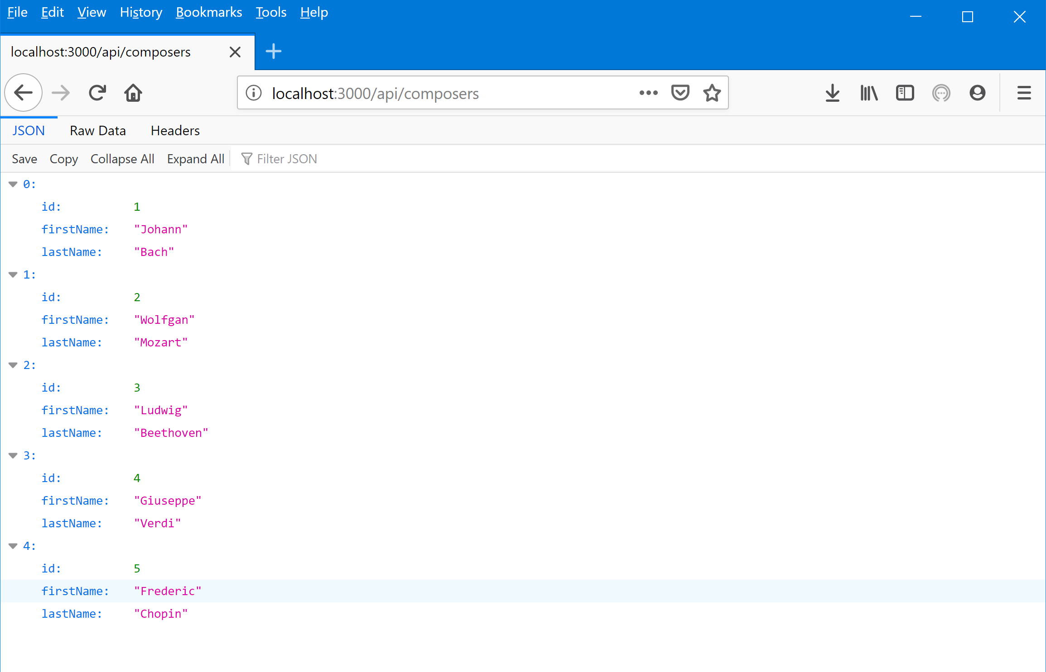

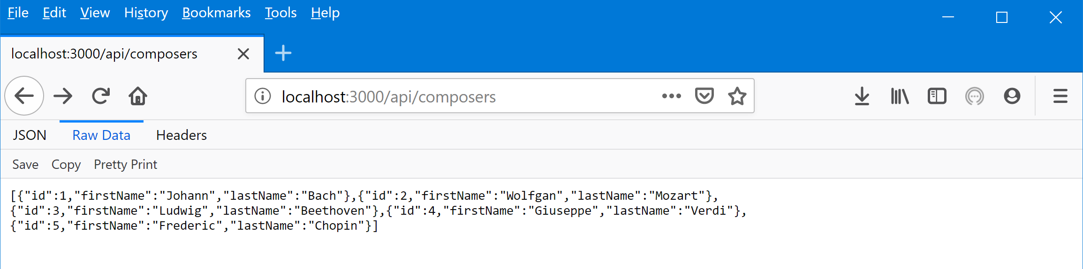

**JSON and Raw Data Screenshots for** [**http://localhost:3000/api/composer/1**](http://localhost:3000/api/composer/1)

