**Group members: Alec Waters Tom Wanous Elsa Freudenthal Folly Quevi-Attakpla Nawaf Alharbi**

*Please, sign*

**Milestone 2: Organization and Business Background** (5 Points)

**Group: HBTS Organization/System: The Fan Zone**

2-1. Hand in this checklist with your Milestone 2 submissions. Each group member must initial below.

2-2. Include copies of group meeting agendas and summary notes. Each group member should take turns preparing agendas and notes.

At least two pagesthat provide background about the organization. Include information to satisfy the following four requirements (*):

2-3.* Include a mission statement if available. If no formal mission statement exists, create a proposed mission statement based on what you know about the organization.

2-4.* List organization/business goals, values/objectives/critical success factors. If written material is available from your source, use it with attribution. If none is available, say so and list your best guess at what they would be, based on information you have obtained. If company reports, brochures or websites exist with this information, include those documents in the workbook and simply refer to them. Do not waste time rewriting material that is readily available.

2-5.* Describe the organization type (business, government, non-profit), industry (retail, manufacturing, professional services, etc.), a description of product and/or services, and customers (internal and external). Provide a brief history, including years in operations. Describe size, by whatever measures are appropriate: total revenues, employees, profits, size relative to industry or competitors, etc. (use estimates if necessary, but identify them as such. Include significant history, growth, decline or reorganization. Compare or contrast with the organization’s industry if relevant. Include management expectations for future changes and/or growth, significant competitive threats and significant opportunities, if any. Discuss potential impact of government regulations and/or economic changes. Characterize employees by experience, skills and attitude if possible. If employee turnover or difficulty in hiring skilled employees is an issue, say so. ). If transactions are involved, describe them by volume, seasonality, complexity, uniformity or whatever other characteristics are appropriate. If you find additional information not already listed that helps to understand the organization, include it.

2-6.* In the discussion above, describe the organization's information systems development maturity level using the Capability Maturity Model (CMM,<http://en.wikipedia.org/wiki/Capability_Maturity_Model> ).

2-7. On a separate sheet, include an organization chart. It is not necessary to list names unless key individuals need to be identified. The goal should be to understand the organization's structure and key stakeholders. Note that the organization structure is sometimes considered a private internal document.

2-8. One to two pages of diagrams plus supporting text. Provide a high level generalized description of the “system” you are to study. Describe the significant subsystems that are within the scope of your study, their inter-relationships, dependencies, and interfaces to each other and to the environment. This diagram will be reviewed to ensure the scope of your study is not too broad. The diagram style is to be determined by the group.

2-9. One to two pages: Describe known **problems** within the existing system, and based on preliminary analysis identify anticipated **benefits from system modification**. Include a brief review of possible **alternative routes** for a solution.

2-10. Which SA&D methods (modeling, structured analysis, object oriented analysis, RAD, agile, outsourcing, etc.) are most appropriate?

2-11. Preliminary Gantt and PERT chart listing project tasks, expected duration, dependencies, etc.

Create using Microsoft Project, available in the student computer labs.

_______ _______ _______ ________ _______

The Fan Zone is a retail business, currently operating out of two stores, one in Willmar, MN and St. Cloud MN. They sell sports memorabilia, sports cards, Magic: The Gathering product, and other items that the community that the store grows would like to see. As a retail business, their main business goal is to move as much product as they can when it comes in, but also to tailor their inventory to what the community of players and collectors wants, so as to better serve their needs. For the purposes of this project, we will be working directly with the store in St. Cloud, and if they like what we have to offer, will then bring the subject up to the Willmar store for possible adoption there as well. The St. Cloud location has been in operation since the Fall of 2014, and is currently run by a single manager and 3 part-time employees during the store hours. Compared to other stores in the area that have been around longer, the Fan Zone has been able to build a loyal customer base who comes in to buy product and play in tournaments at least once a week, sometimes more. The current business partners are expecting more growth to the store as the amount of tournaments that go on brings in more people, with the possibility of opening a third store in another city being a goal for sometime in the near future.

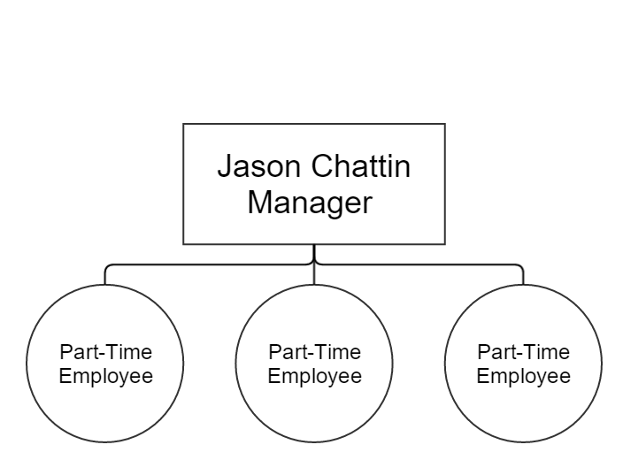

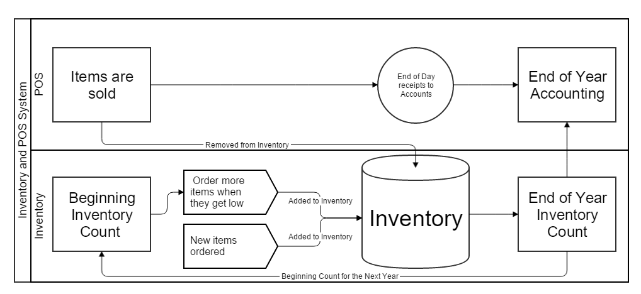

The above diagram is a rough description of the current system used to track inventory at the Fan Zone. Basically, at the end of each calendar year, the store takes a full inventory count of everything in the store, which will then be used for the end of year accounting process and as the next years Beginning Inventory Count. Then during the year, as items are sold, items are ordered by the manager when they seem to be getting low, and then added to the store shelves to be sold as space becomes available on the shelves. Throughout the year as well new items are ordered and added to the shelves, replacing older items that are no longer in stock rotation or in the case of trading card games may have been removed from the most current format. These items are then ordered on a regular basis, until at a point they too rotate out for newer product. On the Point-of-Sale (POS) side, they currently only keep track of what different types of items have been sold, i.e. trading card singles and general merchandise. At the end of the day they then print a receipt that details these items, record it for their account, and then store it until they need to send the totals to the accountant for recordkeeping. This process is then repeated throughout the year, until the end of it, at which time an inventory count is taken for accounting purposes. The only inventory numbers they have are the beginning and end, otherwise throughout the year no accurate record of merchandise is kept. The POS uses cash register terminal to record all of the sales, a computer for looking up single trading card prices, and a credit card machine for recording any sales using a Debit or Credit card.

Current System Analysis:

In talking with the manager, the biggest flaw of the current system is that no accurate record is kept of the inventory in the store, which could lead to product having been stolen some time throughout the year and there would be no way to tell at the end of year count. Along with this, the current system does not allow for clear communication between the stores about the product that they have available at the stores, so whenever a customer wants a product that the store doesn’t have, they have to call and hope that someone at the other store knows what they are looking for. The major benefits of modifying this system to using an integrated Inventory and POS system would be that throughout the year, items would be more accurately recorded of, allowing for management to decide what items to continue to order for the next year and what products they should stop ordering due to low rate of return. It would also allow for the stores to better communicate with each other on what inventory the other has, and be able to submit transfer request for items from the other store, which could then be fulfilled at the end of each business day or a specified time each day. Finally, the change to the Inventory system would allow for management to more accurately track orders that they have with vendors, so they don’t order more than the stores may need. Another route that could be taken could be individual spreadsheets of the items that the stores want to keep track of kept on Google Drive, that both stores could access and update at anytime, or an application could be built from the ground up with the specifications of the stores, such as an inventory system that both stores could access. However, there is no need to reinvent the wheel in the inventory management software world, as there are many developed integrate POS and Inventory systems already out there that allow for multiple store inventories, order tracking, and they can create their own financial documents on how much the inventory is returning to the business in sales. We believe that this would be the best route for the Fan Zone, as it is much more secure for the business than an application that would be developed in about 3 months.

**2-10: Most appropriate SA&D Methods**

Since the main task we will be handling is constructing an inventory system, object-oriented design would be highly beneficial. Since the approach keeps in mind all stakeholders involved (including the customers), OOD aims to have data stored in one place, which not only makes it more accessible but makes new entry more feasible.

Another project we brought forth is designing a feed that pulls The Fan Zone’s Facebook posts and brings it directly into their website. If this is something that is pursued in tandem with inventory, agile methodology would be appropriate. This line of thinking would make it easier to work on both projects while being able to backtrack if necessary.

**2-11: Gantt Chart**

