**Milestone 3: Requirements Identification and Analysis** (6 Points)

**Group: HBTS Organization/System: The Fan Zone**

3-1. Hand in this checklist with your submissions. Each group member must initial below.

3-2. Include copies of group meeting agendas and summary notes, inserted into the "Agendas" tab in the back of the workbook. Each group member must take turns preparing agendas and notes.

3-3. In one page, describe which requirements analysis techniques are best suited for collecting information about the system requirements. Briefly summarize why each technique would or would not be useful in the current project. (Discuss research, sampling, observation, questionnaires, interviews, prototyping, joint requirement planning, etc.)

3-4. Collect input forms, screen prints (or screen diagrams if screen prints are not available), sample reports, written policies and procedures. Collect samples of both blank input forms and samples that are filled in with data. Be sure to get examples of routine and exceptional transactions. If confidentiality is an issue, create a dummy form/screen with simulated data, or black out confidential information. *Keep in mind the problem the analysis is trying to understand. Do not include documents, printouts, etc. that do not relate to the issues being studied* **(refer to 2-9)**

3-5. Problem Statements summary, listing urgency, visibility, preliminary benefit, ranking, proposed solution.

3-6. Create and fill in a document similar to the "**Request for Systems Services**" (see template in the book).

3-7. Draft Statement of Work (SOW).

3-8. Any other documents and/or output from techniques that are useful to the analysis and not already listed.

**Group members: _________ ___________ __________ _________ ___________**

*Please, sign*

3-3 Analysis Techniques

**Observation**

Through our observations of how the Fan Zone currently maintains their inventory, we can put together a better plan to implement a new inventory system to better track what products are in their inventory. After this, we can figure out the questions that we will ask the manager to better fit the system to his and the employees needs. Through conducting our own observations, we will also get a better feel for the general business environment, which will also help to tailor the solution that we help them implement.

**Interviews**

This will be our primary source of information for the project. Face to face interviews with the manager and employees about the questions that we have from our observations and any input that they have for us will be the best way to communicate any requirements that they have for the solution and any restraints that come along with that. This will also be the best time to find any disagreements between what we are looking to propose and what they are looking for, which will allow for better development on our end.

**Prototyping**

This analysis will be very important in gaining information about what constraints we need to take in the programming, and any constraints that come along with the computer system that they have at the Fan Zone. This will also be a good time to decide whether or not we will be developing the program in-house, or if we will take an already existing solution available and help to tailor that to the needs of the business.

3-4 Input Forms

Currently the Fan Zone does not have any way to track what products that they have in the store in real time, and have to rely on just keeping track in an excel sheet, so that they know when they need to be ordered. The only official count of the inventory happens at the end of the year for accounting purposes. Pictured below is their current POS, which will stay with any system that we implement, and the inventory system will be maintained on their computer system next to the register.

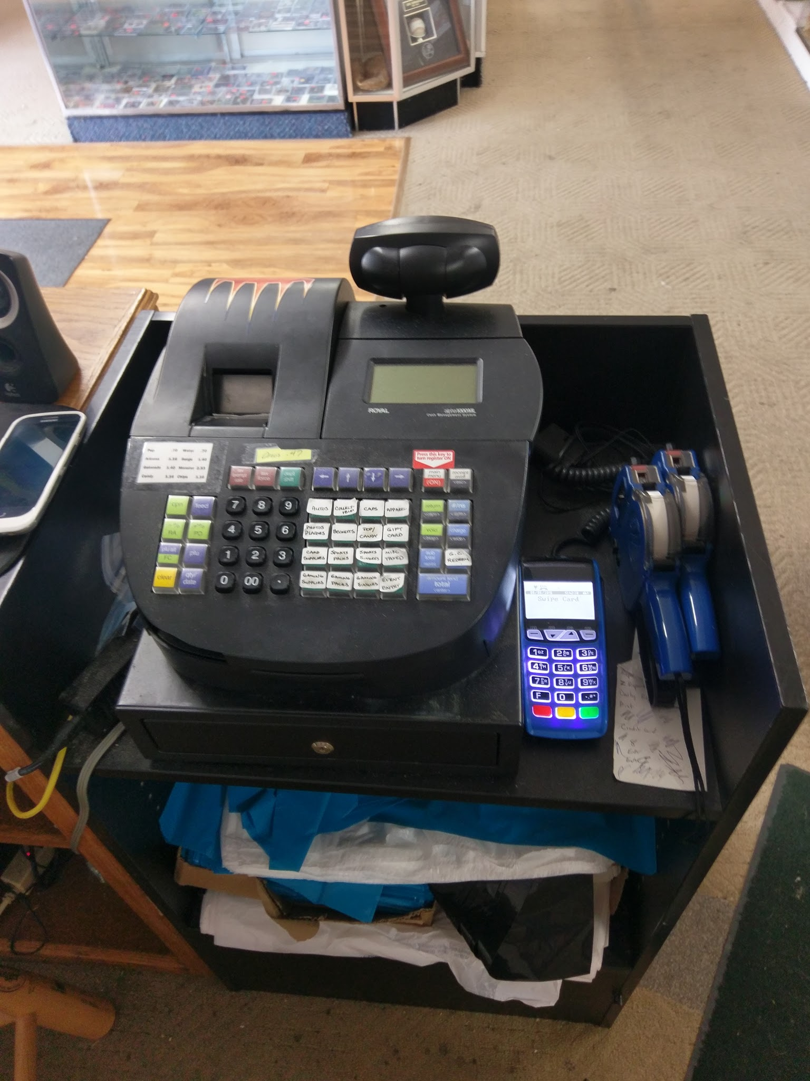

3-5 Problem Statements Summary

|  |  |  |  |
| --- | --- | --- | --- |
| **Problem** | **Priority** | **Description** | **Proposition** |
| Lacking Inventory System | High | Merchandise being checked out must be manually entered – no barcode scanning. There is also no automation of merchandise, if something needs to be found it is by personal knowledge. | Create an automated system with SQL Server Database to automate flows and allow merchandise information to be stored and accessed. |
| Website Outdated | Medium | Fan Zone website has not been updated in months, and functions such as item sorting are broken. | Re-coding of functions, and possibly create feed from Facebook posts to website as to create easier updates. |
| Finding Inventory Between Stores | Medium | Two Fan Zones exist in Minnesota, and neither can communicate electronically what merchandise they have on hand. If one store needs something specific, it is not practical to check to see if the other has it. | This goes along with creating the inventory system with SQL Server Database, giving both stores equal access and automation. |

3-6 Systems Service Request

***Husky business & technology solutions (HBTS)***

***Request for Systems Services***

***Requested by: Nawaf Alharbi Date: 9/23/26***

***Department: Information Systems***

***Location: 720 4th Avenue South***

***St. Cloud, MN 56301-4498***

***Contact: Email: alna1201@stcloudstate.edu***

***Type of request:***

*( X ) New System.*

*( ) Immediate – Operation are impaired or opportunity lost.*

*( ) System Enhancement.*

*( ) System Error Correction.*

***Urgency:***

*( ) Immediate – Operation are impaired or opportunity lost*

*( ) Problems exist, but can be worked around*

*( X ) Business losses can be tolerated until new system installed*

***Problem Statement:***

*Merchandise being checked out must be manually entered – no barcode scanning. There is also no automation of merchandise, if something needs to be found it is by personal knowledge. Fan Zone website has not been updated in months, and functions such as item sorting are broken. Two Fan Zones exist in Minnesota, and neither can communicate electronically what merchandise they have on hand. If one store needs something specific, it is not practical to check to see if the other has it.*

***Service request:***

*I request a thorough analysis of our current operations with the intent to design and build a completely new information system. This system should handle all purchasing transaction, support display and reporting of critical purchasing data, and assist purchasing agents in commodity buying.*

*IS LIAISON:*

*SPONSOR:*

***---------------------------------- TO BE COMPLETED BY SYSTEMS PRIORITY BOARD ------------------------------------***

*( ) Request approved. Assigned to:*

*( ) Recommend revision. Start date:*

*( ) Suggest user development.*

*( ) Reject for reason:*

3-7 Statement of Work



Company: Fan Zone

**Introduction**

Fan zone is a sports cards and collectibles shop located in Waite Park and Willmar Minnesota. They carry a vast majority of cards from top sports league for example like the NBA and NFL. Most of the collection is based on Minnesota home teams like the Timberwolves and the Vikings. But they do also carry some of the popular local teams or well known franchises like the Green Bay Packers. Currently fan zone has a problem with their inventory system for cards. It requires the employees to have knowledge and remember if certain cards are carried. Also tracking the card to see if it’s on hand. No simple search system to show if the product is in stock. The same system is used to locate merchandise and that could be hard since counts can get mixed up or not have the right size for the customer.

**Objective**

Husky business & technology solutions has met with Fan Zone and after meetings and a look into their inventory systems. We’re planning on providing a new system of keep track of the cards Fan Zone has in stock to make the process faster and get the customer on there way. Also we plan on fixing up the inventory system of the merchandise in store so we can meet the specific accommodations the customer might be looking for so we wouldn’t have to always rely on personal knowledge.

**Scope of work**

Since Fan zone has been around for awhile it’s a popular store among card friends. We plan on creating an automated system with SQL Server Database to keep track of the card inventory in stock. This way whenever a new card comes in the store. It’ll be inserted in the inventory system. So when a customer's comes the card can be found and access. No Need for employee knowledge to find the item. Also we’ll implement this system for their merchandise system. After this system is implemented we hope it can attract more customers and move sales throughout the day between two stores. Another priority is to have an implementation so each other can electronically access each other stores inventory to better attend customer needs. We believe certain stores might carry more of a specific card then the other stores do to what’s could be popular in that area. This system will cut out time and easier access to more cards.

**Period of performance**

We plan to have this system completed by the last day of the class. December 8th 2016.

**Location of work**

Husky business & technology solutions (HBTS)

720 4th Ave S, St Cloud, MN 56301