**Milestone 4: Process Analysis – Data Flow Diagram**  (6 Points)

**Group: HBTS**

**Organization/System: The Fan Zone**

4-1. Hand in this checklist with your submissions. Each group member must initial below.

4-2. Include copies of group meeting agendas and summary notes. Each group member must

take turns preparing agendas and notes.

**4.3** Following the Event-Driven Process Modeling Strategy, prepare the following for your group project.

4-3-1. High level system context diagram.

4-3-2. Functional Decomposition diagram (Level 0 DFD).

4-3-3. Use Case List and a High Level Use Case Diagram (same detail as Level 0 DFD).

4-3-4. Event Decomposition Diagram (Level 1 DFD).

4-3-5. Data flow diagrams for each event (Level 2 DFD).

4-3-6. At least one decision table or decision tree that explains the logic involved in a process that was included in the system data flow diagram.

4-98. Any other documents and/or output from techniques that are useful to the analysis and not already listed.

**Group members: _________ ___________ __________ _________ ___________**

*Please, sign*

**4.3-1: Context Diagram**

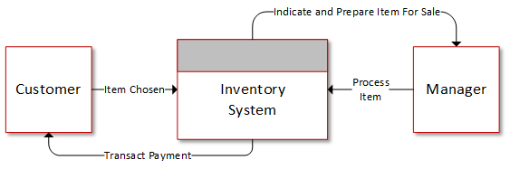

**4.3-2: Level-0 Diagram**

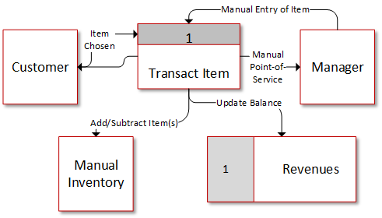

NOTE: Because there is not inventory system that tracks the items that are in the store, the diagrams above are the most detailed that they can be, do to the lack of complexity in the system itself.