**Milestone 5: Data Analysis – Entity Relationship Diagram** (8 Points) **Group: HBTS Organization/System: The Fan Zone**

5-1. Hand in this checklist with your submissions. Each group member must initial below.

5-2. Include copies of group meeting agendas and summary notes. Each group member must take turns preparing agendas

and notes. Organize these into a separate tab in the back of the book.

5-3. Create an Entity Relationship Data model. The following items are required:

A preliminary list of entities/attributes. Identify those things that should be kept track of. Anything that the system should capture, store or produce information about. If you anticipate a possible future need to track entities, include them now (Example: a business with a single "data store" that may expand to multiple locations in the future). This is a preliminary working list, so revisions are normal. Use this list to separate entities from attributes.

A finalized list of entities, and their "Business Definition". Give a brief description of each entity, and list any assumptions about each. Note any system objectives that the data model should help accomplish.

A Context Data Model. Show the relationships between entities with one simple diagram per relationship (most will pairs: binary degree). Several relationships can be shown on a single page. Label the relationships with a short verb phrase. Identify cardinality (one to one, one to many, many to many, optional, mandatory, minimum, maximum etc.).

A Key-Based Data Model. At this stage all many to many relationships must be resolved with associative entities. Primary key attributes must be identified for all entities. Foreign key attributes must be identified for each entity on the many side of a one to many relationship.

A Fully Attributed Data Model. Each attribute should describe one entity (except foreign keys).

5-4. Normalization. Eliminate repeating groups/multi-valued attributes (1NF). For any entities with compound primary keys, all attributes must be defined by the full key (2NF). Identify and eliminate any attributes that are derived from other attributes. For entities with non-compound keys, check for attributes that are dependent on other attributes (3NF). Finally, review for simplicity and eliminate redundancy. Include a brief statement of your findings, and changes, if any.

**Group members: _________ ___________ __________ _________ ___________**

*Please, sign*

**5-3.1: Entity Relationship Data model**

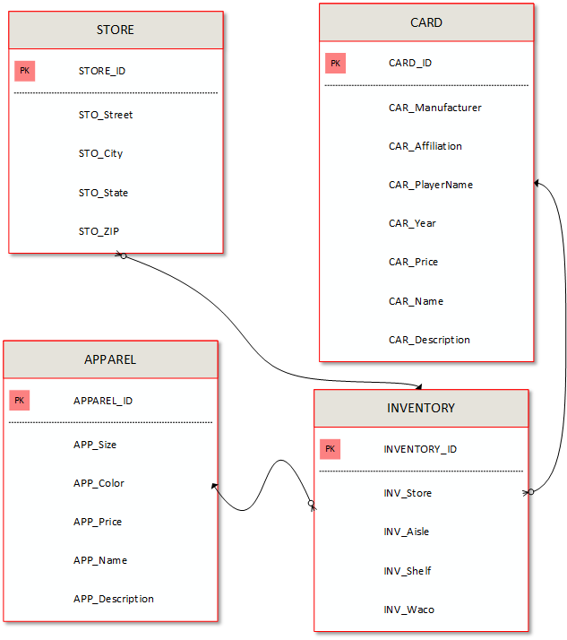

**Business Definitions**

**STORE**

STORE_ID The store’s unique ID Identifier

STO_Street Street location of store

STO_City City that store is located in

STO_State State that store is located in

STO_ZIP Zip code that store is located in

**CARD**

CARD_ID The card’s unique ID identifier

CAR_Manufacturer Name of the card manufacturer

CAR_Affiliation Affiliation/Genre/Type of the card (ex: football, baseball, pokemon, etc.)

CAR_Name Name on card

CAR_Year Year card was distributed

CAR_Price For sale cost of card

**APPAREL**

APPAREL_ID The apparel’s unique ID identifier

APP_Size The apparel size (S, M, L, XL, 2XL, etc.)

APP_Color The color of the apparel (black, gray, red, etc.)

APP_Price For sale cost of apparel

**INVENTORY**

INVENTORY_ID The inventory’s unique ID identifier

INV_Store Which store the inventory is stored at

INV_Shelf Which shelf the inventory is located on

INV_Waco The specific bin in which the inventory is located

**5-4: Normalization**

