HTML Editor

Release 2

Team C

Braxton Frederick, Andrew Vogler,   
Arron Reed, Adam Audycki, Dylan Hogue

**Introduction**

Our team was assigned to design a text editing program for HTML coding, able to open a File and have text or HTML constructs inserted, as well as making said text/constructs editable via keyboard entry or through menu selections that automatically add in changes to the page.

**High Level Design**

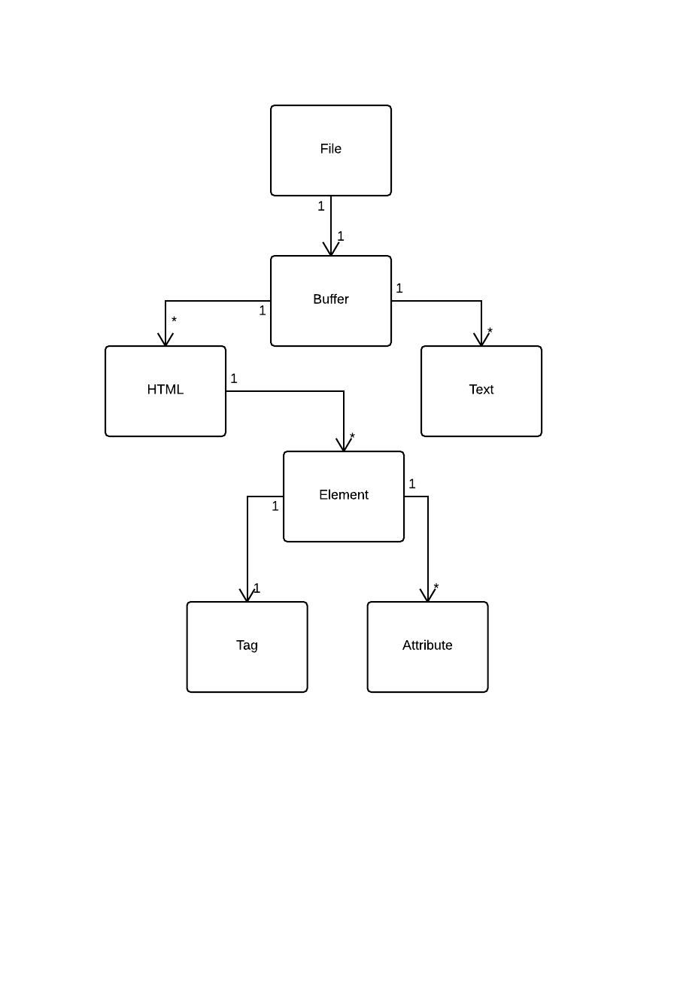

The domain for our project revolves around the actual HTML file, and everything builds off that, starting with the text buffer where all of the changes are displayed. From the buffer, we have the HTML and the text as two separate facets of the domain, with the HTML being further broken down into tags and attributes. This design exemplifies the fact that we have to focus equally on text and HTML in the surface-level functions of our program.

**Complete UML System Diagram**

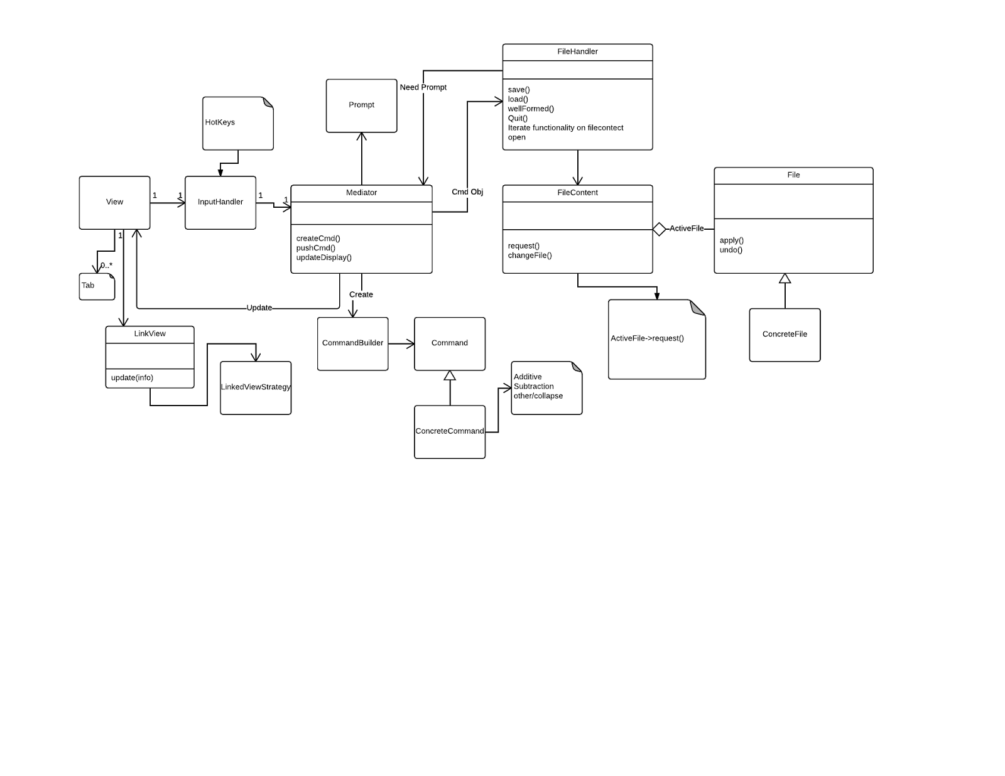

**Class Interactions**

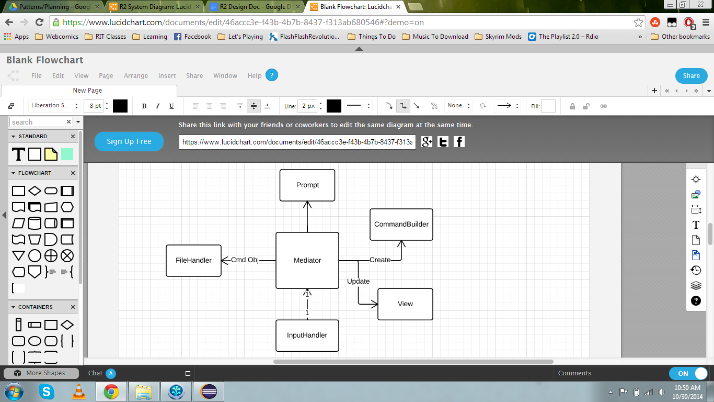Our first major class is the Mediator, which is used to interpret requests from other classes and receive information for them by telling other classes what methods to run and getting the results. The Mediator has knowledge of five different classes; Prompt, FileHandler, InputHandler, View, and CommandBuilder.

Prompt is a class that creates page dialogs based on given information from the Mediator.

FileHandler is a class which handles the saving and loading of files, along with performing well-formed checks.

InputHandler is another Mediator class, with knowledge of Mediator and our Observable objects. The main purpose of this class is to pass information between Observable and Mediator, in order to reduce the number of things that Mediator is directly tied into.

View is a class which contains all of our Observable objects, and is used to display all of our content.

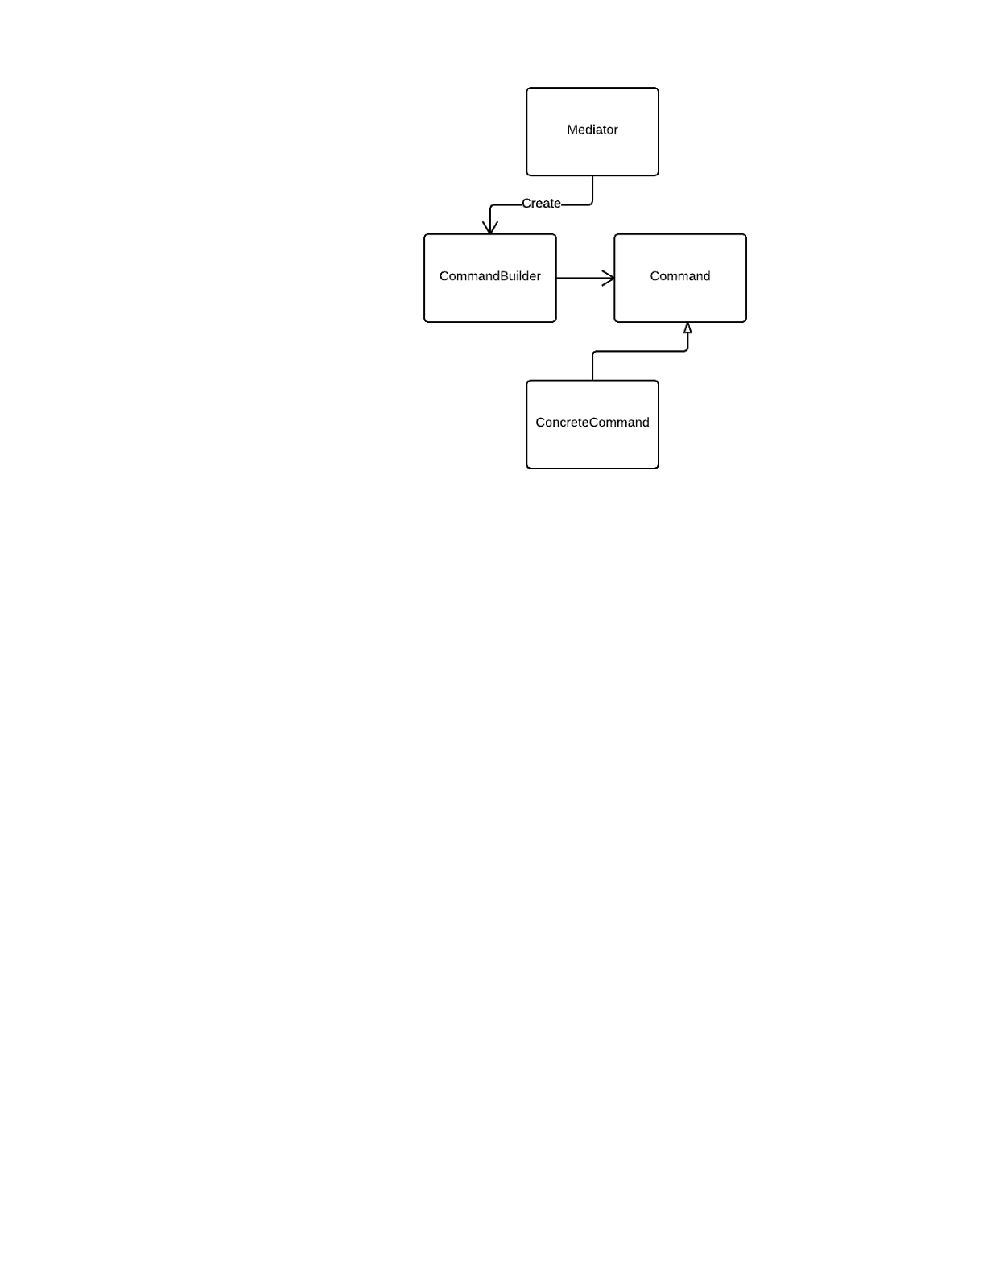

CommandBuilder is a Builder class, with knowledge of Command and Mediator. CommandBuilder takes in orders from Mediator, uses the information given to decide what kind of command needs to be run, and tells Command to make it, finally passing the result back to the Mediator.

Command is a Command class, with knowledge of CommandBuilder. The purpose of this class is to support Undo/Redo operations, using commands to control the undo/redo content stack, and sending its commands through CommandBuilder and Mediator to be used in the FileContent.

ViewListener is an Observer class, which waits for user input and then sends it to the InputHandler, which acts as the Mediator. 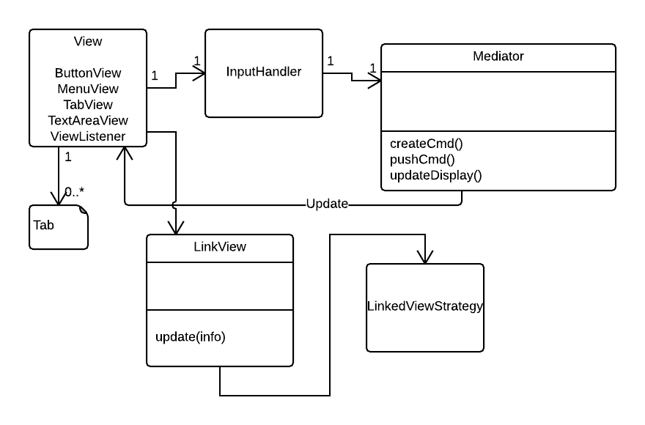

LinkedView is a Strategy class, with knowledge of LinkedViewStrategy and two concrete subclasses. The purpose of these classes is to sort all of the HTML links on the page in a new dialog, and use given information to determine if it should run the SortByAlpha subclass or the SortByAppear subclass to sort the links.

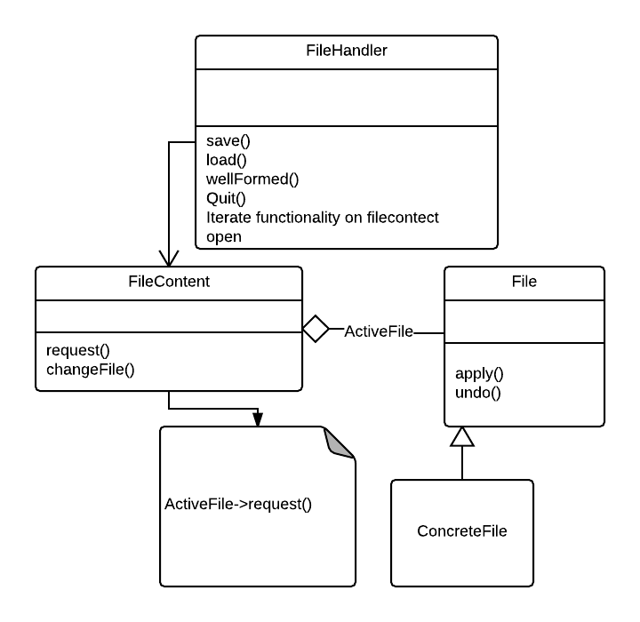

The FileHandler class manages all changes to the File, using FileContent as a dummy file which interprets all of the change requests to File.

FileContent acts as the current file and stores changes, and contains a switch for changing tabs, upon which the current file is saved before loading up the other tab.

**Sequence Diagrams**

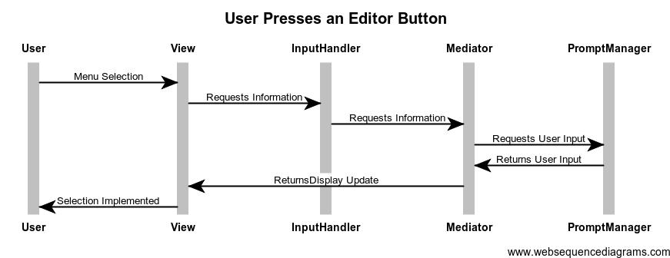

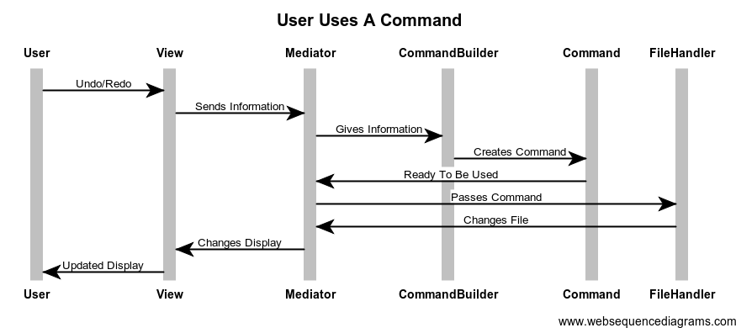

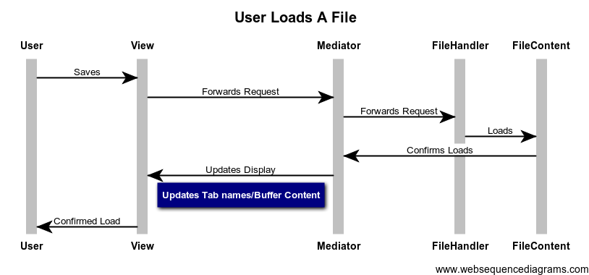

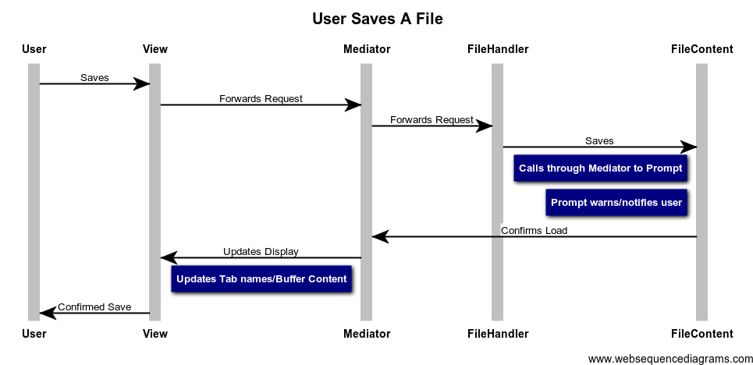

**Implementation State**

We feel our implementation completes the given requirements to a satisfactory level. Having spent several meetings on the patterns alone, we were able to use the following meetings to ensure that we properly implemented the patterns in our code. The only pattern that might not have been used to its full potential was the Strategy pattern, since we only used it to choose between two strategies.

In the final stretch of coding, we were able to work in some of the requirements that were removed from our instructions for R1 and R2 due to our language switch. We were not required to do Word Wrap, Auto-Indent, Command-Line ARGs, reduced functionality if not Well-Formed, or Outline View. However, we were able to implement the reduced functionality requirement, as well as word wrap.

**Conclusion**

With this second--final--release of the HTML Editor project, we feel that the implementation of our patterns into our project, and the functionality of the project itself, are in a good place. We spent almost as much time this release on the details of our design and our usage of patterns as we did on the coding. Our system diagram is a testament to this, much more detailed than the R1 diagram, representing every major class interaction in our underlying system. For this release, we implemented five different design patterns. The ViewListener subsystem is an Observer, which we use to update the View classes and trade input information with the rest of the program. The CommandBuilder subsystem is a Builder, which we use to take information on what types of commands to create, and work with Command (a Command class) to create and “distribute” commands throughout the project. The LinkedView subsystem uses Strategy to choose how to sort the URLs present in the file and display them to the user. The Mediator and InputHandler are Mediator classes, used as information hubs, with almost all classes functioning through Mediator, so that they are less dependant on each other and more on just Mediator.

Looking back at the entire project, we feel that we’d have had a much easier time if we had used Java from the start. While Javascript is slightly simpler to implement the functionality in, it was almost impossible to properly use patterns in, and using it for our first release set us back a lot of work for the start of R2, even considering the removed requirements we negotiated. We also agreed that if it was possible, we’d have started this release sooner, and done more research into built in functionalities before diving into code. We had meetings the majority of days between R1 and R2, for several hours each time, and it still felt like a rush to the finish. This wasn’t helped by a couple instances of us trying to implement something and then shortly after realizing there was a simpler built in way to do it, leading us to scrapping code and implementing the simpler way.

**Pattern Usage Tables**

|  |  |  |
| --- | --- | --- |
| **Name:** Mediator | **GoF:** Mediator |  |
| **Class** | **Role In Pattern** | **Description** |
| Mediator | Mediator | Breaks up subsystems and interprets information for them |
| FileHandler | Colleague | Gets information from Mediator for updating File |
| FileContent | Colleague | Gets information from Mediator for updating File |
| InputHandler | Colleague | Gets information from Mediator for updating View |
| CommandBuilder | Colleague | Gets information from Mediator for creating commands |

|  |  |  |
| --- | --- | --- |
| **Name:** InputHandler | **GoF:** Mediator |  |
| **Class** | **Role In Pattern** | **Description** |
| InputHandler | Mediator | Takes information from Observers, sends to Mediator |
| Observable | Colleague | Has information for InputHandler to use and trade with Mediator |
| Mediator | Colleague | Interprets information from Observable and sends it back to update the View |

|  |  |  |
| --- | --- | --- |
| **Name:** Command | **GoF:** Command |  |
| **Class** | **Role In Pattern** | **Description** |
| Command | Command | Used to edit the File after being sent to FileContent through Mediator |
| CommandBuilder | Client | Creates the commands |
| Mediator | Invoker | Gives instructions for commands to be created |
| FileContent | Reciever | Commands are sent to FileContent to be used to update the File |

|  |  |  |
| --- | --- | --- |
| **Name:** ViewListener | **GoF:** Observer |  |
| **Class** | **Role In Pattern** | **Description** |
| ViewListener | Observer | Gets updates from View, sends them through InputHandler and Mediator, and pushes updates to View |
| View | Subject | Encapsulates all of the View classes |
| MenuView | ConcreteSubject | Handles selection from menu bar |
| ButtonView | ConcreteSubject | Handles clicking on buttons |
| BufferView | ConcreteSubject | Handles the text area |
| TabView | ConcreteSubject | Handles switching file tabs |

|  |  |  |
| --- | --- | --- |
| **Name:** CommandBuilder | **GoF:** Builder |  |
| **Class** | **Role In Pattern** | **Description** |
| CommandBuilder | Builder | Takes information and creates a Command to send through Mediator |
| Command | Product | Used for Undo/Redo operations and other File edit operations |
| Mediator | Director | Tells the Builder what Command to create, sends Command to where it’s needed |

|  |  |  |
| --- | --- | --- |
| **Name:** LinkedView | **GoF:** Strategy |  |
| **Class** | **Role In Pattern** | **Description** |
| LinkedView | Context | Displays all URLs in the file, uses Strategy to decide how to display |
| LinkedViewStrategy | Strategy | Forwards information from the Context and chooses the correct ConcreteStrategy |
| SortByAlpha | ConcreteStrategy | Sorts URLs alphabetically |
| SortByAppear | ConcreteStrategy | Sorts URLs in order of appearance |

**CRC Cards**

|  |
| --- |
| **Class:** AdditiveCommand |
| **Responsibilities:** Applies or undoes the addition of text into the buffer. |
| **Uses:** Command |
| **Used By:** CommandBuilder, Mediator, File, FileContent, FileHandler |
| **Authors:** Braxton Frederick, Andrew Vogler |

|  |
| --- |
| **Class:** BtnView |
| **Responsibilities:** Contains methods to display buttons and run attached functions. |
| **Uses:** ViewListener |
| **Used By:** MainView, ViewListener |
| **Authors:** Dylan Hogue, Andrew Vogler |

|  |
| --- |
| **Class:** Command |
| **Responsibilities:** An abstract class that provides structure for undo/redo operations. |
| **Uses:** N/A |
| **Used By:** File, FileContent, FileHandler, Mediator, ConcreteCommands |
| **Authors:** Adam Audycki, Braxton Frederick |

|  |
| --- |
| **Class:** CommandBuilder |
| **Responsibilities:** Handles the creation of commands. |
| **Uses:** Command, PromptManager |
| **Used By:** Mediator |
| **Authors:** Braxton Frederick |

|  |
| --- |
| **Class:** ErrorCommand |
| **Responsibilities:** Overrides Command if something is not Undoable. |
| **Uses:** Command |
| **Used By:** CommandBuilder, Mediator, File, FileContent, FileHandler |
| **Authors:** Andrew Vogler |

|  |
| --- |
| **Class:** File |
| **Responsibilities:** Contains getters and setters for File information, and applies Commands to the File object. |
| **Uses:** Command |
| **Used By:** FileContent, FileHandler, Command |
| **Authors:** Andrew Vogler, Braxton Frederick |

|  |
| --- |
| **Class:** FileContent |
| **Responsibilities:** Runs Undo commands and switches File being viewed. |
| **Uses:** File |
| **Used By:** FileHandler |
| **Authors:** Andrew Vogler, Braxton Frederick |

|  |
| --- |
| **Class:** FileHandler |
| **Responsibilities:** Runs save, load, and open commands, and the well-formed check. |
| **Uses:** FileContent, File, PromptManager |
| **Used By:** Mediator |
| **Authors:** Adam Audycki, Braxton Frederick |

|  |
| --- |
| **Class:** InputHandler |
| **Responsibilities:** Handles events fired from button presses or menu selections. |
| **Uses:** Mediator |
| **Used By:** View subsystems |
| **Authors:** Braxton Frederick, Andrew Vogler |

|  |
| --- |
| **Class:** InsertImageCommand |
| **Responsibilities:** Overrides undo/redo to insert/remove an Image URL. |
| **Uses:** Command |
| **Used By:** CommandBuilder, Mediator, File, FileContent, FileHandler |
| **Authors:** Adam Audycki |

|  |
| --- |
| **Class:** InsertLinkCommand |
| **Responsibilities:** Overrides undo/redo to insert/remove a URL. |
| **Uses:** Command |
| **Used By:** CommandBuilder, Mediator, File, FileContent, FileHandler |
| **Authors:** Adam Audycki |

|  |
| --- |
| **Class:** InsertListCommand |
| **Responsibilities:** Overrides undo/redo to insert/remove a List structure. |
| **Uses:** Command |
| **Used By:** CommandBuilder, Mediator, File, FileContent, FileHandler |
| **Authors:** Adam Audycki |

|  |
| --- |
| **Class:** InsertTableCommand |
| **Responsibilities:** Overrides undo/redo to insert/remove Table structures. |
| **Uses:** Command |
| **Used By:** CommandBuilder, Mediator, File, FileContent, FileHandler |
| **Authors:** Braxton Frederick |

|  |
| --- |
| **Class:** InsertTagCommand |
| **Responsibilities:** Overrides undo/redo to insert/remove an HTML tag. |
| **Uses:** Command |
| **Used By:** CommandBuilder, Mediator, File, FileContent, FileHandler |
| **Authors:** Adam Audycki |

|  |
| --- |
| **Class:** LinkedView |
| **Responsibilities:** Creates a View for the LinkView display. |
| **Uses:** LinkedViewStrategy, ViewListener |
| **Used By:** ViewListener, MainView |
| **Authors:** Adam Audycki, Andrew Vogler |

|  |
| --- |
| **Class:** LinkedViewStrategy |
| **Responsibilities:** Parses all of the URLs in the file to be displayed. |
| **Uses:** SortByAlpha, SortByAppear |
| **Used By:** LinkedView |
| **Authors:** Adam Audycki |

|  |
| --- |
| **Class:** MainFile |
| **Responsibilities:** Starts the main program. |
| **Uses:** MainView, MenuView, Mediator, InputHandler |
| **Used By:** N/A |
| **Authors:** Andrew Vogler, Dylan Hogue |

|  |
| --- |
| **Class:** MainView |
| **Responsibilities:** Creates the main window, buttons, menus, and buffer. |
| **Uses:** InputHandler, View subsystems |
| **Used By:** MainFile, Mediator, ViewListener, InputHandler |
| **Authors:** Andrew Vogler |

|  |
| --- |
| **Class:** Mediator |
| **Responsibilities:** Sends commands and information between classes. |
| **Uses:** CommandBuilder, FileHandler, InputHandler, MainView, PromptManager |
| **Used By:** InputHandler, FileHandler |
| **Authors:** Adam Audycki, Braxton Frederick, Andrew Vogler |

|  |
| --- |
| **Class:** MenuView |
| **Responsibilities:** Methods to display and run drop down menu functions. |
| **Uses:** ViewListener |
| **Used By:** MainView, ViewListener |
| **Authors:** Dylan Hogue, Andrew Vogler |

|  |
| --- |
| **Class:** PromptManager |
| **Responsibilities:** Creates pop up prompts for getting user input or giving warnings. |
| **Uses:** N/A |
| **Used By:** Mediator, CommandBuilder, FileHandler |
| **Authors:** Andrew Vogler, Braxton Frederick, Arron Reed |

|  |
| --- |
| **Class:** SortByAlpha |
| **Responsibilities:** ConcreteStrategy for LinkView that sorts URLs alphabetically. |
| **Uses:** N/A |
| **Used By:** LinkedViewStrategy |
| **Authors:** Adam Audycki, Andrew Vogler |

|  |
| --- |
| **Class:** SortByAppear |
| **Responsibilities:** ConcreteStrategy for LinkView that sorts URLs by appearance. |
| **Uses:** N/A |
| **Used By:** LinkedViewStrategy |
| **Authors:** Adam Audycki |

|  |
| --- |
| **Class:** SubtractiveCommand |
| **Responsibilities:** Applies or undoes the subtraction of text from the buffer. |
| **Uses:** Command |
| **Used By:** CommandBuilder, Mediator, File, FileContent, FileHandler |
| **Authors:** Braxton Frederick |

|  |
| --- |
| **Class:** TabView |
| **Responsibilities:** Creates tabs in main window used to switch between open files. |
| **Uses:** ViewListener, MainView, TextAreaView |
| **Used By:** MainView, ViewListener |
| **Authors:** Andrew Vogler |

|  |
| --- |
| **Class:** TextAreaView |
| **Responsibilities:** Handles changes to the buffer. |
| **Uses:** ViewListener |
| **Used By:** MainView, ViewListener |
| **Authors:** Andrew Vogler |

|  |
| --- |
| **Class:** ViewListener |
| **Responsibilities:** Receives updates from the View and sends them to Mediator. |
| **Uses:** InputHandler |
| **Used By:** View subsystems, Mediator |
| **Authors:** Dylan Hogue, Andrew Vogler |

|  |
| --- |
| **Class:** ImagePreviewer |
| **Responsibilities:** Displays user selected image from list of all in file. |
| **Uses:** N/A |
| **Used By:** MainView, InputHandler |
| **Authors:** Dylan Hogue, Andrew Vogler |

|  |
| --- |
| **Class:** FormatHelper |
| **Responsibilities:** Format HTML to follow indentation standards on button press. |
| **Uses:** MainView, TextAreaView |
| **Used By:** MainView |
| **Authors:** Dylan Hogue, Andrew Vogler |

**Note: Classes which have other classes passed through them are not counted as using said classes.**