**ANSWER THAT REQUIRED IMAGES**

Question 2:- # Top x number of entries from the dataset and display as markdown format

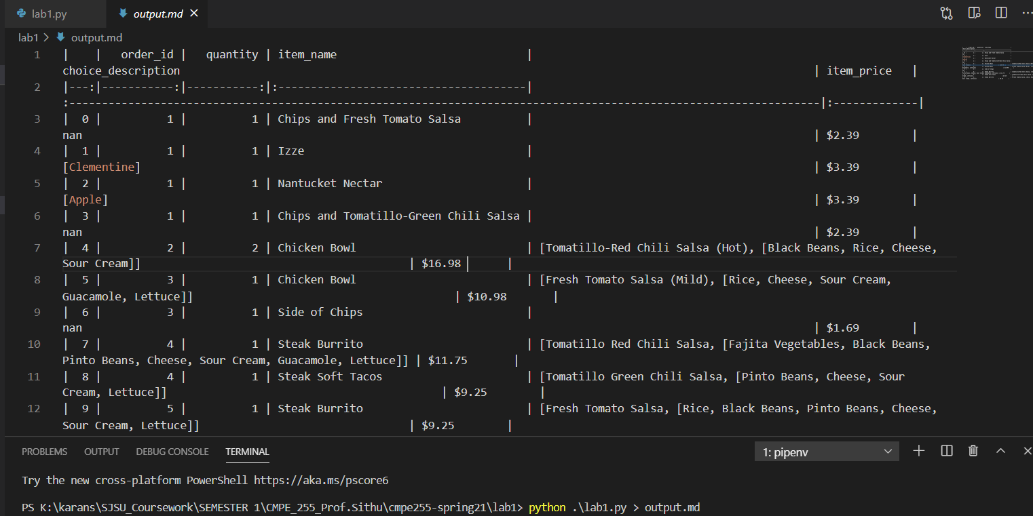

Question 13: # TODO

# 1. convert the dictionary to a DataFrame

# 2. sort the values from the top to the least value and slice the first 5 items

# 3. create a 'bar' plot from the DataFrame

# 4. set the title and labels:

# x: Items

# y: Number of Orders

# title: Most popular items

# 5. show the plot. Hint: plt.show(block=True).

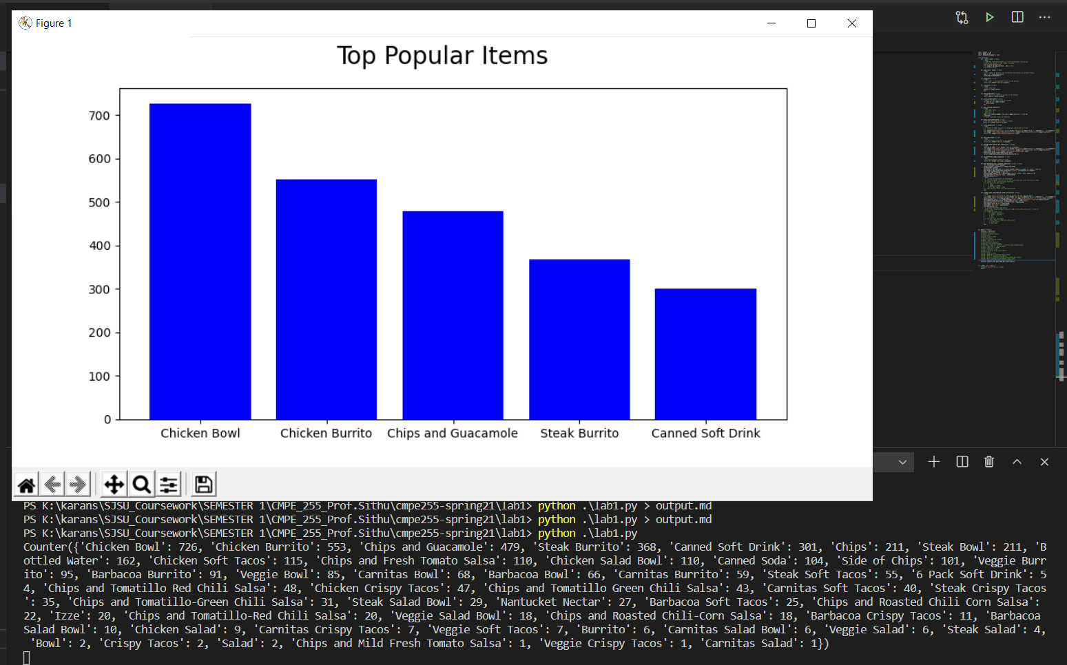

Question 14:- # TODO

# 1. create a list of prices by removing dollar sign and trailing space.

# 2. groupby the orders and sum it.

# group = self.chipo.groupby('order_id').agg({'float_item_price_list': ['sum']})

# print(group)

# 3. create a scatter plot:

# x: orders' item price

# y: orders' quantity

# s: 50

# c: blue

# 4. set the title and labels.

# title: Numer of items per order price

# x: Order Price

# y: Num Items

