KampungKu Interface Design Case Study

PART A: Service Booking Flow

1. Service List / Home Page
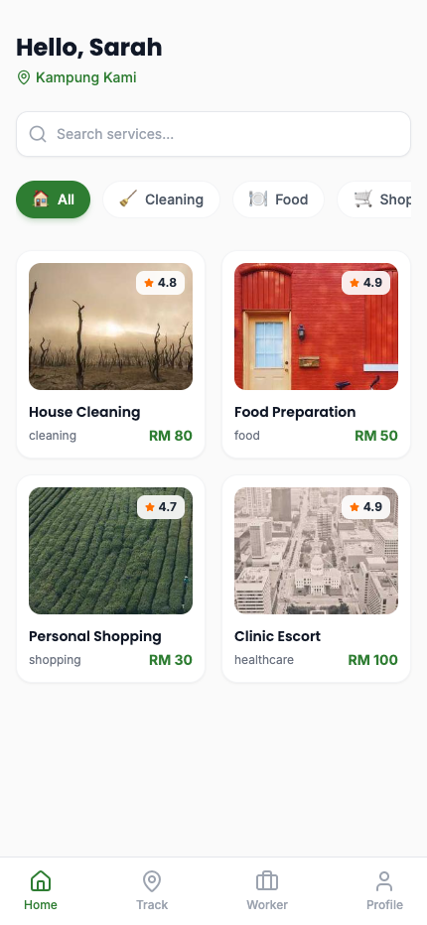

2. Service Details Page
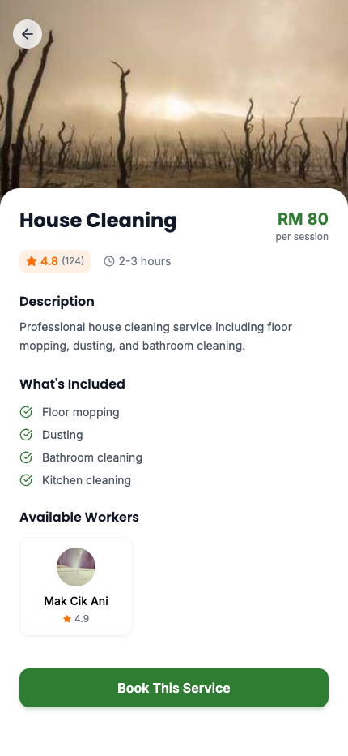

3. Booking Form / Scheduling Page
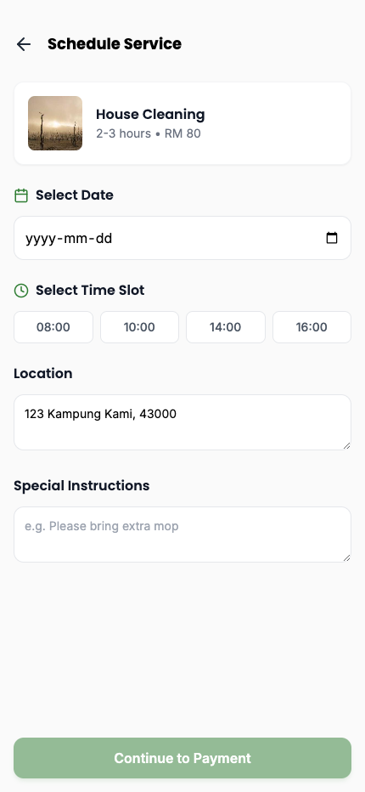

4. Payment Method Page
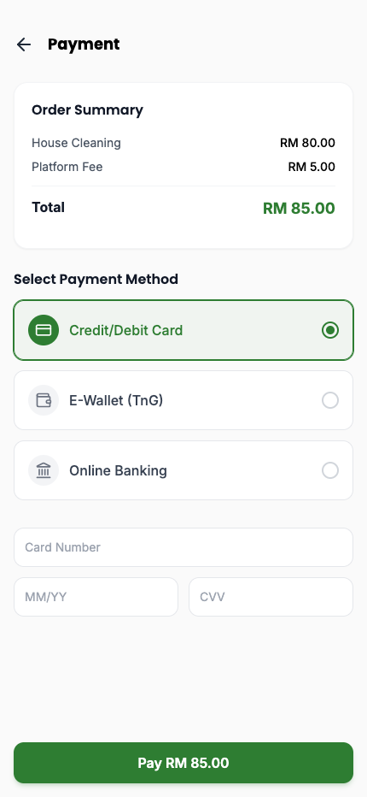

5. Booking Confirmation Page
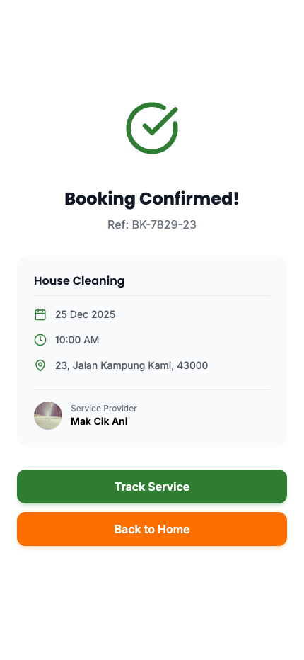

PART B: Worker Module

1. Worker Status / Assigned Job Screen
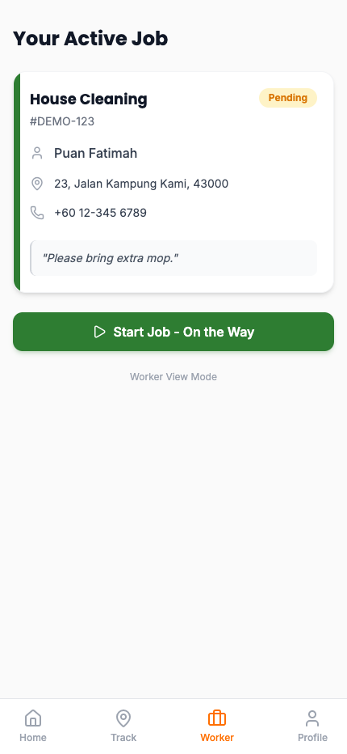

2. Real-Time Map Tracking Screen
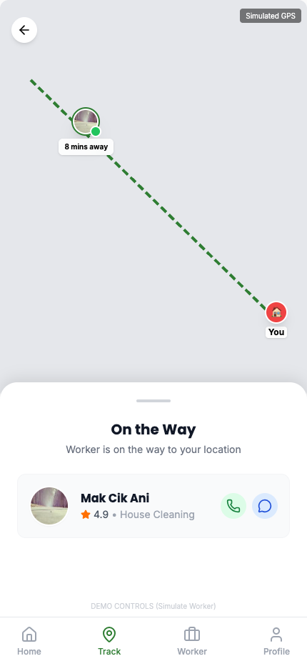

3. User View: Service in Progress
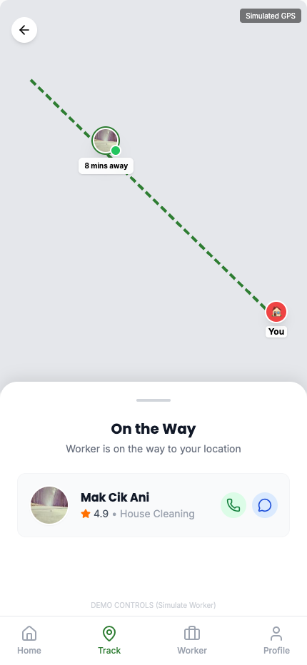

4. Service Completion Screen
