

Database Management Design Project

-- Marist Housing Move out

12/01/2012

Siting Wang

**Table of Contents**

Executive Summary……………………………………………………………...3

Entity Relationship Diagram……………………………………………………..4

Tables

* Student………………………………………………………………….....5-6
* Building…………………………………………………………………..7-8
* Room……………………………………………………………………..9-10
* Visitor…………………………………………………………………....11-12
* Staff……………………………………………………………………...13-14
* Moveout…………………………………………………………………15-16

Views……………………………………………………………...…………....17

Queries…………………………………………………………………………18

Stored Procedures………………………………………………………………19

Triggers………………………………………………………………………....20

Security…………………………………………………………………………20

Implementation Notes and Known Problems…………………………………..21

Future Enhancements…………………………………………………………..21

**Executive Summary**

Housing selection happens every academic year. At the end of every school year, Marist resident students are require to move out of the building with their personal belongings, and will replace with new resident areas in the following year. When the moving out day approached, it brings a lots of work for housing staff and security officers. Housing staff need to keep track on the date and time that students are leaving; security officers need to get the information of the non-Marist students and faculty who are entering the building. With all the considering, creating a database with all the information will be easy for them, and it might reduce their quantities of work.

This database is designed to keep track of the people who are enter the building when they swipe their ID card, and for those who need to sign in with security people in order to get in the building. This database is also designed to keep track the date that student move out, so the housing staff can check with students when they leave.

**Entity Relationship Diagram**

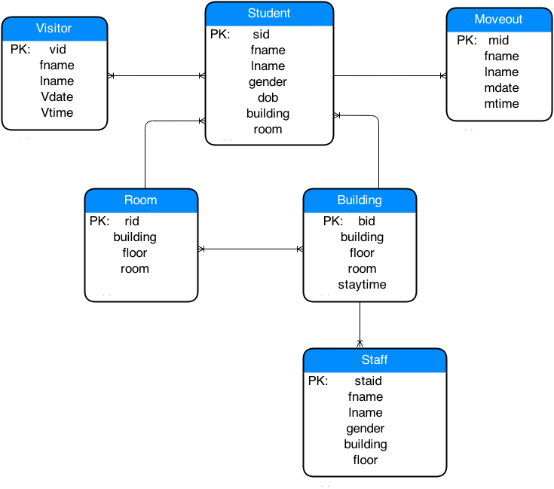

**Student Table**

**Description:**

This table is needed to keep track the information of students who are living in the building and planning to move out the building at the end of school year. Table student, building, room, staff are benefit for housing people, and table visitor is benefit for security officers to track on people who are enter the building.

**Create Statement:**

**--student**

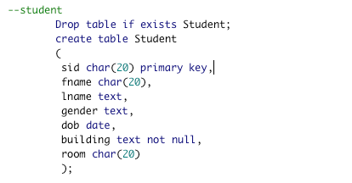

**Insert Statements:**

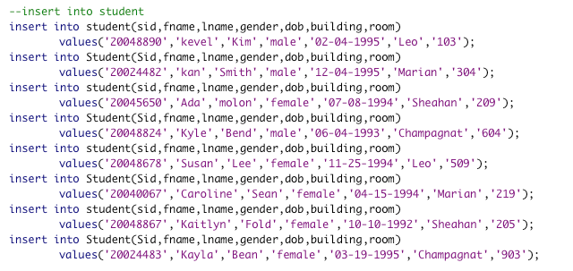

**Sample Data:**

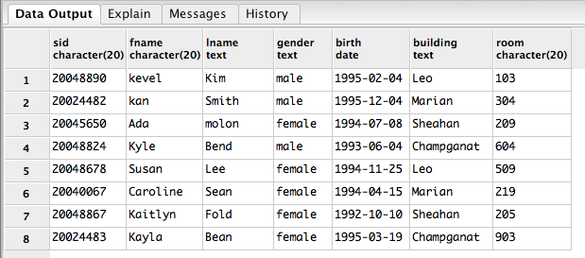

**Functional Dependencies:**

Sid->fname, lname, gender, birth, building, room

**Building Table**

**Description:**

This building table consists of the freshmen buildings, and lists of building, floor, room, and student’s stay time.

**Create Statement:**

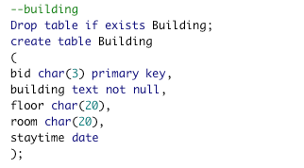

**Insert Statements:**

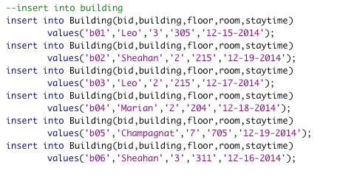

**Sample Data:**

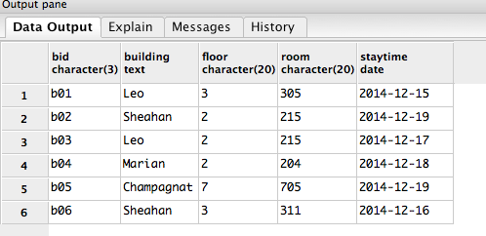

**Functional Dependencies:**

bid-> building, floor, room, staytime

**Room Table**

**Description:**

This table is needed to keep track the information of students who are living in the building and planning to move out the building.

**Create Statement:**

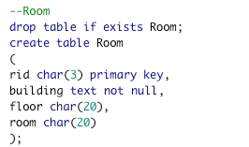

**Insert Statements:**

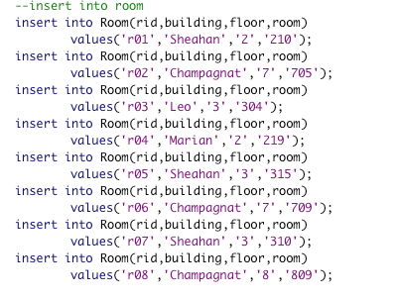

**Sample Data:**

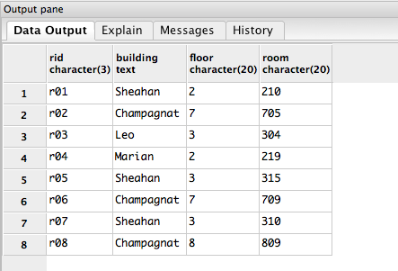

**Functional Dependency:**

rid->building,floor,room

**Visitor Table**

**Description:**

This visitor table lists visitor’s first name, last name, visit date, visit time. With more information of visitors, it will be easy for security officers to keep track on.

**Create Statement:**

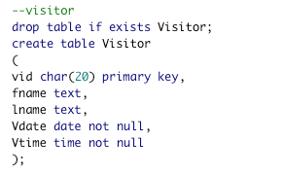

**Insert Statements:**

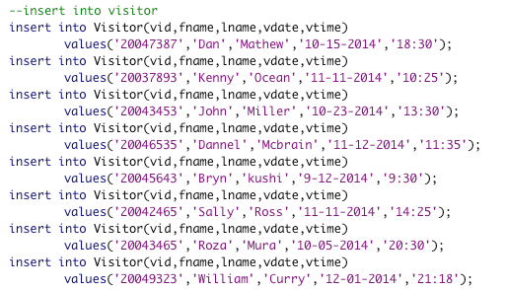

**Sample Data:**

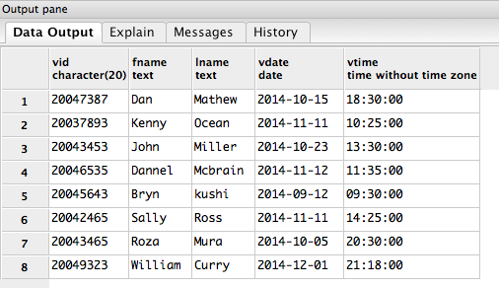

**Functional Dependency:**

vid->fname,lname,vdate,vtime

**Staff Table**

**Description:**

This table lists the staff’s first name, last name, gender, building that they in charge, and floor they live.

**Create Statement:**

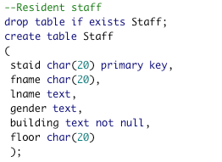

**Insert Statements:**

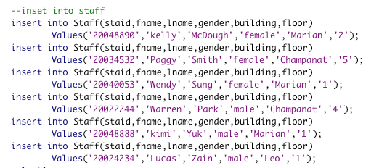

**Sample Date:**

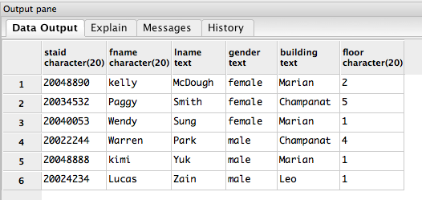

**Functional Dependency:**

Staid->fname,lname,gender,building,floor

**Moveout Table**

**Description:**

This table lists the first name, last name, moveout date, and move time of students, so staff can check with students.

**Create Statement:**

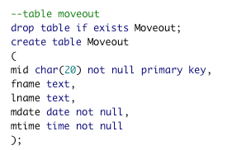

**Insert Statements:**

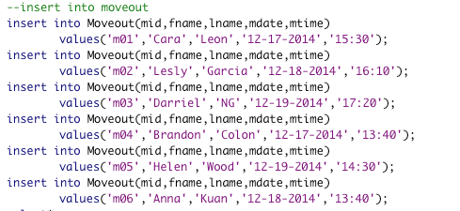

**Sample Date:**

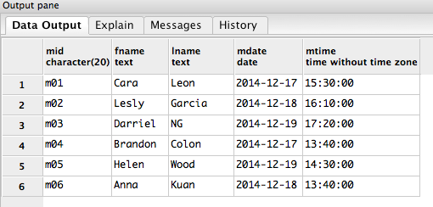

**Functional Dependency:**

mid->fname,lname,mdate,mtime

**Views**

Description:

This view displays anyone who visit the building at 11-11-2014.

Create Statement:

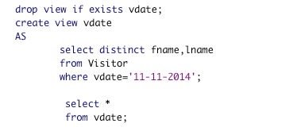

Sample data:

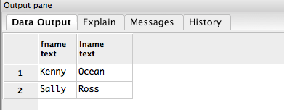

**Reports and Queries:**

This query gets the fname and lname of student who live in the Sheahan, and they are both female.

Create Statement:

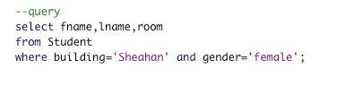

Sample Data:

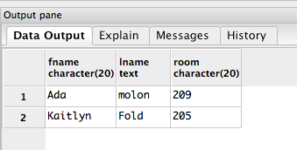

**Stored Procedures**

Count the total number of students.

**Create Statement:**

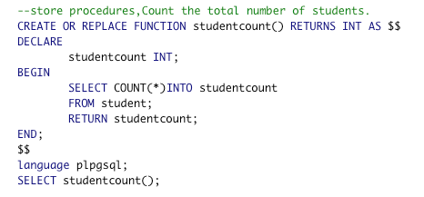

**Sample Data:**

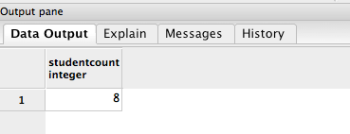

**Triggers**

CREATE OR REPLACE FUNCTION current_date_set() RETURNS trigger AS $date_trigger$ BEGIN

IF NEW.mdate IS NULL OR NEW.mdate = '' THEN NEW.mdate = current_date;

END IF;

RETURN NEW;

END;

$date_trigger$

LANGUAGE plpgsql;

CREATE TRIGGER date_trigger

BEFORE INSERT ON Moveout

FOR EACH ROW

EXECUTE PROCEDURE current_date_set();

drop trigger _trigger on Moveout;

SELECT CURRENT_DATE;

**Security**

There are two types of users identified for the database.

1. Database admins are able to change, update, and maintain all the tables on the database.

CREATE ROLE_admin

GRANT SELECT, INSERT, UPDATE, DELETE

ON ALL TABLES

TO db_admin;

1. Users are only allow to see the database, but not able to modify anything.

CREATE ROLE user

GRANT SELECT

ON ALL TABLE IN SCHMA USER

TO user;

**Implementation Notes and Known Problems:**

Implementation seems pretty good so far. With all the databases, admin will able to know more about the move out date of students. This database could be more interesting if admin add more items into each table, and add more tables. Since there are all sample database, it would be more useful if having the real database, because it will avoid the redundancies. Also, in the database, it separate the student and staff which means in this case, student do not have the role of being staff. However, in many real situation, student can also play a role as staff. So if there is student who is also staff, there might be more problems.

**Future Enhancements**

Each table could have include more specific items. For the staff table, it would be better to point out that they are more referring to resident assistant or resident director. Plus, it will be better to add a table to indicate the connection between staff and student, because student can also be a staff in some case.