Savannah

Description of the game /user/ | First, you see the main menu. After you click on the „New Game” tab, you can choose between 2 animals. Lion/Gazelle that you chose. You can of course move on the map, drink and attack other animals or eat plants depending on your species.
Description of the game /programmer/ | Your game consists of a map full of floura and fauna, modelling the ecosystem of the savanna (seriously).  Lineage tree:  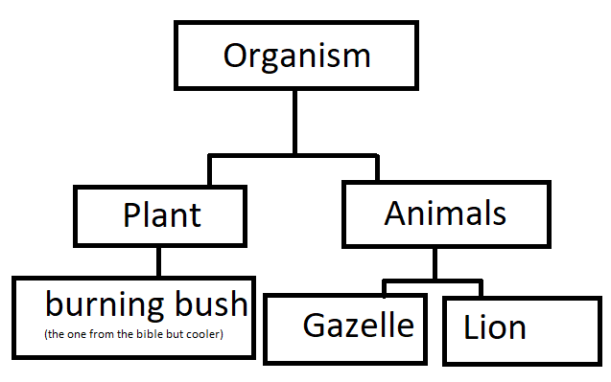
Animals : properties | Every single animal has Health Points(HP),  What describes the current state of health.  Affected by:  -Fights with another animal  -Thirst  -Hunger
Animails : methods | -Move  -Attack  -Eat  -Drink
Lion | You can attack Gazelles and die if your HP gets lower than 0 by retaliation.  You can eat dead Gazelles and drink water.
Gazelle | You can get attacked (but you automatically defend yourself by retaliating) and die if your HP<=0.  You can eat plants and drink water.
Plants : properties | Plants have HP as well, and if a Gazelle munches on it’s leafs too much, it may drop to 0 and wither.
Modules: | -Core (Engine)  -Common (Basic solution)  -UI (WPF)
WPF : Menu | On this tab you can click on a button; one of the listed four: New Game, Music, Options, Quit.
Core

