When a public repository solves most of the problem — Facilitator Guide
ELIXIR-UK RDM Club · FAIR-in-action · ~60 min
For many data types in life sciences (sequencing, proteomics, structures), depositing in the appropriate community repository handles 80% of FAIR automatically. This module covers how to recognise that situation and guide researchers to the right home.
Section 1: Introduction & FAIR principles · 0–10 min
Key FAIR principles: F, A, I, R
Learning objectives
- Participants can name the four FAIR principles
- Participants understand that FAIR has both infrastructure and content dimensions
🗣 Welcome. We’ll work through a real, published dataset and see the FAIR principles as actual files and metadata decisions — not theory. The key idea: a repository gives you F and A almost for free; the I and R are your job.
- FAIR = Findable, Accessible, Interoperable, Reusable (Wilkinson 2016)
- The repository handles the plumbing; the researcher supplies the content
💡 Tip: If attendees haven’t seen FAIR before, spend 2 extra minutes pointing to each letter and asking the group what they think it means before revealing the definition — this activates prior knowledge.
Section 2: The dataset · 10–15 min
Learning objectives
- Participants know what RNA-seq data consists of and why batch effects matter
- Participants can identify the three components of a repository submission
🗣 RNA-seq is a great worked example. Three things go into the repository: metadata, raw FASTQ, and the count matrix. Batch effects can swamp the biology — record them in metadata from day one.
- Worked dataset: Alivernini et al. 2020 · E-MTAB-9224
- Same structure for scRNA-seq, proteomics (PRIDE), metabolomics (MetaboLights)
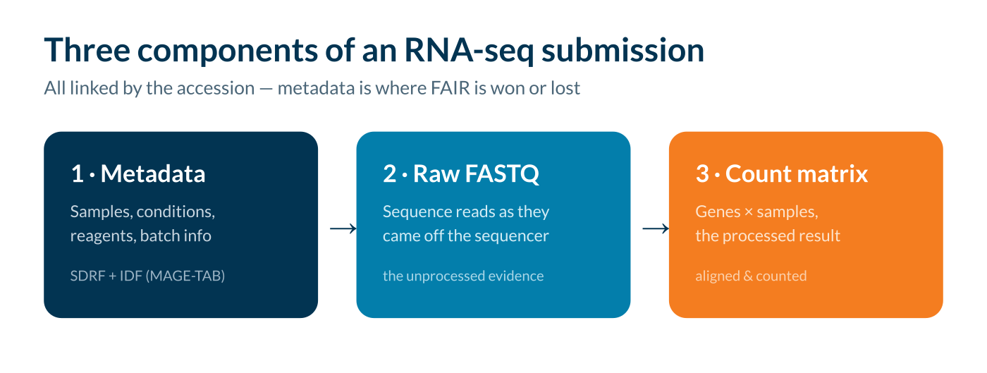
Three components of an RNA-seq submission: metadata, raw FASTQ, count matrix
💡 Tip: If the group includes non-bioinformaticians, draw the count matrix on a whiteboard (rows = genes, columns = samples, values = read counts). One minute here pays off for the rest of the session.
Section 3: Finding the data · 15–25 min
Key FAIR principles: F1, F4, A1
Learning objectives
- Participants can explain what a persistent identifier is and why it matters
- Participants can locate a dataset in ArrayExpress by accession number
- Participants understand that open HTTPS access satisfies A1 and A1.1
🗣 F1 — the accession is a permanent, citable ID. F4 — indexed and keyword-searchable. One click downloads over HTTPS, no login: that’s A1/A1.1. Then point them at your institution’s preferred repository.
- Accession E-MTAB-9224 is globally unique & persistent
- Where your researchers deposit: [ your institution’s preferred repository ]
✏ Exercise: Exercise 1 (5 min): find the accession in the Alivernini paper, then locate it in ArrayExpress. What’s visible before you download anything?
💡 Tip: If attendees struggle to find the accession in the paper, point them to the Data Availability section at the end — a real-world lesson that accession numbers aren’t always prominently placed.
Section 4: Metadata & community standards · 25–40 min
Key FAIR principles: F2, F3, R1.3, I1
Learning objectives
- Participants can describe what MAGE-TAB (IDF + SDRF) is and what each file contains
- Participants can critically assess whether metadata is sufficient for reuse
- Participants understand the role of ontologies in making metadata interoperable
🗣 This is where FAIR is won or lost. MAGE-TAB = IDF (study-level) + SDRF (per-sample + file links). Use ontology terms (EFO, OBI, UBERON), not free text, so machines can read it.
- F2 rich metadata · F3 SDRF links each sample to its FASTQ
- R1.3 community standard (MAGE-TAB) · I1 controlled vocabularies
✏ Exercise: Exercise 2 (8 min): open the SDRF for E-MTAB-9224. Clear variable names? Batch info recorded? Ontology URIs or free text? Could you reuse it without contacting the authors?
💡 Tip: Allow 2–3 minutes for pairs to discuss before opening up to the group. If time is short, skip the hands-on element and walk through a single SDRF row together, pointing out fields that are and aren’t present.
Section 5: Building a FAIR metadata spreadsheet · 40–50 min
Key FAIR principles: F2, R1, R1.2
Learning objectives
- Participants can complete a minimum-viable RNA-seq metadata spreadsheet
- Participants understand that good FAIR practice begins at experimental design, not submission
🗣 Everything we’ve discussed comes from a spreadsheet you fill in as you run the experiment — which becomes the SDRF. Annotare can’t conjure information that was never recorded; batch info especially is lost if not captured at the bench.
- Compulsory: sample IDs, condition, replicates, platform, reference genome + version, protocol
- Strongly recommended: batch (run/date/operator), RIN, QC, confounders, software versions
💡 Tip: The key insight: most metadata cannot be retrospectively retrieved — batch information in particular is often lost if not recorded at the bench. For advanced groups, ask them to look up the EFO term for ‘rheumatoid arthritis’ at ebi.ac.uk/ols4.
Section 6: Licensing, provenance & wrap-up · 50–60 min
Key FAIR principles: R1.1, R1.2
Learning objectives
- Participants understand why a data licence is required and know the common options
- Participants can articulate the most common failures in FAIR practice
- Participants can map each FAIR principle to the correct lifecycle stage
🗣 No licence = others can’t legally reuse it (CC0 or CC-BY). Provenance: genome build and software versions matter. Take-home: repositories do F/A, you supply I/R, and FAIR starts at experimental design. Ask everyone for one specific change they’ll make.
- Repository handles F1, F3, F4, A1, A2 · you must provide F2, I1, R1
- Local support: [ set up your institution profile ]
💡 Tip: The ‘one specific change’ prompt is a closing commitment device — people are more likely to act on a concrete, self-generated commitment than a general instruction. Signpost the Galaxy RNA-seq FAIR tutorial as follow-up.

