Overview
All models in the system are comprised of two parts. The first part is the docker images. These images are automatically created on the server from the files in <SourceLocation>\Containers. The second part of a model is the database data. We need to keep the data in the Images, Models, and ModelScenarios tables up to date.

Prerequisites
Git installed (https://git-scm.com/)
Visual Studio 2017 installed
Permissions granted for GET in Visual Studio Online
Source cloned from VSO into <SourceLocation> (git clone https://cloudolssonassociates.visualstudio.com/DefaultCollection/_git/GET)
Model cloned from VSO (git cone https://cloudolssonassociates.visualstudio.com/DefaultCollection/GET/_git/GET-Models)

Limitations
This process assumes all images are loaded and running from a single machine.
There is no automated way to remove a model.
We cannot use this process to rename a model, scenario, or image.
We cannot use this process to create a new scenario.

Processes

Creating a New Model
- Start a new branch
- Create a new folder inside of <SourceLocation for GET-Models>\Containers with the name of the model. This name should be all lower case and less than 30 characters.
- Inside of that folder create
  - A “Model” folder and place all the model files into there.
  - A SampleInputFiles folder and any example input files (these are used for testing).
  - Copy in a Dockerfile from one of the other Models
- Open Visual Studio with the GET solution
- Add a new database file
  - Paste in the contents of <SourceLocation>\Tools\InsertModel.sql
  - Update contents according to comments in the file
- Check-in and pull request

Updating Existing Model Files
- Start a new branch
- Update files inside of <SourceLocation>\Containers\<ModelName>\Model
- Check-in and pull request

Updating Existing Model Settings
- Start a new branch
- Open Visual Studio with the GET solution
- Add a new database file
  - Paste in the contents of <SourceLocation>\Tools\UpdateModel.sql
  - Update contents according to comments in the file
- Check-in and pull request

Starting a New Branch
The branch name you put in below should be meaningful and unique.
From a command line
cd <SourceLocation>
git checkout master
git pull
git checkout -b <BranchName>

Add a new database file
- In Solution Explorer, Navigate to 5.DatabasesPrimaryMigrations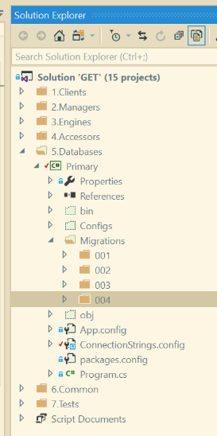
- Right click the highest numbered folder and select AddNew Item…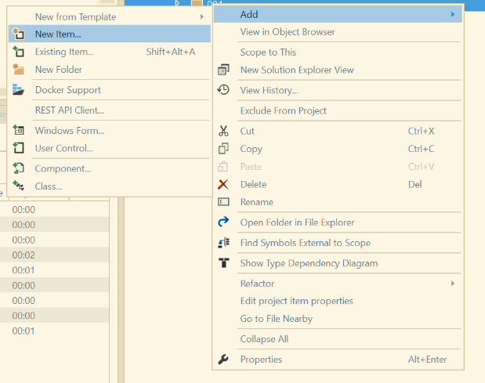
- Select Visual C# ItemsGeneralText File and name the file ###.DescriptiveName.sql. ### should be the sequential next number file from the folder.
- Right click the new file and select Properties. Set the “Build Action” to “Embedded Resource”.

Check-in and Pull Request

Check-in
cd <SourceLocation>
git pull
git merge origin/master
*** You may have merge conflicts here that will need to be resolved. This can be a messy process so it is probably best to go through this together the first couple times if necessary ***
git push -u origin <BranchName>

Pull Request
Go to https://cloudolssonassociates.visualstudio.com/_git/GET/pullrequests
Create a new pull request, verify your changes look correct, and assign someone to review it.

Settings File
A settings.txt file can be added to a model folder to set model configurations. For now it’s there to toggle between Delimited or FixedWidth files but will probably be used for more setttings in the future.

Note if the file is not present, the system will assume Structured files as fixed width and Unstructured files are delimited. To override this (say for a delimited structured file), make this the content of the settings.txt fie:
{FileFormat:2}
Where 1 = Fixed Width, 2 = Delimited
See Spanish Springs model folder for an example.

