**BDTM: Big Data Tools for Managers**

**1st Internal Question Pattern**

Q1. Demonstrate MySQL Database operation [10]

1. Create Database
2. List all databases
3. …
4. …
5. ..

……

Q2. Demonstrate MySQL Table operation [10]

1. Create & Select Database
2. Create Table
3. …
4. …

Q3. Demonstrate MySQL Table Constraint [10]

1. …
2. …
3. …

Q4. Working with SELECT clause [10]

1. …
2. …
3. …

Q5. Demonstrate Aggregate functions, Group by, Having clause [10]

1. …
2. …
3. …

**BDTM: Big Data Tools for Managers**

**1st Internal Answer sheets**

USN : ______________________________________________

Name : ______________________________________________

Class Section : ______________________________________________

Notes:

* Write Proper USN, Name, and Class sections
* The answer sheet should have screenshots with the query & outputs
* Write the proper Question numbers before attaching screenshots.
* No need to write full questions in the answer sheet, the question label is enough

Q1 -> (a,b,c,d) , Q2 -> (1,2,3,4,5)

* Creation of database/table name must match exactly as per the questions.
* Table data must match exactly with the questions.
  + Column name must be as per the question paper
  + 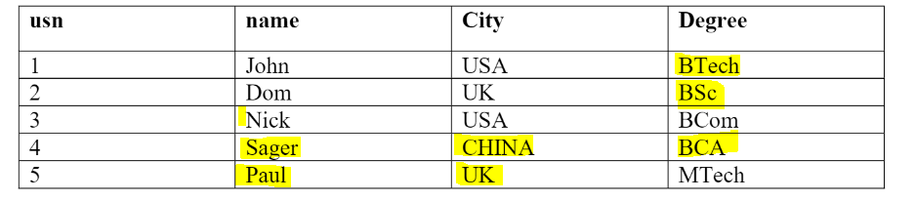Table data ie. upper/lower case, spelling..etc must be as per the question paper

How Answer sheets look like:

Q1. Demonstrate MySQL operation

1. Create database

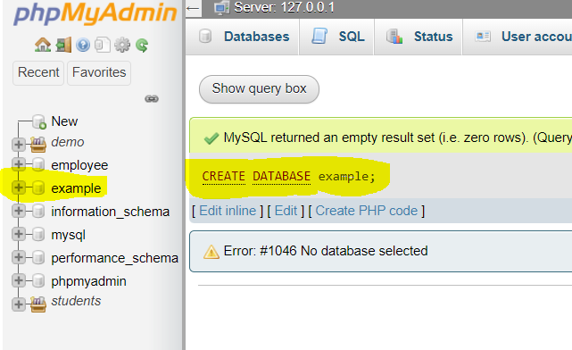

1. List all the database

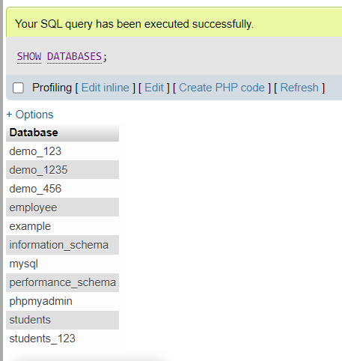

C)…………………………….

< ------------------- Screenshots ----------------------- >

Q2. Demonstrate MySQL Statement

1. List all the tables

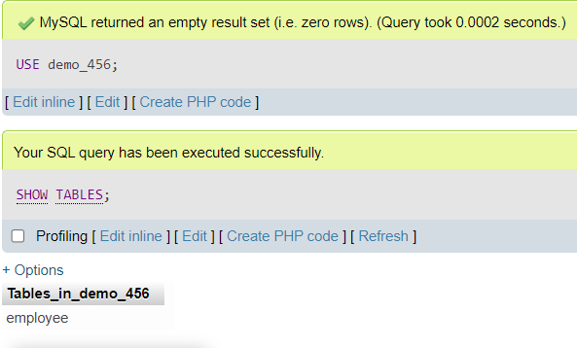

B………………….

< ------------------- Screenshots ----------------------- >

C……………….

< ------------------- Screenshots ----------------------- >

D………..

< ------------------- Screenshots ----------------------- >