**BDTM: Big Data Tools for Managers**

**1st Internal Answer Sheet [Set-B]**

Q1. Demonstrate Basic database operation with MySQL [10]

1. Create a database BOOK in MySQL

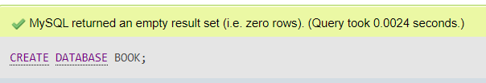

1. List all the databases available in MySQL

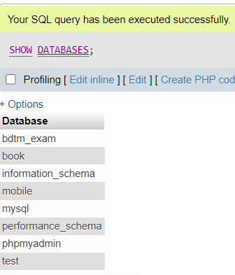

1. Select the BOOK database, and list all the tables available in BOOK database

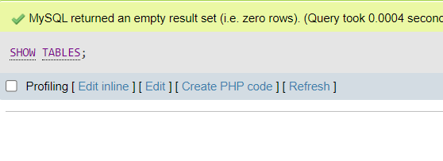

1. Remove BOOK database from MySQL

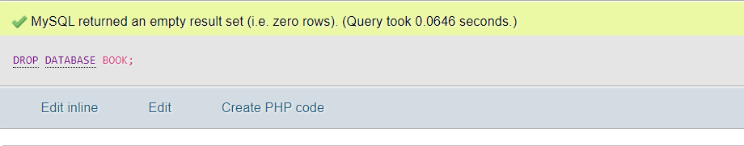

1. List all the databases available in MySQL

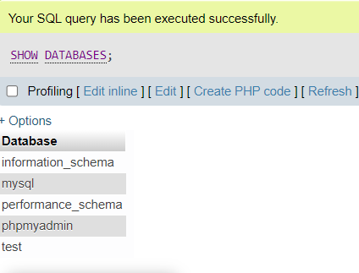

Q2. Demonstrate Basic RDBMS table operations with MySQL [10]

|  |  |  |  |
| --- | --- | --- | --- |
| PRODUCT_ID | PRODUCT_NAME | MRP | CURRENCY |
| PRD_1001 | Lifebuoy Handwash | 100 | INR |
| PRD_1002 | Per Cara Pro Shampoo | 1.5 | USD |
| PRD_1003 | Mamaearth Hair Oil | 250 | INR |
| PRD_1004 | Liquid Handwash | 185 | INR |
| PRD_1005 | Mamaearth Shampoo | 300 | INR |

1. Create database SAMPLE, and create above given PRODUCT table in SAMPLE database

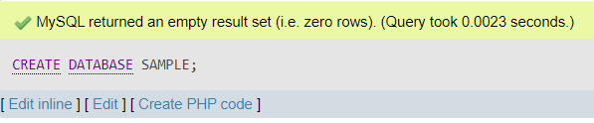

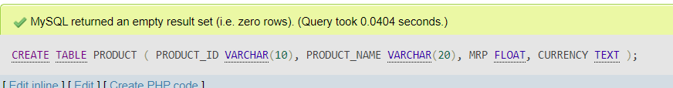

1. Insert above given sample records in PRODUCT table

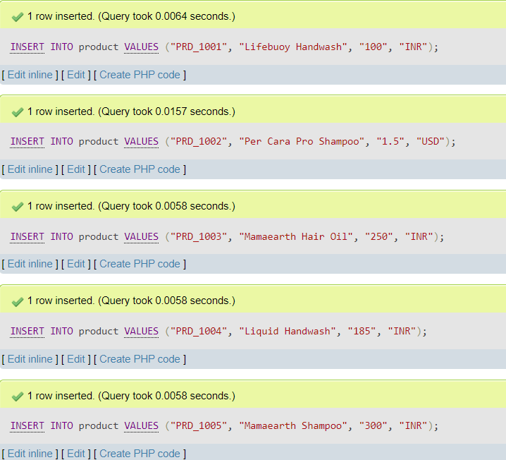

1. Display PRODUCT table structure

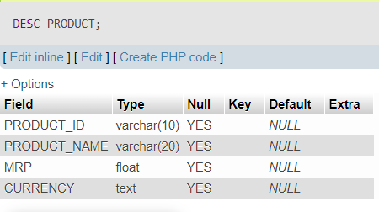

1. Truncate PRODUCT table

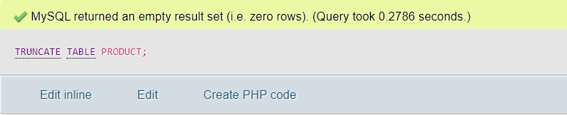

1. Delete PRODUCT table from SAMPLE database

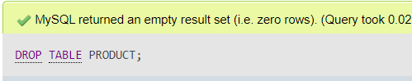

Q3. Demonstrate NOT NULL, UNIQUE and DEFAULT Constraint in MySQL Table [10]

|  |  |  |  |  |  |  |  |
| --- | --- | --- | --- | --- | --- | --- | --- |
| **USN** | **NAME** | **DOB** | **ADDRESS** | **CITY** | **STATE** | **PINCODE** | **CGPA** |
| 1SI23MBA01 | AAA | 1995-01-01 | B H ROAD | TUMKUR | KARNATAKA | 572103 | 8.5 |
| 1SI23MBA02 | BBB | 1996-01-01 | BANGALORE | BANGALORE | KARNATAKA | 560001 | 9.5 |
| **1SI23MBA02** | **BBB** | **1996-01-01** | **BANGALORE** | **BANGALORE** | **KARNATAKA** | **572103** | **9.5** |
| **1SI23MBA04** |  | **1999-01-01** | **B H ROAD** | **TUMKUR** | **KARNATAKA** | **572103** | **8.5** |
| **1SI23MBA05** | **FFF** | **1999-01-01** | **B H ROAD** |  |  |  |  |

1. Create above table “students_exam“ with following constraint

* USN with UNIQUE constraint
* NAME with NOT NULL constraint
* CITY, STATE, PINCODE and CGPA having DEFAULT value TUMKUR, KARNATAKA, 572103 and 0



1. Insert above records into the students_exam table

(Note : The error message is expected while inserting records into the table and place same error message as part of answers for 3rd, 4th & 5th records)

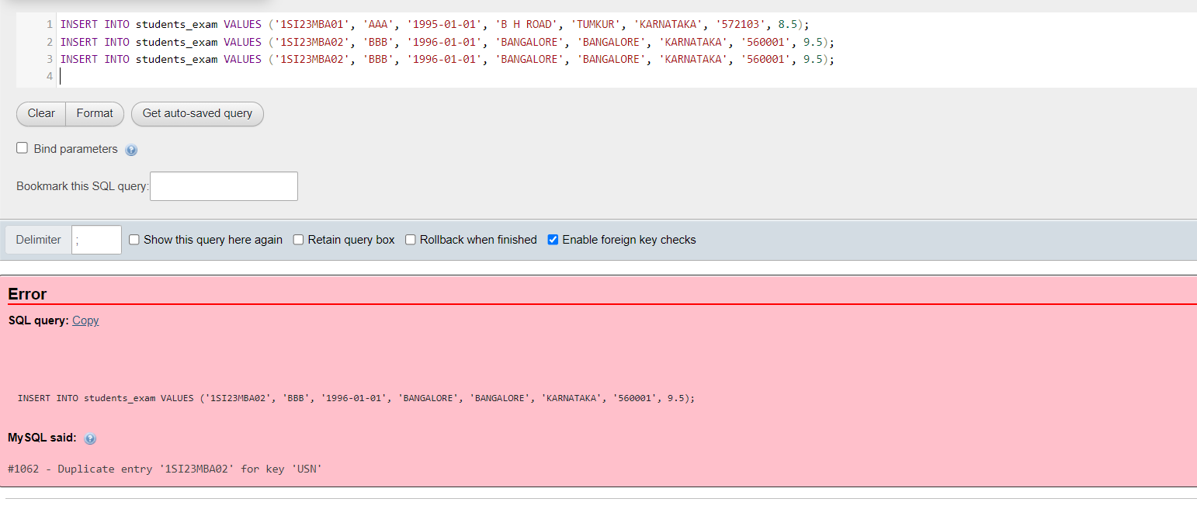

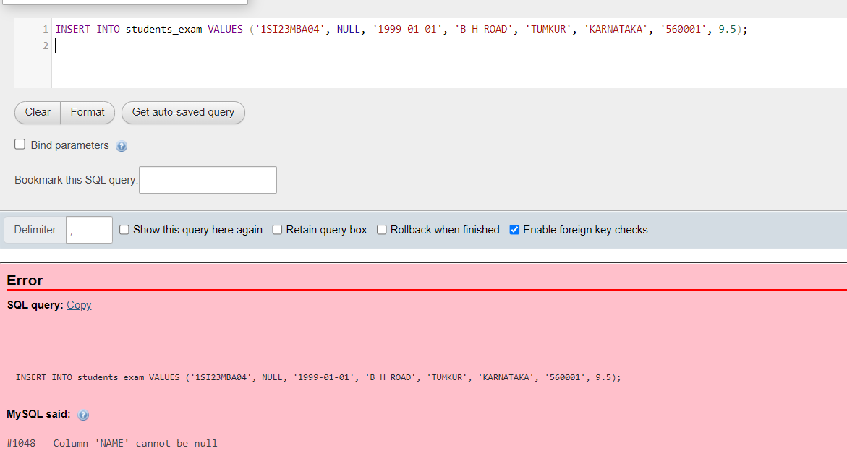

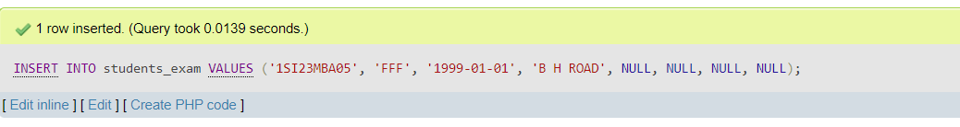

OR

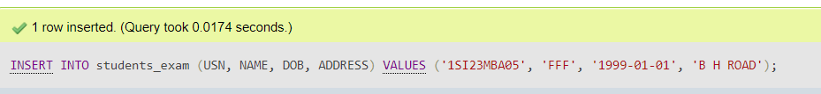

Q4. Working with SELECT clause in MySQL Table [10]

Copy mysql code from below link and paste into the SQL window to create and insert sample records. After executing given code in selected database new table will be created name “student_details”

<https://raw.githubusercontent.com/sitmbadept/sitmbadept.github.io/main/BDTM/SQL/student_details.sql>

1. Display single column gender from student_details table

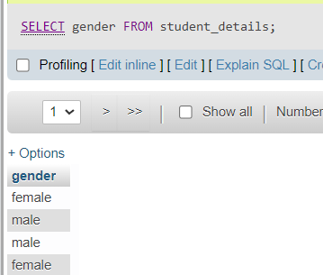

1. Display unique values for class name from student_details

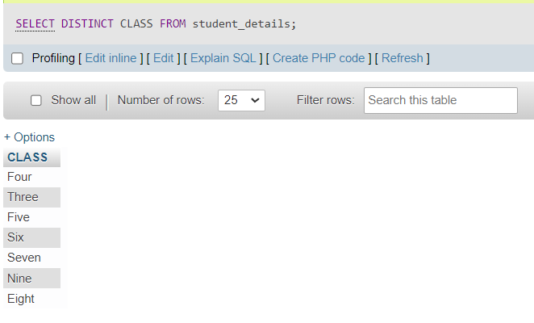

1. Display unique values name, gender details from student_details table

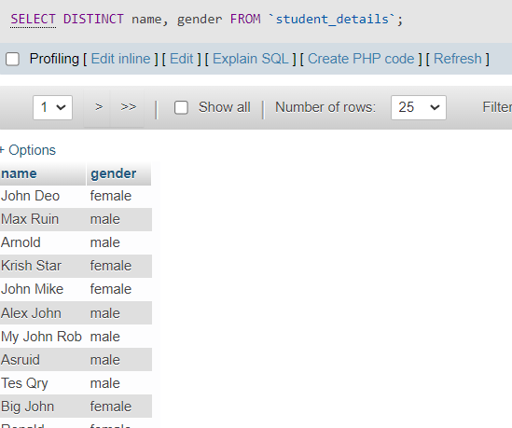

1. Display distinct records from student_details

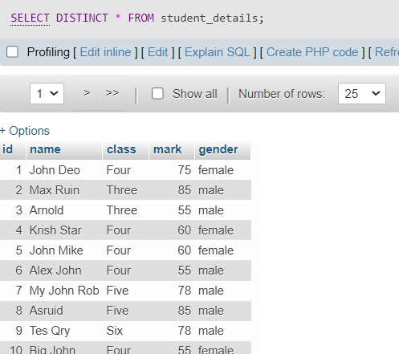

1. Display all the records from student_details, also sort data in ascending order by name and descending order by gender (everything in one query)

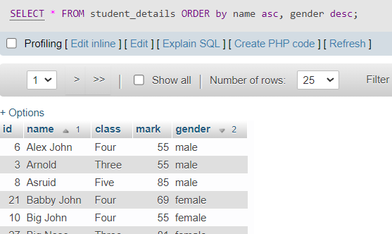

Q5. Demonstrate advance SELECT clause in MySQL [10]

Copy mysql code from given link and paste into the SQL windows to create and insert sample database & tables in

MySQL. After executing given code, new database will be created name “bdtm_exam” in MySQL.

<https://raw.githubusercontent.com/sitmbadept/sitmbadept.github.io/main/BDTM/SQL/bdtm-exam.sql>

1. Write a query to get the total salaries payable to employees

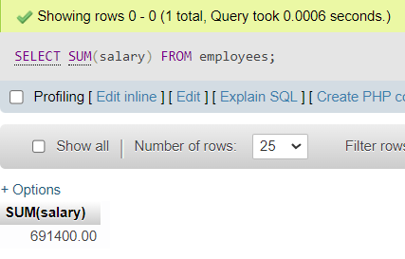

1. Write a query to get the total salaries payable to employees by their department_id

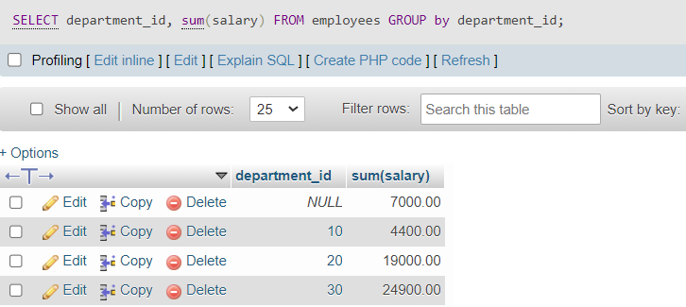

1. Write a query to get the highest, lowest, sum, and average salary of all employees.

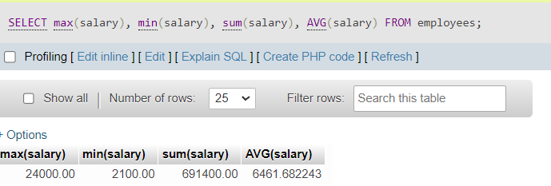

1. Write a query to get the department_id and total salary of the employees where total salary is greater than or equal to 5000.

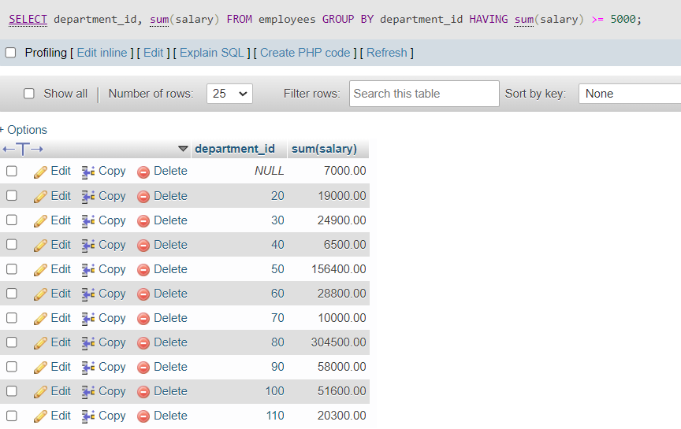

1. Write a query to get the total salary, maximum, minimum, average salary of employees (job ID wise), for department ID 50 only.

