**Big Data Tools for Managers**

**Dept. of MBA, Siddaganga Institute of Technology-Tumkur**

Below is the student details dataset; this exercise makes you familiar with importing sql table & data from the .sql file

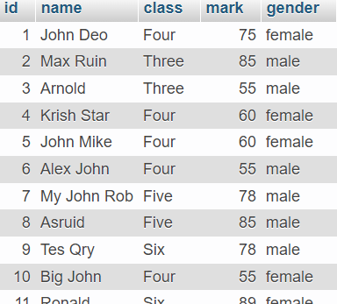

Write SQL statement for following:

1. Import **student_details.sql** file in phpMyAdmin
2. View the table structures of student_details table.
3. Display students name from the table
4. Display class name from the table
5. Display Unique class name
6. Import student_details.sql file in phpMyAdmin

Download **student_details.sql** file from the below link

<https://raw.githubusercontent.com/sitmbadept/sitmbadept.github.io/main/BDTM/SQL/student_details.sql>

Steps 1: Click on Import option in phpMyAdmin

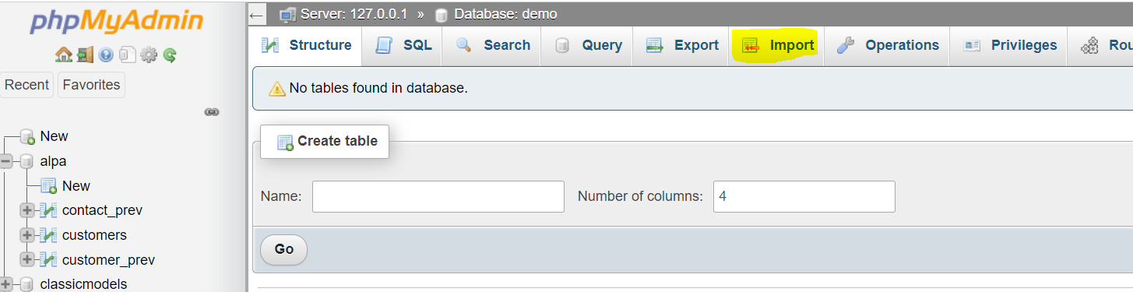

Steps 2: Choose downloaded **student_details.sql** file

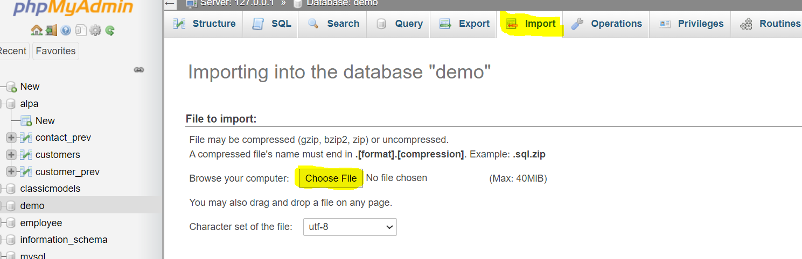

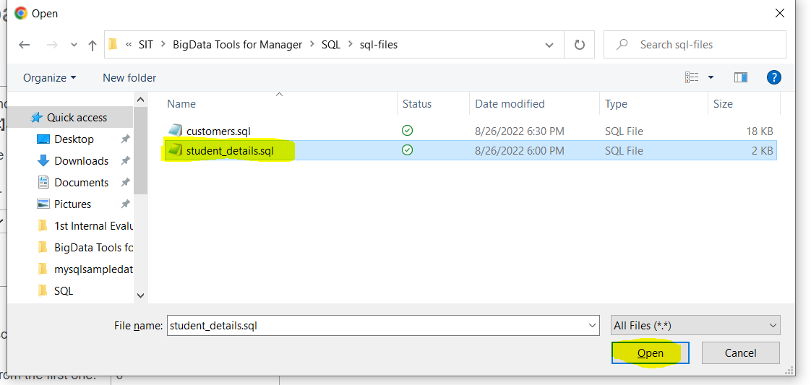

Click on **Open**

1. View the table structures of student_details table.

**DESCRIBE student_details;**

1. Display students name from the table

**SELECT name FROM student_details;**

1. Display class name from the table

**SELECT class FROM student_details;**

1. Display Unique class name

**SELECT DISTINCT class FROM student_details;**