**Big Data Tools for Managers**

**Dept. of MBA, Siddaganga Institute of Technology-Tumkur**

Below is the customer dataset; this exercise makes you familiar with where clause & filtering data in MySQL.

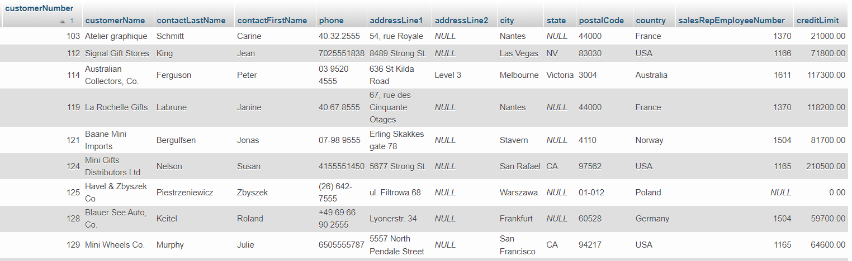

Download customer dataset from below link:

<https://raw.githubusercontent.com/sitmbadept/sitmbadept.github.io/main/BDTM/SQL/customers.sql>

Write SQL Code for following Statements.

1. Import customer data into MySQL…ignore this step if you imported already.
2. Display customers from Canada
3. Display customers from USA, Canada, UK
4. Display customers whose contactLastName is Brown
5. Display customers whose contactLastName is Brown and is from Country USA
6. Display the customers whose creditLimit Between range from 90,000 to 2,00,000

AND customers from Canada

1. Display the customers where customerNumber starts from 400.
2. Display the customers where customerNumber up to 120.
3. Display the customers where customerNumber between 150 to 160
4. Display the customers for given postalCode (44000, 4110, 60528, 10022)
5. Display the customers where creditLimit between (90,000 to 1,00,000) and Country From USA or Country From Canada
6. Import dataset

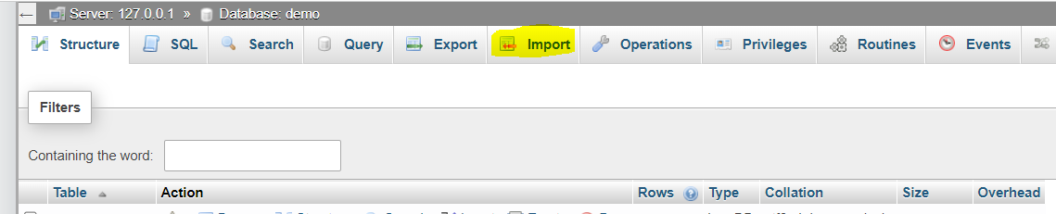

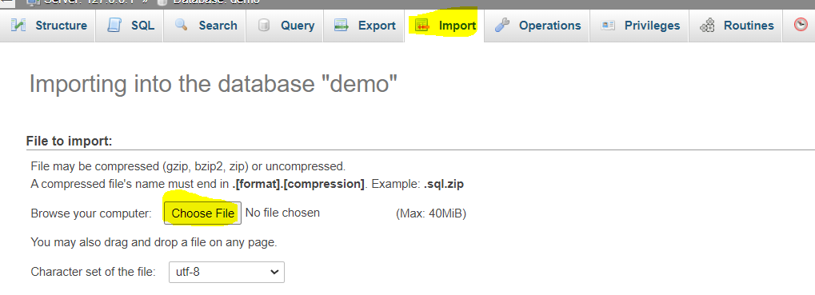

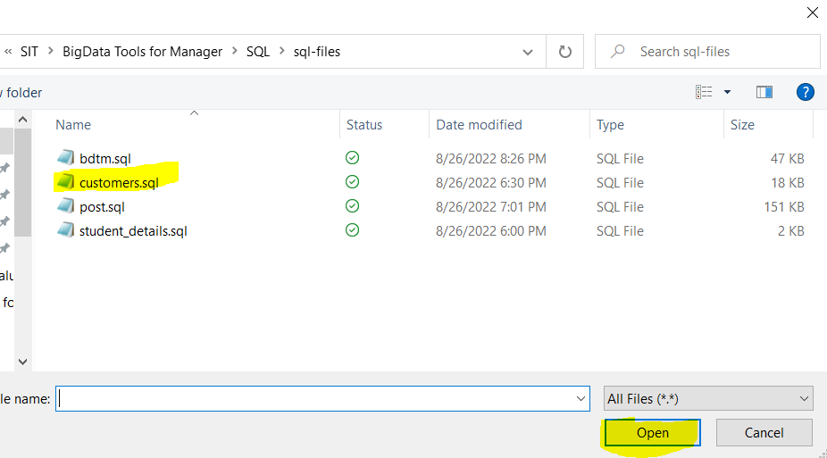

Click on Open after selecting customer.sql file

1. Display customers from Canada

SELECT * FROM customers WHERE country = "Canada";

1. Display customers from USA, Canada, UK

[SELECT](http://localhost:90/phpmyadmin/url.php?url=https://dev.mysql.com/doc/refman/8.0/en/select.html) * FROM customers WHERE country [IN](http://localhost:90/phpmyadmin/url.php?url=https://dev.mysql.com/doc/refman/8.0/en/comparison-operators.html%23function_in) ("Canada" , 'USA', 'UK');

1. Display customers whose contactLastName is Brown

SELECT * FROM customers WHERE contactLastName = "Brown";

1. Display customers whose contactLastName is Brown and is from Country USA

SELECT * FROM customers WHERE contactLastName = "Brown" AND country = "USA";

1. Display the customers whose creditLimit Between range from 90,000 to 2,00,000

AND customers from UK

[SELECT](http://localhost:90/phpmyadmin/url.php?url=https://dev.mysql.com/doc/refman/8.0/en/select.html) * FROM customers

WHERE creditLimit BETWEEN 90000 [AND](http://localhost:90/phpmyadmin/url.php?url=https://dev.mysql.com/doc/refman/8.0/en/logical-operators.html%23operator_and) 200000

[AND](http://localhost:90/phpmyadmin/url.php?url=https://dev.mysql.com/doc/refman/8.0/en/logical-operators.html%23operator_and) country = 'UK';

1. Display the customers where customerNumber starts from 400.

SELECT * FROM customers WHERE customerNumber >= 400;

1. Display the customers where customerNumber up to 120.

SELECT * FROM customers WHERE customerNumber < 120;

1. Display the customers where customerNumber between 150 to 160

SELECT * FROM customers WHERE customerNumber BETWEEN 150 AND 160;

OR

SELECT * FROM customers WHERE customerNumber >= 150

AND customerNumber <= 160;

1. Display the customers for given postalCode (44000, 4110, 60528, 10022)

SELECT * FROM customers

WHERE postalCode IN (44000, 4110, 60528, 10022);

1. Display the customers where creditLimit between (90,000 to 1,00,000) and Country From USA or Country From Canada

SELECT * FROM customers

WHERE creditLimit BETWEEN 90000 AND 100000

AND country IN ('USA', 'Canada');