**Big Data Tools for Managers**

**Dept. of MBA, Siddaganga Institute of Technology-Tumkur**

Below is the employee dataset; this exercise makes you familiar with update and delete statement from Data Manipulation Language(DML).

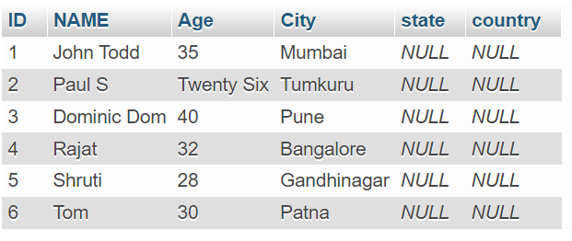

Download customer dataset from below link:

Link 1: <https://raw.githubusercontent.com/sitmbadept/sitmbadept.github.io/2022/BDTM/SQL/employee-update.sql>

OR

Link 2 : [https://drive.google.com/file/d/18K8l0ELAU_1dH04YWkvLdFohRm2PbtDD](https://drive.google.com/file/d/18K8l0ELAU_1dH04YWkvLdFohRm2PbtDD/view?usp=sharing)

Write SQL Code for following Statements.

1. Import employee data into MySQL
2. Display all the records from employee table
3. Update Age with appropriate numbers for Employee ID : 2 / Employee Name : Paul S
4. Display all the records after updating Age
5. Update State name as per city
6. Display all the records after updating State
7. Update country name as India for all the employee
8. Display all the records after updating Country
9. Delete employee who all are from Karnataka
10. Display all the records after deleting Karnataka employee
11. Delete all the employee records
12. Display all the records after deleting all the records
13. Import dataset

Option -1

Import data using Navigation Bar

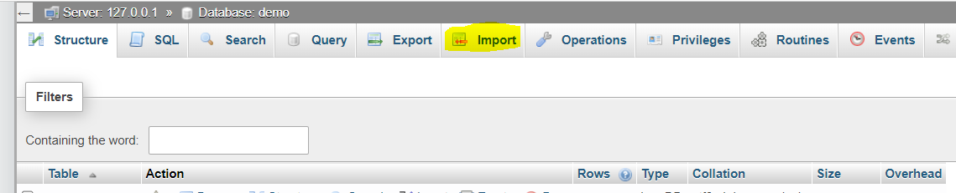

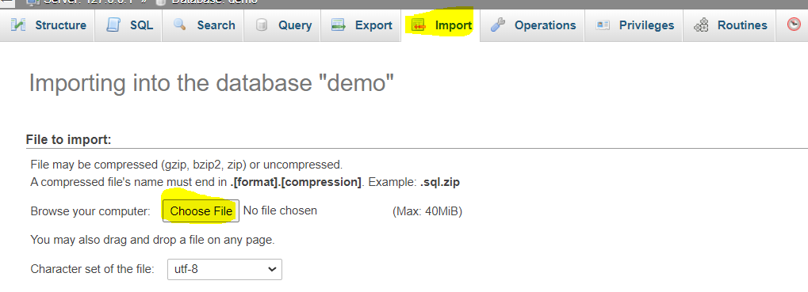

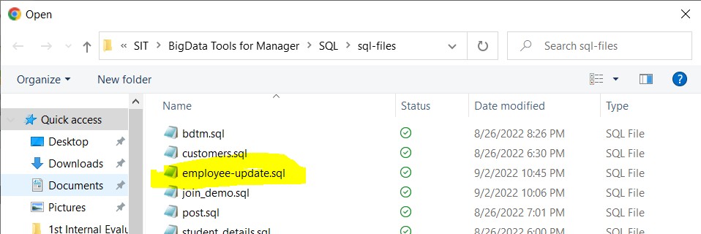

Click on Open after selecting employee-update.sql file

**Option-2:**

Copy the SQL code from above given link and paste in SQL window.

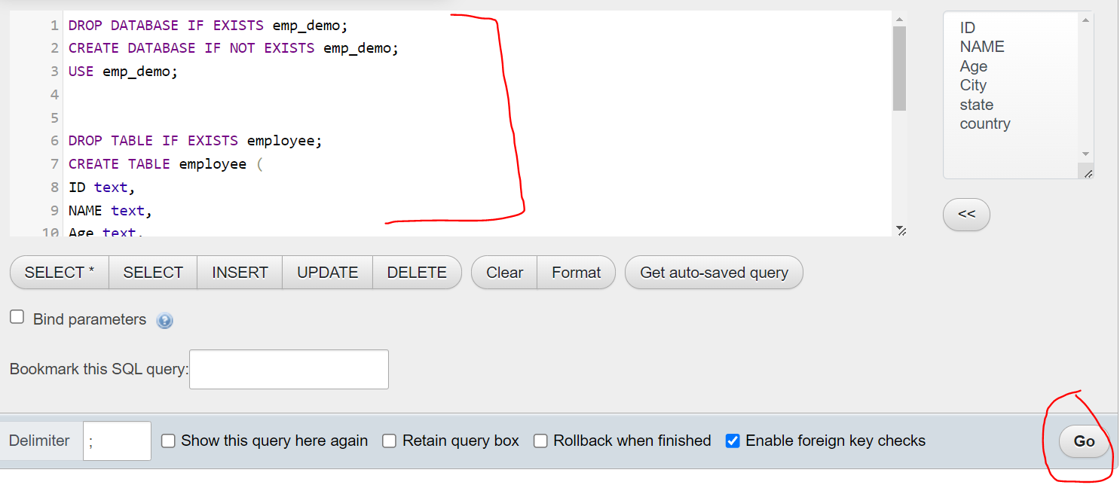

After importing database, select emp_demo database in phpmyadmin

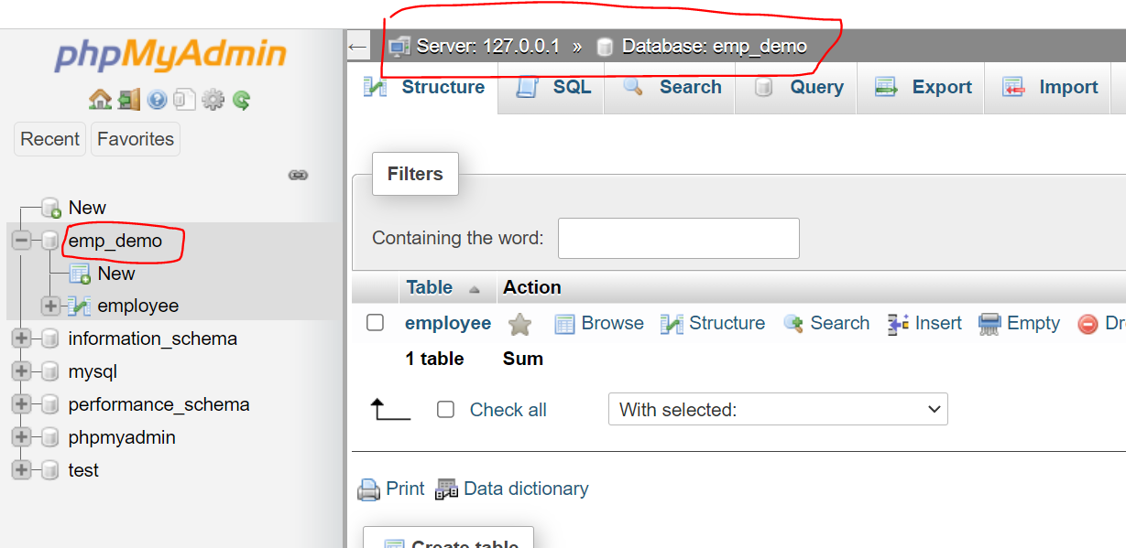

1. Display all the records from employee table

**SELECT * FROM employee;**

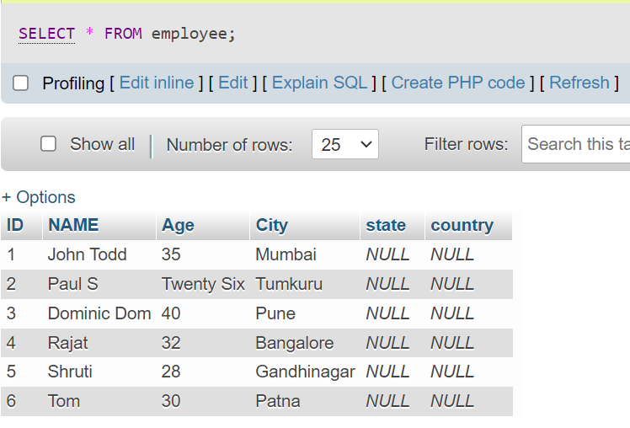

1. Update Age with appropriate numbers for Employee ID : 2 / Employee Name : Paul S

**UPDATE employee SET Age=26 WHERE ID=2;**

OR

**UPDATE employee SET Age=26 WHERE NAME='Paul S';**

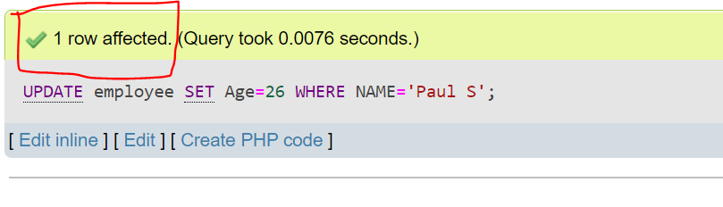

Query result will show number of records got affected with new value.

1. Display all the records after updating Age

**SELECT * FROM employee;**

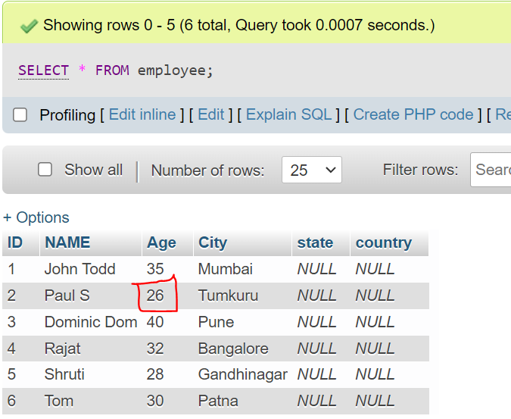

1. Update State name as per city

**UPDATE employee SET STATE = 'Karnataka' WHERE CITY IN ('Tumkuru','Bangalore');**

**UPDATE employee SET STATE = 'Maharashtra' WHERE CITY IN ('Pune','Mumbai');**

**UPDATE employee SET STATE = 'Bihar' WHERE CITY = 'Patna';**

**UPDATE employee SET STATE = 'Gujarat' WHERE CITY = 'Gandhinagar';**

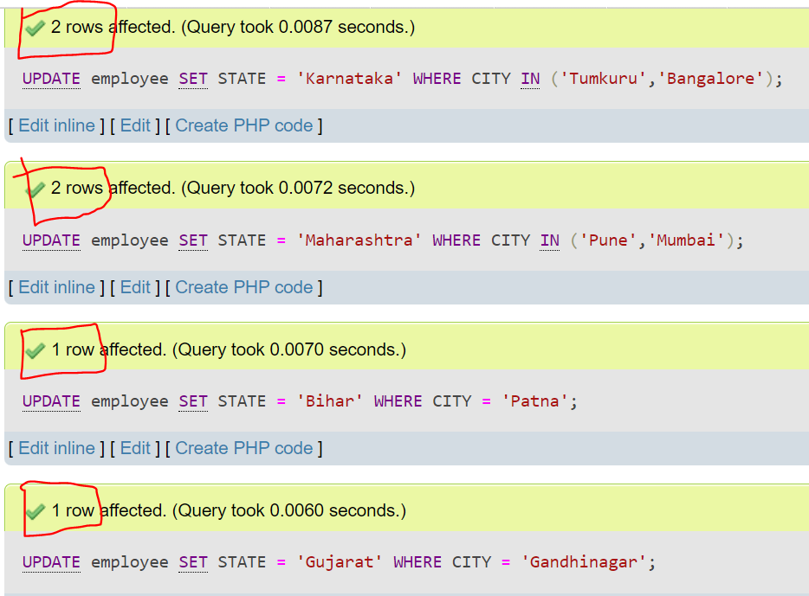

1. Display all the records after updating State

**SELECT * FROM employee;**

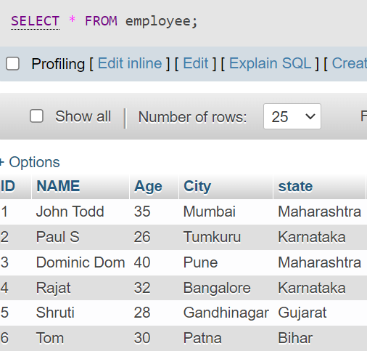

1. Update country name as India for all the employee

**UPDATE employee SET country='India';**

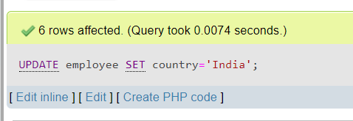

1. Display all the records after updating Country

**SELECT * FROM employee;**

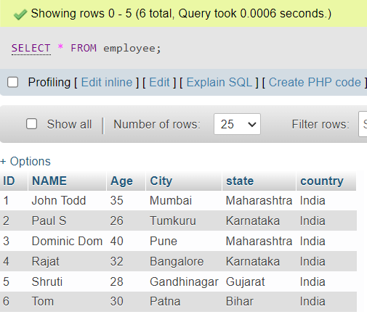

1. Delete employee who all are from Karnataka

**DELETE FROM employee WHERE state='Karnataka';**

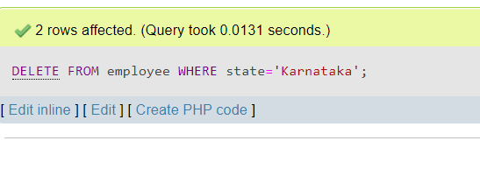

1. Display all the records after deleting Karnataka employee

**SELECT * FROM employee;**

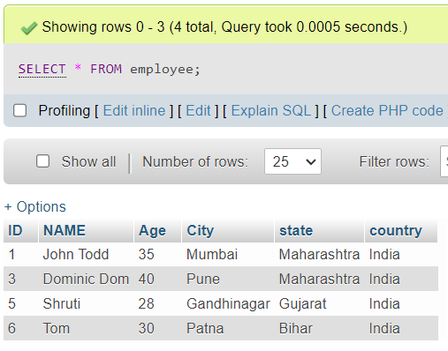

1. Delete all the employee records

**TRUNCATE TABLE employee;**

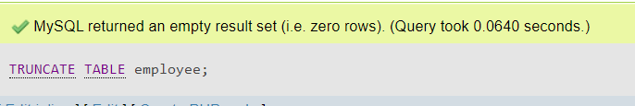

1. Display all the records after deleting all the records

**SELECT * FROM employee;**

