**Big Data Tools for Managers**

**Dept. of MBA, Siddaganga Institute of Technology-Tumkur**

Below is the link to download sample_db dataset; this exercise makes you familiar with Union, Union All and View in MySQL.

Link-1 : <https://raw.githubusercontent.com/sitmbadept/sitmbadept.github.io/main/BDTM/SQL/sample_db.sql>

OR

Link-2 : <https://drive.google.com/file/d/18jUcbMpZv8NZqc4xQLeJdLg3X1duaVKA/view?usp=sharing>

Write SQL Code for following Statements.

1. Import sample_db database into MySQL.
2. List all the tables available in sample_db
3. Display all the records from customers_1
4. Display all the records from customers_2
5. Combine customers_1 and customers_2 tables
6. Combine customers_1 and customers_2 tables; also display duplicate records if available
7. Display common records from the customers_1 and customers_2
8. Select Customer names from both table (customers_1 and customers_2)
9. Create View to display all the records from customers_1 and customers_2
10. Create View to display common records from customers_1 and customers_2
11. Import sample_db database

Copy pastes entire SQL codes from given link.

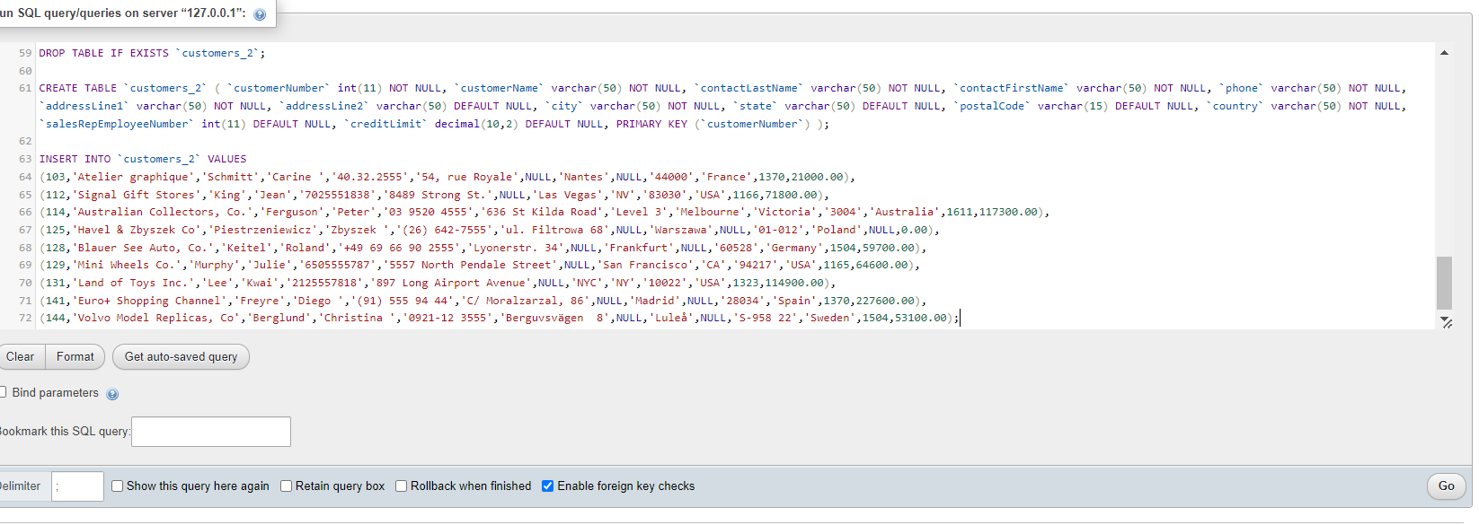

Select the **sample_db** database after importing

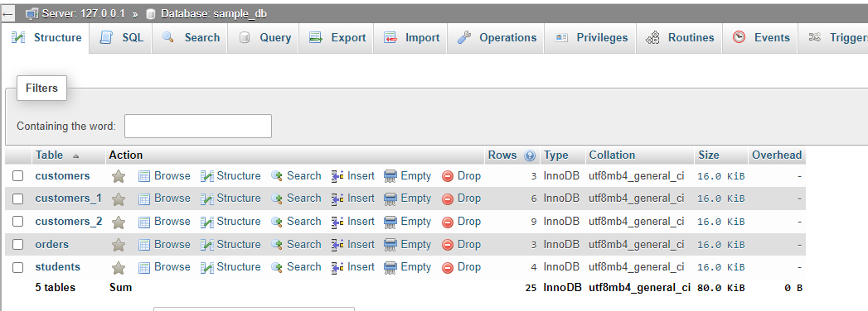

1. List all the tables available in sample_db

**SHOW TABLES;**

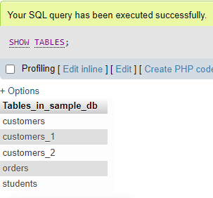

1. Display all the records from customers_1

**SELECT * FROM customers_1;**

1. Display all the records from customers_2

**SELECT * FROM customers_2;**

1. Combine customers_1 and customers_2 tables

[**SELECT**](http://localhost:90/phpmyadmin/url.php?url=https://dev.mysql.com/doc/refman/8.0/en/select.html)**\* FROM customers_1**

**UNION**

[**SELECT**](http://localhost:90/phpmyadmin/url.php?url=https://dev.mysql.com/doc/refman/8.0/en/select.html)**\* FROM customers_2;**

1. Combine customers_1 and customers_2 tables; also display duplicate records if available

[**SELECT**](http://localhost:90/phpmyadmin/url.php?url=https://dev.mysql.com/doc/refman/8.0/en/select.html)**\* FROM customers_1**

**UNION ALL**

[**SELECT**](http://localhost:90/phpmyadmin/url.php?url=https://dev.mysql.com/doc/refman/8.0/en/select.html)**\* FROM customers_2;**

1. Display common records from the customers_1 and customers_2

[**SELECT**](http://localhost:90/phpmyadmin/url.php?url=https://dev.mysql.com/doc/refman/8.0/en/select.html)**\* FROM customers_1**

**INTERSECT**

[**SELECT**](http://localhost:90/phpmyadmin/url.php?url=https://dev.mysql.com/doc/refman/8.0/en/select.html)**\* FROM customers_2;**

1. Select Customer names from both table (customers_1 and customers_2)

**SELECT customerName FROM customers_1**

**UNION**

**SELECT customerName FROM customers_2;**

1. Create View to display all the records from customers_1 and customers_2

**CREATE VIEW display_all_record as**

**SELECT * FROM customers_1**

**UNION**

**SELECT * FROM customers_2;**

1. Create View to display common records from customers_1 and customers_2

**CREATE VIEW display_common_record as**

**SELECT * FROM customers_1**

**INTERSECT**

**SELECT * FROM customers_2;**