**Big Data Tools for Managers**

**Dept. of MBA, Siddaganga Institute of Technology-Tumkur**

Below is the shopping dataset; this exercise makes you familiar with Join, Group By, View in MySQL table.

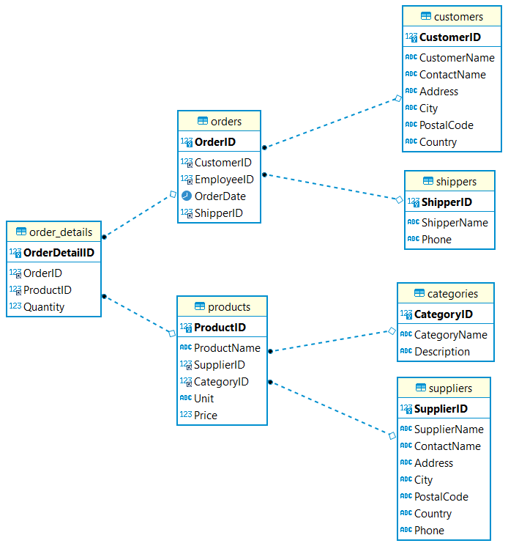

Download Shopping dataset from below link:

Link-1 : <https://raw.githubusercontent.com/sitmbadept/sitmbadept.github.io/main/BDTM/SQL/bdtm.sql>

OR

Link-2 : [https://drive.google.com/file/d/18gRCY5Yp-8y16jS51wiFGLnTLrP2uHve](https://drive.google.com/file/d/18gRCY5Yp-8y16jS51wiFGLnTLrP2uHve/view?usp=sharing)

Write SQL Code for following Statements.

1. Import Shopping data into MySQL…ignore this step if you imported already.
2. Show table names
3. Join Order details table with Orders table & Customer Table
4. Join Orders table with Shipping table to get shipper name
5. Display the total order qty by customer name
6. Display the total order qty by supplier name
7. Display maximum unit sold product name
8. Create a view to display join between Orders & Customer Table
9. Import dataset

Option -1

Import data using Navigation Bar

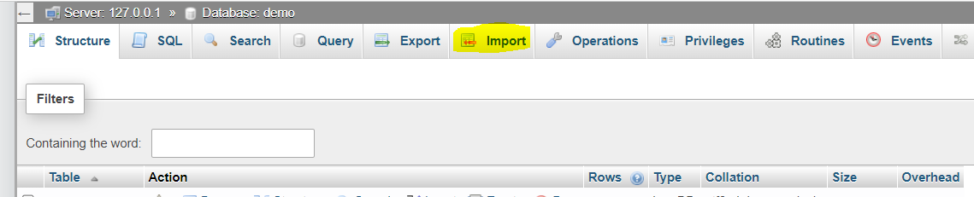

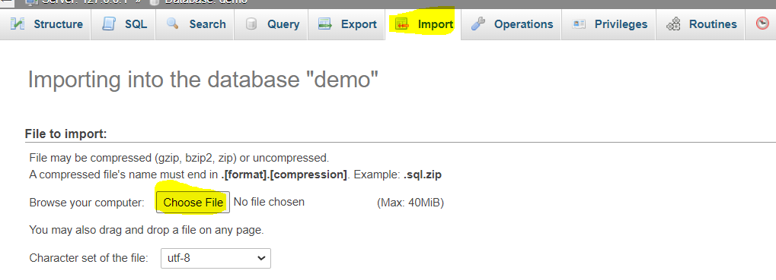

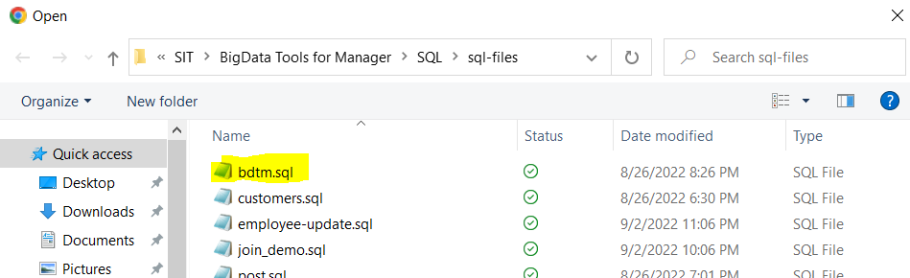

Click on Open after selecting bdtm.sql file

**Option-2:**

Copy the SQL code from above given link and paste in SQL window

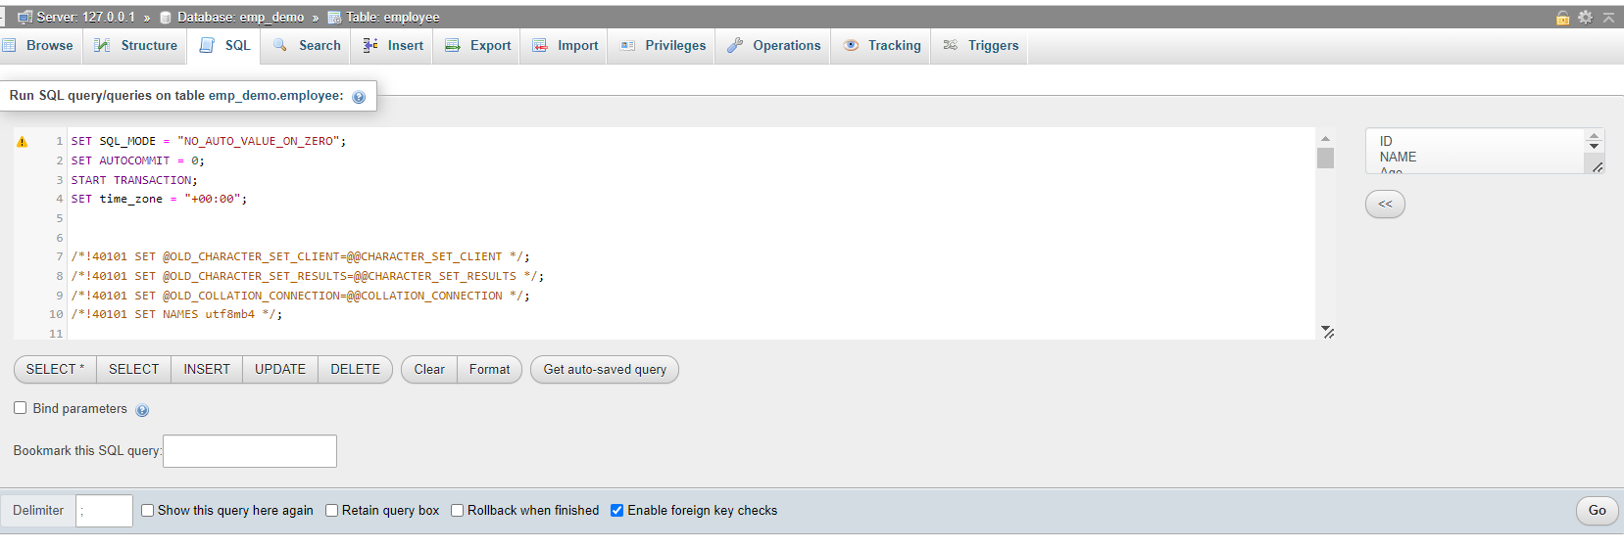

After importing database, select bdtm database in phpmyadmin

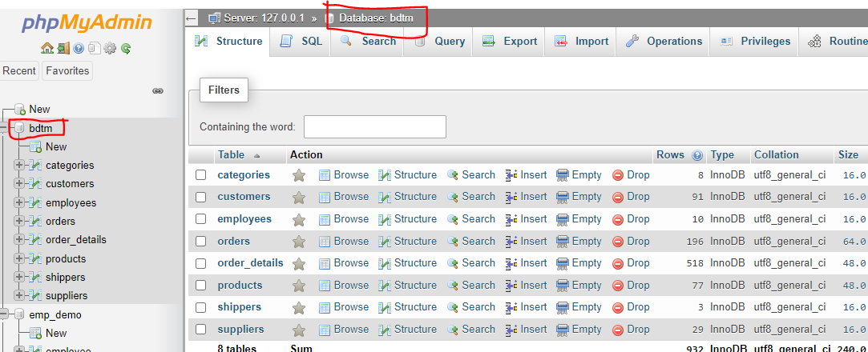

1. Show table names

SHOW TABLES;

1. Join Order details , Orders table & Customer Tables

SELECT order_details.*,

orders.*,

customers.*

FROM order_details

LEFT JOIN orders ON order_details.OrderID = orders.OrderID

LEFT JOIN customers ON orders.CustomerID = customers.CustomerID;

1. Join Orders table with Shipping table to get shipper name

SELECT orders.*, shippers.ShipperName, shippers.Phone FROM orders

LEFT JOIN shippers ON orders.ShipperID = shippers.ShipperID;

1. Display the total order qty by customer name

SELECT CustomerName, SUM(Quantity)

FROM order_details

LEFT JOIN orders ON order_details.OrderID=orders.OrderID

LEFT JOIN customers ON orders.CustomerID = customers.CustomerID

GROUP BY CustomerName;

1. Display the total order qty by supplier name

SELECT SupplierName, sum(Quantity)

FROM order_details

LEFT JOIN products ON order_details.ProductID = products.ProductID

LEFT JOIN suppliers ON suppliers.SupplierID = products.SupplierID

GROUP BY SupplierName;

1. Display maximum unit sold product name

SELECT ProductName, MAX(Quantity)

FROM order_details

LEFT JOIN products ON order_details.ProductID = products.ProductID;

1. Create a view to display join between Orders & Customer Table

CREATE VIEW customer_order AS

SELECT orders.*, customers.CustomerName, customers.Address, customers.City, customers.Country FROM orders

LEFT JOIN customers ON customers.CustomerID = orders.CustomerID;

Display join data using view

SELECT * FROM customer_order;