**Big Data Tools for Managers**

**Dept. of MBA, Siddaganga Institute of Technology-Tumkur**

This exercise makes you to get familiar with DDL Alter statement in MySQL.

Table Name : EVENTS

|  |  |  |  |
| --- | --- | --- | --- |
| **EVENT_ID** | **NAME** | **DATE** | **VENUE** |
| EVT_1 | NATIONAL LEVEL PAPER PRESENTATION | 2023-01-01 | BIRALA AUDITORIUM |
| EVT_2 | TECHNICAL QUIZ | 2023-02-18 | MBA DEPARTMENT |
| EVT_3 | SPANDANA [STATE LEVEL CULTURAL FESTIVAL] | 2023-03-15 | BIRALA AUDITORIUM |
| EVT_4 | HACKATHON | 2023-06-06 | ADMIN BLOCK |

Write a DDL SQL statements for the following questions:

1. Create EVENTS above given tables along with the data.
2. Add new column COLLEGE with Default Value SIT
3. Add multiple columns CITY, STATE, PINCODE with Default Value
4. View the table data
5. Delete column STATE from EVENTS table
6. Rename column NAME to EVENT_NAME in EVENTS table
7. Rename EVENTS table to EVENTS_2023
8. Create EVENTS above given tables along with the data.

**CREATE TABLE EVENTS (**

**EVENT_ID CHAR(10),**

**NAME VARCHAR(50),**

**DATE DATE,**

**VENUE VARCHAR(50)**

**);**

**INSERT INTO EVENTS VALUES ("EVT_1", "NATIONAL LEVEL PAPER PRESENTATION", "2023-01-01", "BIRALA AUDITORIUM");**

**INSERT INTO EVENTS VALUES ("EVT_2", "TECHNICAL QUIZ", "2023-02-18", "MBA DEPARTMENT");**

**INSERT INTO EVENTS VALUES ("EVT_3", "SPANDANA [STATE LEVEL CULTURAL FESTIVAL]", "2023-03-15", "BIRALA AUDITORIUM");**

**INSERT INTO EVENTS VALUES ("EVT_4", "HACKATHON", "2023-01-01", "ADMIN BLOCK");**

1. Add new column COLLEGE with Default Value SIT

**ALTER TABLE EVENTS**

**ADD COLUMN COLLEGE VARCHAR(10) DEFAULT "SIT";**

1. Add multiple columns CITY, STATE, PINCODE with Default Value

**ALTER TABLE EVENTS**

**ADD COLUMN CITY VARCHAR(10) DEFAULT "TUMKUR",**

**ADD COLUMN STATE VARCHAR(10) DEFAULT "KARNATAKA",**

**ADD COLUMN PINCODE VARCHAR(6) DEFAULT "572103";**

1. View the table data

**SELECT * FROM EVENTS;**

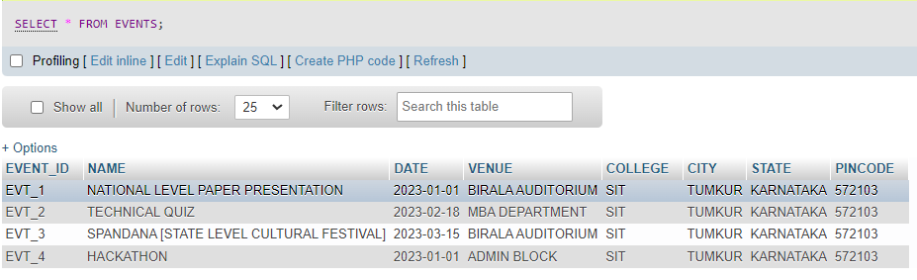

1. Delete column STATE from EVENTS table

**ALTER TABLE EVENTS**

**DROP COLUMN STATE;**

1. Rename column NAME to EVENT_NAME in EVENTS table

**ALTER TABLE EVENTS**

**CHANGE COLUMN NAME EVENT_NAME VARCHAR(50);**

View table data

**SELECT * FROM EVENTS;**

1. Rename EVENTS table to EVENTS_2023

**ALTER TABLE EVENTS**

**RENAME TO EVENTS_2023;**